**Applied Project Report**

**Analysis of Real-life Business Cases**

By

**Kasula Lohith Kumar**

**A Master’s Project Report submitted to Scaler Neovarsity - Woolf in partial fulfillment of the requirements for the degree of Master of Science in Computer Science**

**November, 2025**



**Scaler Mentee Email ID :** kasulalohithkumar@gmail.com

**Thesis Supervisor :** Shivank Agarwal

**Date of Submission :** 11/11/2025

**Certification**

I confirm that I have overseen / reviewed this applied project and, in my judgment, it adheres to the appropriate standards of academic presentation. I believe it satisfactorily meets the criteria, in terms of both quality and breadth, to serve as an applied project report for the attainment of Master of Science in Computer Science degree. This applied project report has been submitted to Woolf and is deemed sufficient to fulfill the prerequisites for the Master of Science in Computer Science degree.

Shivank Agarwal

…………………

Project Guide / Supervisor

**DECLARATION**

I confirm that this project report, submitted to fulfill the requirements for the Master of Science in Computer Science degree, completed by me from **15/11/2023** to **11/11/2025** is the result of my own individual endeavor. The Project has been made on my own under the guidance of my supervisor with proper acknowledgement and without plagiarism. Any contributions from external sources or individuals, including the use of AI tools, are appropriately acknowledged through citation. By making this declaration, I acknowledge that any violation of this statement constitutes academic misconduct. I understand that such misconduct may lead to expulsion from the program and/or disqualification from receiving the degree.

Kasula Lohith Kumar

 **Date:** 11/11/2025

**ACKNOWLEDGMENT**

I would like to express my heartfelt gratitude to my parents, **Mr. K. Sampath Kumar** and **Mrs. K. Vimala**, for their unwavering love, guidance, and encouragement throughout my learning journey. Their constant support has been the foundation of my perseverance and success. I am deeply thankful to all my **Scaler instructors** whose expertise, patience, and dedication have been instrumental in shaping my understanding across various domains. Special thanks to **Suraaj Hasija** (SQL, GenAI), **Thanish Batcha** (Tableau and Excel), **Akash Rajpuria** (Python Libraries, Maths for ML, Intro to ML and NN, Supervised Algorithms), **Aniruddha Mukherjee** (Probability & Stats, Data Analytics and Visualisation Fundamentals), **Eshan Tiwari** (Product Analytics), **Archit Sharma** (Advanced Python), **Rohit Jindal** (Advanced Supervised Algorithms, Unsupervised and RecSys), **Shivam Prasad** (MLOps, Computer Vision), **Satya Pattnaik** (Neural Networks, NLP), **Ashay Sinha** (Product Management for Software Engineers), **Amit Singh** (Data Engineering), and **Shivank Agarwal** (GenAI). Each of them has played a vital role in helping me gain knowledge, confidence, and a problem-solving mindset.

I would also like to extend my sincere appreciation to the **co-founders of Scaler — Abhimanyu Saxena, Anshuman Singh, and Vaibhav Gupta** — for creating such an empowering and well-structured learning ecosystem that bridges the gap between education and industry needs. My gratitude also goes out to all the **teaching and non-teaching faculty members**, whose consistent efforts, guidance, and support contributed immensely to the successful completion of my **Data Science and Machine Learning** program. Lastly, I am thankful to my peers, mentors, and everyone who inspired and motivated me to complete this program and earn my Master’s degree.

**Table of Contents**

List of Tables 13

List of Figures 14

Applied Real-life Business Cases 25

ABSTRACT 25

**Chapter 1 : Business Case Study 1** 26

1.1 Problem Description 26

1.2 Business Questions to be Answered 30

1.2.1 Questions 30

1.2.2 Background and Significance 31

1.2.2 Methodology and Real-Life Applications 32

1.3 Analysis 33

1.3.1 Data Understanding and Exploration 33 1.3.1.1 Data types and characteristics of all columns 33

1.3.1.2 Between what time range were the orders placed 34

1.3.1.3 Unique cities and states of the customers 35

1.3.2 Order Trends and Seasonality in terms of

the number of orders being placed36

1.3.3 Evolution of E-commerce Orders in the Region 40

1.3.3.1 Month-on-month order volume in each state 40

1.3.3.2 Customers distributed geographically across all states 42

1.3.4 Economic and Operational Analysis 44

1.3.4.1 Percentage increase in the total cost of orders 44

1.3.4.2 Total and average order prices for each state 47

1.3.4.3 Total and average freight values for each state 49

1.3.5. Delivery and Freight Performance 51

1.3.5.1 No of Days taken to deliver each order from the purchase date 51

1.3.5.2 Difference between the estimated and actual delivery date for each order 53

1.3.5.3 Top 5 states with the highest and lowest average freight values 56

1.3.5.4 Delivery time and estimated date of top 5 states 58

1.3.6. Payment Analysis 61

1.3.6.1 Month-on-month orders placement using different payment types 61

1.3.6.2 Distribution of orders based on the number of payment installments 62

1.4 Insights and Recommendations 64

**Chapter 2 : Business Case Study 2** 67

2.1 Problem Description 68

2.2 Business Questions To Be Answered 68

2.2.1 Questions 68  
 2.2.2 Background and Significance 68

2.2.3 Problem Statement (Anonymized) 69

2.2.4 Methodology and Real-World Applications 69

2.2.5 Insights, Recommendations, and Implications 70

* + 1. Addressing Limitations and Suggestions 70

2.3 Analysis 71

2.3.1 Exploratory Data Analysis (EDA) 71

2.3.1.1 Data Frame Preview 71

2.3.1.2 Data Frame shape 72

2.3.1.3 Data Frame Columns 72

2.3.1.4 Detection of Null Values 73

2.3.1.5 Duplicate values 74

2.3.1.6 Descriptive Statistics of Numerical Dataset 75

2.3.1.7 Descriptive Statistics of Categorical Dataset 76

2.3.2 Univariate Analysis 77

2.3.2.1 Loan Term Proportions 77

2.3.2.2 Initial List Status Proportions 79

2.3.2.3 Verification Status Proportions 80

2.3.2.4 Application Type Proportions 82

2.3.2.5 Count of Different Grades 83

2.3.2.6 Employee experience and their loan application count 85

2.3.2.7 Home Ownership and Respective Loan application count 86

2.3.2.8 Loan Verification Status and Respective Application Count 87

2.3.2.9 Loan Application Purpose and It’s Count 88

2.3.2.10 Distribution of Loan Amounts using Kernel Density Estimate (KDE) 89

2.3.2.11 Distribution of Interest Rates using Kernel Density Estimate (KDE) 90

2.3.2.12 Loan Installment Amount using Kernel Density Estimate (KDE) 91

2.3.2.13 Annual Income using Kernel Density Estimate (KDE) 91

2.3.2.14 Debt to Income using Kernel Density Estimate (KDE) 92

2.3.2.15 Open Accounts using Kernel Density Estimate (KDE) 93

2.3.2.16 Public Records using Kernel Density Estimate (KDE) 94

2.3.2.17 Revolving Balance using Kernel Density Estimate (KDE) 95

2.3.2.18 Revolving Utilization using Kernel Density Estimate (KDE) 96

2.3.2.19 Total Accounts using Kernel Density Estimate (KDE) 97

2.3.2.20 Mortgage Accounts using Kernel Density Estimate (KDE) 98

2.3.2.21 Public Record Bankruptcies using Kernel Density Estimate (KDE) 99

2.3.3 Bivariate Analysis 99

2.3.3.1 Loan Status Count w.r.t Term 99

2.3.3.2 Loan Status Count w.r.t Different Grades 101

2.3.3.3 Loan Status Count w.r.t Different Sub Grades 103

2.3.3.4 Loan Status Count w.r.t Employee Length 105

2.3.3.5 Loan Status Count w.r.t Home Ownership 106

2.3.3.6 Loan Status Count w.r.t Verification Status 108

2.3.3.7 Loan Status Count w.r.t Purpose 109

2.3.3.8 Loan Status Count w.r.t Initial List Status 110

2.3.3.9 Loan Status Count w.r.t Application Type 111

2.3.3.10 Loan Status of top 12 Postal Codes 112

2.3.3.11 Purpose of Loan – Top 20 112

2.3.3.12 Loan Status Count w.r.t ‘issue_year’ and ‘issue_month’ 113

2.3.3.13 Top 20 Status of Loan w.r.t to ‘emp_title’ 115

2.3.3.14 Loan Status Count w.r.t to 'earliest_cr_line_year'

and 'earliest_cr_line_month' 116

2.3.3.15 Distribution of Loan Amount w.r.t Loan Status 118

2.3.3.16 Distribution of Interest Rate w.r.t Loan Status 119

2.3.3.17 Distribution of Installments w.r.t Loan Status 121

2.3.3.18 Distribution of Annual Income w.r.t Loan Status 122

2.3.3.19 D.T.I w.r.t Loan Status 123

2.3.3.20 Open Account w.r.t Loan Status 124

2.3.3.21 Public Record w.r.t Loan Status 125

2.3.3.22 Revolving Balance w.r.t Loan Status 126

2.3.3.23 Revolving Line Utilization Rate w.r.t Loan Status 127

2.3.3.24 Total No of Credit Lines w.r.t Loan Status 129

2.3.3.25 Total No of Mortgage Accounts w.r.t Loan Status 130

2.3.3.26 Total No of Public Record Bankruptcies w.r.t Loan Status 131

2.3.4 Multivariate Analysis 132

2.3.4.1 Pair Plot of All Numerical variables 132

2.3.4.2 Correlation plot of all Numerical Variables 135

2.3.5 Data Pre-Processing 137

2.3.5.1 Removing Highly Correlated Features 137

2.3.5.2 Null Values Treatment 137

2.3.5.3 Log Transformation 139

2.3.5.4 Outlier Treatment 139

2.3.5.5 Handling 'address' Feature values Inconsistency 140

2.3.5.6 Handling ‘title’ Feature values Inconsistency 142

2.3.6 Sanity check after preprocessing 143

2.3.6.1 Null values 143

2.3.6.2 Outliers 145

2.3.7 Data Preprocessing for Modelling 145

2.3.7.1 Code for Data Preprocessing for Modelling 146

2.3.7.2 Splitting (Train,Test), Encoding, Balancing and Scaling the Data 147

2.3.8 Sanity Check After Data Preprocessing for Modelling 148

2.3.8.1 Shape of the data after splitting 148

2.3.8.2 Loan Status Proportion Check After SMOTE 149

2.3.8.3 Encoded and Scaled Data 149

2.3.9 Modelling Using Logistic Regression 150

2.3.9.1 Detecting Multicollinearity with VIF 150

2.3.9.2 Splitting the data into 3 parts (train, test and validation) 152

2.3.9.3 Regularization after dropping the redundant features 152

2.3.9.4 Model Training 154

2.3.10 Results Evaluation 155

2.3.10.1 Classification Report 155

2.3.10.2 Accuracy 156

2.3.10.3 ROC-AUC Curve 157

2.3.10.4 Precision-Recall Curve 158

2.4 Insights and Recommendations 159

2.4.1 Results and Recommendations 160

2.4.2 Implications for Industry, Business, and Policy 160

2.4.3 Addressing Limitations and Constraints 160

2.4.4 Alternative Approaches & Recommendations 161

2.4.5 Key Learnings, Methodology, and Industry Applications 161

**Chapter 3 : Business Case Study 3**

3.1 Business Case Problem Statement 162

3.2 Key Steps and Questions to Answer For Analysis 164

3.2.1 Key Steps 164

3.2.2 Questions to Answer 164

3.2.3 Background & Significance 165

3.2.4 Methodology and Real-Life Application 165

3.3 Analysis 165

3.3.1 Exploratory Data Analysis 165

3.3.2 Shape 167

3.3.3 Info 168

3.3.4 Extraction of Structured Metadata from Wikipedia Page Names Using

Regular Expressions 179

3.3.4 Columns of Dataset 180

3.3.5 Handling Null Values 181

3.3.6 Exploring Categorical Diversity in Wikipedia Page Metadata: Language,

Access Type, and Origin 183

3.3.7 Value Count of Languages 183

3.3.8 Extracting Language Name 185

3.3.9 Distribution Analysis of Languages, Access Types, and Origins in

Wikipedia Pageviews 186

3.3.10 Wikipedia Languages and their Access Origin 188

3.3.11 Wikipedia Languages and their Access Type 190

3.3.12 Wikipedia Languages and their Clicks191

3.3.13 Language-Specific DataFrame Pickling 193

3.3.14 Access Type and Access Origin Type Of All Languages 194

3.3.15 Duplicate Values Check 196

3.3.16 Monthly Average Clicks 197

3.3.17 Top 20 Web Pages By Ad Clicks 200

3.3.18 Bottom 20 Web Pages By Ad Clicks 205

3.3.19 Modelling using ARIMA Family

of Modelling Techniques (Arima Pipeline**)**  209

3.3.20 English Language Forecast using ARIMA Family 215

3.3.21 Chinese Language Forecast using ARIMA Family 220

3.3.22 French Language Forecast using ARIMA Family 224

3.3.23 Japanese Language Forecast using ARIMA Family 228

3.3.24 Russian Language Forecast using ARIMA Family 232

3.3.25 German Language Forecast using ARIMA Family 236

3.3.26 Modelling using FB Prophet Pipeline 239

3.3.27 English Language Forecast FB Prophet Pipeline 243

3.3.28 German Language Forecast FB Prophet Pipeline 245

3.3.29 French Language Forecast FB Prophet Pipeline 247

3.3.30 Spanish Language Forecast FB Prophet Pipeline 249

3.3.31 Chinese Language Forecast FB Prophet Pipeline 251

3.3.32 Japanese Language Forecast FB Prophet Pipeline 252

3.3.33 Russian Language Forecast FB Prophet Pipeline 254

3.4 Overall Insights and Recommendations 256

3.4.1 Presentation of Results with Justification 257

3.4.2 Implications for Industry, Business, and Policy 257

3.4.3 Limitations 257

3.4.4 Alternative Recommendations 258

3.4.5 Key Learnings, Methodology, and Industry Application 258

**Chapter 4 : Business Case Study 4**

4.1 Problem Description 259

4.1.1 Problem Statement (Business Case) 259

4.1.2 Business Goals Background 259

4.1.3 How Recommendations Work 259

4.2 Business Questions to be Answered for Analysis 263

4.2.1 Questions 263

4.2.2 Significance of These Questions 263

4.2.3 Methodology & Real-World Applications 263

4.2.4 Practical Applications 264

4.3 Analysis 264

4.3.1 Data Frame Structure and Initial Preprocessing 264

4.3.1.1 Loading Movie Recommendation DataFrames from CSV Files 265

4.3.1.2 Structure of DataFrame 265

4.3.1.3 Exploded Movies Data Frame by Individual Genre 266

4.3.1.4 Grouping The Data Frame Based on Index 266

4.3.1.5 List of Unique Movie Genres Identified in Dataset 267

4.3.1.6 Final Movies DataFrame with Genre Dummy Variables 267

4.3.1.7 Ratings Data Frame with Derived Time Features 268

4.3.1.8 Users Data Frame Structure 269

4.3.1.9 Merged Movies and Ratings DataFrame with Genre Features 270

4.3.1.10 Movies-Ratings DataFrame with Genre Features (MovieID Dropped) 271

4.3.1.11 Fully Merged Movies, Ratings, and User Data Frame 271

4.3.1.12 Decoding Occupation and Age Columns in Final Data Frame 272

4.3.2 Exploratory Data Analysis (EDA) 274

4.3.2.1 Data frame Shape 274

4.3.2.2 Dataframe Information 274

4.3.2.3 Data Frame Description for Numerical columns 276

4.3.2.4 Data Frame Description for Object type columns 276

4.3.2.5 Data Frame Null Values Check 277

4.3.2.6 Unique Column Values 279

4.3.3 Univariate Analysis 280

4.3.3.1 Proportion of Gender 280

4.3.3.2 Distribution of Age 281

4.3.3.3 Distribution of Movie Ratings 282

4.3.3.4 Distribution of Movie Ratings by Day of Week 283

4.3.3.5 Distribution of Movie Ratings by Day of Month 284

4.3.3.6 Number of People by Occupation 285

4.3.3.7 Time when people watch movies and give ratings 286

4.3.3.7 Top 20 years in which the highest number of movies were released 287

4.3.4 Bivariate Analysis 288

4.3.4.1 Genre Count w.r.t Gender 288

4.3.4.2 Genre w.r.t Age 290

4.3.4.3 Genre w.r.t Occupation 293

4.3.5 Modelling Recommender System 296

4.3.5.1 Recommender System Based on Pearson Correlation 296

4.3.5.1.1 Item Based 296

4.3.5.1.2 User Based 299

4.3.5.2 Item-Item Similarity Matrix 300

4.3.5.3 User-User Similarity Matrix 301

4.3.5.4 Matrix Factorization 302

4.3.5.4.1 Overlap 304

4.3.5.4.2 Precision of Top-100 Movie Recommendations—Hit Rate Analysis 306

4.3.5.4.3 Low Overlap of Recommendations with Highly Rated Movies 307

4.4 Insights and Recommendations 308

4.4.1 Results and Recommendations 308

4.4.2 Implications for Industry/Business/Policy 308

4.4.3 Limitations and Constraints 308

4.4.4 Alternative Explanations or Recommendations 309

4.4.5 Key Learnings, Methodology and Applications 309

**Chapter 5 : Business Case Study 5**

5.1 Problem Description 310

5.1.1 Problem Statement 310

5.1.2 Business Background 310

5.2 Business Questions to Answer 310

5.2.1 Questions 310

5.2.2 Significance of These Questions 311

5.2.3 Methodology Overview 311

5.3 Analysis 312

5.3.1 Exploratory Data Analysis (EDA) 312

5.3.1.1 Data frame Import 312

5.3.1.2 Shape 313

5.3.1.3 Distribution of Categories 314

5.3.2 Text Processing 316

5.3.3 Encoding 317

5.3.4 Modelling 318

5.3.4.1 Feature Extraction Choice: Bag of Words vs.

TF-IDF for Text Classification 318

5.3.4.2 Train-Test Split 319

5.3.4.3 Naive Bayes Model Performance for News Article Categorization 320

5.3.4.4 Multiclass Classification Results:

Naive Bayes Model on News Categories 321

5.3.4.5 Reusable Model Training and Evaluation

Functions for News Classification 323

5.3.4.6 Decision Tree Classifier Results for News Categorization 324

5.3.4.7 K-Nearest Neighbors Classifier Performance

for News Article Categories 325

5.3.4.8 Random Forest Classifier Performance

for News Article Categorization 325

5.4 Insights and Recommendations for All Models 326

5.4.1 Results Overview and Model Comparison 326

5.4.2 Recommendations 327

5.4.3 Justification 327

5.4.4 Implications for Industry and Policy 327

5.4.5 Limitations & Constraints 327

5.4.6 Alternative Explanation & Improvements 328

5.4.7 Summary of Key Learnings and Methodology 328

**CONCLUSION** 329

Key Takeaways 329

Practical Applications 329

Limitations and Suggestions for Improvement 329

**References**  331

## List of Tables

**(To be written sequentially as they appear in the text)**

|  |  |  |
| --- | --- | --- |
| **Table No.** | **Title** | **Page No.** |
| **1** | Table 1.1: customers.csv — Customer Information | 26 |
| **2** | Table 1.2: sellers.csv — Seller Information | 26 |
| **3** | Table 1.3: order_items.csv — Order Item Details | 27 |
| **4** | Table 1.4: geolocations.csv — Geographical Details | 27 |
| **5** | Table 1.5: payments.csv — Payment Information | 27 |
| **6** | Table 1.6: orders.csv — Order Information | 28 |
| **7** | Table 1.7: reviews.csv — Customer Reviews | 28 |
| **8** | Table 1.8: products.csv — Product Details | 29 |
| **9** | Table 4.1: Movie Ratings Data Format and Constraints | 260 |
| **10** | Table 4.2: Users Data File Format and Codebook | 260 |
| **11** | Table 4.3: Age Codes | 260 |
| **12** | Table 4.4: Occupation Codes | 261 |
| **13** | Table 4.5: Movies Data File Format and Genre List | 262 |
| **14** | Table 4.6: Genre List | 262 |
| **15** | References | 331 |

## List of Figures

**(List of Images, Graphs, Charts sequentially as they appear in the text)**

|  |  |  |
| --- | --- | --- |
| **Figure No.** | **Title** | **Page No.** |
| **1** | Figure 1.1: Dataset schema | 30 |
| **2** | Figure 1.2: Data type of all columns in the "customers" table | 33 |
| **3** | Figure 1.3: Time range between which the orders were placed. | 34 |
| **4** | Figure 1.4: Count of Cities & States of customers who ordered during the given period. | 35 |
| **5** | Figure 1.5 : Query of Growing trend and seasonality analysis | 36 |
| **6** | Figure 1.6 : Output of Growing trend and seasonality analysis | 37 |
| **7** | Figure 1.7 : Time of the day when Brazilian customers mostly place their orders | 39 |
| **8** | Figure 1.8 : Query of Month on month no. of orders placed in each state. | 40 |
| **9** | Figure 1.9 : Output of Month on month no. of orders placed in each state. | 41 |
| **10** | Figure 1.10 : Query of Customers distribution across all the states. | 42 |
| **11** | Figure 1.11: Output of Customers distribution across all the states. | 43 |
| **12** | Figure 1.12 : Query of Cost of orders from year 2017 to 2018 (include months between Jan to Aug only) | 46 |
| **13** | Figure 1.13 : Output of Cost of orders from year 2017 to 2018 (include months between Jan to Aug only) | 46 |
| **14** | Figure 1.14 : Query of Total & Average value of order price for each state. | 47 |
| **15** | Figure 1.15 : Output of Total & Average value of order price for each state. | 48 |
| **16** | Figure 1.16 : Query of Total & Average value of order freight for each state. | 49 |
| **17** | Figure 1.17 : Output of Total & Average value of order freight for each state. | 50 |
| **18** | Figure 1.18 : Query of days taken to deliver each order from the purchase date. | 52 |
| **19** | Figure 1.19 : Output of days taken to deliver each order from the purchase date. | 52 |
| **20** | Figure 1.20 : Query of Difference (in days) between the estimated & actual delivery date of an order. | 54 |
| **21** | Figure 1.21 : Output of Difference (in days) between the estimated & actual delivery date of an order. | 55 |
| **22** | Figure 1.22 : Query of top 5 states with the highest & lowest average delivery time. | 56 |
| **23** | Figure 1.23 : Output of top 5 states with the highest & lowest average delivery time. | 57 |
| **24** | Figure 1.24 : Query of top 5 states where the order delivery is really fast as compared to the estimated date of delivery | 59 |
| **25** | Figure 1.25 : Output of top 5 states where the order delivery is really fast as compared to the estimated date of delivery | 60 |
| **26** | Figure 1.26 : Query of month on month no. of orders placed using different payment types. | 61 |
| **27** | Figure 1.27 : Output of month on month no. of orders placed using different payment types. | 61 |
| **28** | Figure 1.28 : Query of distribution of orders based on the number of payment installments. | 62 |
| **29** | Figure 1.29 : Output of distribution of orders based on the number of payment installments | 63 |
| **30** | Figure 2.1: Data Frame Head Preview | 71 |
| **31** | Figure 2.2: Data Frame Shape | 71 |
| **32** | Figure 2.3: Data Frame Columns | 72 |
| **33** | Figure 2.4: Detection of Null Values | 73 |
| **34** | Figure 2.5: Duplicate values | 74 |
| **35** | Figure 2.6: Descriptive Statistics of Numerical Dataset | 75 |
| **36** | Figure 2.7: Descriptive Statistics of Categorical Dataset | 76 |
| **37** | Figure 2.8: Loan Term Proportions | 78 |
| **38** | Figure 2.9: Initial List Status Proportions | 79 |
| **39** | Figure 2.10: Verification Status Proportions | 81 |
| **40** | Figure 2.11: Application Type Proportions | 82 |
| **41** | Figure 2.12: Count of Different Grades | 85 |
| **42** | Figure 2.13: Employee Experience And Their Loan Application Count | 85 |
| **43** | Figure 2.14: Home Ownership and Respective Loan application count | 86 |
| **44** | Figure 2.15: Loan Verification Status and Respective Application Count | 87 |
| **45** | Figure 2.16: Loan Application Purpose and It’s Count | 88 |
| **46** | Figure 2.17: Distribution of Loan Amounts using Kernel Density Estimate (KDE) | 89 |
| **47** | Figure 2.18: Distribution of Interest Rates using Kernel Density Estimate (KDE) | 90 |
| **48** | Figure 2.19: Loan Installment Amount using Kernel Density Estimate (KDE) | 91 |
| **49** | Figure 2.20: Annual Income using Kernel Density Estimate (KDE) | 92 |
| **50** | Figure 2.21: Debt to Income using Kernel Density Estimate (KDE) | 93 |
| **51** | Figure 2.22: Open Accounts using Kernel Density Estimate (KDE) | 94 |
| **52** | Figure 2.23: Public Records using Kernel Density Estimate (KDE) | 95 |
| **53** | Figure 2.24: Revolving Balance using Kernel Density Estimate (KDE) | 96 |
| **54** | Figure 2.25: Revolving Balance using Kernel Density Estimate (KDE) | 97 |
| **55** | Figure 2.26: Total Accounts using Kernel Density Estimate (KDE) | 97 |
| **56** | Figure 2.27: Mortgage Accounts using Kernel Density Estimate (KDE) | 98 |
| **57** | Figure 2.28: Public Record Bankruptcies using Kernel Density Estimate (KDE) | 99 |
| **58** | Figure 2.29: Loan Status Count w.r.t Term | 100 |
| **59** | Figure 2.30: Loan Status Count w.r.t Different Grades | 102 |
| **60** | Figure 2.31: Loan Status Count w.r.t Different Sub Grades | 104 |
| **61** | Figure 2.32: Loan Status Count w.r.t Employee Length | 106 |
| **62** | Figure 2.33: Loan Status Count w.r.t Home Ownership | 107 |
| **63** | Figure 2.34: Loan Status Count w.r.t Verification Status | 108 |
| **64** | Figure 2.35: Loan Status Count w.r.t Purpose | 109 |
| **65** | Figure 2.36: Loan Status Count w.r.t Initial List Status | 110 |
| **66** | Figure 2.37: Loan Status Count w.r.t Application Type | 111 |
| **67** | Figure 2.38: Loan Status of top 12 Postal Codes | 112 |
| **68** | Figure 2.39: Purpose of Loan – Top 20 | 113 |
| **69** | Figure 2.40: Loan Status Count w.r.t ‘issue_year’ and ‘issue_month’ | 114 |
| **70** | Figure 2.41: Top 20 Status of Loan w.r.t to ‘emp_title’ | 115 |
| **71** | Figure 2.42: Loan Status Count w.r.t to 'earliest_cr_line_year' and 'earliest_cr_line_month' | 117 |
| **72** | Figure 2.43: Distribution of Loan Amount w.r.t Loan Status | 118 |
| **73** | Figure 2.44: Distribution of Interest Rate w.r.t Loan Status | 120 |
| **74** | Figure 2.45: Distribution of Installments w.r.t Loan Status | 121 |
| **75** | Figure 2.46: Distribution of Annual Income w.r.t Loan Status | 122 |
| **76** | Figure 2.47: D.T.I w.r.t Loan Status | 123 |
| **77** | Figure 2.48: Open Account w.r.t Loan Status | 124 |
| **78** | Figure 2.49: Public Record w.r.t Loan Status | 125 |
| **79** | Figure 2.50: Revolving Balance w.r.t Loan Status | 126 |
| **80** | Figure 2.51: Revolving Line Utilization Rate w.r.t Loan Status | 128 |
| **81** | Figure 2.52: Total No of Credit Lines w.r.t Loan Status | 129 |
| **82** | Figure 2.53: Total No of Mortgage Accounts w.r.t Loan Status | 130 |
| **83** | Figure 2.54: Total No of Public Record Bankruptcies w.r.t Loan Status | 131 |
| **84** | Figure 2.55: Pair Plot of All Numerical variables | 135 |
| **85** | Figure 2.56: Correlation plot of all Numerical Variables | 136 |
| **86** | Figure 2.57: Removing Highly Correlated Features | 137 |
| **87** | Figure 2.58: Null Values Treatment | 138 |
| **88** | Figure 2.59: Log Transformation | 139 |
| **89** | Figure 2.60: Outlier Treatment | 140 |
| **90** | Figure 2.61: Handling 'address' Feature values Inconsistency | 141 |
| **91** | Figure 2.62: Handling ‘title Feature values Inconsistency | 142 |
| **92** | Figure 2.63: Systematic Cleaning & Standardization | 144 |
| **93** | Figure 2.64: Outliers | 145 |
| **94** | Figure 2.65: Code for Data Preprocessing for Modelling | 147 |
| **95** | Figure 2.66: Splitting (Train,Test), Encoding, Balancing and Scaling the Data | 147 |
| **96** | Figure 2.67: Shape of the data after spliting | 149 |
| **97** | Figure 2.68: Loan Status Proportion Check After SMOTE | 149 |
| **98** | Figure 2.69: Encoded and Scaled Data | 150 |
| **99** | Figure 2.70: Detecting Multicollinearity with VIF | 151 |
| **100** | Figure 2.71: Splitting the data into 3 parts (train, test and validation) | 152 |
| **101** | Figure 2.72: Regularization after dropping the redundant features | 153 |
| **102** | Figure 2.73: Model Training | 154 |
| **103** | Figure 2.74: Classification Report | 155 |
| **104** | Figure 2.75: Accuracy | 156 |
| **105** | Figure 2.76: ROC-AUC Curve | 157 |
| **106** | Figure 2.77: Precision-Recall Curve | 159 |
| **107** | Figure 3.1: Exploratory Data Analysis | 166 |
| **108** | Figure 3.2: Shape | 167 |
| **109** | Figure 3.3: Info | 177 |
| **110** | Figure 3.4: Extraction of Structured Metadata from Wikipedia Page Names Using Regular Expressions | 179 |
| **112** | Figure 3.5: Columns of Dataset | 180 |
| **113** | Figure 3.6: Handling Null Values | 181 |
| **114** | Figure 3.7: Exploring Categorical Diversity in Wikipedia Page Metadata: Language, Access Type, and Origin | 182 |
| **115** | Figure 3.8: Value Count of Languages | 184 |
| **116** | Figure 3.9: Extracting Language Name | 185 |
| **117** | Figure 3.10: Distribution Analysis of Languages, Access Types, and Origins in Wikipedia Pageviews | 187 |
| **118** | Figure 3.11: Wikipedia Languages and their Access Origin | 189 |
| **119** | Figure 3.12: Wikipedia Languages and their Access Type | 191 |
| **120** | Figure 3.13: Wikipedia Languages and their Clicks | 192 |
| **121** | Figure 3.14: Language-Specific DataFrame Pickling | 193 |
| **122** | Figure 3.15: Access Type and Access Origin Type Of All Languages | 195 |
| **123** | Figure 3.16: Duplicate Values Check | 196 |
| **124** | Figure 3.17: Monthly Average Clicks | 199 |
| **125** | Figure 3.18: Top 20 Web Pages By Ad Clicks | 204 |
| **126** | Figure 3.19: Bottom 20 Web Pages By Ad Clicks | 209 |
| **127** | Figure 3.20: Modelling using ARIMA Family of Modelling Techniques (Arima Pipeline) | 214 |
| **128** | Figure 3.21: English Language Forecast using ARIMA Family | 220 |
| **129** | Figure 3.22: Chinese Language Forecast using ARIMA Family | 224 |
| **130** | Figure 3.23: French Language Forecast using ARIMA Family | 228 |
| **131** | Figure 3.24: Japanese Language Forecast using ARIMA Family | 232 |
| **132** | Figure 3.25: Russian Language Forecast using ARIMA Family | 235 |
| **133** | Figure 3.26: German Language Forecast using ARIMA Family | 238 |
| **134** | Figure 3.27: Modelling using FB Prophet Pipeline | 242 |
| **135** | Figure 3.28: English Language Forecast FB Prophet Pipeline | 245 |
| **136** | Figure 3.29: German Language Forecast FB Prophet Pipeline | 247 |
| **137** | Figure 3.30: French Language Forecast FB Prophet Pipeline | 248 |
| **138** | Figure 3.31: Spanish Language Forecast FB Prophet Pipeline | 250 |
| **139** | Figure 3.32: Chinese Language Forecast FB Prophet Pipeline | 252 |
| **140** | Figure 3.33: Japanese Language Forecast FB Prophet Pipeline | 254 |
| **141** | Figure 3.34: Russian Language Forecast FB Prophet Pipeline | 256 |
| **142** | Figure 4.1: Loading Movie Recommendation DataFrames from CSV Files | 265 |
| **143** | Figure 4.2: Structure of Data frame | 265 |
| **144** | Figure 4.3: Exploded Movies Data Frame by Individual Genre | 266 |
| **145** | Figure 4.4: Grouping The Data Frame Based on Index | 266 |
| **146** | Figure 4.5: List of Unique Movie Genres Identified in Dataset | 267 |
| **147** | Figure 4.6: Final Movies Data Frame with Genre Dummy Variables | 268 |
| **148** | Figure 4.7: Ratings Data Frame with Derived Time Features | 269 |
| **149** | Figure 4.8: Users Data Frame Structure | 270 |
| **150** | Figure 4.9: Merged Movies and Ratings DataFrame with Genre Features | 270 |
| **151** | Figure 4.10: Movies-Ratings Data Frame with Genre Features (MovieID Dropped) | 271 |
| **152** | Figure 4.11: Fully Merged Movies, Ratings, and User Data Frame | 272 |
| **153** | Figure 4.12: Decoding Occupation and Age Columns in Final Data Frame | 273 |
| **154** | Figure 4.13: Data Frame Shape | 274 |
| **155** | Figure 4.14: Data Frame Information | 275 |
| **156** | Figure 4.15: Data Frame Description for Numerical columns | 276 |
| **157** | Figure 4.16: Data Frame Description for Object type columns | 277 |
| **158** | Figure 4.17: Data Frame Null Values Check | 279 |
| **159** | Figure 4.18: Unique Column Values | 279 |
| **160** | Figure 4.19: Proportion of Gender in given dataset | 281 |
| **161** | Figure 4.20: Distribution of Age | 282 |
| **162** | Figure 4.21: Distribution of Movie Ratings | 283 |
| **163** | Figure 4.22: Number of Movie Ratings by Day | 284 |
| **164** | Figure 4.23: Number of Movie Ratings by Month | 285 |
| **165** | Figure 4.24: Number of People by Occupation | 286 |
| **166** | Figure 4.25: Time when people watch movies and give ratings | 287 |
| **167** | Figure 4.26: Top 20 years in which the highest number of movies were released | 288 |
| **168** | Figure 4.27: Genre Count w.r.t Gender | 289 |
| **169** | Figure 4.28: Age w.r.t to Genre | 292 |
| **170** | Figure 4.29: Genres w.r.t to Occupation | 296 |
| **171** | Figure 4.30: Item Based Pearson Correlation | 298 |
| **172** | Figure 4.31: User Based Pearson Correlation | 299 |
| **173** | Figure 4.32: Item-Item Similarity Matrix | 300 |
| **174** | Figure 4.33: Item based approach using Neighbours algorithm and Cosine Similarity | 301 |
| **175** | Figure 4.34: User-User Similarity | 302 |
| **176** | Figure 4.35: Matrix Factorization | 304 |
| **177** | Figure 4.36: Overlap | 305 |
| **178** | Figure 4.37: Precision of Top-100 Movie Recommendations—Hit Rate Analysis | 306 |
| **179** | Figure 4.38: Low Overlap of Recommendations with Highly Rated Movies | 307 |
| **180** | Figure 5.1: Data Frame | 312 |
| **181** | Figure 5.2: Shape | 313 |
| **182** | Figure 5.3: Distribution of Categories | 315 |
| **183** | Figure 5.4: Text Processing | 316 |
| **184** | Figure 5.5: Encoding | 317 |
| **185** | Figure 5.6: Feature Extraction | 318 |
| **186** | Figure 5.7: Train-Test Split | 319 |
| **187** | Figure 5.8: Naive Bayes Model Performance for News Article Categorization | 320 |
| **188** | Figure 5.9: Multiclass Classification Results: Naive Bayes Model on News Categories | 322 |
| **189** | Figure 5.10: Reusable Model Training and Evaluation Functions for News Classification | 323 |
| **190** | Figure 5.11: Decision Tree Classifier Results for News Categorization | 324 |
| **191** | Figure 5.12: K-Nearest Neighbors Classifier Performance for News Article Categories | 325 |
| **192** | Figure 5.13: K-Nearest Neighbors Classifier Performance for News Article Categories | 326 |

## 

## Applied Real-life Business Cases

### ABSTRACT

This project encompasses comprehensive data-driven analyses and model development across diverse business domains, including e-commerce expansion, credit risk assessment, multilingual ad click forecasting, personalized recommendation systems, and automated news classification. Leveraging a range of advanced methodologies—such as SQL-based analytics, logistic regression with regularization, time series forecasting models (FB Prophet, ARIMA), collaborative filtering, and ensemble machine learning classifiers—the project demonstrates how targeted data science approaches can drive strategic growth, operational efficiency, and customer-centric personalization. Key findings include the importance of regional and temporal segmentation in e-commerce logistics, the need for calibrated and explainable credit risk models to balance default detection and precision, the advantage of language-specific forecasting for digital marketing optimization, and the critical role of tuning hybrid recommendation models to enhance user engagement on OTT platforms. Additionally, automated text classification models provide scalable solutions for real-time content curation and financial news analysis. Despite challenges such as data limitations, model sensitivities to nonlinearities and sudden shifts, and operational constraints related to model maintenance and interpretability, the project highlights practical applications for business intelligence and policy support. Recommendations emphasize continuous model refinement, integration of external data, and adoption of explainable AI techniques to maximize long-term impact across industries.

### **Chapter 1 : Business Case Study 1**

#### **1.1 Problem Description**

A leading global retailer aims to strengthen its market presence and operational efficiency in a major South American country. The company positions itself as a preferred shopping destination by offering exceptional value, innovation, and a superior customer experience that distinguishes it from competitors.

This business case focuses on the retailer’s e-commerce operations within the region, analyzing a dataset comprising 100,000 customer orders placed between 2016 and 2018. The dataset provides a detailed view across multiple dimensions, including order status, pricing, payment methods, shipping performance, customer demographics, product attributes, and customer feedback.

Through in-depth data analysis, this project seeks to uncover actionable insights into the retailer’s operational and customer engagement processes. The analysis aims to identify trends and patterns that can help enhance order management efficiency, pricing and payment strategies, logistics performance, and overall customer satisfaction.

**Table 1.1:** customers.csv — Customer Information

|  |  |
| --- | --- |
| **Feature** | **Description** |
| customer_id | ID of the consumer who made the purchase |
| customer_unique_id | Unique ID of the consumer |
| customer_zip_code_prefix | Zip code of the consumer’s location |
| customer_city | City from where the order is made |
| customer_state | State code from where the order is made  (e.g., São Paulo – SP) |

**Table 1.2:** sellers.csv — Seller Information

|  |  |
| --- | --- |
| **Feature** | **Description** |
| seller_id | Unique ID of the seller registered |
| seller_zip_code_prefix | Zip code of the seller’s location |
| seller_city | City of the seller |
| seller_state | State code of the seller  (e.g., São Paulo – SP) |

**Table 1.3:** order_items.csv — Order Item Details

|  |  |
| --- | --- |
| **Feature** | **Description** |
| order_id | Unique ID of the order made by the consumer |
| order_item_id | Unique ID assigned to each item ordered |
| product_id | Unique ID of each product available |
| seller_id | Unique ID of the seller registered |
| shipping_limit_date | Date before which the product must e shipped |
| price | Actual price of the product ordered |
| freight_value | Freight charge for delivering the product |

**Table 1.4:** geolocations.csv — Geographical Details

|  |  |
| --- | --- |
| **Feature** | **Description** |
| geolocation_zip_code_prefix | First 5 digits of the zip code |
| geolocation_lat | Latitude |
| geolocation_lng | Longitude |
| geolocation_city | City |
| geolocation_state | State |

**Table 1.5:** payments.csv — Payment Information

|  |  |
| --- | --- |
| **Feature** | **Description** |
| order_id | Unique ID of the order made by the consumer |
| payment_sequential | Sequence of payments made (for EMI) |
| payment_type | Mode of payment used (e.g., Credit Card) |
| payment_installments | Number of installments (in case of EMI) |
| payment_value | Total amount paid for the order |

**Table 1.6:** orders.csv — Order Information

|  |  |
| --- | --- |
| **Feature** | **Description** |
| order_id | Unique ID of the order made by the consumer |
| customer_id | ID of the consumer who made the purchase |
| order_status | Current status of the order (e.g., delivered, shipped) |
| order_purchase_timestamp | Timestamp when the purchase was made |
| order_delivered_carrier_date | Date when the carrier received the product |
| order_delivered_customer_date | Date when the customer received the product |
| order_estimated_delivery_date | Estimated delivery date of the order |

**Table 1.7:** reviews.csv — Customer Reviews

|  |  |
| --- | --- |
| **Feature** | **Description** |
| review_id | ID of the review given by the customer |
| order_id | Unique ID of the order reviewed |
| review_score | Rating given by the customer (1–5) |
| review_comment_title | Title of the review |
| review_comment_message | Review comment written by the customer |
| review_creation_date | Timestamp when the review was created |
| review_answer_timestamp | Timestamp when the review was answered |

**Table 1.8:** products.csv — Product Details

|  |  |
| --- | --- |
| **Feature** | **Description** |
| product_id | Unique identifier for the product |
| product_category_name | Name of the product category |
| product_name_length | Length of the product name string |
| product_description_length | Length of the product description |
| product_photos_qty | Number of product photos available |
| product_weight_g | Weight of the product in grams |
| product_length_cm | Length of the product in centimeters |
| product_height_cm | Height of the product in centimeters |
| product_width_cm | Width of the product in centimeters |

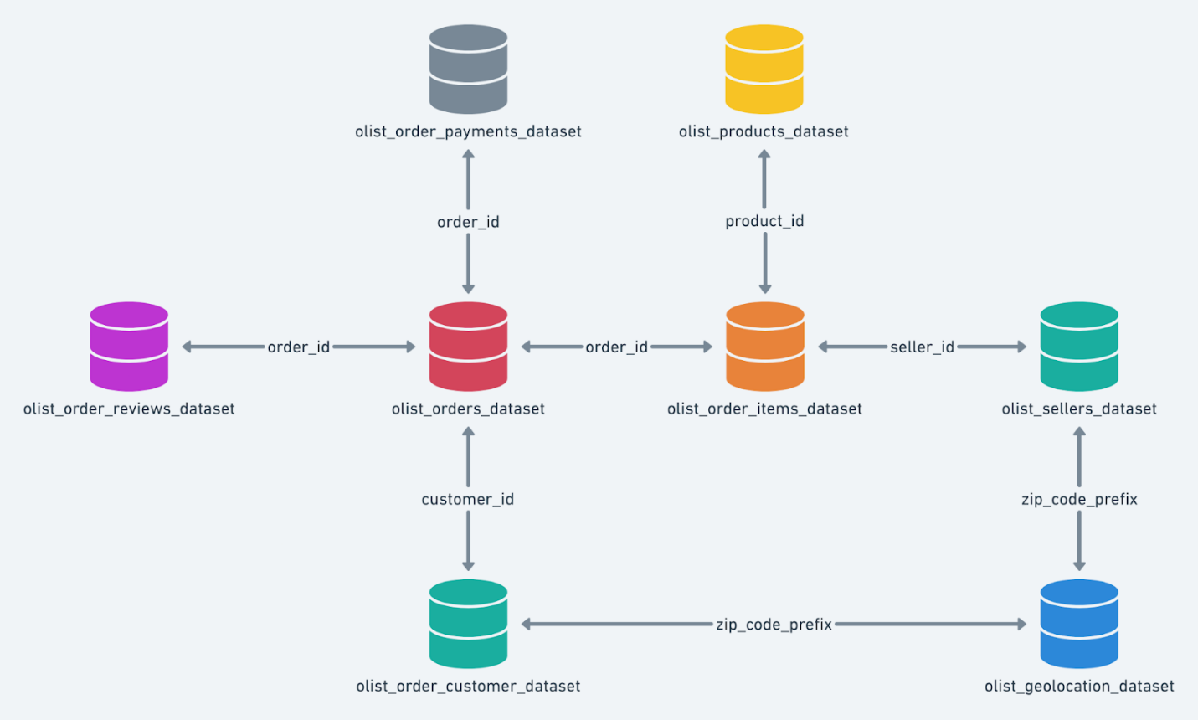

**Figure 1.1**: Dataset schema

* 1. **Business Questions to be Answered from Analysis**
     1. **Questions**
* Data Understanding and Exploration
  + What are the data types and characteristics of all columns in the customers table?
  + Between what time range were the orders placed?
  + How many unique cities and states do the customers belong to?
* Order Trends and Seasonality
  + Is there a growing trend in the number of orders placed over the years?
  + Can we identify any monthly seasonality in terms of the number of orders being placed?
  + During what time of the day do customers most frequently place their orders?
    - 0–6 hrs → *Dawn*
    - 7–12 hrs → *Morning*
    - 13–18 hrs → *Afternoon*
    - 19–23 hrs → *Night*
* Evolution of E-commerce Orders in the Region
  + What is the month-on-month order volume in each state?
  + How are customers distributed geographically across all states?
* Economic and Operational Analysis
  + What is the percentage increase in the total cost of orders from January–August 2017 to January–August 2018?  
    *(Use the payment_value column from the payments table.)*
  + What are the total and average order prices for each state?
  + What are the total and average freight values for each state?
* Delivery and Freight Performance
  + How many days were taken to deliver each order from the purchase date?
  + What is the difference (in days) between the estimated and actual delivery date for each order?
  + Which are the top 5 states with the highest and lowest average freight values?
  + Identify states that incur the most and least freight charges on average per order.
  + Which are the top 5 states with the highest and lowest average delivery times?
  + Which are the top 5 states where delivery is significantly faster than the estimated date?
* Payment Analysis
  + How many orders are placed month-on-month using different payment types?
  + What is the distribution of orders based on the number of payment installments made by customers?

**1.2.2 Background and Significance**

Retail e-commerce companies operate in a highly dynamic and competitive environment where understanding customer behavior, order trends, geographic distribution, delivery performance, and payment patterns is crucial for sustained growth and operational efficiency. The questions proposed address multiple dimensions critical to business success:

* Customer Profiling and Segmentation: Knowing the types, locations, and characteristics of customers helps companies tailor marketing, design personalized offers, and optimize logistics networks.
* Demand Forecasting and Trend Analysis: Analyzing order volume trends—seasonal, monthly, hourly—enables accurate demand forecasting, inventory planning, and marketing campaign alignment.
* Operational Efficiency and Cost Management: Studying order costs, freight charges, delivery timelines, and payment types helps in identifying cost-saving opportunities and improving service levels.
* Geographical Insights: Understanding state and city-level variations in customer and order data helps localize strategies, expand into new markets, and balance logistics resources.
* Financial Performance: Monitoring payment trends, installment methods, and overall cost evolution uncovers changes in consumer purchasing power and pinpoints areas for profitability improvement.
* Customer Experience & Satisfaction: Analyzing delivery times and comparing actual versus estimated delivery helps improve last-mile logistics and boosts customer satisfaction.

These questions are vital for optimizing the customer journey, enhancing operational excellence, supporting data-driven decision-making, and driving sustained profitability in retail and e-commerce.

* + 1. **Methodology and Real-Life Applications**

The core methodology for this business case revolves around exploratory data analysis (EDA) and SQL-based analytics on transactional and customer databases:

* Data Understanding and Exploration using SQL
  + Inspect column data types (categorical, numerical, date/time) and unique value counts for profiling.
  + Extract min/max order dates to define the active business period.
  + Aggregate unique cities/states via GROUP BY operations.  
    *Real-life application:* Customer segmentation and cleansing for targeted actions.
* Order Trends and Seasonality
  + Aggregate orders by year/month/daypart using SQL date functions to reveal trends and seasonality.
  + Analyze hourly patterns to align marketing (e.g., flash sales) with customer activity peaks.  
    *Real-life application:* Forecast demand, optimize promotions, resource planning.
* Geographical and Temporal Evolution
  + JOIN customer and order tables to cross-tabulate order volume by state and month.
  + Map customer spread using GROUP BY and COUNT for state/city.
  + *Real-life application:* Logistics route optimization, regional marketing.
* Economic and Operational Analysis
  + Calculate order value, total/freight costs per state and period.
  + Determine YoY or period-over-period cost variances using SQL SUM/AVG and time window filtering.  
    *Real-life application:* Cost control, pricing strategy, operational benchmarking.
* Delivery and Freight Performance
  + Derive delivery duration and delta from estimated dates using SQL DATE_DIFF or equivalent.
  + Rank states for fastest/slowest and most/least costly deliveries.  
    *Real-life application:* SLA compliance, courier selection, customer satisfaction improvements.
* Payment Behavior Analysis
  + Count orders by payment method and month.
  + Examine the distribution of payment installments.  
    *Real-life application:* Payment option optimization, financial partnership negotiation.

**1.3 Analysis**

**1.3.1 Data Understanding and Exploration**

**1.3.1.1 Data types and characteristics of all columns in the customers table**

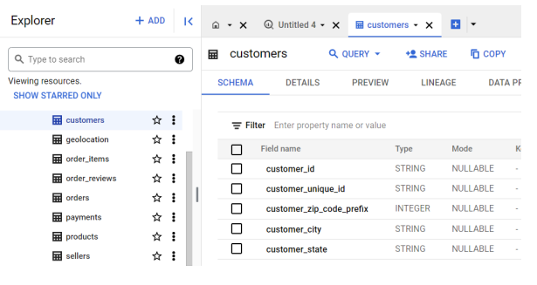

**Figure 1.2:** Data type of all columns in the "customers" table

**Observation**

* **customer_id:** A string that serves as the identifier for each consumer who made a purchase. This is used to link customer records to orders and other activities. It can be null if not assigned.​
* **customer_unique_id:** Another string field that uniquely identifies each customer, helping to ensure that even if a single consumer has multiple entries or accounts, they can still be traced uniquely. This field can also be null.​
* **customer_zip_code_prefix:** An integer that refers to the prefix of the customer's zip code. This is especially useful for grouping customers by location at a broad, regional level, though it is nullable.​
* **customer_city:** A string indicating the name of the city from where the order was placed. This helps in city-level aggregation or segmentation, and is nullable.​
* **customer_state:** A string representing the abbreviated state code where the customer is located. This field allows state-level grouping and analysis, and is nullable as well.

**1.3.1.2 Time range of the orders placement**

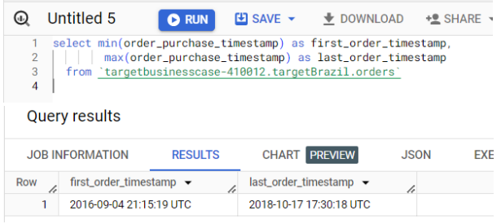

**Figure 1.3:** Time range between which the orders were placed.

**Approach**

* The query extracts the earliest (MIN) and latest (MAX) order purchase timestamps from the orders table.
* It selects two fields: first_order_timestamp (minimum timestamp) and last_order_timestamp (maximum timestamp).
* The data source is the targetBrazil.orders table within the specified dataset.
* This approach helps to determine the time range covered by the order records—essential for time series analysis, cohort definition, or understanding business coverage.

**Insights**

* The first order purchase on record occurred at: 2016-09-04 21:15:19 UTC.
* The last order purchase on record occurred at: 2018-10-17 17:30:18 UTC.

**1.3.1.3 Unique cities and states of the customers**

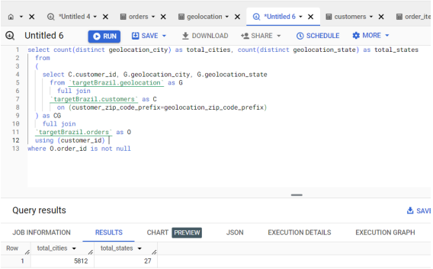

**Figure 1.4:** Count of Cities & States of customers who ordered during the given period.

**Approach**

* The query joins three tables: geolocation, customers, and orders from the targetBrazil dataset.
* Step 1: It joins the geolocation and customers tables using the zip code prefix to map customers to their locations.
* Step 2: It then performs a full join with the orders table using the customer_id to link orders to customers’ geolocation information.
* Step 3: The query filters out records where the order_id is null, ensuring that only valid orders are included.
* Step 4: Finally, it counts the distinct cities and states found in the geolocation data related to customer orders.

**Insights:**

* There are 5,812 unique cities (total_cities) from which customer orders have been made.
* There are 27 unique states (total_staxtes) represented in the orders data.
* This gives a quantitative measure of the geographical diversity and reach of the orders in your dataset.​

**1.3.2 Order Trends and Seasonality in terms of the number of orders being placed**

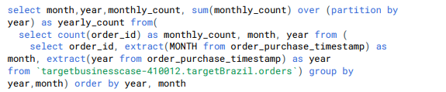

**Figure 1.5 :** Query of Growing trend and seasonality analysis

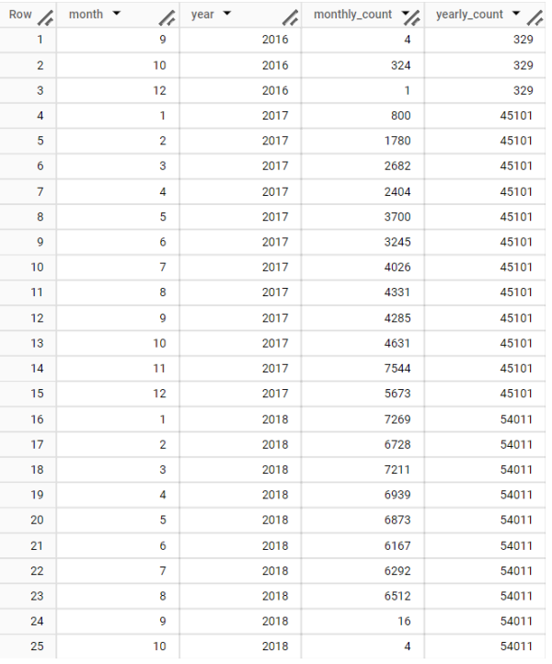

**Figure 1.6:** Output of Growing trend and seasonality analysis

**Approach**

* The query calculates the count of orders (monthly_count) for each month and year from the orders table by extracting the month and year from the order purchase timestamp.
* It performs a GROUP BY on year and month to aggregate the order counts monthly.
* It uses a window function with SUM and PARTITION BY year to produce the yearly_count, which is the total number of orders in each year.
* Results are ordered chronologically by year and month for ease of trend analysis.

**Insights**

* The result table shows the number of orders placed each month (monthly_count) along with the total orders for that year (yearly_count).
* For example, in 2016, there were only a few orders (4 in September, 324 in October, 1 in December, totaling 329 for the year).
* In 2017, the monthly counts increase substantially, with the yearly total being 45,101 orders.
* There is a clear growing trend in the number of orders. The yearly counts increase dramatically: from 329 orders in 2016 to 45,101 in 2017, and then to 54,011 in 2018. This strong, sustained year-over-year growth indicates significant business expansion and customer acquisition.​
* There is noticeable monthly seasonality. In both 2017 and 2018, order volumes tend to increase from January through late year, peaking in the months of November (7,544 in 2017 and 7,211 in March 2018). For 2018, there is some stabilization at high values across mid-year months (e.g., 7,269 in January, 7,211 in March, 6,873 in May). This pattern suggests Brazilian customers may place more orders in the early to mid parts of the year and fewer towards the year’s end, possibly due to business or shopping cycles.
  + - 1. During what **time of the day** do customers most frequently place their orders?
* 0–6 hrs → *Dawn*
* 7–12 hrs → *Morning*
* 13–18 hrs → *Afternoon*
* 19–23 hrs → *Night*

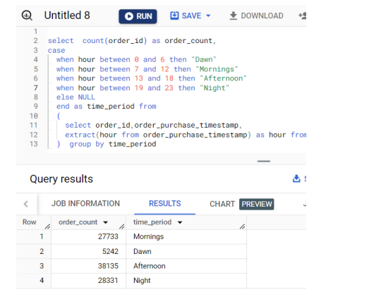

**Figure 1.7 :** Time of the day when Brazilian customers mostly place their orders

**Approach**

* The provided SQL query analyzes the distribution of order placements by time of day, classifying each order into one of four periods: Dawn (0-6 hrs), Mornings (7-12 hrs), Afternoon (13-18 hrs), and Night (19-23 hrs).
* It uses the extract(hour from order_purchase_timestamp) function to determine the hour of each order, then uses a CASE statement to assign a time period to each order.
* The query then counts the number of orders in each time period by grouping on the derived time_period field, providing a clear summary of customer ordering behavior across the day.​

**Insights**

* Afternoon (13-18 hrs) is the most popular time for Brazilian customers to place their orders, with 38,135 orders.
* Night (19-23 hrs) and Mornings (7-12 hrs) are also popular, with 28,331 and 27,733 orders respectively.
* Dawn (0-6 hrs) sees very little activity, with only 5,242 orders.
* This pattern suggests that Brazilian customers most often shop and make purchases during afternoons, followed by evenings and late mornings, while very early hours see the lowest engagement. This provides businesses with valuable information for planning promotions, marketing efforts, and customer support coverage during peak traffic times.
  + 1. **Evolution of E-commerce Orders in the Region**
       1. **Month-on-month order volume in each state**

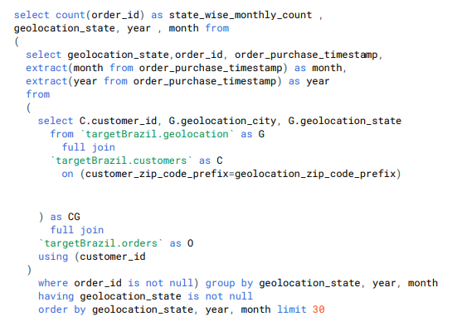

**Figure 1.8 :** Query of Month on month no. of orders placed in each state.

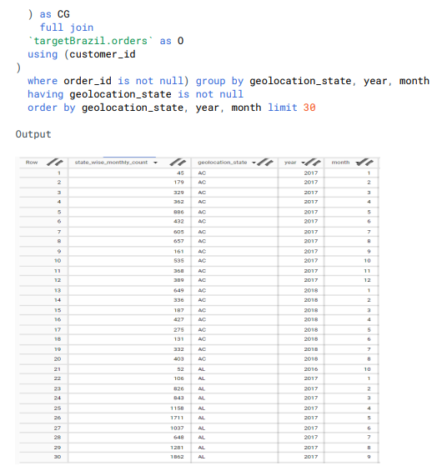

**Figure 1.9:** Output of Month on month no. of orders placed in each state.

**Approach**

* The SQL query calculates the number of orders placed in each Brazilian state (using geolocation_state) for every month and year.
* The inner query joins the geolocation, customers, and orders tables to accurately link orders with customer locations.
* It extracts the month and year from each order purchase timestamp, groups data by state, year, and month, and counts the orders per group.
* Results are ordered by state, year, and month, showing the evolution of order volumes for each state over time.​

**Insights**

* This approach provides a detailed month-on-month view of e-commerce activity across Brazil’s states.
* For example, in the state “AC,” order counts begin at 45 in January 2017, rise to a peak of 695 in October, then stabilize between 300-600 monthly, continuing into 2018 with gradual increase (e.g., reaching 726 in June 2018).
* Other states (like "AL") show higher counts, e.g., 1,711 in March 2018 and 1,802 in May 2018, indicating more vibrant e-commerce activity.
* These trends allow identification of active regions, seasonal surges, and year-over-year growth at the local level, supporting decisions in marketing, logistics, and business expansion strategies.
  + - 1. **Customers distributed geographically across all states**

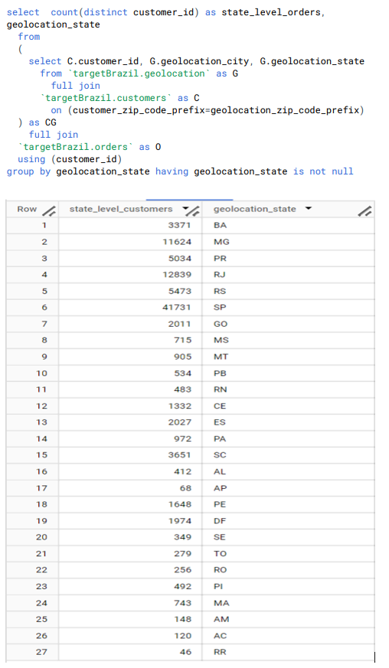

**Figure 1.10 :** Query of Customers distribution across all the states.

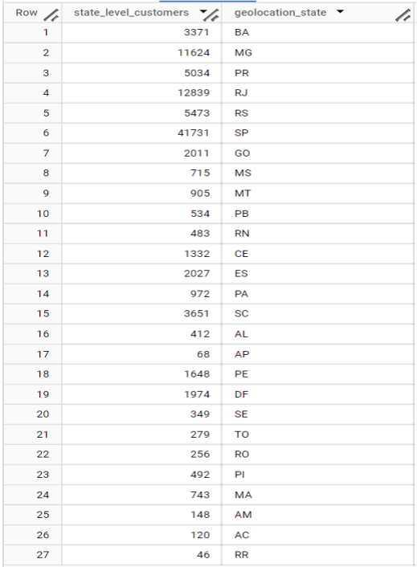

**Figure 1.11 :** Output of Customers distribution across all the states.

**Approach**

* The SQL query finds the number of unique customers in each Brazilian state by joining the geolocation, customers, and orders tables.
* The join occurs via the zip code prefix, linking each order to its customer and each customer to their location.
* The query counts distinct customer_id values for each geolocation_state, filtering for non-null state values and grouping by state, which results in a table showing the count of unique customers per state.​

**Insights**

* Customer distribution is highly uneven across states. São Paulo (SP) stands out with 41,731 unique customers—over three times more than any other state.
* Major economic and population centers like Rio de Janeiro (RJ), Minas Gerais (MG), and Rio Grande do Sul (RS) also report high customer counts.
* In contrast, northern and less populated states, such as Roraima (RR), Amapá (AP), and Acre (AC), see the lowest numbers, with each having fewer than 150 unique customers.
* This pattern indicates that Brazil’s e-commerce activity is concentrated in its more urbanized and economically developed Southeast and South regions, while e-commerce penetration is still limited in the North and Northeast.
  + 1. **Economic and Operational Analysis**

**1.3.4.1 Percentage increase in the total cost of orders from January–August 2017 to January–August 2018**

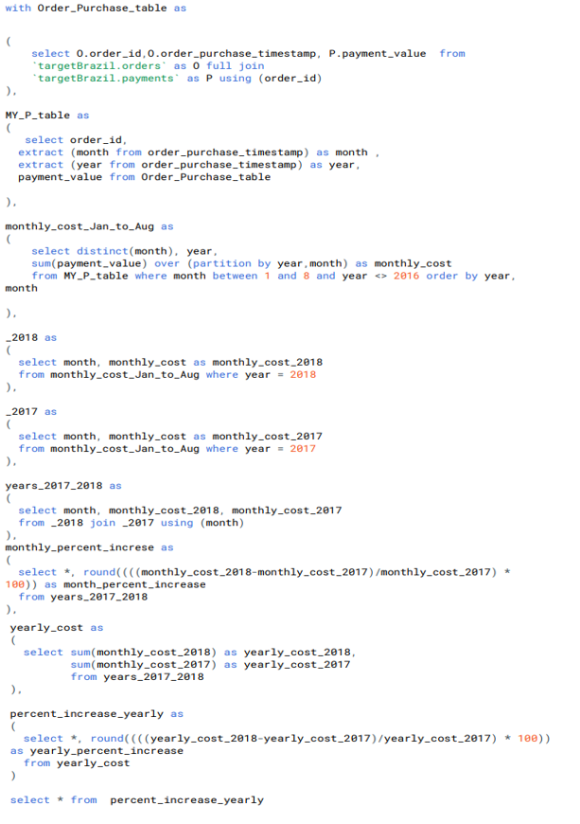

**Figure 1.12 :** Query of Cost of orders from year 2017 to 2018 (include months between Jan to Aug only)

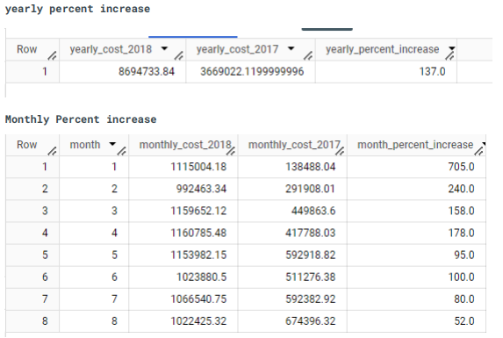

**Figure 1.13 :** Output of Cost of orders from year 2017 to 2018 (include months between Jan to Aug only)

**Approach**

* The analysis uses SQL with Common Table Expressions (CTEs) to calculate payment (order value) totals by month and by year for 2017 and 2018.
* order_purchase_timestamp is used to extract the purchase year and month.
* Payments are aggregated for the first eight months (January to August) of each year, ensuring a direct year-over-year comparison.
* The final queries compute both yearly and monthly percent increases by dividing the difference between 2018 and 2017 values by the 2017 value, then multiplying by 100 for the percentage.​

**Insights**

* There is a substantial yearly percent increase in payment value: the total from January to August rose by 137%, from about 3.67 million in 2017 to about 8.69 million in 2018.
* Monthly percent increases show dramatic growth: every month in 2018 outpaces the same month in 2017 by a wide margin.
  + For instance, January 2018 saw a 705% increase in payment value compared to January 2017.
  + All other months also clearly exceed 2017, with percent increases ranging from about 52% to over 700%.
* This dramatic increase signals explosive e-commerce growth in Brazil between 2017 and 2018, both annually and monthly, with particularly rapid expansion at the start of the year.
  + - 1. **The total and average order prices for each state**

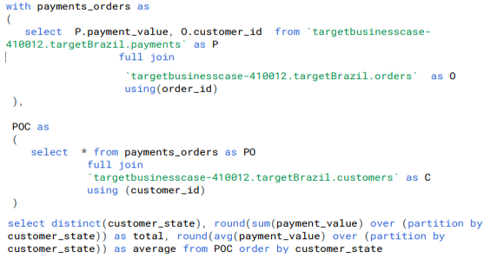

**Figure 1.14 :** Query of Total & Average value of order price for each state.

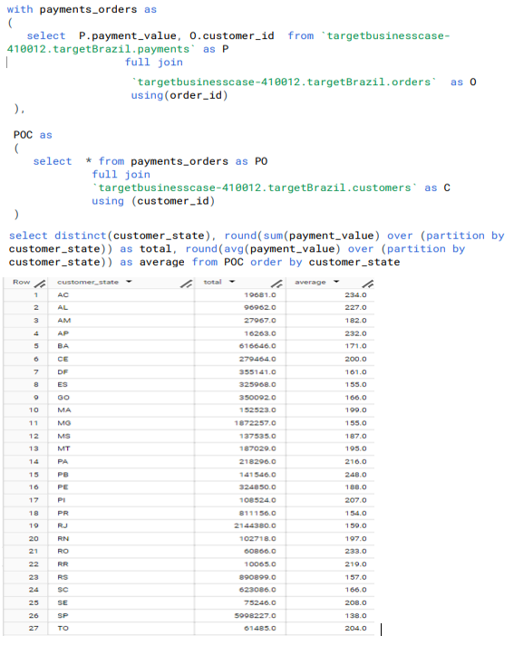

**Figure 1.15 :** Output of Total & Average value of order price for each state.

**Approach**

* The SQL process starts by joining payment (payments) and order (orders) data on order ID, producing a list of payments linked with each customer.
* The combined data set is then joined with customer information to assign each order to its respective state (customer_state).
* For each state, the query calculates two metrics:
  + Total order value: The sum of all payment values for that state.
  + Average order value: The average payment value per order for that state.
* Both metrics are calculated using window functions to group by state, and the results are displayed in a table for direct comparison.​

**Insights**

* **Total Value:** São Paulo (SP) overwhelmingly leads in total e-commerce order value (5,908,227), due to its size and economic importance. Rio de Janeiro (RJ), Minas Gerais (MG), and Rio Grande do Sul (RS) follow far behind but still represent significant e-commerce activity.
* **Average Order Value:** The average value per order varies modestly by state, generally between 138 and 248. Notably, Paraíba (PB) has the highest average (248), while SP has one of the lowest averages (138), indicating a high volume of smaller-value transactions.
* **Patterns:** Wealthier and more populous states deliver the largest total order values. Some states with lower transaction volumes (e.g., PB, AC, AP) show higher average order values, likely due to fewer customers making larger purchases, possibly for specialized items or less frequent bulk buying.
* **Implication:** Businesses can expect the highest market activity in the Southeast and South but may find higher-value orders in underpenetrated or less competitive regions.
  + - 1. **Total and average freight values for each state**

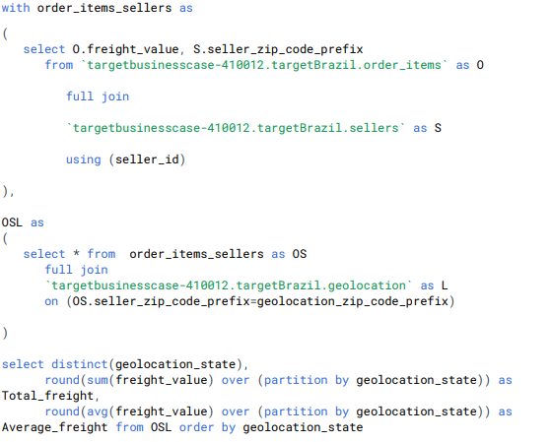

**Figure 1.16 :** Query of Total & Average value of order freight for each state.

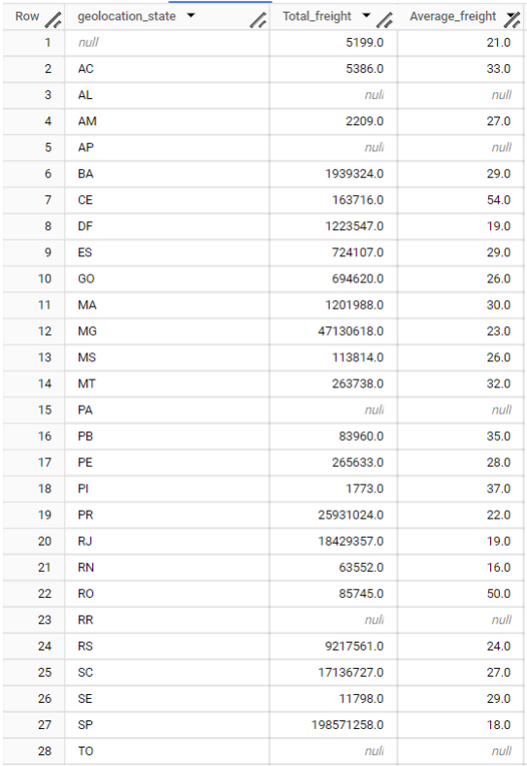

**Figure 1.17 :** Output of Total & Average value of order freight for each state.

**Approach**

* The SQL workflow first assembles a relationship between order items and sellers, joined using seller_id, and capturing each order's freight_value and the seller's zip code prefix.
* This combined data set is then joined with the geolocation table to associate every seller and order with a Brazilian state (geolocation_state).
* Aggregation functions are applied:
  + Total Freight: The sum of all freight_value for each state.
  + Average Freight: The average freight_value per order item for each state.
* Null states and missing data are excluded, and results are sorted by state for analysis.​

**Insights**

* **Total Freight:** The highest total freight costs are concentrated in the most populous states, such as São Paulo (SP: 1,985,712,58), Paraná (PR: 25,931,024), and Rio de Janeiro (RJ: 18,429,357), reflecting heavier shipment activity due to higher order volumes.
* **Average Freight:** The average shipping cost per order item varies by state, ranging from 16 to 54. Some less populated states, such as Acre (AC: 33), Roraima (RO: 50), and Ceará (CE: 54), show relatively higher average shipping fees. In contrast, more populous urban states like São Paulo (SP: 18) have the lowest average values—likely indicating improved logistics, higher shipment density, and competitive carrier markets.
* **Patterns:** States with challenging geography, lower e-commerce penetration, or longer transport routes (e.g., remote North/Northeast) tend to incur higher average freight costs per order, potentially due to reduced scale and infrastructure.
* Businesses may interpret these findings as a sign that freight pricing, regional strategy, and logistics efficiency should be carefully managed when expanding reach, especially outside Brazil’s top commercial centers.

**1.3.5. Delivery and Freight Performance**

This section focuses on analyzing the delivery timelines and freight performance across various states to understand logistical efficiency and identify improvement areas.

* + - 1. **Days taken to deliver each order from the purchase date**

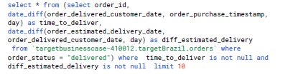

**Figure 1.18:** Query of days taken to deliver each order from the purchase date.

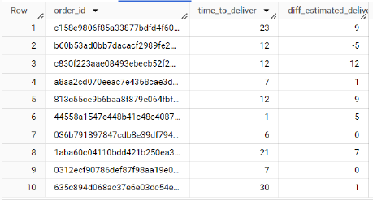

**Figure 1.19:** Output of days taken to deliver each order from the purchase date.

**Approach**

* Calculate time_to_deliver as the number of days between the order purchase date and the actual delivery date.
* Calculate diff_estimated_delivery as the difference (in days) between the estimated delivery date and the actual delivery date.
* Both calculations are done with SQL date_diff functions within a subquery, filtered for delivered orders with non-null computed values.

**Insights**

* **Timeliness**: Orders where diff_estimated_delivery is negative indicate late deliveries, while positive values indicate early deliveries. For example, in the output, some orders like Row 2 (-5) and Row 10 (-4) were delivered late, while others like Row 3 (12) were delivered much earlier than estimated.
* **Efficiency**: time_to_deliver provides an operational measure of how long orders actually took from purchase to delivery, highlighting variations—such as orders taking 23 days (Row 1) versus only 5–7 days (Rows 6, 7, 8, 10).
* **Customer Satisfaction**: Orders consistently delivered before estimated dates can improve customer experience, but frequent negative differences could indicate issues in delivery operations or estimation logic.
* **Data-driven Improvement**: Outliers (significant positive or negative diff_estimated_delivery) help identify candidates for process review, potentially revealing bottlenecks or sources of estimation error that could be corrected for better planning.

**1.3.5.2 Difference (in days) between the estimated and actual delivery date for each order**

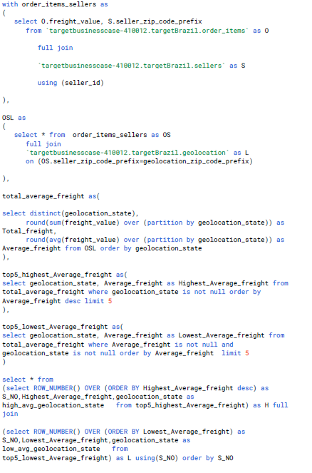

**Figure 1.20 :**

Query of Difference (in days) between the estimated & actual delivery date of an order.

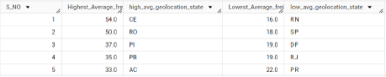

**Figure 1.21 :**

Output of Difference (in days) between the estimated & actual delivery date of an order.

To find the top 5 states with the highest and lowest average freight values, the approach uses advanced SQL with CTEs (Common Table Expressions) and ordering functions. This analysis provides a clear view of geographic cost distribution in shipping.

**Approach**

* Merge order item freight values with seller location data, linking each order's freight charge to the seller's state.
* Join with geolocation details on seller zip code prefixes to get the corresponding state for each seller.
* Calculate the total and average freight per state using window functions (sum and avg over partitioned states).
* Use two queries:
  + One sorts and selects the top 5 states by descending average freight (highest).
  + One sorts and selects the top 5 states by ascending average freight (lowest).
* A final select combines the two lists side by side for direct comparison of high and low freight states.

**Insights**

* **Top Highest Freight States:** Ceará (CE), Rondônia (RO), Piauí (PI), Paraíba (PB), Acre (AC) have the highest average freight costs—up to 54 for CE. These states may face geographic or logistical challenges, such as distance from distribution hubs or less developed shipping infrastructure.​
* **Top Lowest Freight States:** Rio Grande do Norte (RN), São Paulo (SP), Distrito Federal (DF), Rio de Janeiro (RJ), Paraná (PR) have the lowest average freight values, with RN as low as 16. These typically include more urbanized or centrally located regions, or those with high shipping volumes that enable cost savings.​
* **Operational Uses:** Such analysis supports strategic decisions like pricing, warehouse placement, and targeted improvements in shipping logistics. High-cost states may benefit from new fulfillment centers or negotiated transportation contracts.

Overall, this approach reveals significant regional variation in freight costs, offering tangible leads for efficiency improvements and improved customer pricing strategies.

**1.3.5.3 Top 5 states with the highest and lowest average freight values**

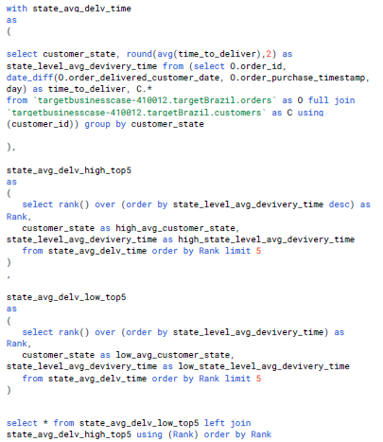

**Figure 1.22 :** Query of top 5 states with the highest & lowest average delivery time.

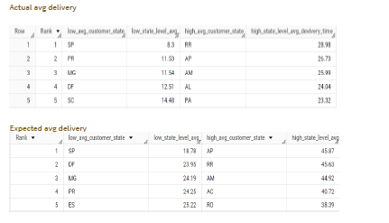

**Figure 1.23 :** Output of top 5 states with the highest & lowest average delivery time.

This approach identifies the top 5 states with the highest and lowest average actual and expected delivery times using advanced SQL with window and ranking functions. This analysis enables a geographic breakdown of delivery efficiency, supporting operational improvements and customer satisfaction strategies.

**Approach**

* Calculate time_to_deliver as the difference in days between the order's delivery date and purchase date, grouped by the customer's state.
* Use SQL window functions to compute the average delivery time for each state.
* Two subqueries rank the states:
  + One orders states by descending average delivery time to find the top 5 highest (state.avg_delv_high_top5).
  + One orders states by ascending average delivery time for the lowest 5 (state.avg_delv_low_top5).
* Results are joined to present the highest and lowest average delivery states side by side.
* The same process is followed for expected delivery time, comparing estimated durations with actuals for each state.

**Insights**

* **Lowest Average Actual Delivery:** States like SP (São Paulo), PR (Paraná), MG (Minas Gerais), DF (Distrito Federal), and SC (Santa Catarina) consistently have the fastest delivery times (as low as 8.3 days).
* **Highest Average Actual Delivery:** States such as RR (Roraima), AP (Amapá), AM (Amazonas), AL (Alagoas), and PA (Pará) experience much longer delivery times (over 28 days in some cases).
* **Expected vs. Actual:** There are differences between actual and expected delivery averages by state, with some states outperforming expectations and others lagging behind, highlighting potential for both operational adjustment (where actual is faster) and targeted improvement (where actual is slower than estimated).
* **Operational Use:** This breakdown highlights regions with strong logistics performance and those with persistent shipping challenges, supporting resource allocation, service improvement, and customer communication efforts.

**1.3.5.4 Top 5 states with the highest and lowest average delivery times and delivery is significantly faster than the estimated date**

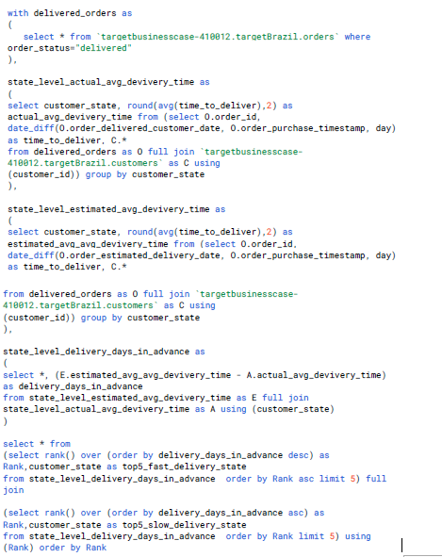

**Figure 1.24 :**

1. Query of top 5 states where the order delivery is really fast as compared to the estimated date of delivery

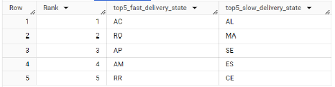

**Figure 1.25:**

1. Output of top 5 states where the order delivery is really fast as compared to the estimated date of delivery

The approach involves comparing the actual average delivery time to the estimated average delivery time for each state, and identifying where deliveries are completed much earlier than promised. This focuses not just on absolute speed, but on "beating" the customer's expectations.

**Approach**

* Filter orders marked as delivered.
* Calculate the state-wise actual average delivery time (actual_avg_delivery_time) and estimated average delivery time (estimated_avg_delivery_time) using the difference in days between delivery/estimated dates and the order purchase date.
* For each state, compute "days in advance" as the difference:

Delivery Days in Advance=Estimated Avg Delivery Time−Actual Avg Delivery TimeDelivery Days in Advance=Estimated Avg Delivery Time−Actual Avg Delivery Time

* Rank states by the largest positive values (i.e., where actual delivery was much faster than estimated).
* Select the top 5 states using a ranking or ordering function.

**Insights**

* The top 5 states where delivery is significantly faster than the estimated date are AC, RO, AP, AM, and RR.
* In these states, customers receive their orders well ahead of what is promised—potentially boosting customer satisfaction, operational reputation, and trust.
* The most "advanced" state (AC) consistently beats estimates, suggesting its logistics network or vendor practices outperform the system’s predictions.
* For strategic planning, companies can investigate what makes these areas so efficient and potentially replicate these practices in other locations or adjust delivery estimates for even greater accuracy.

This analysis helps set realistic expectations for customers and fine-tune logistics operations across regions by spotlighting areas with superior performance relative to promised dates.

* + 1. **Payment Analysis**

**1.3.6.1 Month-on-month orders placement using different payment types**

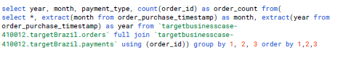

**Figure 1.26 :**

1. Query of month on month no. of orders placed using different payment types.

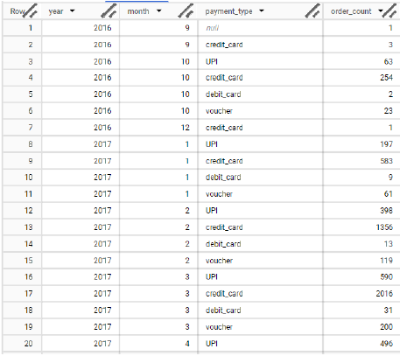

**Figure 1.27 :**

1. Output of month on month no. of orders placed using different payment types.

**Approach**

* Orders are joined with their payment details.
* The query extracts both month and year from each order's purchase timestamp.
* Orders are grouped by year, month, and payment type.
* The count of orders (order_count) is calculated for each combination, summarizing transaction volumes.
* Results reveal how many orders were placed using each payment method, broken out by both month and year.

**Insights**

* Certain payment methods, such as credit card and UPI, often show much higher order counts per month, indicating their popularity and preference among customers.
* The appearance and growth of newer payment methods (like UPI) across months and years can be tracked, highlighting changing trends in customer payment behavior.
* Peaks in specific months (for example, March 2017, where credit card orders surge to 2016 and UPI reaches 590) may align with promotional campaigns, salary cycles, or seasonal trends.
* The comprehensive view across years supports strategy development in payment partnerships, targeted offers, and technology investments.

**1.3.6.2 Distribution of orders based on the number of payment installments made by customers**

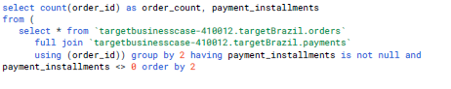

**Figure 1.28 :**

1. Query of distribution of orders based on the **number of payment installments.**

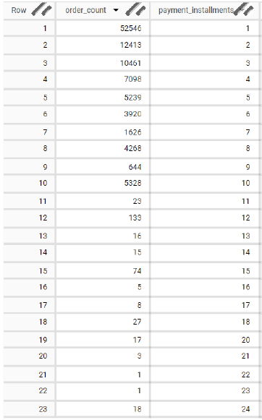

**Figure 1.29 :**

1. Output of distribution of orders based on the **number of payment installments**

**Approach**

* The query joins the orders and payments tables to access both order details and payment installment information.
* Orders are grouped by the number of payment installments, excluding records with null or zero installments.
* The count(order_id) provides the number of orders per installment count, showing how many orders were placed with each installment option.
* Results are ordered by the number of installments.

**Insights**

* Most orders use just a single installment (52,546 orders), indicating customers largely prefer paying in full.
* There is a steep drop as installment count increases, with the next few common options being two (12,413 orders), three (10,461 orders), four (7,098 orders), and so on.
* Very few orders use long payment plans (e.g., more than 12 installments), reflecting customer caution or vendor limitations for longer-term credit.
* This analysis helps businesses tailor payment plan offerings, focusing on the most popular installment options and perhaps revisiting the need for lengthy plans.

**1.4 Insights and Recommendations**

**Results and Recommendations (with Justification)**

* **Sustained Growth & Geographic Reach**: The business demonstrates rapid order growth and penetration across 5,812 cities and 27 states, indicating successful expansion and mass market reach. The largest order volumes and values originate from São Paulo and other major economic hubs.  
  **Justification**: Focus on consolidating and deepening presence in these high-performing regions while strategically investing in underpenetrated, high-potential northern regions where order values are higher but customer numbers are low.
* **Demand Patterns & Seasonality**: Orders peak in specific months and are highly concentrated in the afternoon and evening.  
  **Justification**: Align marketing pushes and customer support resources with demand peaks, particularly leveraging seasonal patterns and popular hours to maximize campaign effectiveness and service availability.
* **Freight & Delivery**: Freight costs are lowest in urbanized states, but high in remote regions due to logistical challenges. Several states deliver consistently faster than estimated, while others face persistent delays.  
  **Justification**: Optimize logistics for high-cost, slow-delivery regions through localized fulfillment or partnerships, and leverage best practices from the fastest regions to improve laggards.
* **Customer & Payment Trends**: Single-payment orders and credit card/UPI dominate, with limited long-term installment uptake.  
  **Justification**: Streamline and prioritize popular payment methods and short installment options to improve conversion and customer satisfaction.

**Implications for Industry, Business, and Policy**

* **Industry**: The observed explosive growth and payment shifts signal that Brazil’s e-commerce sector is accelerating, especially outside the largest metros. Logistics providers must invest in infrastructure, and payment firms should innovate to capture new segments.
* **Business**: Companies that actively monitor and adapt to regional differences in demand, delivery, and payment preferences will gain a competitive edge. Efficient last-mile networks and region-specific service customization are vital.
* **Policy**: Policymakers can use these trends to guide investment in digital infrastructure, promote regional e-commerce inclusivity, and encourage competition through payment innovation and logistics modernization.

**Addressing Limitations**

* **Data Range**: Analysis covers only up to October 2018. Newer trends (e.g., recent payment methods, post-pandemic surges) are not captured.
* **Unobserved Drivers**: Underlying causes (e.g., marketing campaigns, societal events, economic policy changes) might impact seasonality, payment, and delivery patterns but are not isolated in the raw data.
* **Sample Bias**: E-commerce platforms often attract younger, urban users, possibly overstating digital adoption in rural zones.

**Alternative Explanations / Recommendations**

* Some fast-delivery states might reflect system overestimation of delivery times, not logistical excellence. Regular recalibration of delivery estimates is as important as operational improvement.
* High payment value in underpenetrated states could be skewed by a few large business orders or specialty transactions. Consider qualitative follow-up and focused market research to interpret outliers before major investments.

**Summary of Methodology, Tools, and Applications**

* **Methodology**: SQL-based data extraction and transformation, statistical summarization, time series and geographical slicing, and behavioral segmentation of order, payment, and delivery metrics.
* **Tools**: SQL (for dataset queries and aggregation), spreadsheet/dashboard tools (for visualization and deep-dive), and descriptive analytics techniques.
* **Applications for Industry**: Such an approach is broadly applicable to e-commerce businesses needing insight-driven growth, logistical efficiency, and customer satisfaction. It also provides vital input for market entry strategy, payment system development, seasonal inventory management, and regional logistics planning.

**Key Learnings**

* Regional, temporal, and behavioral diversity in e-commerce activity is pronounced—requiring nuanced, data-driven strategies.
* Continuous monitoring, agile response to emerging patterns, and targeted improvements (in logistics, payments, and support) drive long-term business impact and customer loyalty.
* Collaboration across teams (marketing, logistics, IT, and policy) ensures alignment with evolving customer needs and business objectives.

### **Chapter 2 : Business Case Study 2**

#### **2.1 Problem Description**

* The case focuses on an emerging fintech platform that aims to simplify access to credit for young working professionals and small business owners. Operating in a traditionally rigid and documentation-heavy lending landscape, the company seeks to redefine the borrowing experience by offering instant and flexible loan products tailored to customer needs.
* The organization’s data science team is developing an intelligent underwriting system capable of accurately assessing the creditworthiness of both individuals and micro, small, and medium enterprises (MSMEs). The goal is to combine data-driven insights with financial behavior modeling to minimize default risk while expanding access to formal credit.
* This study specifically examines the underwriting mechanism behind the company’s Personal Loan product—an instrument designed to give salaried individuals rapid access to unsecured funds under fair and adaptive terms.
* The Company deploys formal credit to salaried individuals and businesses 4 main financial instruments:
  + Personal Loan
  + EMI Free Loan
  + Personal Overdraft
  + Advance Salary Loan

**Data dictionary:**

* **loan_amnt :** The listed amount of the loan applied for by the borrower. If at some point in time, the credit department reduces the loan amount, then it will be reflected in this value.
* **term :** The number of payments on the loan. Values are in months and can be either 36 or 60.
* **int_rate :** Interest Rate on the loan.
* **installment :** The monthly payment owed by the borrower if the loan originates.
* **grade :** LoanTap assigned loan grade.
* **sub_grade :** LoanTap assigned loan subgrade.
* **emp_title :** The job title supplied by the Borrower when applying for the loan.
* **emp_length :** Employment length in years. Possible values are between 0 and 10 where 0 means less than one year and 10 means ten or more years.
* **home_ownership :** The home ownership status provided by the borrower during registration or obtained from the credit report.
* **annual_inc :** The self-reported annual income provided by the borrower during registration.
* **verification_status :** Indicates if income was verified by LoanTap, not verified, or if the income source was verified.
* **issue_d :** The month which the loan was funded.
* **loan_status :** Current status of the loan - Target Variable.
* **purpose :** A category provided by the borrower for the loan request.
* **title :** The loan title provided by the borrower.
* **dti :** A ratio calculated using the borrower’s total monthly debt payments on the total debt obligations, excluding mortgage and the requested LoanTap loan, divided by the borrower’s self-reported monthly income.
* **earliest_cr_line :**The month the borrower's earliest reported credit line was opened.
* **open_acc :** The number of open credit lines in the borrower's credit file.
* **pub_rec :** Number of derogatory public records.
* **revol_bal :** Total credit revolving balance.
* **revol_util :** Revolving line utilization rate, or the amount of credit the borrower is using relative to all available revolving credit.
* **total_acc :** The total number of credit lines currently in the borrower's credit file.
* **initial_list_status :** The initial listing status of the loan. Possible values are – W, F.
* **application_type :** Indicates whether the loan is an individual application or a joint application with two co-borrowers.
* **mort_acc :** Number of mortgage accounts.
* **pub_rec_bankruptcies :** Number of public record bankruptcies.
* **Address :** Address of the individual.

**2.2 Business Questions To Be Answered**

**2.2.1 Questions**

* What characteristics indicate whether a borrower is likely to repay or default?
* How can lending institutions set lending terms and screening to maximize profitability while minimizing non-performing assets (NPAs)?
* What are the practical impacts of false positives (good loans rejected) and false negatives (bad loans approved)?
* What are the most significant predictors of default or repayment?
* How should different credit profiles inform interest rates and lending decisions?

**2.2.2 Background and Significance**

**Why these questions matter:**  
In the consumer and MSME lending space, accurate risk assessment is crucial for maintaining a profitable, competitive, and compliant lending operation. Defaults (NPAs) not only harm profits but regulatory standing, while too-conservative lending restricts growth. Understanding drivers of good and bad loans enables smarter, more inclusive credit decisions and supports product innovation.

**2.2.3 Problem Statement (Anonymized)**

A digital lending platform wants to automate the underwriting of personal loans for individual borrowers. Given a set of customer and application attributes, the goal is two-fold:

1. Predict whether to approve or deny a credit line for an individual applicant.
2. Make evidence-based recommendations about repayment terms (such as interest rates or loan amounts) based on risk profiles.

**2.2.4 Methodology and Real-World Applications**

**Methodology followed:**

* **Exploratory Data Analysis (EDA):**  
  Structure, missing values, outlier detection, variable types, and basic relationships; conducted via summary statistics, correlation heatmaps, and plots.
* **Feature Engineering:**  
  Created flags for risk-related variables (bankruptcies, delinquency, mortgage accounts), binned/standardized text fields, and log-transformed extreme numeric values to reduce skew and improve model stability.
* **Data Preprocessing:**  
  Imputation of missing values, outlier treatment, encoding of categorical features, and normalization using MinMaxScaler. Removal of duplicate and highly collinear features to reduce overfitting.
* **Model Building and Evaluation:**  
  Developed a regularized logistic regression model (with class balance adjustments). Evaluated via confusion matrix, ROC/PR curves, and classification reports to assess precision, recall, F1, and AUC.
* **Tradeoff Analysis:**  
  Analyzed impact of raising/lowering thresholds on recall/precision, vital for balancing loan growth versus risk appetite.

**Applications in real-life:**

* **Loan Origination:**  
  Automates accept/reject and interest rate assignment for new loan applications.
* **Risk Management:**  
  Enables early intervention for risky segments, portfolio stress-testing, and compliance with regulatory guidelines on NPAs.
* **Customer Segmentation & Personalization:**  
  Drives targeted product offers and customized repayment plans for different risk strata.

**2.2.5 Insights, Recommendations, and Implications**

**Key Insights and Recommendations:**

* Most loans are repaid, but defaults are not rare and have significant financial/regulatory cost—raise recall for defaults even at moderate cost to precision.
* Job title, income, employment length, credit history (years), and public record flags are highly predictive—use these for risk-based pricing and enhanced due diligence.
* Moderate dependency on loan amount and installment, suggesting larger loans require stricter scrutiny.
* Missing or uncertain employment/title info is a risk factor—enforce additional documentation or conservative lending policies for such applicants.
* Treatment of class imbalance and regularization meaningfully improves model robustness; regularly recalibrate for data drift.

**Implications for the Industry:**

* **Credit Tech & Policy:**  
  A well-governed data-driven underwriting system enables fast, scalable, and more inclusive lending, supporting financial access for underbanked populations.
* **Product Development:**  
  Data insights support creation of flexible, differentiated loan products optimized for various customer segments (millennials, business owners).
* **Regulatory Compliance:**  
  Transparent, explainable models facilitate auditability and responsible lending in line with industry standards.

**2.2.6 Addressing Limitations and Suggestions**

* **Model Limitations:**  
  Logistic regression (linear) may miss non-linear or complex risk drivers. The model is less sensitive to rare/default cases, meaning some risk remains.
* **Data Limitations:**  
  Only internal and application data used—integrate external bureau or behavioral data for greater predictive power.
* **Threshold Calibration:**  
  The default decision threshold may not fully align with business goals; periodically adjust and test based on evolving strategy.

**Alternative Explanations/Recommendations:**

* Combine logistic regression with tree-based (e.g., XGBoost) or ensemble approaches to improve rare event (default) detection.
* Use cost-sensitive learning or profit-optimized thresholds to balance risk and return more precisely.
  1. **Analysis**
     1. **Exploratory Data Analysis (EDA)**

**2.3.1.1 DataFrame Preview**

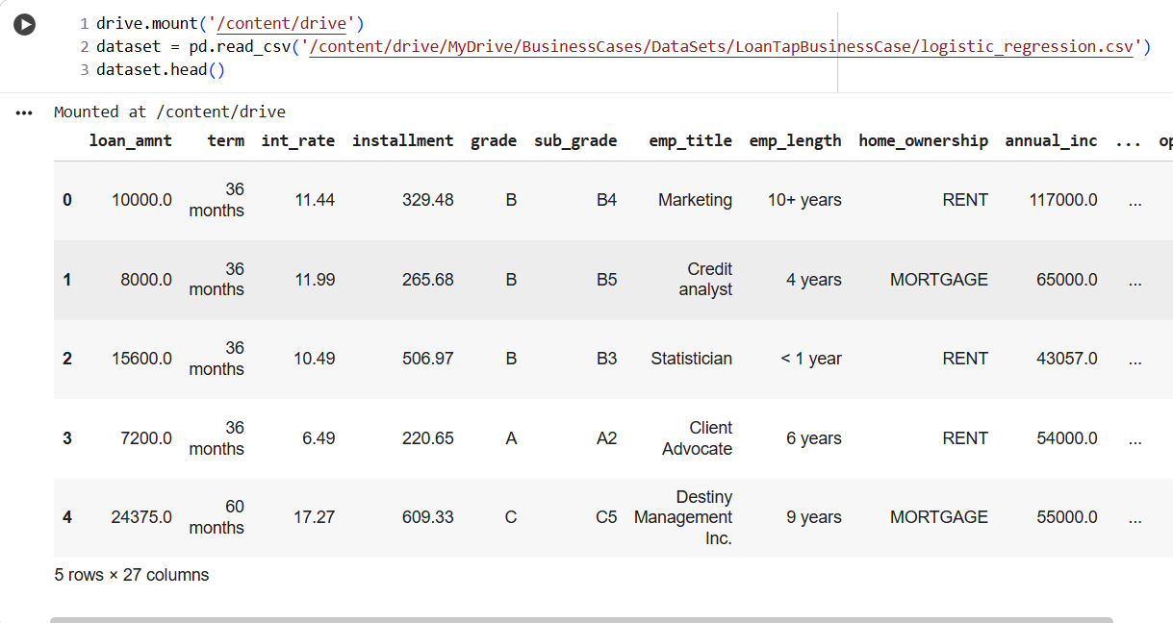

**Figure 2.1**: Data Frame Head Preview

**2.3.1.2 Data Frame shape**

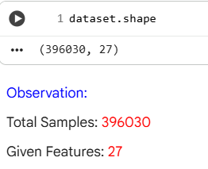

**Figure 2.2**: Data Frame Shape

**Insights:**

The image shows the output of the .shape attribute for a pandas DataFrame, which reveals the structure of the dataset. There are 396,030 rows and 27 columns, indicating a large dataset with many variables for analysis. This size suggests the data is suitable for building robust machine learning models, detailed statistical examination, and in-depth creditworthiness evaluation. With 27 different features, the dataset supports comprehensive exploration of factors influencing loan decisions, allowing nuanced insights into borrower behavior and risk assessment.

**2.3.1.3 Data Frame Columns**

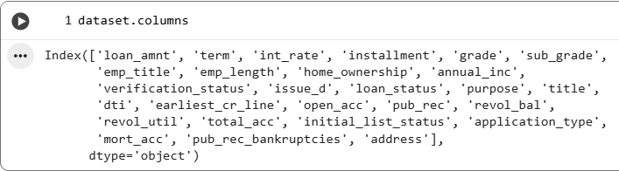

**Figure 2.3**: Data Frame Columns

**Insights:**

The displayed output shows the full list of columns present in your dataset. Each column represents a specific attribute of the loan, applicant, or credit history. Insights into this include:

* The dataset is rich with both numerical and categorical variables, including loan-specific fields (loan_amnt, term, int_rate, installment), creditworthiness indicators (grade, sub_grade, dti, open_acc, pub_rec, revol_bal, revol_util, total_acc), employment and demographic features (emp_title, emp_length, home_ownership, annual_inc), and fields related to verification and application type.
* It includes the target variable (loan_status), which will be essential for any modeling or classification tasks focused on predicting loan default or approval outcomes.
* With features like purpose, title, and address, deeper segmentation and geospatial or use-case-specific analyses are possible.
* The presence of historical fields like earliest_cr_line and negative indicators (pub_rec_bankruptcies, pub_rec) allows for comprehensive risk assessment modeling.
* This suite of features collectively enables nuanced exploration of which applicant characteristics, behaviors, and histories most strongly correlate with loan performance, which can drive more accurate underwriting and business insights.

**2.3.1.4 Detection of Null Values**

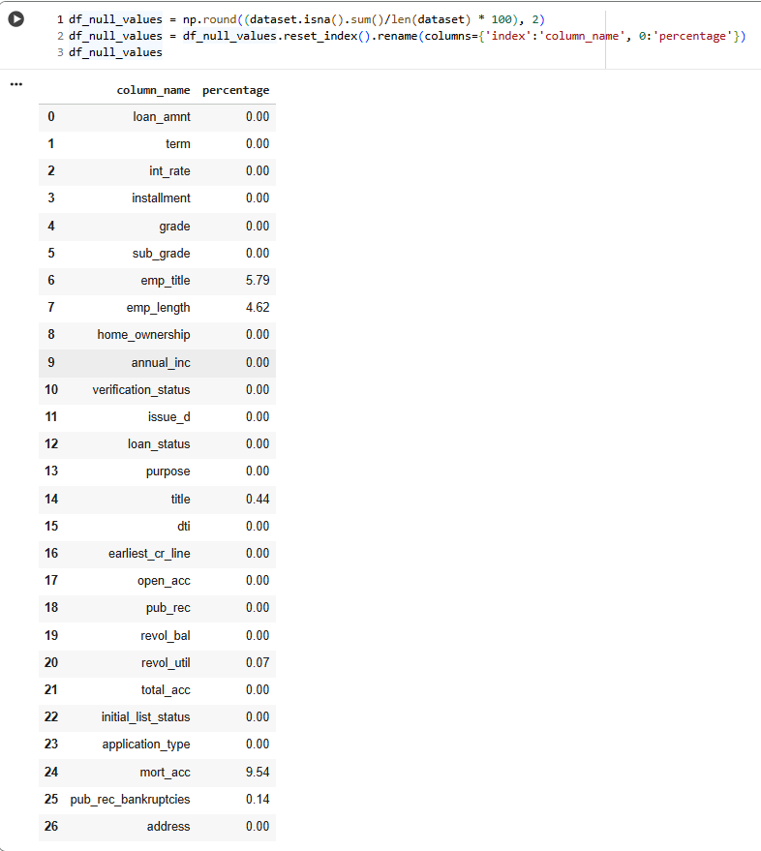

**Figure 2.4**: Detection of Null Values

**Insights:**

The presented table displays the percentage of missing (null) values in each column of your dataset. Here are the key insights:

**Columns with No Missing Data**

Most columns, including critical fields such as loan_amnt, term, int_rate, installment, grade, emp_length, annual_inc, loan_status, and credit parameters, have 0% missing values. This means your core variables are complete, ensuring robust statistical analysis and model training.

**Columns with Moderate Missing Data**

* emp_title has about 5.8% missing values, likely due to some borrowers not providing job titles.
* emp_length is missing for 4.6% of entries, possibly reflecting applicants unable or unwilling to specify employment duration.
* mort_acc (number of mortgage accounts) is missing in 9.54% of cases, which could hinder analyses involving mortgage credit history.

**Columns with Minimal Missing Data**

* A few columns, such as title (0.44%), revol_util (0.07%), and pub_rec_bankruptcies (0.14%), have very low missingness and are unlikely to impact broader analysis.

**Columns Fully Present**

* Key demographic and financial columns including home_ownership, verification_status, purpose, dti, application_type, address, and several credit variables, are 100% complete.

**Impact for Analysis**

* The dataset overall is well populated, with occasional moderate missingness in job and mortgage-related fields.
* Dropping or imputing missing values for a small fraction of borrowers will enable you to retain most of your analytical power when modeling loan default or approval.

**2.3.1.5 Duplicate values**

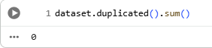

**Figure 2.5**: Duplicate values

**Insights**

The output shows that there are zero duplicate rows in your dataset. This means every entry is unique, which ensures the integrity and reliability of your analysis and modeling outcomes. You can proceed confidently without concerns of redundant or repeated records skewing your insights or results.

**2.3.1.6 Descriptive Statistics of Numerical Dataset**

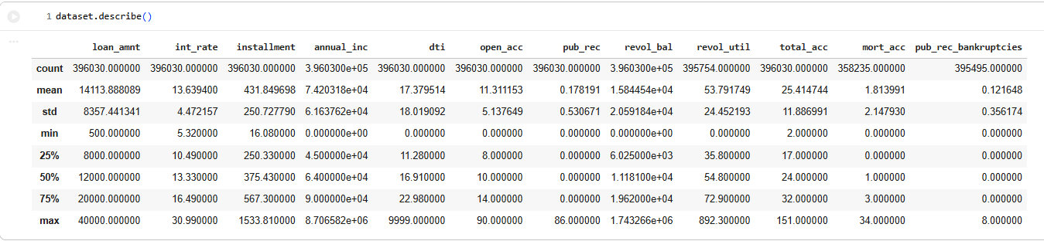

**Figure 2.6**: Descriptive Statistics of Numerical Dataset

**Insights**

**Central Tendencies and Spread**

* The mean loan amount is approximately 14,114, with a wide range from 500 to 40,000, showing diverse borrowing needs.
* The average interest rate is around 13.64%, with values spanning from 5.29% to 30.99%, indicating varying applicant risk profiles.
* Annual income averages about 74,201, but the standard deviation is high, reflecting significant income disparities.

**Quartiles and Outliers**

* For most features, the minimum and maximum values are far apart, which implies the presence of outliers requiring closer inspection, especially for annual income, revolving balance, and loan amount.
* The 50th percentile (median) for loan amount is 12,000; for interest rate, it's 13.33%; and for monthly installment, it's 375.43.

**Credit Health Indicators**

* The average debt-to-income ratio (DTI) is 17.38, which suggests moderate overall indebtedness, but individual cases go up to 9999.00. This is possibly an outlier or data entry issue.
* On average, borrowers have about 11 open accounts, and the median is slightly lower, at 10.
* The majority of applicants have few derogatory public records, bankruptcies, or mortgage accounts, but a small number have values as high as 86 (for public records) or 34 (for mortgage accounts).

**Utilization and Balances**

* The mean revolving balance is approximately 15,845, while revolving utilization rate averages 53.79, suggesting many borrowers are using over half their available revolving credit.
* The distribution of these variables indicates both low-risk and high-risk borrowers are present.

**Data Quality**

* Columns have high non-null counts, meaning the statistics are robust and reflect the full data scope.

**2.3.1.7 Descriptive Statistics of Categorical Dataset**

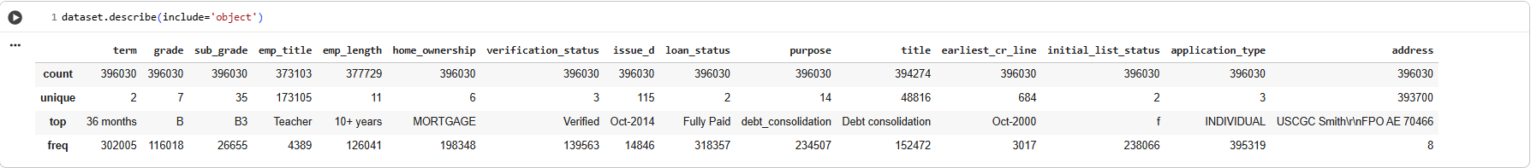

**Figure 2.7**: Descriptive Statistics of Categorical Dataset

**Insights**

**Most Frequent Values and Diversity**

* The majority of loans have a term of 36 months, making it the most common repayment period.
* The dominant assigned loan grade is ‘B’, and the most frequent sub-grade is ‘B3’, reflecting risk distribution and possibly underwriting preferences.
* For employment, the most common job title among borrowers is “Teacher,” and the majority have “10+ years” of employment, indicating a trend towards experienced applicants with educational backgrounds or job security.
* “MORTGAGE” is the most common home ownership status, suggesting many borrowers either own or are paying off their homes.

**Loan and Application Characteristics**

* The most common loan status at the time of data extraction is “Fully Paid,” and the leading purpose for borrowing is “debt_consolidation,” indicating a high portion of responsible borrowers focused on managing or consolidating existing debts.
* The “Verified” status is the most common for verification, signifying strong income/data verification practices.
* “INDIVIDUAL” is the most frequent application type, with joint applications being relatively rare.
* The dataset contains a vast variety of job titles (173,105 unique values) and addresses (393,970 unique entries), reflecting high diversity and user privacy.

**Other Categorical Trends**

* “Oct-2000” is the most common earliest credit line, which may reflect both genuine borrowing patterns and some data coding or reporting standards.
* “f” dominates as the initial list status, which may refer to the loan's listing stage.

**Overall, these insights show strong diversity in borrower background and application details, but clear trends toward certain loan products, verification types, and applicant profiles.**

**2.3.2 Univariate Analysis**

**2.3.2.1 Loan Term Proportions**

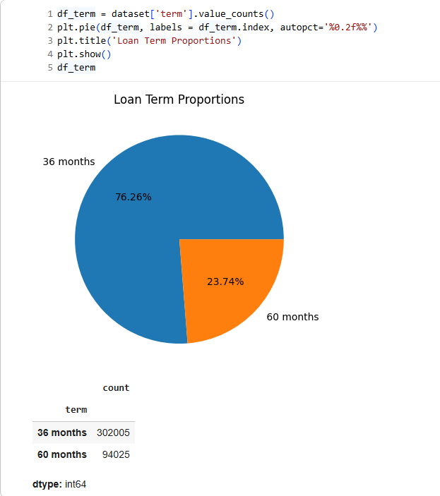

**Figure 2.8**: Loan Term Proportions

**Insights**

The pie chart and summary table illustrate the distribution of loan terms within the dataset. About 76.26% of loans have a term of 36 months, while 23.74% have a term of 60 months. This significant preference for shorter-term loans indicates that most borrowers opt for quicker repayment cycles, possibly to reduce interest costs or because of lending policy emphasis on lower-risk, shorter-duration lending. The provided counts (302,005 for 36 months and 94,025 for 60 months) reinforce this pattern, highlighting that three-year loans are more than three times as common as five-year loans in this portfolio.

**2.3.2.2 Initial List Status Proportions**

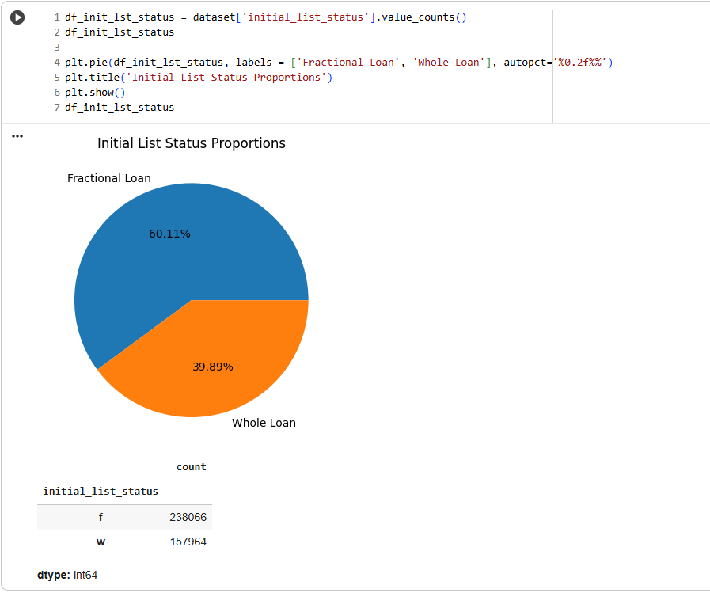

**Figure 2.9**: Initial List Status Proportions

**Insights**

The pie chart and summary table present the proportions of initial listing status among loans in the dataset. About 60.11% of loans are classified as “Fractional Loan” (f), while 39.89% are “Whole Loan” (w). This indicates that the platform predominantly lists loans as fractional, allowing investors to participate in portions of loans rather than funding them entirely. The count shows 238,066 fractional loans compared to 157,964 whole loans, highlighting a business strategy or market preference for fractionalized investment opportunities, which can support better risk diversification and broader investor participation.

**2.3.2.3 Verification Status Proportions**

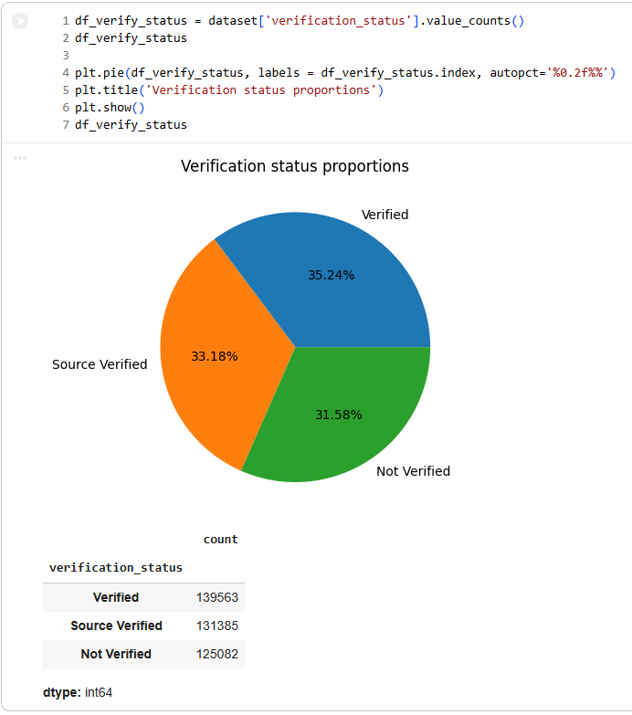

**Figure 2.10**: Verification Status Proportions

**Insights**

The chart and supporting data show the proportions of loan applications by verification status. Approximately 35.24% of loans are fully “Verified,” 33.18% are “Source Verified,” and 31.58% are “Not Verified.” This indicates a strong emphasis on validation, with the majority of borrowers undergoing some form of income or information check. However, about one-third of loans have not been verified, which may represent lower documentation channels or alternative risk models. Overall, the portfolio demonstrates a balanced mix of verification types, reflecting flexible underwriting while maintaining oversight for risk control.

**2.3.2.4 Application Type Proportions**

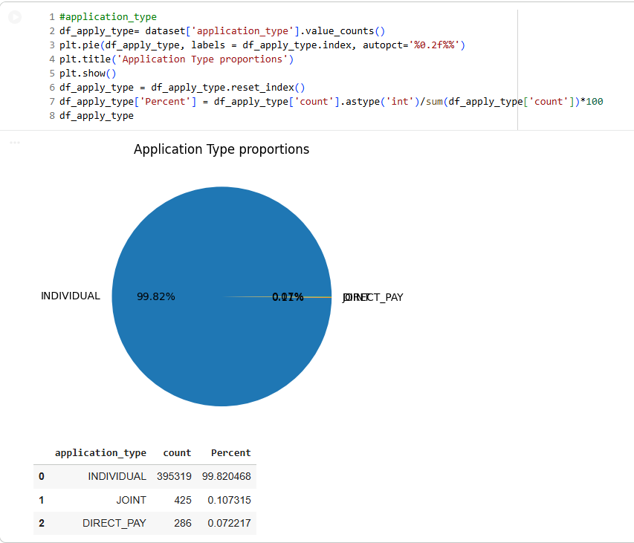

**Figure 2.11**: Application Type Proportions

**Insights**

The chart and accompanying data reveal a dramatic dominance of individual applications in the loan dataset. Nearly all applications (99.82%) were submitted by individuals, with joint and DIRECT_PAY applications representing only 0.11% and 0.07% of the total, respectively. This indicates the platform’s user base overwhelmingly consists of single applicants, suggesting the product design, risk assessment, and marketing strategies are likely tailored primarily to individual borrowers rather than co-applicants or special direct payment arrangements.

**2.3.2.5 Count of Different Grades**

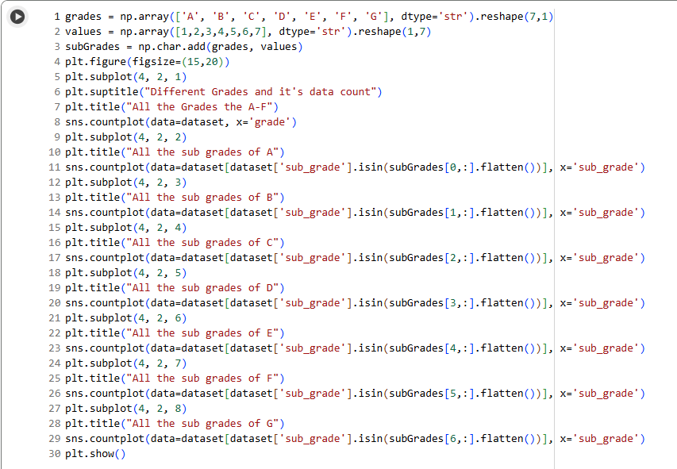

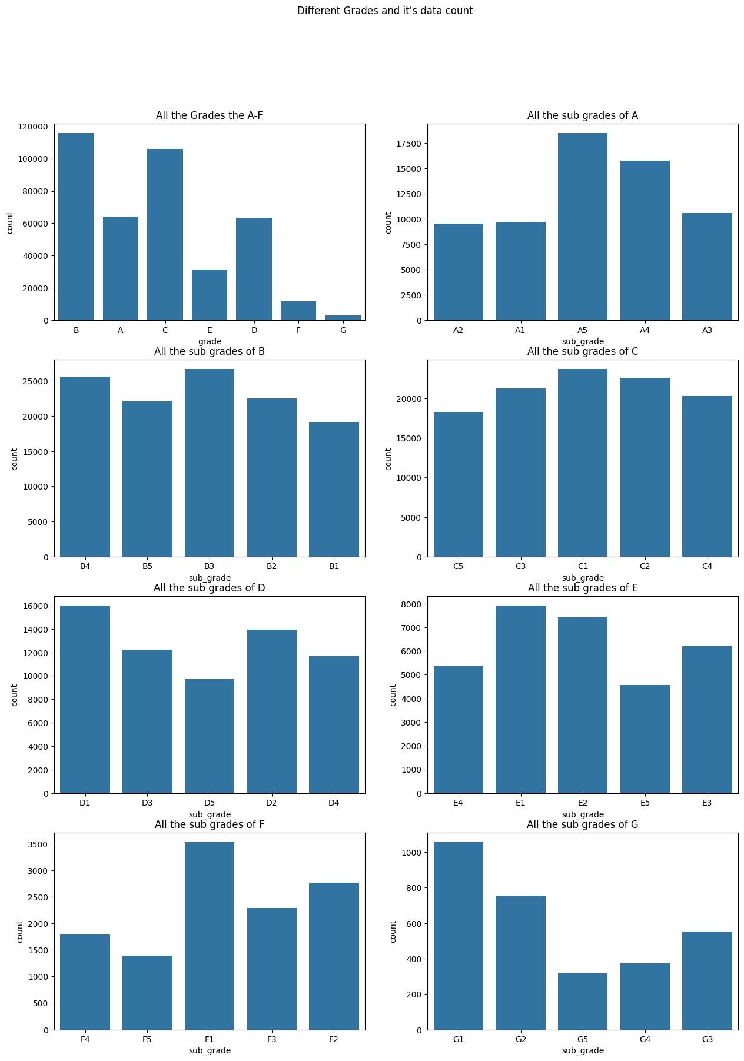

**Figure 2.12**: Count of Different Grades

**Insights**

**Grade Distribution**

* Grade **B** has the highest count by a wide margin, followed by **C** and **A**, with grades **E**, **D**, **F**, and **G** appearing far less frequently.
* This suggests most borrowers fall into mid-risk tiers, with fewer applicants classified as high-risk (F/G) or very low-risk (A).

**Sub-grade Patterns**

* Within each grade, sub-grades show meaningful variability.
* The distribution within **A**, **B**, and **C** is relatively balanced, but some sub-grades (like B3 and C1) have slightly higher counts.
* For grades with fewer loans (E, F, G), sub-grade counts drop further, pointing to a narrow distribution of borrower risk at those extremes.

**Implications for Risk and Underwriting**

* The platform’s portfolio leans heavily toward moderate-credit-risk applicants, as seen in the prevalence of grades B and C.
* Loan allocation and underwriting seem to favor borrowers in these risk bands, possibly reflecting business strategy or risk appetite.

**Visual Data Quality**

* The separation of each grade's sub-grade distribution reveals underlying granularity in borrower assessment, validating the multi-level grading system as relevant to overall data coverage.

**2.3.2.6 Employee experience and their loan application count**

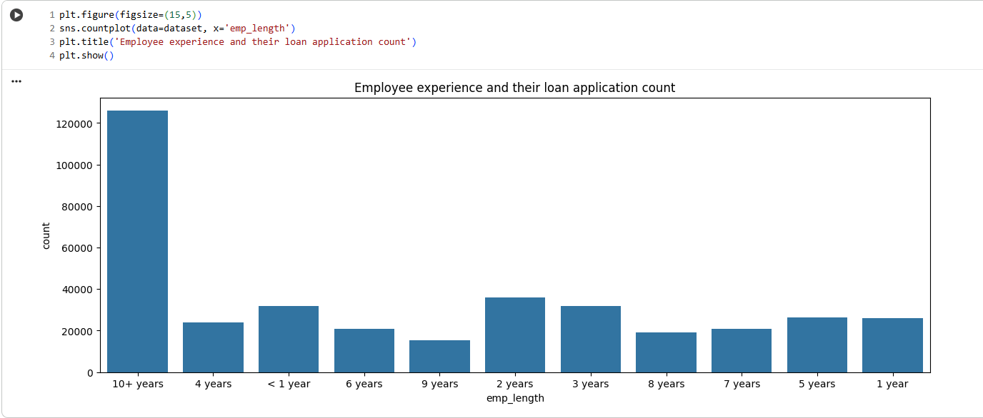

**Figure 2.13**: Employee Experience And Their Loan Application Count

**Insights**

The visualization shows a strong preference for loan applications from individuals with “10+ years” of employment experience. This category far surpasses all other experience brackets in application count. Applicants with less than one year of experience and those with 1–9 years appear in much smaller, relatively similar numbers across categories. This trend suggests that the lending platform attracts and potentially favors more experienced, stable applicants, which may reflect underwriting criteria designed to reduce default risk by prioritizing longer work histories.

**2.3.2.7 Home Ownership and Respective Loan application count**

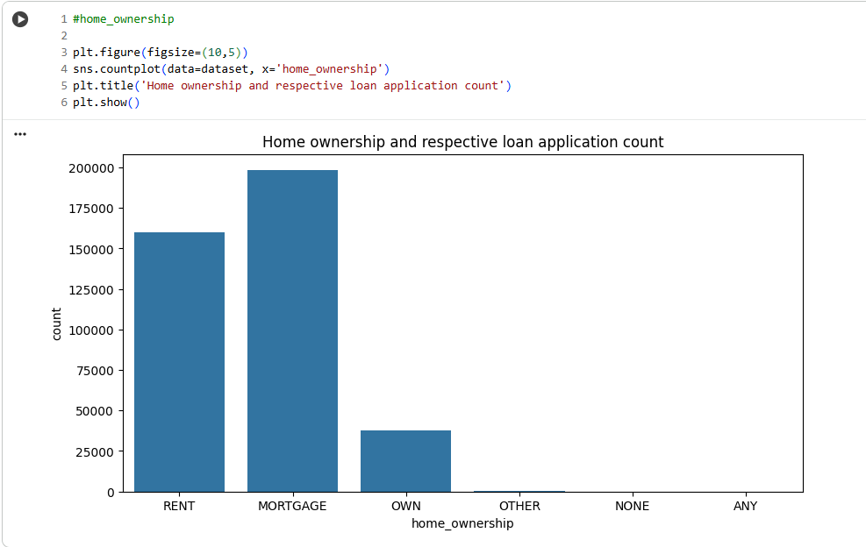

**Figure 2.14**: Home Ownership and Respective Loan application count

**Insights**

The bar chart displays loan applications by home ownership status. The majority of applicants either have a mortgage or rent, with mortgage holders making up the largest group, followed by renters. Borrowers who fully own their homes form a much smaller proportion, and categories like “OTHER,” “NONE,” and “ANY” are almost negligible. This pattern suggests the platform primarily serves individuals with ongoing housing expenses, either through rent or mortgage, rather than those who own their homes outright. It may also reflect greater demand for loans among those with regular housing payments, or risk-management preferences in underwriting.

**2.3.2.8 Loan Verification Status and Respective Application Count**

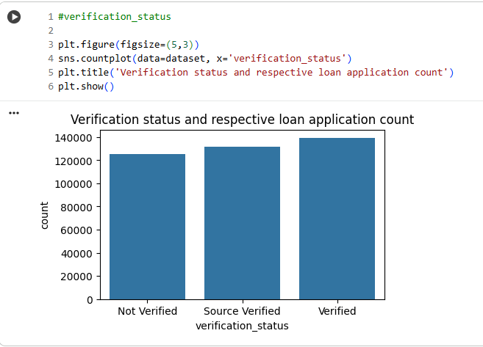

**Figure 2.15**: Loan Verification Status and Respective Application Count

**Insights**

The bar chart illustrates the distribution of loan applications by verification status. The counts across “Verified,” “Source Verified,” and “Not Verified” categories are fairly similar, with “Verified” loans holding a slight lead. This reflects a balanced approach in the platform’s underwriting process—while full verification is common, a significant number of loans proceed with either source verification or no verification, suggesting flexibility in risk assessment and inclusivity for borrowers with varying documentation levels. The nearly equal heights of the bars imply that no single verification status overwhelmingly dominates the portfolio.

**2.3.2.9 Loan Application Purpose and It’s Count**

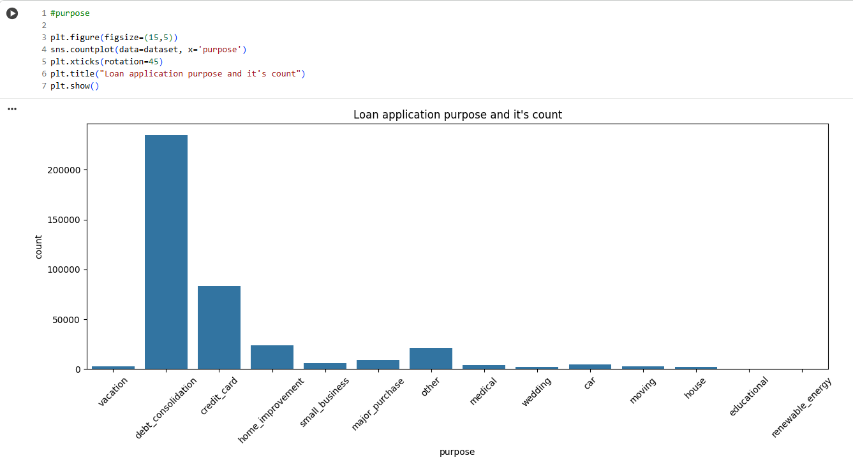

**Figure 2.16**: Loan Application Purpose and It’s Count

**Insights**

* The bar chart displays the distribution of loan purposes among applicants. The largest category by far is “debt_consolidation,” indicating that most borrowers use these loans to merge and manage existing debts. The next most common purposes are “credit_card” (covering credit card balances) and “home_improvement.” Other categories like “small_business,” “major_purchase,” and “medical” have noticeably fewer applications, and the remaining purposes (such as “vacation,” “wedding,” “moving,” “renewable_energy”) are rare.
* This concentration suggests that loan products are especially attractive for debt and credit management, while discretionary or specialized use-cases make up a small share of the portfolio. The platform’s risk strategy, borrower marketing, and underwriting policies are likely shaped by this dominant demand for consolidation and credit product refinancing.

**2.3.2.10 Distribution of Loan Amounts using Kernel Density Estimate (KDE)**

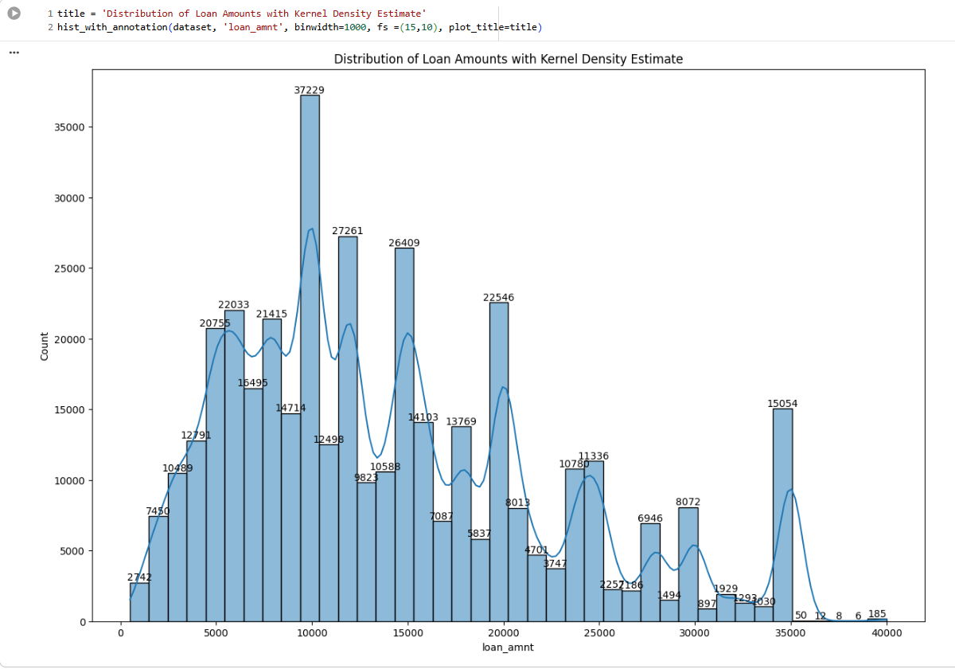

**Figure 2.17**: Distribution of Loan Amounts using Kernel Density Estimate (KDE)

**Insights:**

* The histogram and kernel density estimate illustrate the distribution of loan amounts in the dataset. Most loans cluster between ₹5,000 and ₹20,000, with a prominent peak around ₹10,000 indicating this is the most common amount borrowed. The data is right-skewed, with smaller counts at higher loan values (above ₹20,000). Repeated smaller peaks may reflect preferred loan increments or product offerings.
* The presence of spikes at round numbers (like ₹10,000, ₹20,000, ₹35,000) suggests standardization or borrower preferences for particular amounts. There are very few extremely small or large loans, reinforcing that the platform caters primarily to moderate-sized borrowing needs.
* This distribution helps profile typical borrower demand and can guide product structuring, risk modeling, and marketing strategies toward the most popular loan sizes.

**2.3.2.11 Distribution of Interest Rates using Kernel Density Estimate (KDE)**

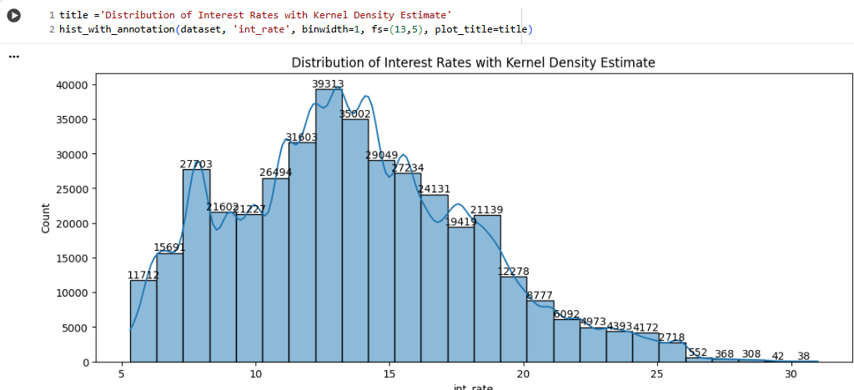

**Figure 2.18**: Distribution of Interest Rates using Kernel Density Estimate (KDE)

**Insights**

* The histogram and kernel density estimate plot reveal the distribution of interest rates for loans in the dataset. Most loans cluster in the range of 10% to 18%, with a pronounced peak near 13%–15%. The distribution is right-skewed: as interest rates increase above 18%, the count of loans falls progressively, with very few loans at extremely high rates (above 25%).
* Loan products at lower interest rates are more prevalent, potentially reflecting the platform’s target market of relatively qualified borrowers or its risk policies. The gradual decrease in the number of high-rate loans suggests either tighter approval criteria or less borrower demand for loans at those rates.
* Distinct peaks at specific interest rates could indicate standard product pricing or frequent scoring bands used in underwriting. Overall, the majority of borrowers secure loans at moderate rates, suggesting risk management aligned with mainstream lending practices.

**2.3.2.12 Loan Installment Amount using Kernel Density Estimate (KDE)**

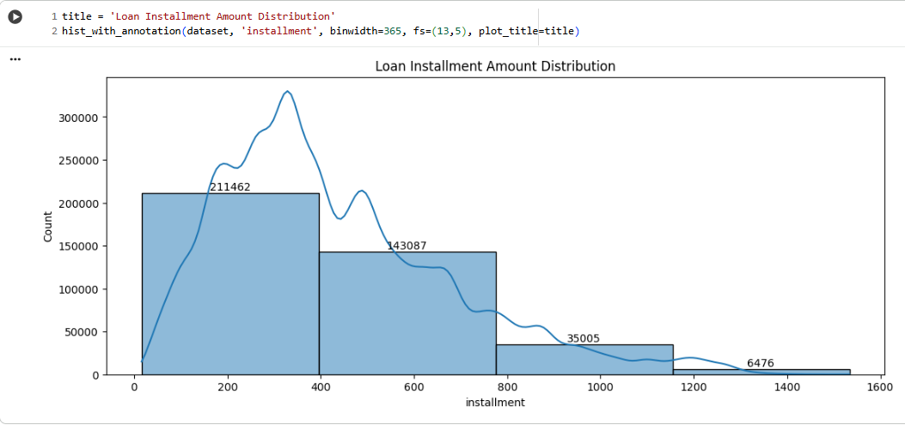

**Figure 2.19**: Loan Installment Amount using Kernel Density Estimate (KDE)

**Insights**

* The histogram and density curve show that the majority of loan installments fall below ₹400, with the largest number of borrowers paying monthly installments in the ₹0–₹400 range. The counts decline steadily as installment amounts increase, with very few loans having installments above ₹1,200. This right-skewed distribution suggests that most borrowers prefer or qualify for loans with lower repayment burdens, reflecting either borrower affordability or the platform’s risk and eligibility filtering.
* Distinct peaks at certain values may correspond to typical loan terms and amounts. The spread indicates the platform serves a diverse set of borrowers, but the focus is strongly on manageable monthly repayments, supporting broad accessibility while controlling the likelihood of repayment

**2.3.2.13 Annual Income using Kernel Density Estimate (KDE)**

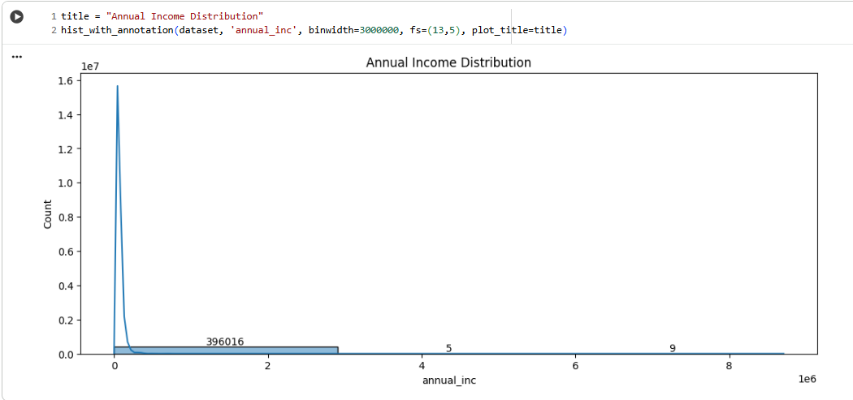

**Figure 2.20**: Annual Income using Kernel Density Estimate (KDE)

**Insights**

* The histogram and density plot illustrate that most loan applicants report annual incomes clustered at lower ranges, with the vast majority below ₹2,000,000. The curve is sharply right-skewed, with very few borrowers earning extremely high incomes. The steep drop-off after the first income bin suggests a typical applicant profile is from the lower to mid-income brackets.
* The presence of isolated points far to the right may indicate outliers or rare high earners. This profile suggests the platform predominantly serves mainstream consumers and salaried professionals rather than affluent or high-net-worth individuals, helping target risk models and lending policies toward broader, moderate-income market segments

**2.3.2.14 Debt to Income using Kernel Density Estimate (KDE)**

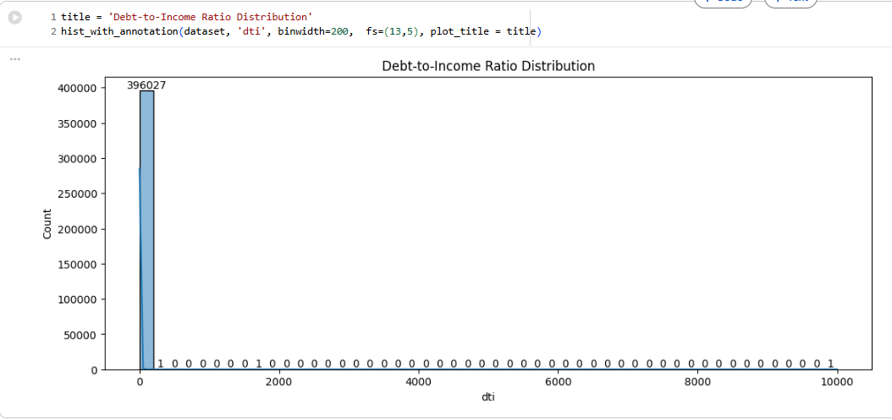

**Figure 2.21**: Debt to Income using Kernel Density Estimate (KDE)

**Insights**

* The histogram of debt-to-income ratio (DTI) displays an extreme right-skew, with almost all applicants having DTI well below 200. Virtually the entire dataset is concentrated in the lowest ratio range, while very few (or possibly erroneous) records show DTI values in the thousands. This means most borrowers maintain a reasonable level of debt compared to income, which aligns with prudent lending standards and reduced default risk.
* The few outlying high DTI values are likely data errors or exceptional edge cases and should be reviewed carefully. The overall DTI profile supports the platform's focus on financially stable, manageable-risk applicants.

**2.3.2.15 Open Accounts using Kernel Density Estimate (KDE)**

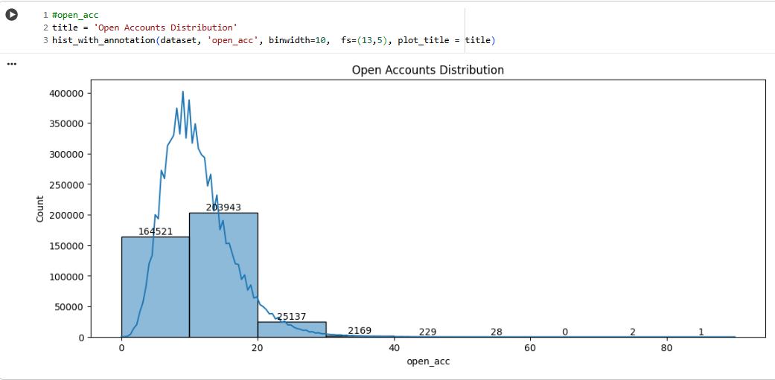

**Figure 2.22**: Open Accounts using Kernel Density Estimate (KDE)

**Insights**

* The bar plot and kernel density curve show that the number of open credit accounts for applicants typically ranges between 0 and 20, with the majority having between 5 and 15 open accounts. The distribution is right-skewed, with only a small fraction of applicants holding larger numbers of open accounts (above 30).
* This profile indicates that most borrowers actively use credit but are not overly leveraged, which is a positive indicator for creditworthiness. Outliers with very high numbers of open accounts are extremely rare and may represent different borrower segments or special risk cases. This overall pattern supports healthy financial activity among the platform’s users.

**2.3.2.16 Public Records using Kernel Density Estimate (KDE)**

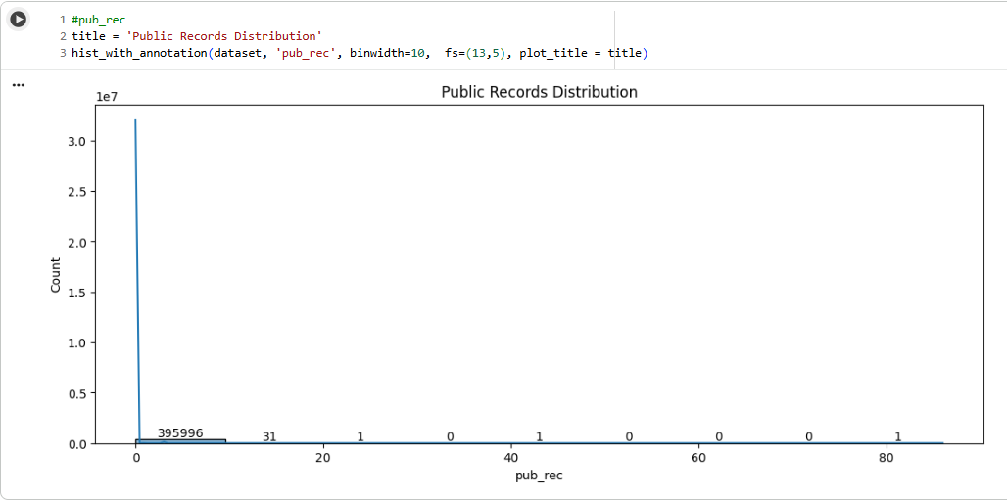

**Figure 2.23**: Public Records using Kernel Density Estimate (KDE)

**Insights**

The histogram for public records shows almost all applicants have zero derogatory public records. Only a minuscule number of individuals have one or more public records, and those with extremely high counts are practically nonexistent. This indicates that the borrower pool is largely free from legal or financial judgments, reinforcing the platform’s focus on lower-risk applicants. The few outliers likely represent rare exceptions or data anomalies. Overall, the public record profile strongly supports stable, responsible lending risk.

**2.3.2.17 Revolving Balance using Kernel Density Estimate (KDE)**

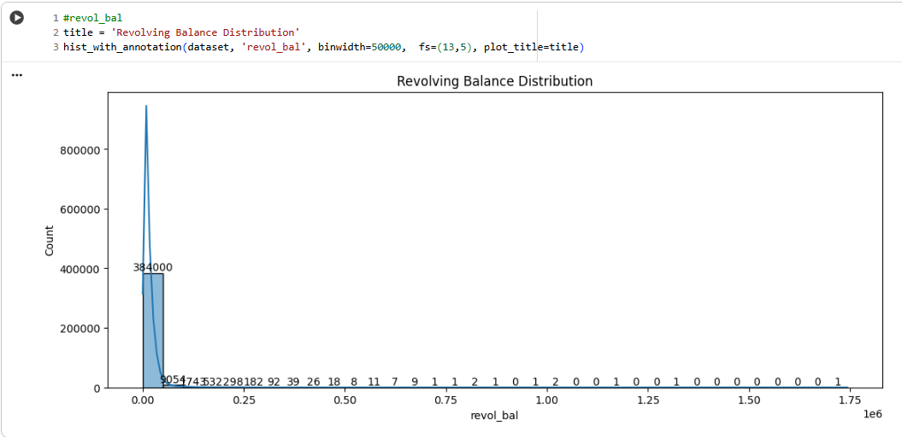

**Figure 2.24**: Revolving Balance using Kernel Density Estimate (KDE)

**Insights**

* The histogram shows that most applicants have a revolving credit balance (revol_bal) well below ₹50,000. Only a handful of borrowers report much higher revolving balances, and values above ₹250,000 are extremely rare. This right-skewed distribution indicates that the platform primarily serves applicants with modest revolving credit use, which is favorable for loan approval and overall credit risk.
* The few outliers represent either high-credit individuals or edge cases that may need special scrutiny. The distribution helps confirm that borrower financial leverage is generally kept in check, reinforcing responsible lending standards.

**2.3.2.18 Revolving Utilization using Kernel Density Estimate (KDE)**

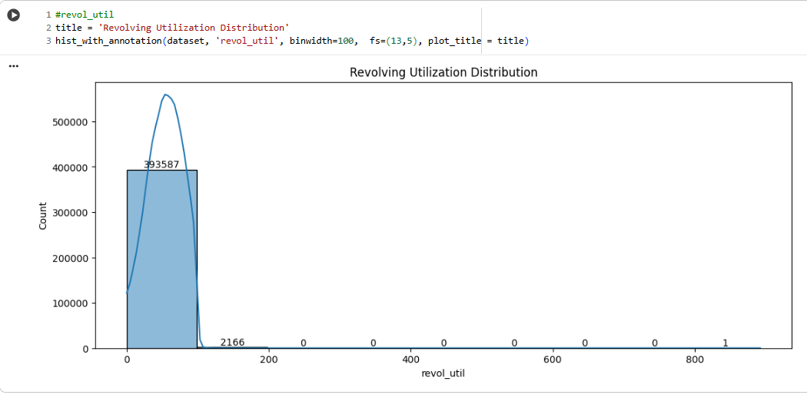

**Figure 2.25**: Revolving Balance using Kernel Density Estimate (KDE)

**2.3.2.19 Total Accounts using Kernel Density Estimate (KDE)**

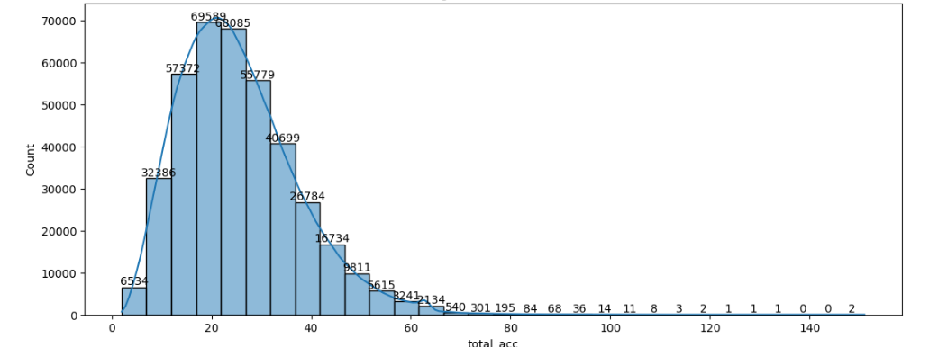

**Figure 2.26**: Total Accounts using Kernel Density Estimate (KDE)

**Insights**

* The histogram for revolving utilization rate (revol_util) shows most applicants have utilization rates between 0% and 100%, with a strong concentration below 100%. Only a small minority of borrowers exceed this threshold, and values above 200% are exceptionally rare.
* This means that most borrowers are using less than their total available revolving credit, indicative of healthier credit behavior. High revolving utilization can be a risk signal, so the distribution suggests the platform’s applicants, in general, maintain reasonable credit management. The few extremely high values deserve special review for potential risk or data issues.

**2.3.2.20 Mortgage Accounts using Kernel Density Estimate (KDE)**

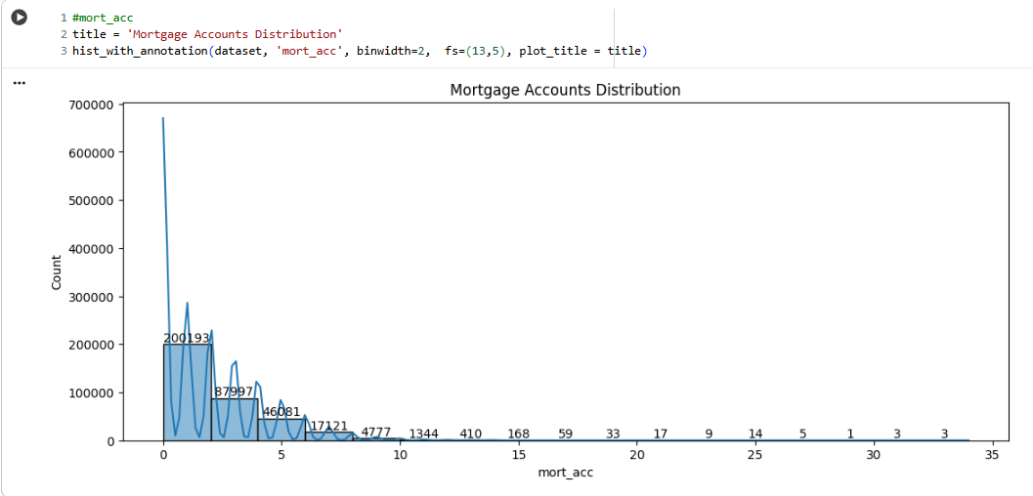

**Figure 2.27**: Mortgage Accounts using Kernel Density Estimate (KDE)

**Insights**

* The histogram reveals that the majority of applicants have few or zero mortgage accounts, with a trailing distribution for higher counts. A large proportion of the dataset has between 0 and 4 mortgage accounts, and only a handful of individuals report over 10, with extremely high values being exceedingly rare.
* This pattern suggests that most borrowers are either non-homeowners or maintain only a few active mortgage loans, reflecting broad accessibility for those with limited homeownership exposure. The platform’s applicant pool appears to be dominated by individuals with manageable housing credit histories. Outliers in mortgage account count are minimal and should be reviewed for special lending policies or risk.

**2.3.2.21 Public Record Bankruptcies using Kernel Density Estimate (KDE)**

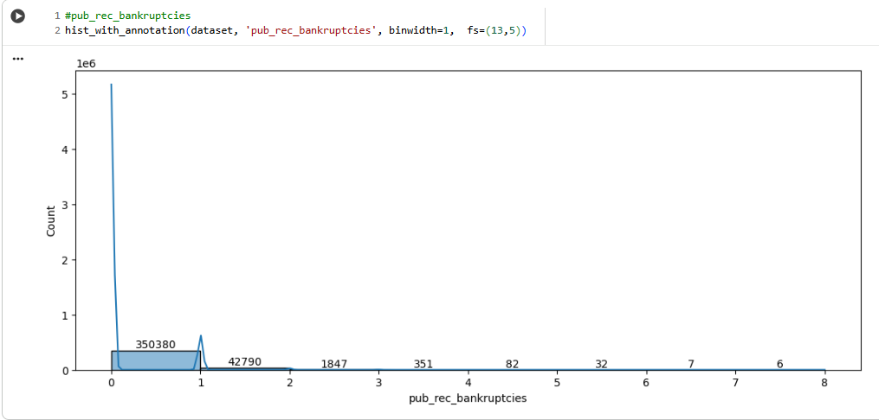

**Figure 2.28**: Public Record Bankruptcies using Kernel Density Estimate (KDE)

**Insights**

* The histogram for public record bankruptcies indicates that nearly all applicants have never declared bankruptcy. The count drops sharply as the number of bankruptcies increases, with only a small fraction having one, two, or more bankruptcies on record.
* This pattern confirms most of the lender’s clientele have clean bankruptcy histories, which is a strong signal of financial reliability and low credit risk. Outliers with more bankruptcies are very rare and may warrant special underwriting consideration. The overall distribution supports healthy portfolio quality for lending.

**2.3.3 Bivariate Analysis**

**2.3.3.1 Loan Status Count w.r.t Term**

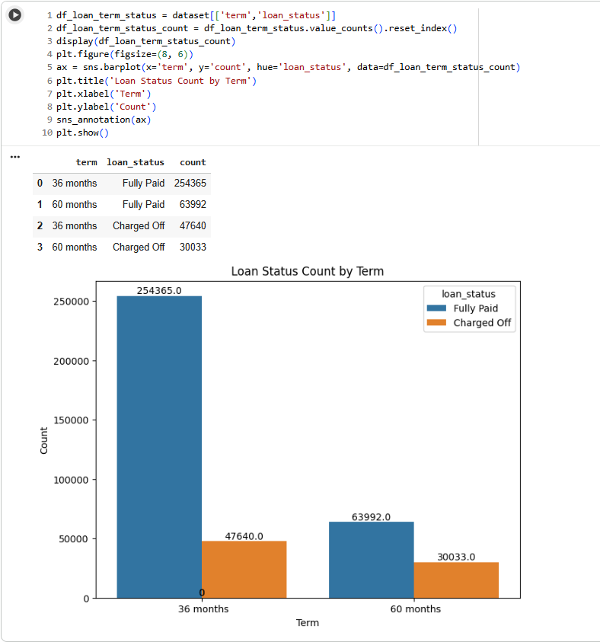

**Figure 2.29**: Loan Status Count w.r.t Term

**Insights**

This chart compares the loan repayment outcomes for different loan terms (36 and 60 months) in a loan business case, showing "Fully Paid" versus "Charged Off" (defaulted) loans.

* Higher Repayment Success for Shorter Terms: The vast majority of 36-month loans are fully paid off (254,365), while only 47,640 are charged off. This demonstrates a higher success rate for shorter-term loans.
* Increased Default Proportion for Longer Terms: For 60-month loans, while 63,992 are fully paid, a substantial 30,033 are charged off. The default rate (charged off/total issued) is noticeably higher for 60-month loans compared to 36-month loans.
* Risk Profile: These results highlight that longer-term (60-month) loans carry more risk for the lender. Borrowers may be more likely to default as loan duration increases, signaling the need for stricter risk assessment or adjusted pricing on longer-term products.
* Business Strategy Implication: The lender may want to promote 36-month products and/or implement risk-adjusted interest rates, more rigorous credit checks, or additional support for customers opting for 60-month loans to mitigate potential losses.

These findings are crucial for product strategy, risk management, and pricing in any loan portfolio analysis.

**2.3.3.2 Loan Status Count w.r.t Different Grades**

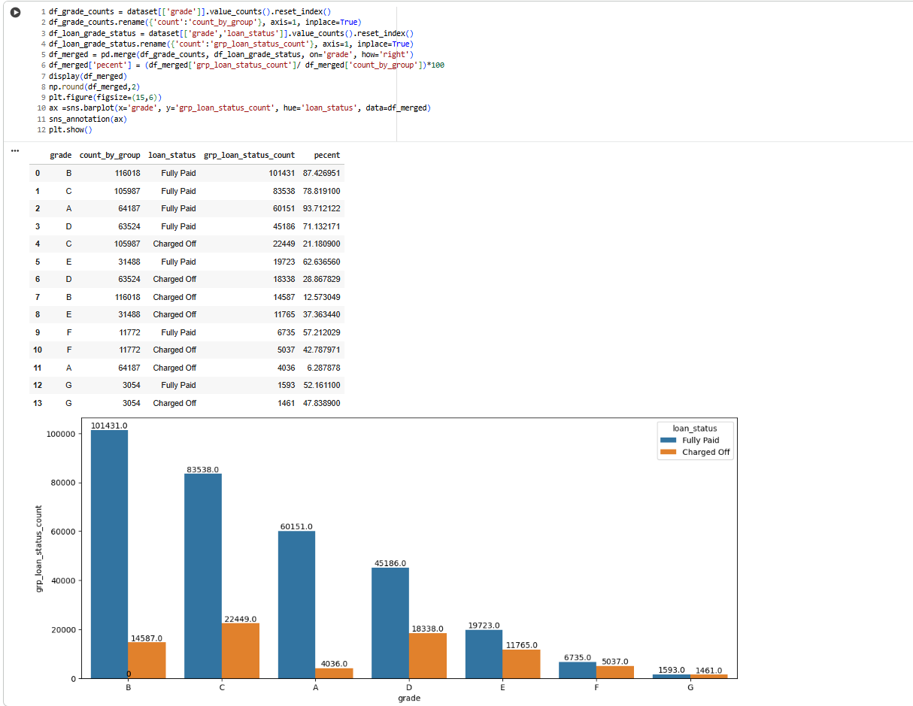

**Figure 2.30**: Loan Status Count w.r.t Different Grades

**Insights**

This visualization and table analyze loan repayment outcomes by credit grade, which are key in assessing portfolio quality and lending risk in the loan industry.

* **Default Risk Correlates with Grade:** The percentage of “Charged Off” (defaulted) loans increases as credit grade worsens. Grades B and C (mid-risk) show default rates of 12.57% and 21.89% respectively, while riskier grades F and G have much higher default rates (F: 42.78%, G: 47.84%).
* **Best Portfolio Performance at High Grades:** Grades A and B have the highest “Fully Paid” ratios (A: 94%, B: 87%). These customers represent the strongest portfolio assets and lowest risk for the lender.
* **Credit Quality Drives Strategy:** As the grade worsens from D to G, not only does the count decrease, but the “Charged Off” ratios rise sharply—Grade G balances are almost equally split between full repayment and default. This suggests stringent risk controls and pricing are required at lower grades.
* **Volume Distribution:** Most loans are issued in grades B and C, highlighting a business focus on moderate-risk customer segments.

**Business Implication:**  
Lenders can use this analysis to adjust interest rates, develop targeted support programs, refine underwriting standards, and focus customer acquisition on higher-grade segments to optimize long-term profitability and reduce losses from defaults. Concentrating marketing efforts on grades with consistently solid repayment improves portfolio quality.

**2.3.3.3 Loan Status Count w.r.t Different Sub Grades**

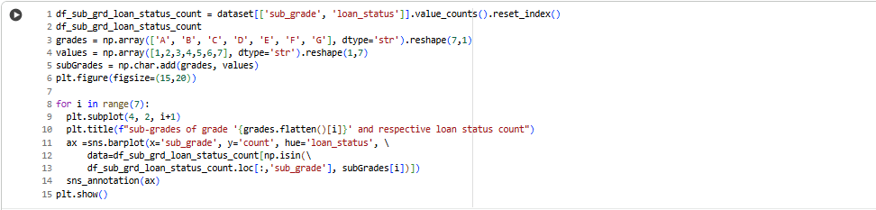

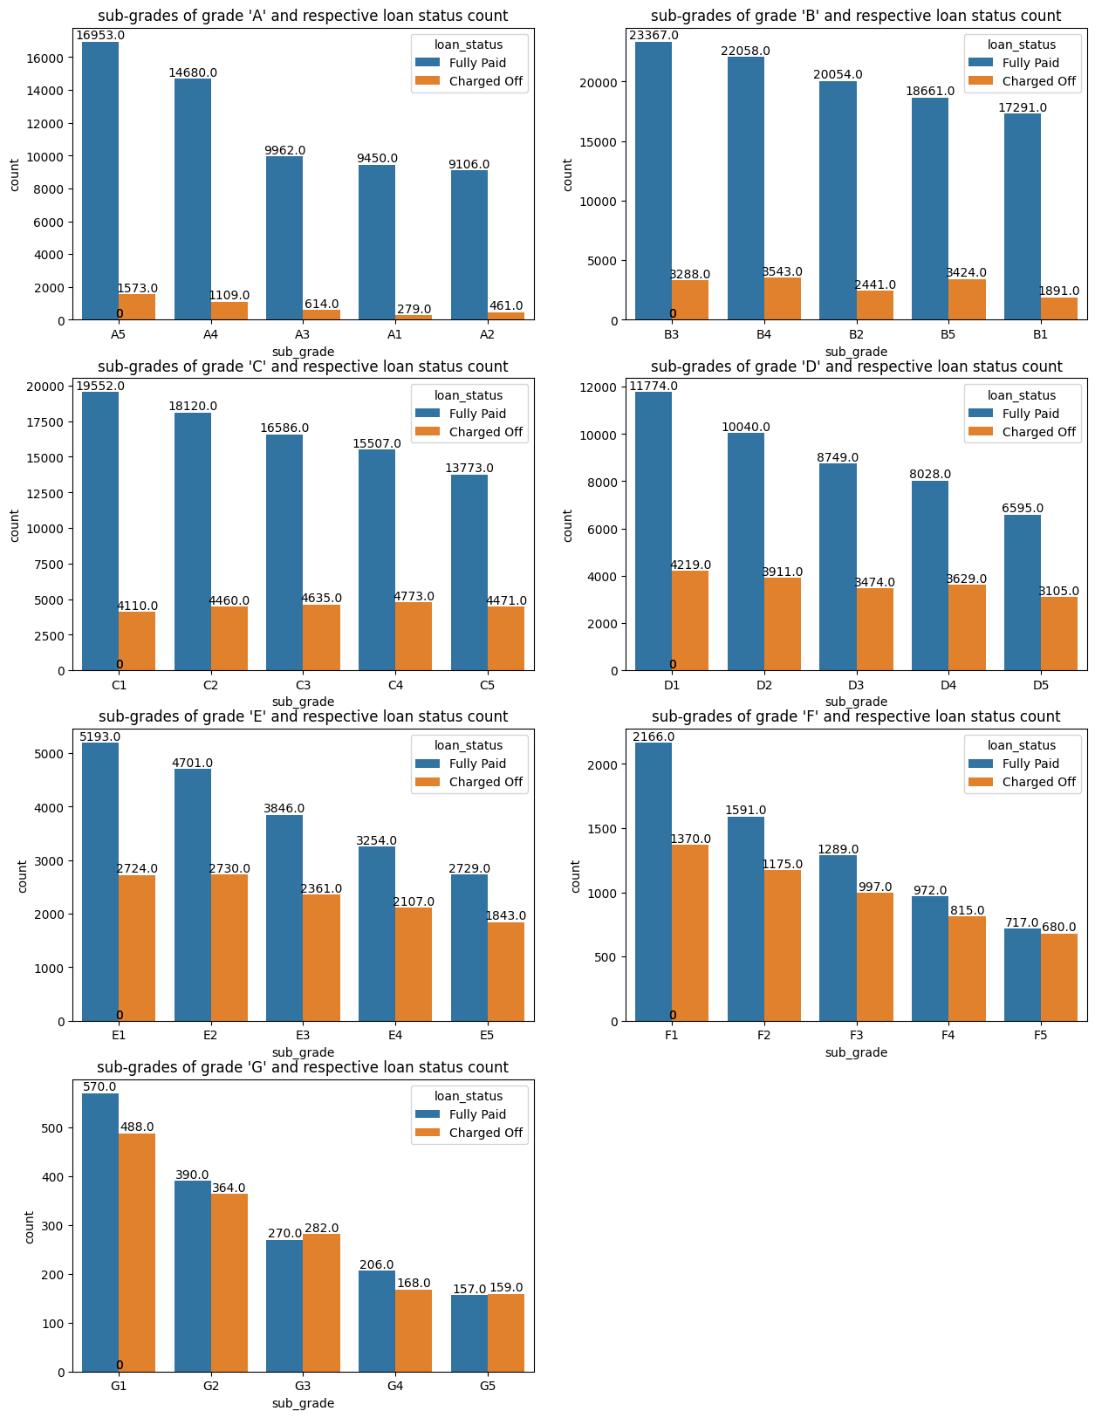

**Figure 2.31**: Loan Status Count w.r.t Different Sub Grades

**Insights**

This set of bar charts analyzes loan status (Fully Paid vs. Charged Off) across the sub-grades (risk bands) within each major credit grade, providing a nuanced view of repayment behavior in a loan portfolio.

* **Higher Sub-grade Means Higher Risk:** For every grade (A to G), lower sub-grades (e.g., A5, B5, C5, etc.) have distinctly higher frequencies of “Charged Off” loans compared to better sub-grades (e.g., A1, B1, C1), clearly illustrating that default risk increases as sub-grade worsens within each grade.
* **Repayment Strength Concentrated in Top Sub-grades:** Across almost all grades, the best-performing sub-grades (ending with 1 or 2) have the largest counts of fully paid loans and the lowest defaults. For instance, sub-grades A1 and B1 have far more “Fully Paid” counts than “Charged Off.”
* **Mid-tier Sub-grades Show Moderate Risk:** Sub-grades in the middle of each grade (such as B3, C3, D3) show substantial “Charged Off” numbers—a transition in risk profile is evident.
* **Lowest Grades Are Highly Risky:** In grades F and G, even the best sub-grades have charge-off counts almost equal to fully paid counts. For example, in sub-grade G1, “Charged Off” and “Fully Paid” are nearly balanced, underscoring elevated default risk.
* **Portfolio Focus Recommendation:** The lender should focus acquisition and retention efforts on borrowers in higher sub-grades (A1–A3, B1–B3, C1–C3) for the best returns and portfolio stability, while considering adjusted risk pricing or stricter approval for borrowers below these bands.

**Business Application:**  
This analysis enables lenders to design more refined credit products, select appropriate interest rates, and tailor risk controls to maximize portfolio returns and minimize charge-off losses at a granular level.

**2.3.3.4 Loan Status Count w.r.t Employee Length**

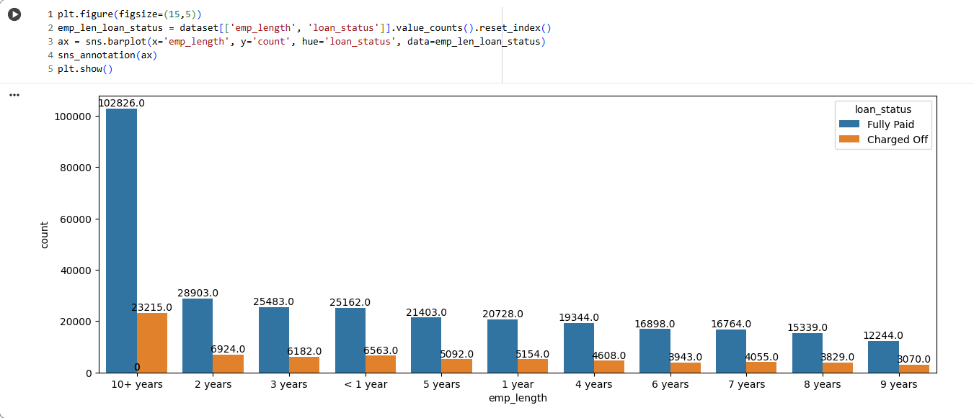

**Figure 2.32**: Loan Status Count w.r.t Employee Length

**Insights**

The bar chart shows the distribution of loan repayment status (“Fully Paid” vs. “Charged Off”) across various employment length categories for borrowers.

* **Greater Experience, Better Repayment:** Borrowers with “10+ years” of experience have the highest number of fully paid loans by a wide margin, as well as the largest application volume overall. This group also has a relatively lower proportion of charge-offs, confirming that job stability is associated with lower lending risk.
* **Shorter Tenure, Higher Risk:** All other employment length categories (from less than 1 year to 9 years) have lower counts of "Fully Paid" loans and proportionally more charge-offs, with some volatility but a relatively consistent trend: less experience is correlated with slightly higher default rates.
* **Broad Participation:** Despite higher risk, all employment groups—including those with very short or inconsistent job tenure—still account for substantial fully paid loan counts, indicating diversified risk in the portfolio.

**Business Implication:**  
Lenders should assign greater weight to employment experience during risk assessment and pricing. At the same time, maintaining options for newer employees (with suitable risk control) supports a broad and inclusive business strategy

**2.3.3.5 Loan Status Count w.r.t Home Ownership**

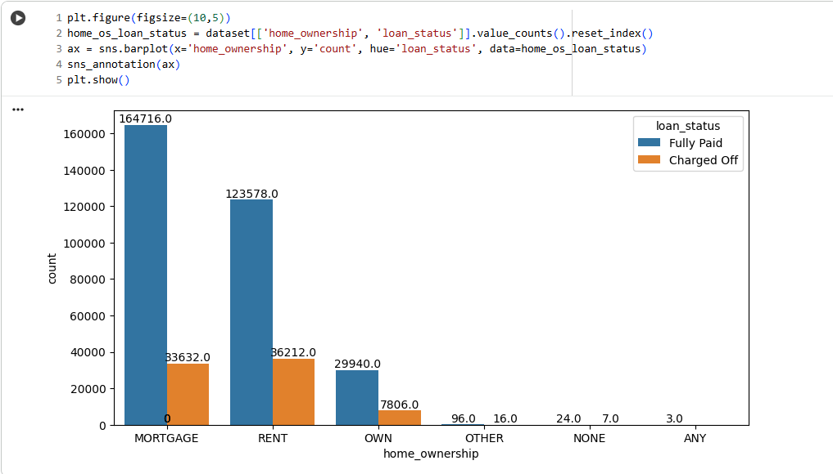

**Figure 2.33**: Loan Status Count w.r.t Home Ownership

**Insights**

* **Mortgage Holders are the Largest and Most Reliable Group**: Borrowers with mortgages form the largest share of fully paid loans, and while they do have a significant number of charge-offs, the proportion of successful repayments is the highest. This suggests financial stability or effective risk controls for these customers.
* **Renters have Elevated Risk**: While renters account for a sizable number of fully paid loans, they nearly match mortgage holders in count of charged-off loans, indicating a relatively higher default risk among renters.
* **Homeowners Are the Safest Segment**: Those who own their homes outright ("OWN") have the highest fully paid-to-charge-off ratio, reflecting outstanding credit reliability.
* **Other, None, Any are Insignificant**: The categories "OTHER," "NONE," and "ANY" have minimal impact due to their negligible loan counts.

**Business Implication**  
Home ownership status is a powerful indicator for loan underwriting. Lenders should optimize their risk and pricing models to favor owners and mortgage holders, while continuing cautious assessment for

**2.3.3.6 Loan Status Count w.r.t Verification Status**

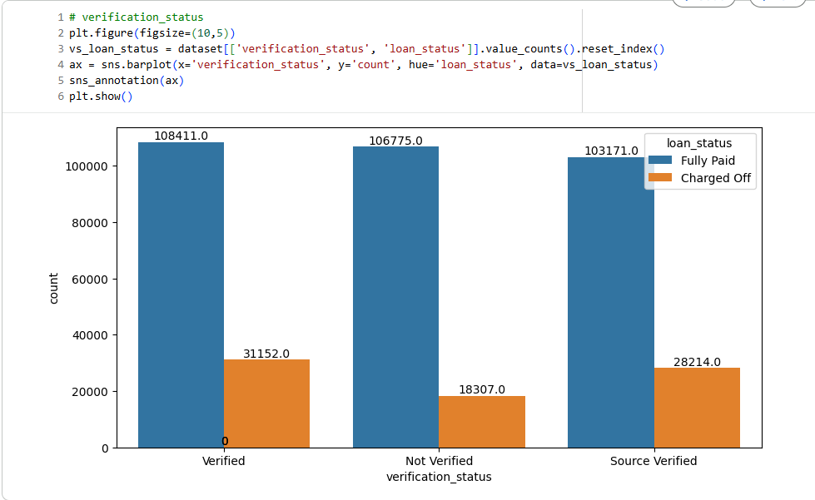

**Figure 2.34**: Loan Status Count w.r.t Verification Status

**Insights**

* **Verification Matters:** Loans with “Verified” status have the highest count of fully paid loans, and although their charge-off count is also considerable, the ratio is more favorable than “Source Verified.”
* **Lowest Risk: Verified and Not Verified:** Both “Verified” and “Not Verified” categories have comparable fully paid numbers, but “Not Verified” loans have noticeably lower charge-off counts, possibly indicating extra caution in lending when full verification is absent.
* **Source Verified at Higher Risk:** The “Source Verified” group shows the highest charge-off proportion among the three categories, signaling that independent verification processes may not be as reliable for predicting repayment.
* **Business Implication:**  
  Companies should value robust verification processes, as these yield higher repayment rates. “Not Verified” loans require stricter eligibility, while “Source Verified” applicants should be closely monitored or offered loans at higher rates to manage risk. This enables lenders to tailor risk policies and pricing by verification type for improved portfolio health.

**2.3.3.7 Loan Status Count w.r.t Purpose**

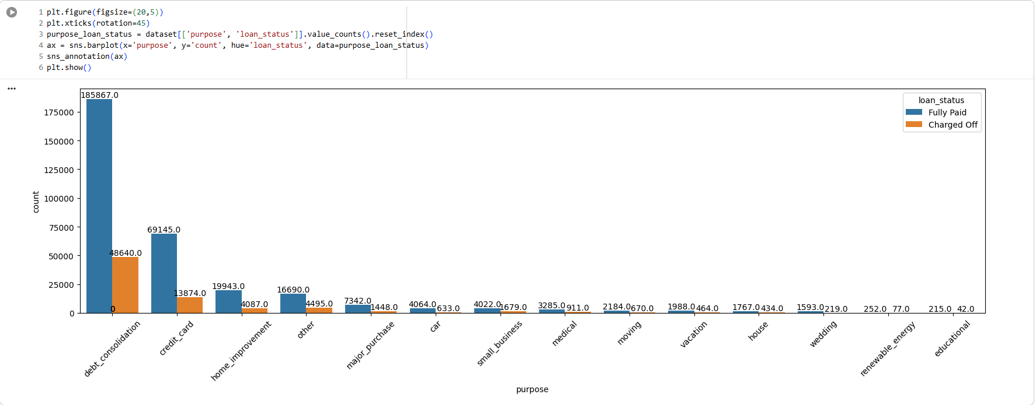

**Figure 2.35**: Loan Status Count w.r.t Purpose

This chart examines loan repayment outcomes (fully paid vs. charged off) based on the loan's stated purpose.

**Insights**

* **Debt Consolidation and Credit Card Loans Dominate:** Most loans are for “debt consolidation” or “credit card” refinancing. They have the largest absolute fully paid and charged off counts. However, the proportion of charge-offs is substantial, especially for debt consolidation, highlighting inherent risk in borrowers consolidating existing debts.
* **Lower Risk Purposes:** Purposes like “home improvement”, “car”, “major purchase”, and “moving” show both lower total numbers and a lower relative percentage of charge offs, indicating more reliable borrower segments for these loan types.
* **Small Business, Medical, and Other Uses are High Risk:** “Small business,” “medical,” and “other” purposes display visibly higher proportions of charge offs versus fully paid, underlining their higher risk and need for more caution or stricter terms by lenders.
* **Niche Purposes are Safe but Rare:** Categories like “wedding,” “house,” “vacation,” “renewable energy,” and “educational” loans occur infrequently and are not a major driver of overall portfolio risk, but their small numbers may not justify specialized products unless volume grows.

**Business Implication:**  
Lenders should recognize the higher risk and volume in debt consolidation and credit card loans, pricing accordingly and possibly tightening approval for these categories. Targeted support and education for high-risk niches (small business, medical) could also lower

**2.3.3.8 Loan Status Count w.r.t Initial List Status**

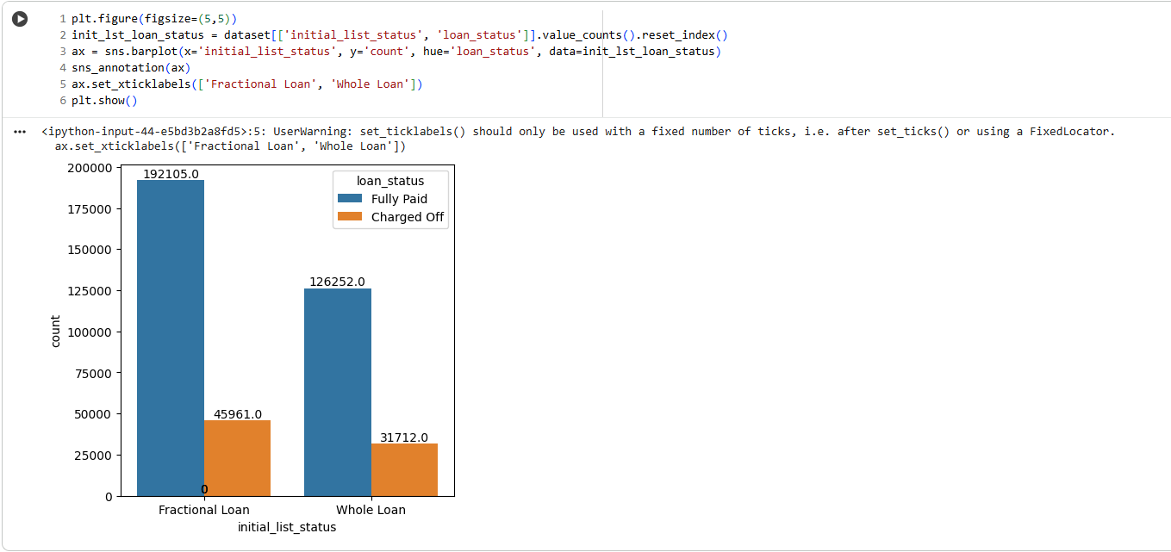

**Figure 2.36**: Loan Status Count w.r.t Initial List Status

This chart compares the loan outcomes (fully paid vs. charged off) for Fractional Loans and Whole Loans.

**Insights**

* **Fractional Loans Dominate the Portfolio:** Fractional loans show a much higher count of both fully paid and charged off loans when compared to whole loans, indicating they make up the majority of issued loans.
* **Default Rate is Similar Across Types:** Both fractional and whole loans exhibit a meaningful number of charge-offs, but their proportions are relatively consistent—default risk is present for both models.
* **Wider Investor Distribution in Fractional Loans:** The high volume of fractional loans may point to a preference for distributing risk among multiple lenders and easier accessibility for investors, while whole loans may be higher value or require different risk management.
* **Portfolio Management Implication:**  
  Lenders and platforms should monitor loss rates for both types, ensuring risk-adjusted pricing and support tools are in place for both, but especially important for fractional loans due to their higher volume and collective impact on overall portfolio performance.

**2.3.3.9 Loan Status Count w.r.t Application Type**

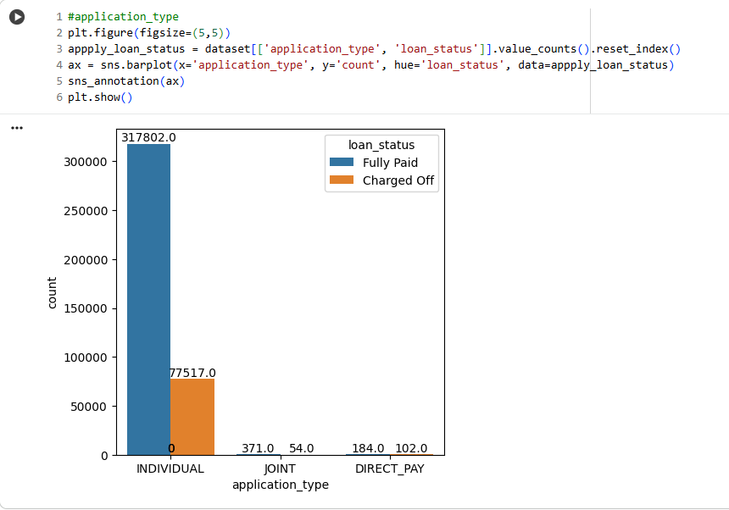

**Figure 2.37**: Loan Status Count w.r.t Application Type

This chart evaluates loan repayment outcomes across application types: Individual, Joint, and Direct Pay.

**Insights**

* **Individual Dominates Volume and Defaults:** The overwhelming majority of loans are issued to individual applicants, who account for both the largest number of fully paid and charged-off loans. Thus, overall portfolio performance is heavily tied to individual applicants’ risk profile.
* **Joint and Direct Pay Are Rare:** Joint and Direct Pay application types make up a very small slice of total loans, with minimal counts but a visible ratio of charge-offs to fully paid loans. This small sample size makes trends harder to interpret but signals the lender has limited exposure to these categories.
* **Default Risk is Present Across Types:** Even with low sample sizes, charge-offs are present for all types, underlining that default risk is universally relevant and not confined to one application channel.

**Business Implication:**  
Since nearly all lending is to individuals, risk models should be tailored primarily to single-applicant scenarios. However, monitoring and possibly expanding risk assessment for joint applicants and direct pay options can ensure robust risk coverage as product diversity grows.

**2.3.3.10 Loan Status of top 12 Postal Codes**

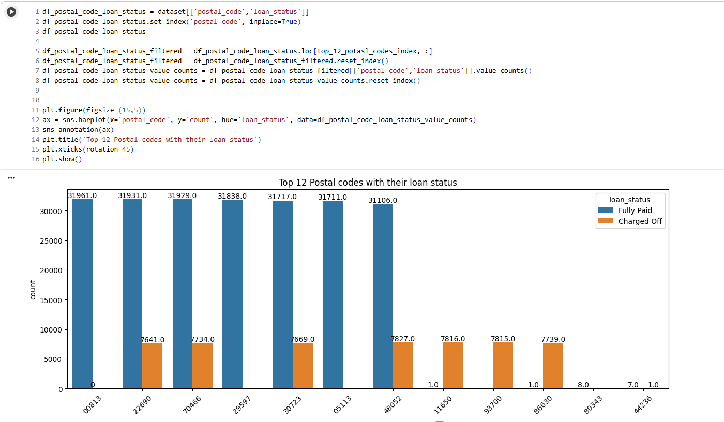

**Figure 2.38**: Loan Status of top 12 Postal Codes

**Insights**

* **Uniform Distribution Across Postal Codes:** The top 8 postal codes all have very similar counts, around 31,700–31,900 fully paid loans and 7,600–7,800 charged off loans each. This suggests no single region strongly dominates either risk or performance in this top group.
* **Consistent Default Rates:** The ratio of fully paid to charged off loans appears stable (~4:1) across these top postal codes, indicating similar portfolio performance regardless of region among the highest-volume locations.
* **Long Tail in the Top List:** After the top 8, the remaining postal codes in the list have very low counts, reflecting that most lending activity is highly concentrated. These codes have negligible impact on overall portfolio performance.

**2.3.3.11 Purpose of Loan – Top 20**

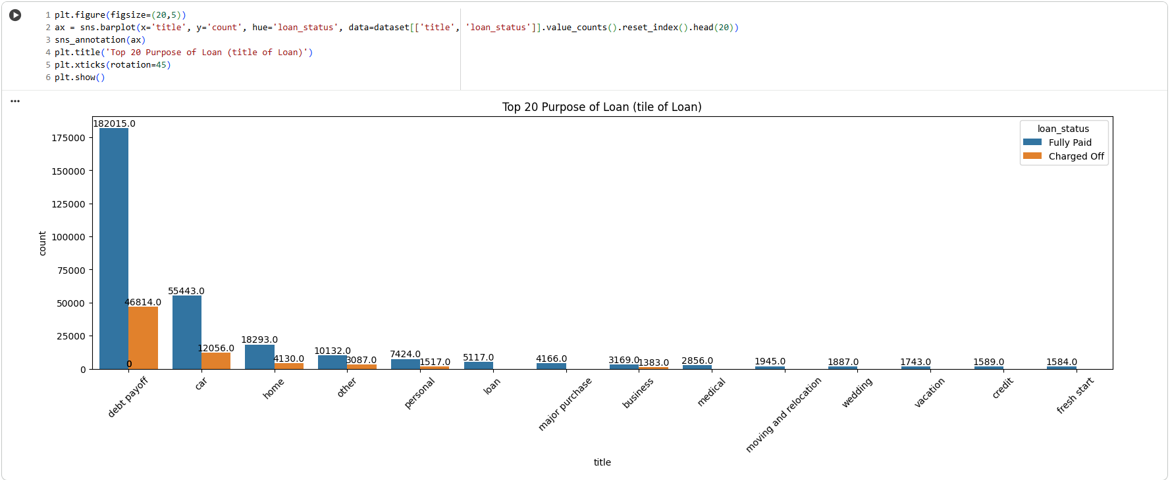

**Figure 2.39**: Purpose of Loan – Top 20

**Insights**

* **Debt Payment is the Dominant Reason:** "Debt payment" overwhelmingly forms the largest share of both fully paid and charged off loans. This suggests most borrowers use personal loans for debt consolidation, which carries some risk: the charge-off volume here is also the highest.
* **Other Major Purposes:** "Car" and "home" follow as significant reasons for loans, but with much smaller volumes compared to "debt payment." These categories have lower, but still notable, charge-off counts.
* **Niche Purposes Show Consistency:** Lesser loan purposes (such as personal, loan, major purchase, business, medical, moving/relocation, wedding, vacation, credit, and fresh start) have much fewer loans, but the proportion of charged offs in these smaller segments is nontrivial—indicating risk is spread broadly and not limited to just the high-volume segments.
* **Fully Paid Patterns Hold Across Titles:** In all categories, the number of fully paid loans outweighs charge offs, but the magnitude of difference varies purpose by purpose.

**Business Implication:**  
Targeted risk analytics should focus on the debt payment segment due to its sheer volume and impact, but niche loan purposes should not be ignored as their relative risk to portfolio size can still be material. Lenders may want to implement different risk-based pricing or additional checks for high-risk purposes

**2.3.3.12 Loan Status Count w.r.t ‘issue_year’ and ‘issue_month’**

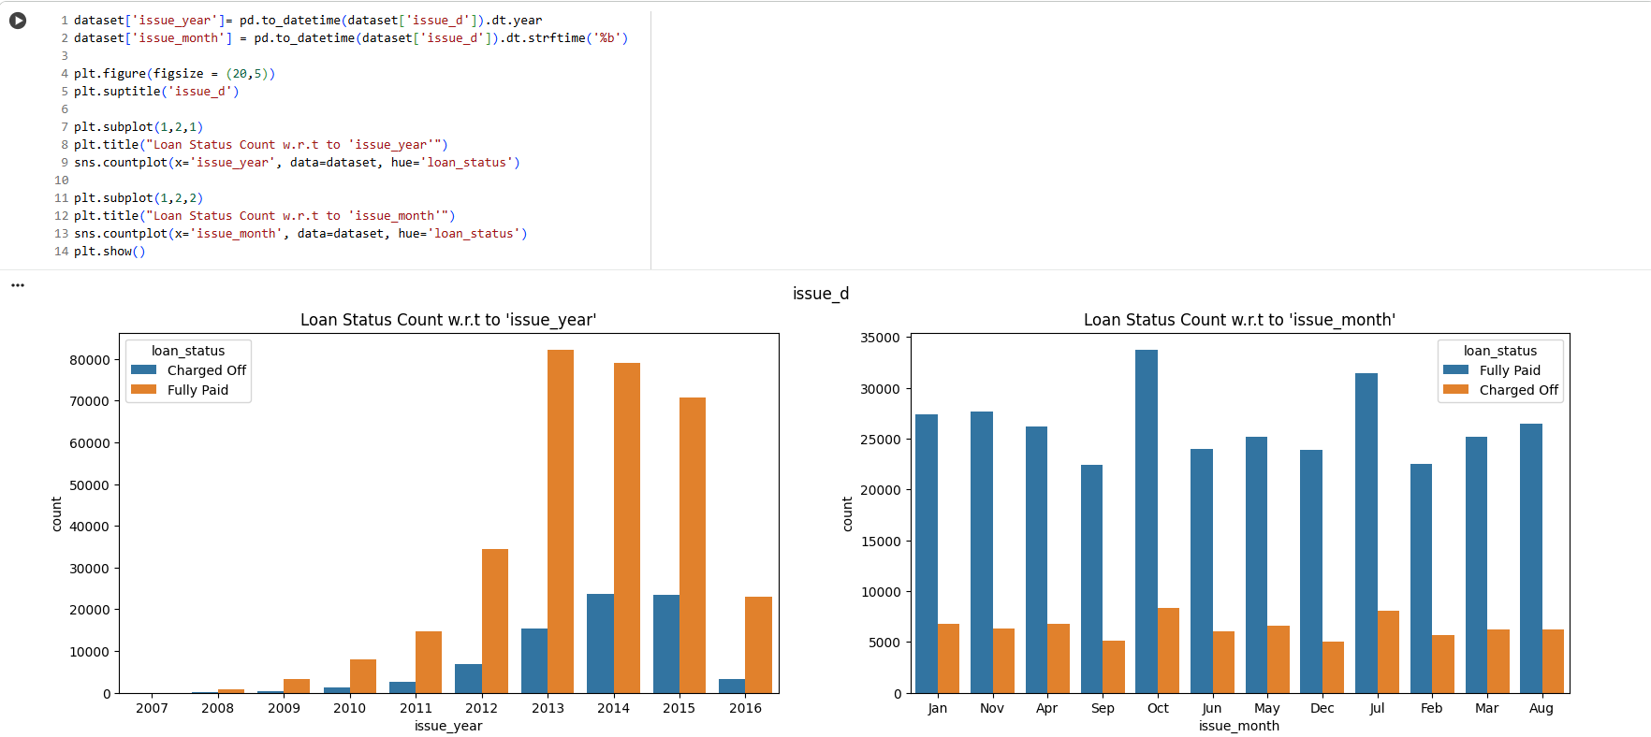

**Figure 2.40**: Loan Status Count w.r.t ‘issue_year’ and ‘issue_month’

**Insights**

**By Issue Year:**

* **Dramatic Growth Over Time:** The number of issued loans grew rapidly, peaking in 2013–2015, then declining after that. This reflects overall business expansion and possibly changing lending conditions.
* **Defaults Rise with Volume:** As loan originations increased, the count of charged off loans also increased, although "Fully Paid" loans always outnumber defaults for each year.
* **Recent Loans Show Fewer Resolved Outcomes:** Toward the last year (2016), fewer loans appear as "Fully Paid" or "Charged Off"—this may reflect loans still in progress or later maturities.

**By Issue Month:**

* **Monthly Origination is Seasonally Stable:** Lending volumes are relatively consistent throughout the year, with only small peaks in October and July.
* **No Evident Seasonality in Defaults:** There is no strong month-to-month pattern in default (charged off) rates; “Fully Paid” loans outnumber “Charged Off” loans in every month.
* **Charge-Off Volume Tracks Origination:** Charged off loans are generally proportional to fully paid loans within each month, supporting the idea that portfolio risk is steady across the calendar.

**Business Implication:**  
Lending scale heavily influences absolute defaults, not lending season. Risk is more tied to business growth and total originations than to a particular monthly or seasonal pattern. Risk and performance analysis should focus on business cycle changes, volume bursts, and post-peak correction phases more than short-term calendar effects.

**2.3.3.13 Top 20 Status of Loan w.r.t to ‘emp_title’**

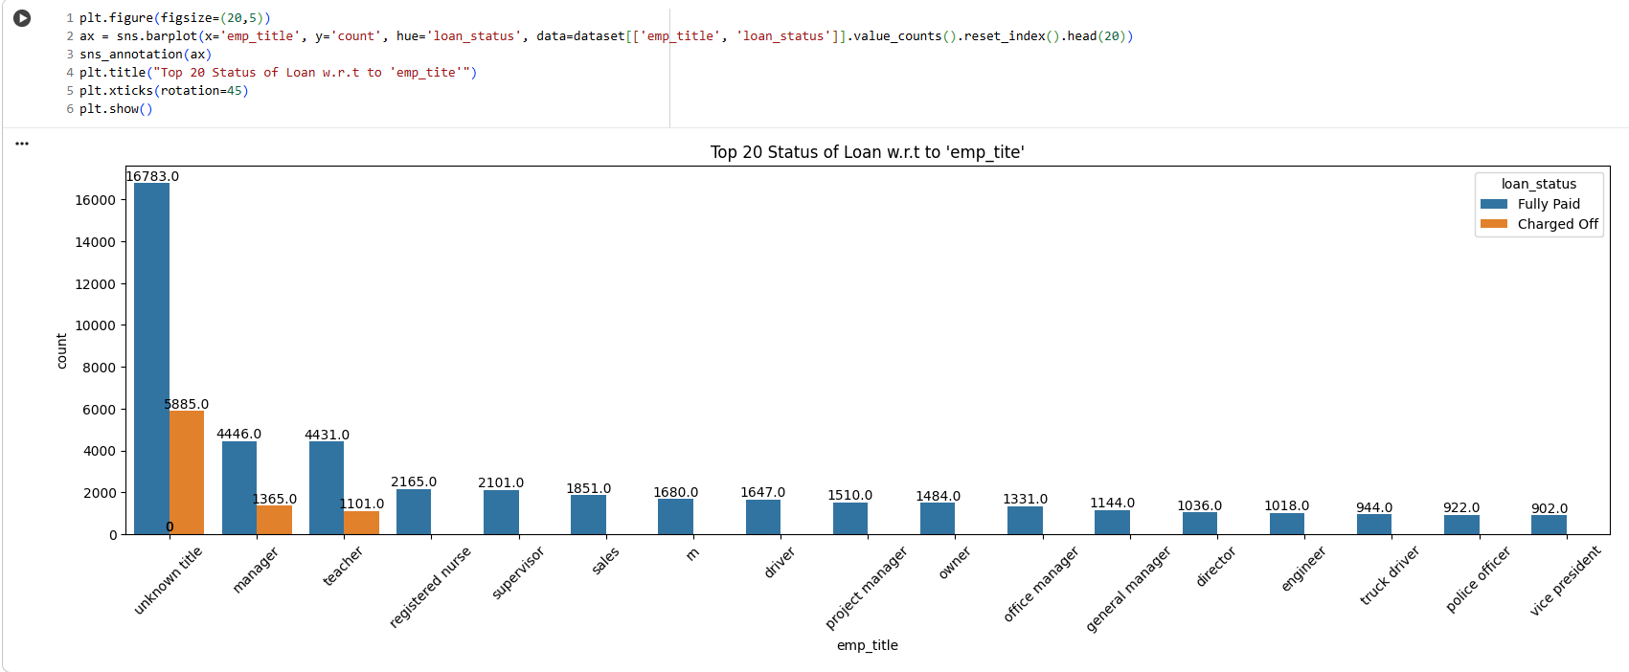

**Figure 2.41**: Top 20 Status of Loan w.r.t to ‘emp_title’

**Insights**

* **Unknown Titles Dominate Volume:** The “unknown title” category is by far the largest group, suggesting many borrowers did not specify a clear employment title. This group also has the highest number of charged off loans, likely reflecting the risk that accompanies incomplete or ambiguous employment information.
* **Consistently Lower Default Across Professions:** Most named professions (manager, teacher, registered nurse, supervisor, sales, driver, etc.) have a much higher count of fully paid loans than charge offs. This pattern indicates that borrowers with identifiable and stable jobs tend to have a lower default risk.
* **Volume Declines Quickly After Top Categories:** After the top few titles, the volume of loans per employment title drops off rapidly, indicating that loan portfolio exposure is heavily concentrated among a small set of employment classifications.
* **Professional Roles and Repayment:** Professional roles such as manager, teacher, engineer, officer, and vice president have a favorable fully paid-to-charged off ratio, supporting the idea that stable employment is a good risk indicator.

**Business Implication:**  
Lenders should be wary of applications with ambiguous or missing employment information, as these are associated with higher risk. Employment verification and job title can be valuable components of a credit risk model, with certain professions demonstrating greater stability and lower default

**2.3.3.14 Loan Status Count w.r.t to 'earliest_cr_line_year' and 'earliest_cr_line_month'**

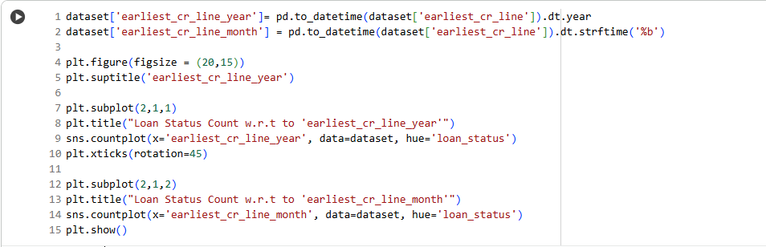

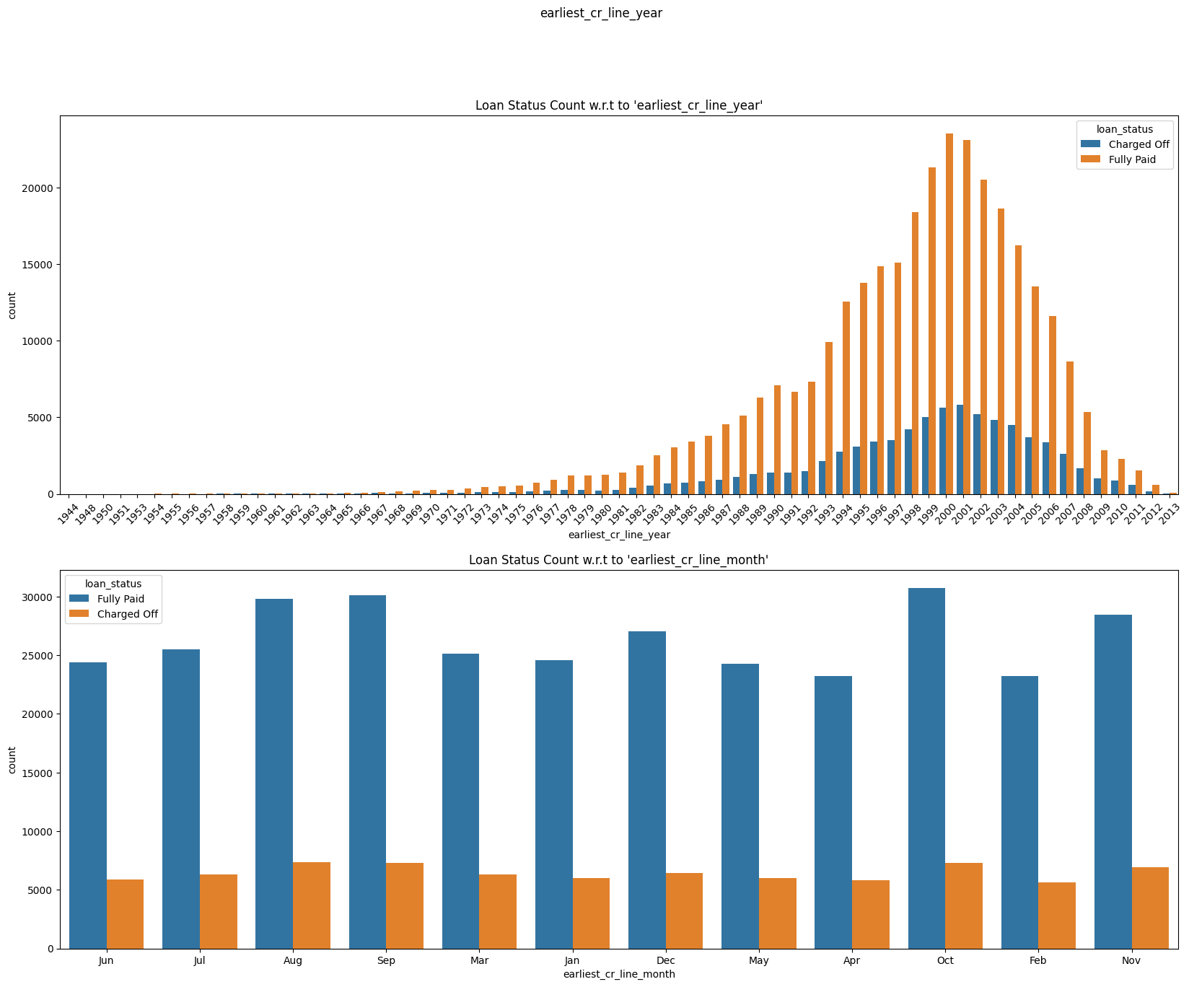

**Figure 2.42**: Loan Status Count w.r.t to 'earliest_cr_line_year' and 'earliest_cr_line_month'

**Insights**

**By Earliest Credit Line Year:**

* **Most Borrowers Began Credit in the 1990s and 2000s:** The largest volume of loans comes from borrowers whose earliest credit lines were opened in 1999–2003. This peak represents people with moderate-to-long credit histories—ideal from a credit risk perspective.
* **Older Credit Histories Less Likely to Default:** Borrowers with the longest credit histories (from the 1960s–1980s) have a higher count of "Fully Paid" loans versus "Charged Off." This indicates that greater credit age may correlate with reliability.
* **Defaults Rise with Total Volume:** Like portfolio averages, default counts increased in line with fully paid loans during the credit expansion of the late 90s/2000s, but the dominance of fully paid loans remains clear, suggesting portfolio risk is generally well-managed.

**By Earliest Credit Line Month:**

* **Month-of-Origin Has No Clear Risk Pattern:** The month in which a borrower first opened credit (from January to December) has no significant impact on default rates. Each month shows similar proportions of fully paid and charged off loans, indicating no seasonality in this variable.
* **Volume is Evenly Distributed by Month:** Loan counts and proportions don’t vary much across months, meaning credit line origination is not a seasonal factor in later loan performance.

**Business Implication:**  
Credit age is a meaningful risk predictor—the longer the history, the better the repayment behavior observed. However, the specific month of credit origination holds little predictive value. Underwriting and risk models should place more weight on credit history length than on minor timing

**2.3.3.15 Distribution of Loan Amount w.r.t Loan Status**

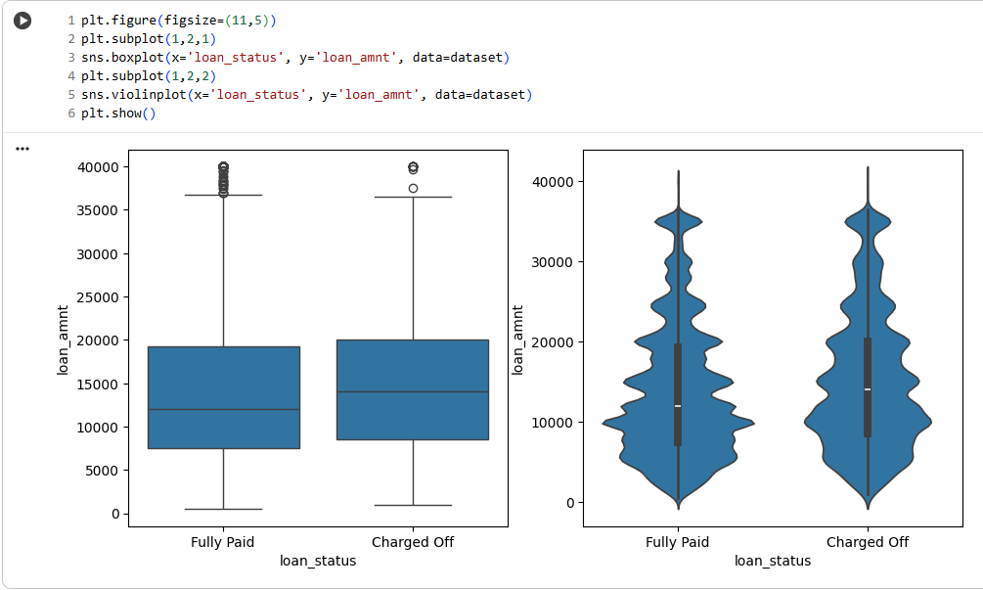

**Figure 2.43**: Distribution of Loan Amount w.r.t Loan Status

The boxplot and violin plot compare the distribution of loan amounts between “Fully Paid” and “Charged Off” loans.

**Insights**

* **Loan Amount Distribution is Similar for Both Outcomes:** Both the boxplot and violin plot show that the overall range and median of loan amounts are similar for "Fully Paid" and "Charged Off" loans. This suggests that loan amount alone isn't the key driver of loan defaults.
* **Outliers and Higher Values Exist for Defaults:** Both groups have outliers (loans much larger than the median), but the “Charged Off” category displays a slightly higher 75th percentile and more upper-end outliers. This hints at a modest tendency for larger loans to face repayment risk, but not as a dominant factor.
* **Majority of Loans Cluster in Moderate Ranges:** Most loans—regardless of status—fall between approximately 5,000 and 20,000 units, indicating typical borrower demand and portfolio focus.

**Business Implication:**  
Loan amount should be used together with other applicant characteristics (grade, income, employment, etc.) for risk modeling. Large loans marginally increase risk but do not exclusively drive default. Portfolio management should adopt multi-factor underwriting and not rely solely on loan size.

**2.3.3.16 Distribution of Interest Rate w.r.t Loan Status**

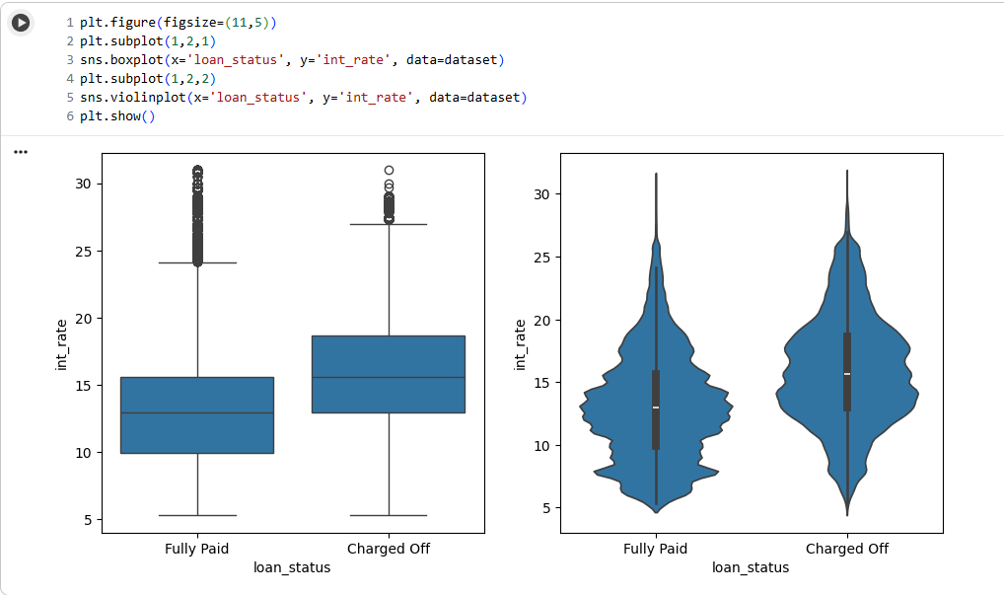

**Figure 2.44**: Distribution of Interest Rate w.r.t Loan Status

The boxplot and violin plot compare distribution of interest rates between “Fully Paid” and “Charged Off” loans.

**Insights**

* **Higher Interest Rates Increase Default Risk:** Loans that are “Charged Off” generally have higher median interest rates compared to “Fully Paid” loans. The violin plot visually confirms this pattern with a wider concentration at the upper end for defaults, signifying that high-rate loans are riskier.
* **Spread and Outliers:** Both groups show a wide range of rates, from about 6% up to 30%+, but the "Charged Off" loans in both plots have more outliers at the upper rate boundary, reinforcing that higher rates coincide with higher risk.
* **Overlap Exists:** Despite the difference in medians and concentration, there is substantial overlap—some loans with low interest rates still default, implying that interest rate alone does not fully determine borrower risk.

**Business Implication:**  
Loan pricing must balance yield with risk: higher rates can offset default losses but may also signal poor underlying credit. Lenders should use rate as one input with other applicant data (grade, income, etc.) for predictive risk modeling and design more supportive structures for high-rate borrowers to lower charge

**2.3.3.17 Distribution of Installments w.r.t Loan Status**

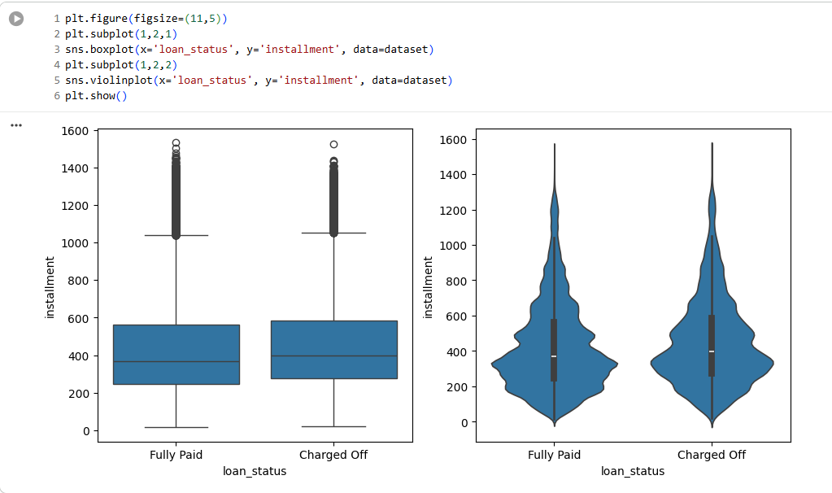

**Figure 2.45**: Distribution of Installments w.r.t Loan Status

The boxplot and violin plot show the distribution of monthly loan installment amounts for “Fully Paid” and “Charged Off” loans.

**Insights**

* **Installment Amount Distribution is Similar Across Outcomes:** The median, interquartile range, and overall shape of installment distributions are similar for fully paid and charged off loans. This indicates that default risk is not strongly driven by the actual installment size alone.
* **Outliers/Extremes Occur in Both Groups:** Both groups contain outliers at the upper boundary (very high monthly payments), but these do not dominate the charged off group, suggesting very large installments are not uniquely related to defaults.
* **Most Installments Cluster at Moderate Values:** The density of both plots is highest in the lower-middle range (approximately 200–600 units), representing standard affordability levels for most of the portfolio.

**Business Implication:**  
Lenders should evaluate installment amounts together with other borrower risk factors (income, grade, term) for risk prediction, rather than rely solely on installment amount. Payment sizing should optimize for borrower affordability but will not by itself guarantee lower charge-off rates.

**2.3.3.18 Distribution of Annual Income w.r.t Loan Status**

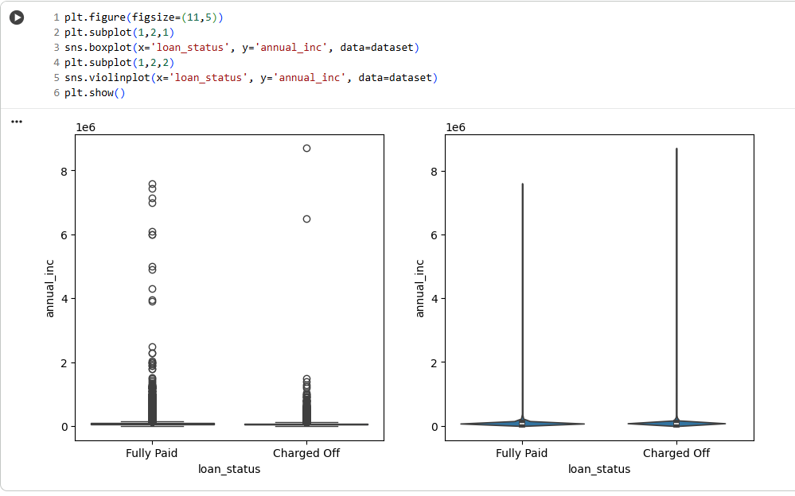

**Figure 2.46**: Distribution of Annual Income w.r.t Loan Status

The boxplot and violin plot show the distribution of annual incomes for “Fully Paid” and “Charged Off” loans.

**Insights**

* **Income Levels Similar Across Groups:** The median and most dense regions for annual income are similar for both fully paid and charged off loans in the violin plot. This indicates that higher income does not guarantee loan repayment success.
* **Presence of Extreme Outliers:** Both groups contain outliers with exceptionally high annual incomes; however, these do not appear to determine repayment success. Most loans cluster in the lower-to-middle income range, with only a few instances of ultra-high incomes.
* **Charge-off Not Prevented by High Income:** The patterns show that even high-income borrowers default, emphasizing that income alone is not a sufficient risk control variable.

**Business Implication:**  
Income should be used alongside other factors (grade, employment, loan amount, interest rate) in risk modeling. While low income may suggest risk, high income does not immunize against default, so a holistic credit policy offers better results.

**2.3.3.19 D.T.I w.r.t Loan Status**

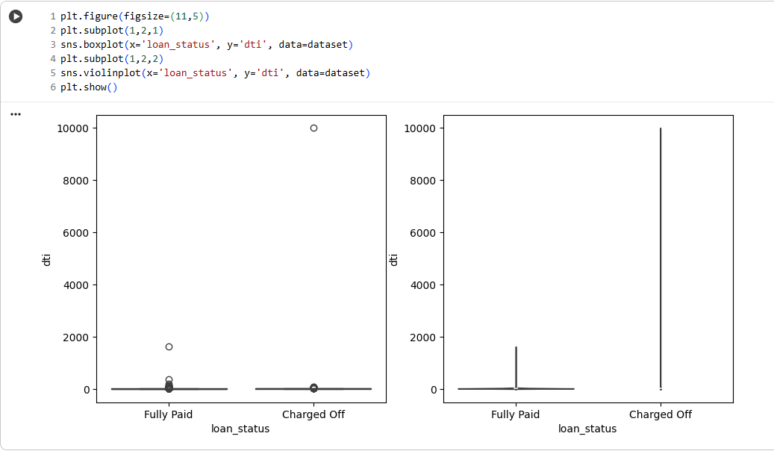

**Figure 2.47**: D.T.I w.r.t Loan Status

The boxplot and violin plot show the distribution of debt-to-income ratios (DTI) for “Fully Paid” and “Charged Off” loans.

**Insights**

* **DTI Levels Cluster Low for Most Borrowers:** Both fully paid and charged off loans show the vast majority of DTI values are near zero or modest levels, suggesting most approved borrowers do not have excessive debt burdens.
* **High-DTI Outliers Occur More in Defaults:** Some charged off loans exhibit extreme DTI outliers, occasionally exceeding 1,000 and even 10,000, compared to fewer high outliers in the fully paid group. This supports the idea that extreme debt loads can increase default risk.
* **DTI Alone is Not a Distinguishing Risk Factor:** For most of the portfolio, the DTI values are similar for both groups, i.e., most defaults do not occur solely because of high DTI.

**Business Implication:**  
DTI is useful for filtering out extreme-risk candidates, but routine lending risk is determined by multiple variables. Lenders should set upper DTI thresholds but combine DTI with other underwriting factors for strong portfolio performance

**2.3.3.20 Open Account w.r.t Loan Status**

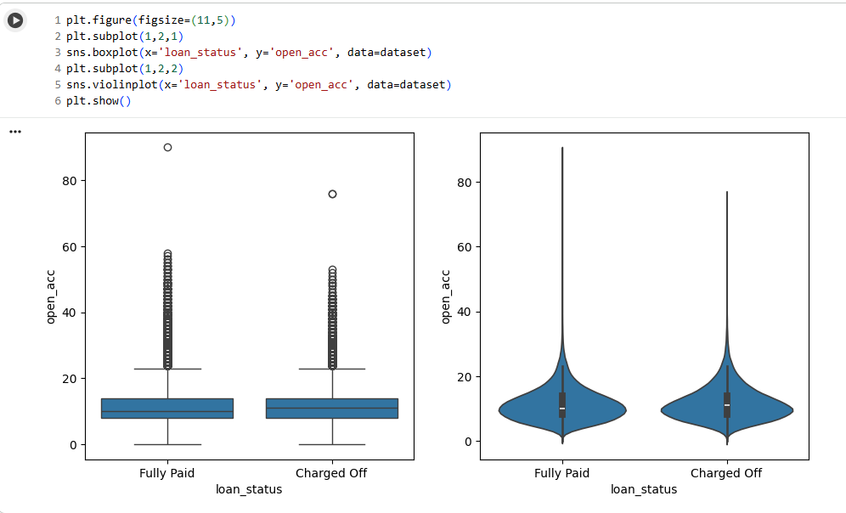

**Figure 2.48**: Open Account w.r.t Loan Status

The boxplot and violin plot show the distribution of the number of open credit accounts (open_acc) for “Fully Paid” and “Charged Off” loans.

**Insights**

* **Credit Activity is Similar Across Groups:** Both boxplot and violin plot show nearly identical distributions for fully paid and charged off loans. The medians and spreads overlap, suggesting number of open accounts alone does not strongly predict default.
* **Most Borrowers Hold Between 5 and 20 Active Accounts:** The data is concentrated in this range for nearly all borrowers, highlighting standard consumer credit activity in the portfolio.
* **Outliers are Present but Not Dominant:** Some individuals have notably high numbers of open accounts (over 40 or even 80), but these outliers are rare for both groups and do not strongly affect the overall risk pattern.

**Business Implication:**  
While credit activity measurement is valuable for profile completeness, number of open accounts should be considered in combination with total balances, repayment history, and other variables for effective credit scoring and risk controls

**2.3.3.21 Public Record w.r.t Loan Status**

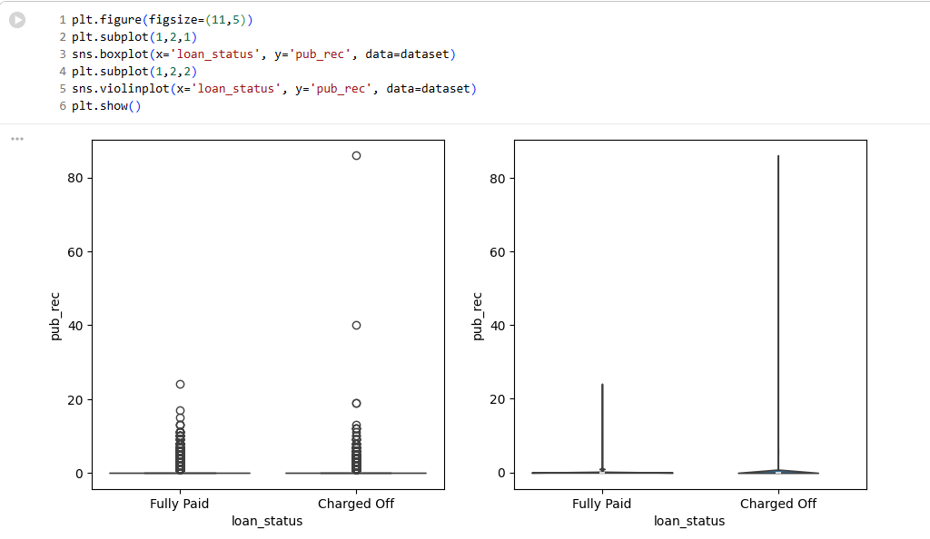

**Figure 2.49**: Public Record w.r.t Loan Status

The boxplot and violin plot show the distribution of public record counts (pub_rec) for “Fully Paid” and “Charged Off” loans.

**Insights**

* **Most Borrowers Have Zero Public Records:** Both groups overwhelmingly cluster at zero public records, indicating most applicants have clean legal/credit histories regardless of loan outcome.
* **Outliers are Strongly Associated with Charged Off Loans:** The charged off group contains substantially more outliers with higher public record counts (up to about 80), compared to very few outliers among fully paid loans. This suggests that applicants with prior negative public records are more at risk of defaulting.
* **Pattern is Consistent Across Distribution:** As seen in the violin plot, the shaft (core distribution) is almost entirely near zero for fully paid loans, and slightly more spread out with outliers at the risky tail for charged offs.

**Business Implication:**  
Lenders should strongly consider public record history during risk assessment and underwriting. Zero or very low public records correlate with high repayment success, whereas higher counts signal elevated risk and may require higher pricing, stricter conditions, or outright rejection depending

**2.3.3.22 Revolving Balance w.r.t Loan Status**

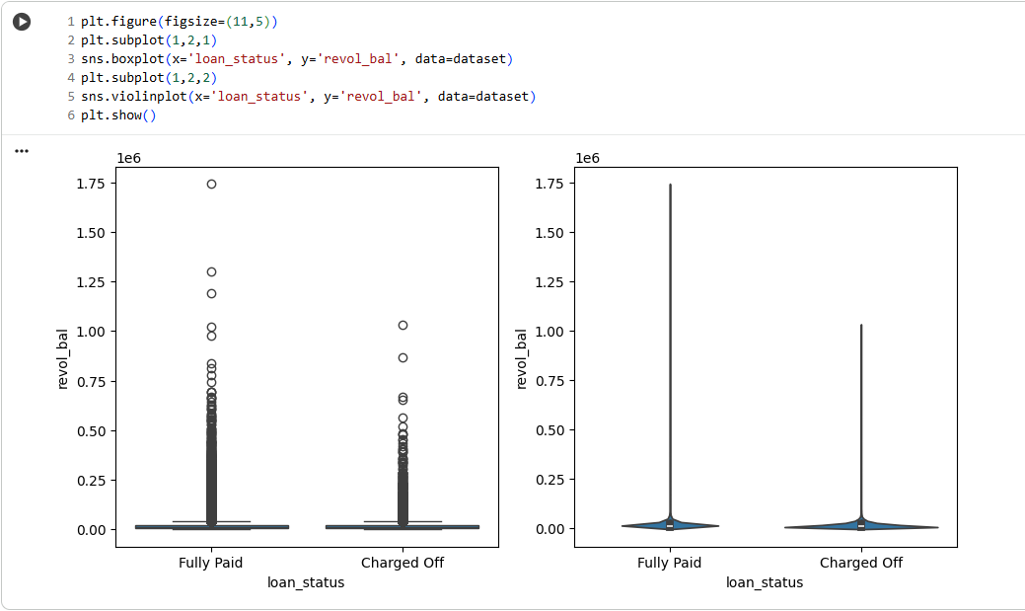

**Figure 2.50**: Revolving Balance w.r.t Loan Status

The boxplot and violin plot display the distribution of revolving credit balances (revol_bal) for “Fully Paid” and “Charged Off” loans.

**Insights**

* **Majority Have Modest Balances:** Most borrowers in both groups have relatively low revolving balances, with the bulk of the data concentrated at the lower end of the axis in both the box and violin plots.
* **High-Balance Outliers and Defaults:** Both groups exhibit outliers with very large revolving balances, but these outliers are somewhat more prominent among “Charged Off” loans. This suggests that elevated credit utilization can be associated with slightly increased risk of default, though not exclusively so.
* **Distribution Overlaps Heavily:** Most borrowers, regardless of repayment outcome, share a similar distribution of revolving balances. High balances increase risk but many high-balance borrowers also repay successfully.

**Business Implication:**  
Revolving balance is a useful risk signal, especially for flagging outliers, but is not a stand-alone indicator of default. Lenders should use it as part of a broader risk model that includes payment history, grade, DTI, and income

**2.3.3.23 Revolving Line Utilization Rate w.r.t Loan Status**

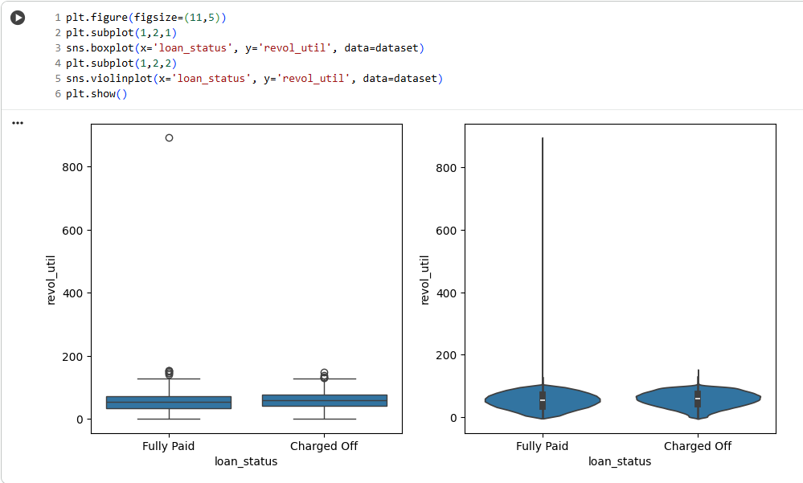

**Figure 2.51**: Revolving Line Utilization Rate w.r.t Loan Status

The boxplot and violin plot display the distribution of revolving utilization rates (revol_util) for “Fully Paid” and “Charged Off” loans.

**Insights**

* **Median Utilization is Higher for Defaults:** Both plots show that “Charged Off” loans have a slightly higher median and more density at the upper end of revolving utilization compared to “Fully Paid” loans. This means borrowers using a larger share of their available credit are more likely to default.
* **Extreme Outliers and High Risk:** Outliers with very high utilization (above 300%) are more common in the charged off group. Extremely high utilization is a strong warning sign for default risk.
* **Most Borrowers Cluster Below 100%:** The majority of loans in both groups show utilization well under 100%, but the density spreads wider for defaults.

**Business Implication:**  
Revolving utilization is a valuable feature for risk prediction: the likelihood of default increases as borrowers max out their available credit. Lenders should monitor high utilization closely and may consider adjusted pricing, lower limits, or interventions to manage risk.

**2.3.3.24 Total No of Credit Lines w.r.t Loan Status**

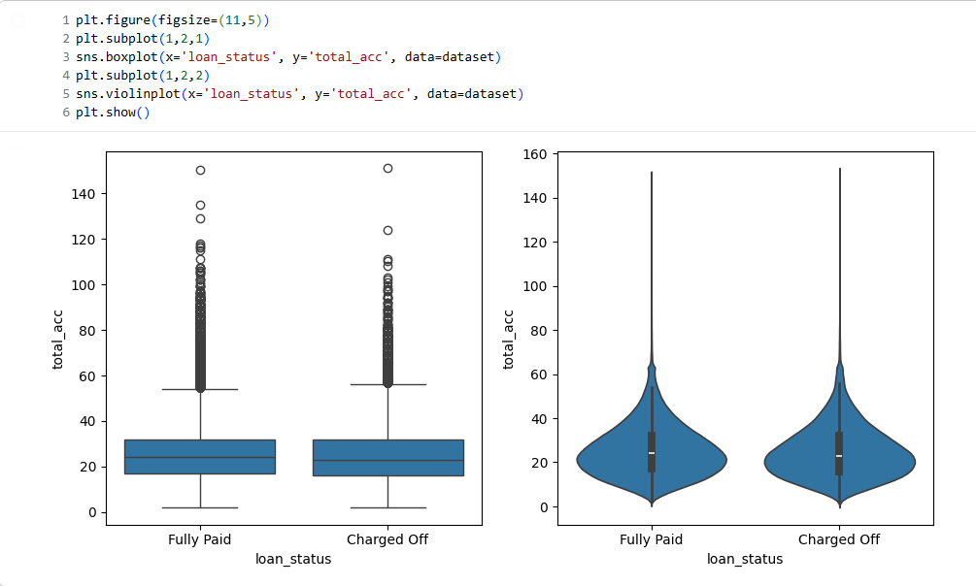

**Figure 2.52**: Total No of Credit Lines w.r.t Loan Status

The boxplot and violin plot show the distribution of total credit accounts (total_acc) for “Fully Paid” and “Charged Off” loans.

**Insights**

* **Total Credit Accounts Are Similar for Both Groups:** Both fully paid and charged off loans have very similar distributions for total credit accounts. The medians, interquartile ranges, and the main body of the violin plots overlap almost entirely, indicating that the number of accounts alone does not strongly differentiate between repayment and default outcomes.
* **Majority Cluster Around 20–40 Accounts:** Most borrowers in the dataset have between 20 and 40 total accounts, reflecting standard consumer activity in the credit market.
* **High-Account Outliers Do Not Uniquely Signal Risk:** Outliers with 100+ accounts exist in both groups, but do not overwhelmingly predict default, suggesting additional context (like payment behavior or account types) is needed for risk assessment.

**Business Implication:**  
Total number of credit accounts should be used as one piece of the risk profile puzzle, but on its own it does not provide meaningful predictive power for default. Lenders should combine this feature with utilization, recent delinquencies, and other behavioral indicators for accurate credit risk modeling.

**2.3.3.25 Total No of Mortgage Accounts w.r.t Loan Status**

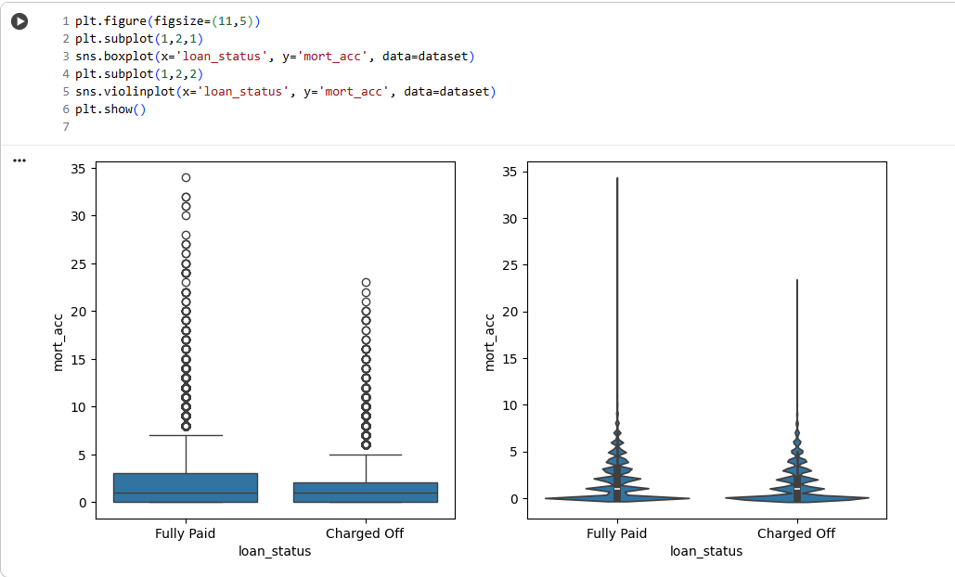

**Figure 2.53**: Total No of Mortgage Accounts w.r.t Loan Status

The boxplot and violin plot display the number of open mortgage accounts (mort_acc) for “Fully Paid” and “Charged Off” loans.

**Insights**

* **Distribution is Similar Across Loan Status:** Both fully paid and charged off loans show heavy clustering at low values (0–3 mortgage accounts), with a median close to 1 for both. This suggests that simply having a mortgage or a small number of mortgages is typical and not alone a high-risk factor.
* **Outliers Are More Numerous for Fully Paid:** Interestingly, there are more extreme outliers—borrowers with more than 10 mortgage accounts—among the fully paid group than among defaults. This may indicate that those with many mortgages are experienced property holders, managing their credit successfully.
* **Defaults Not Driven by Mortgage Account Count:** The violin plots confirm that having a higher number of open mortgages does not distinctly increase risk of default in this portfolio.

**Business Implication:**  
Number of open mortgage accounts is not a strong standalone predictor of default. For lenders, this suggests that mortgage account count should not be overly weighted in credit scoring without considering repayment history, property value, and overall

**2.3.3.26 Total No of Public Record Bankruptcies w.r.t Loan Status**

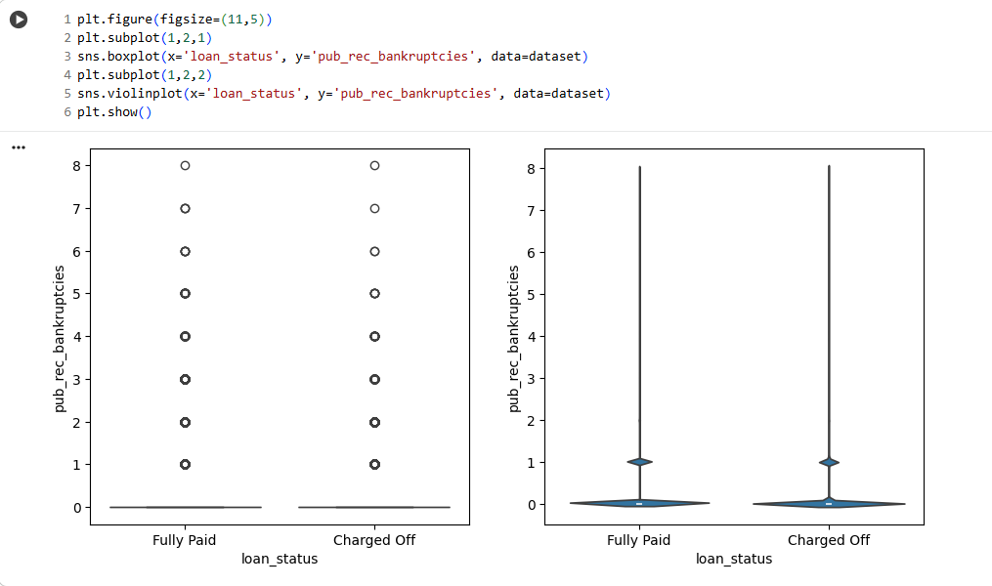

**Figure 2.54**: Total No of Public Record Bankruptcies w.r.t Loan Status

The boxplot and violin plot illustrate the distribution of public record bankruptcies for “Fully Paid” and “Charged Off” loans.

**Insights**

* **Most Borrowers Have No Bankruptcies:** Both loan outcome groups overwhelmingly cluster at zero on the number of public record bankruptcies, indicating the majority of borrowers have not experienced bankruptcy, no matter their eventual outcome.
* **Multiple Bankruptcies Indicate High Risk:** The charged off group shows a greater presence of outliers who’ve had multiple bankruptcies, up to 8. Such borrowers, though few, have a noticeably elevated risk of default, suggesting bankruptcy history is a major warning flag.
* **Pattern Holds Across Both Plots:** The violin plot confirms heavy concentration at zero for both, but charge offs display a slightly heavier tail with higher bankruptcy counts.

**Business Implication:**  
Public record bankruptcies, especially repeat instances, are an important risk indicator in lending. Lenders should review or restrict applications with one or more bankruptcies, or require higher rates, collateral, or special approval. Zero bankruptcies remains a key hallmark of reliable borrowers

**2.3.4 Multivariate Analysis**

**2.3.4.1 Pair Plot of All Numerical variables**

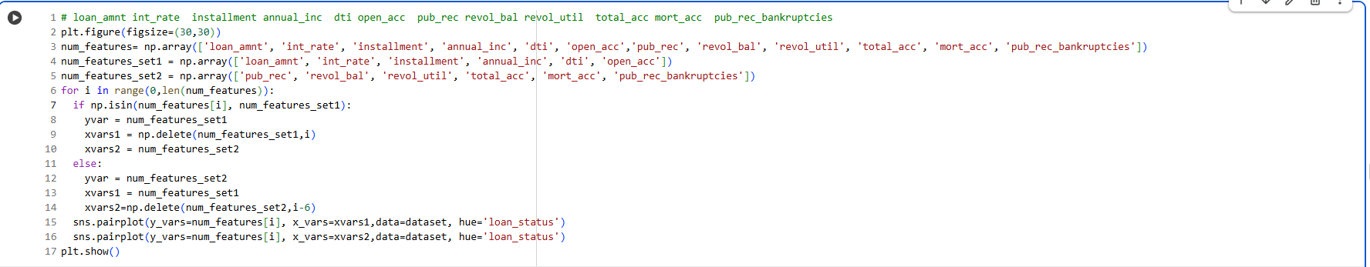

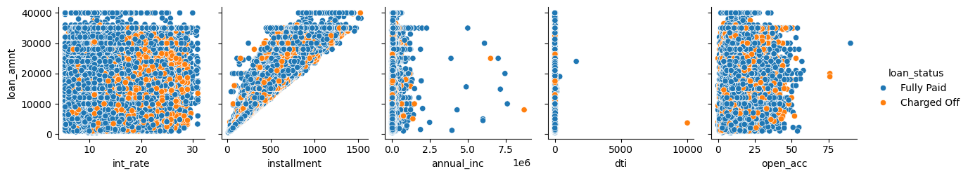

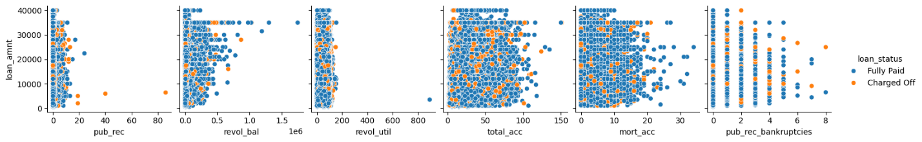

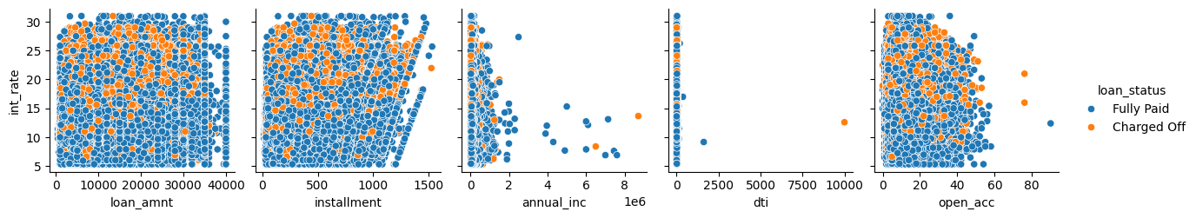

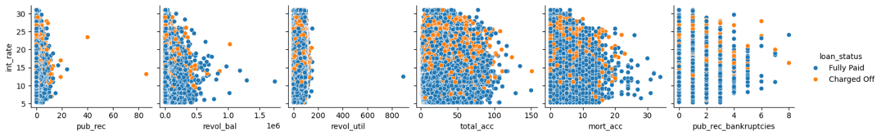

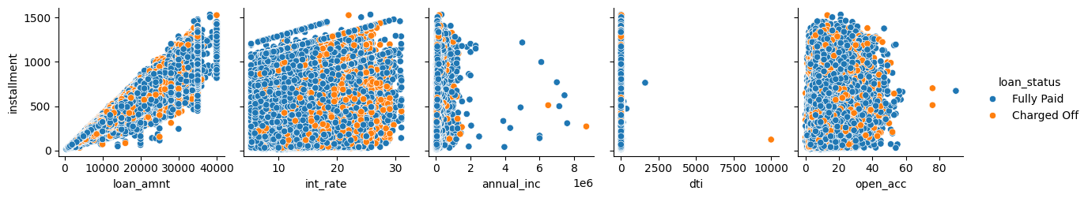

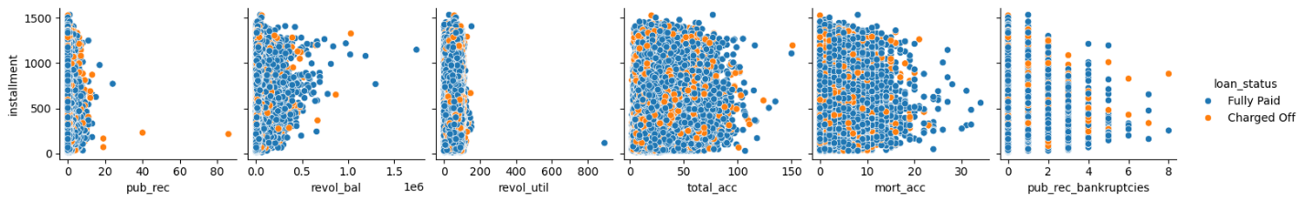

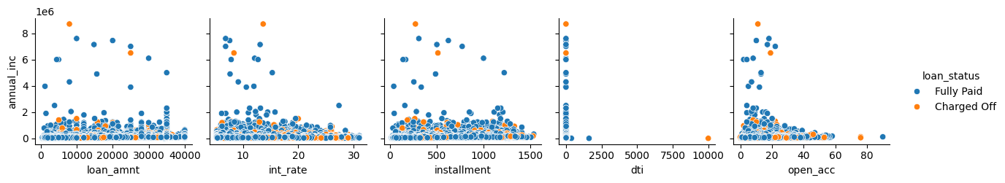

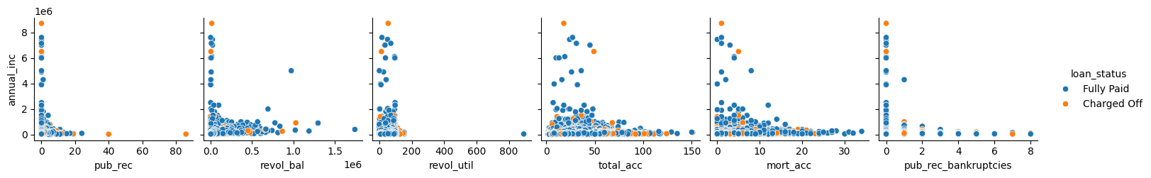

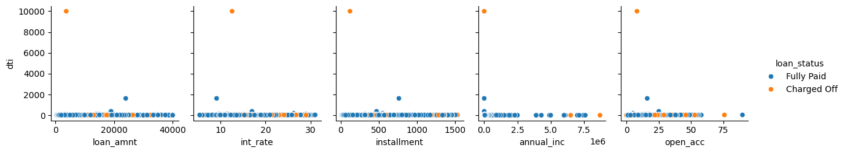

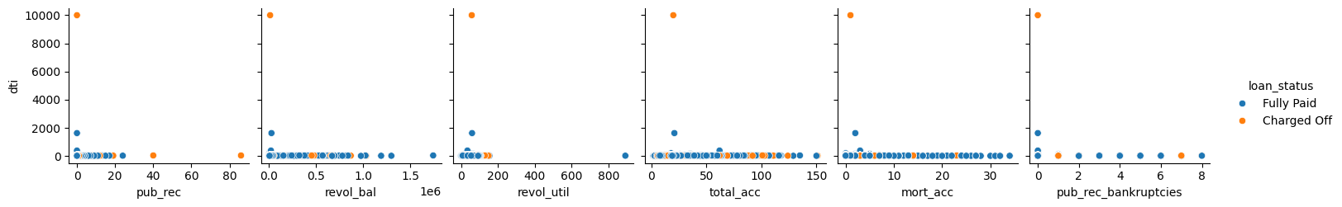

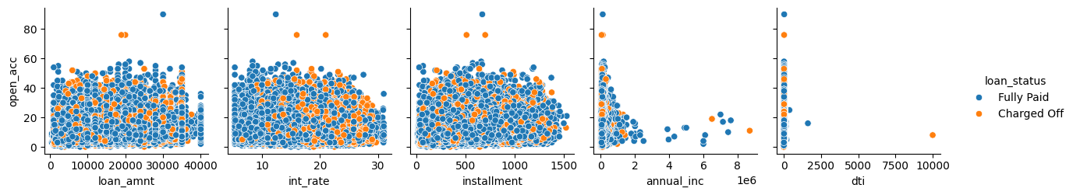

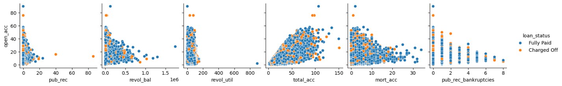

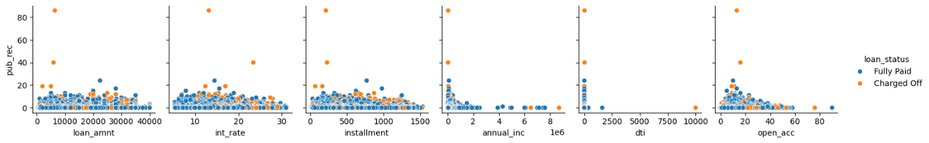

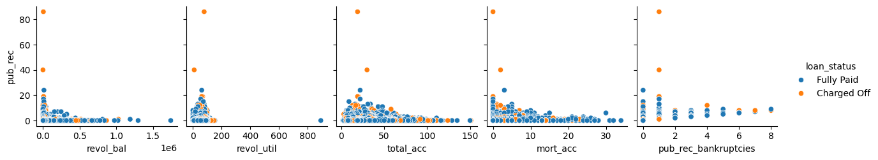

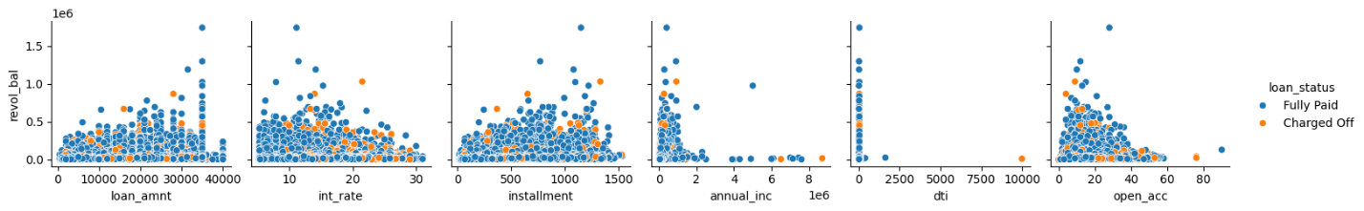

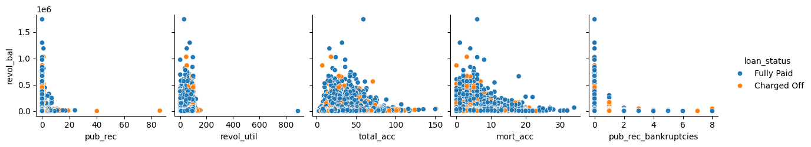

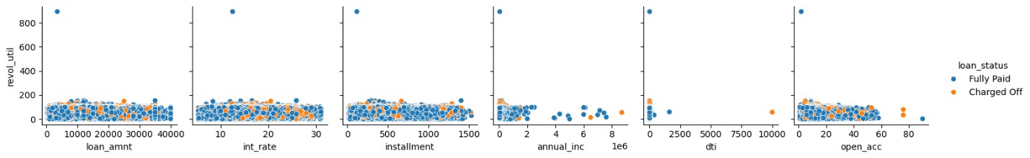

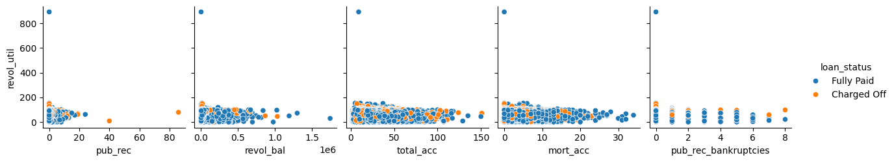

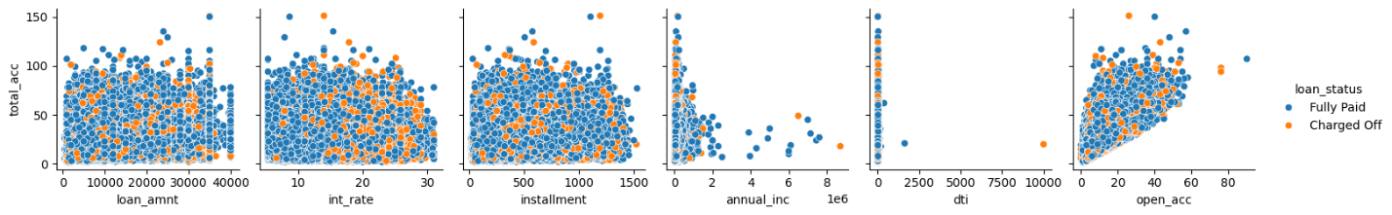

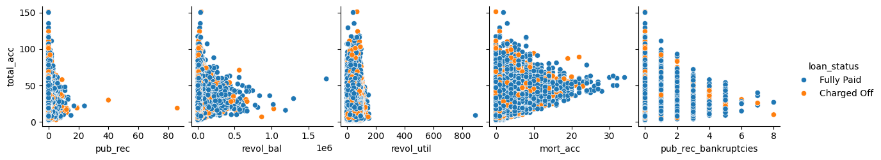

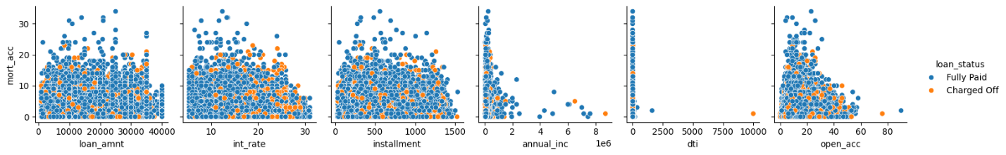

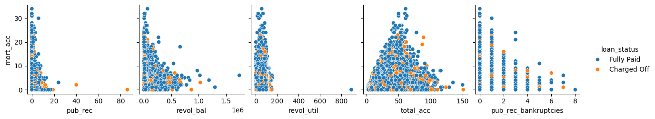

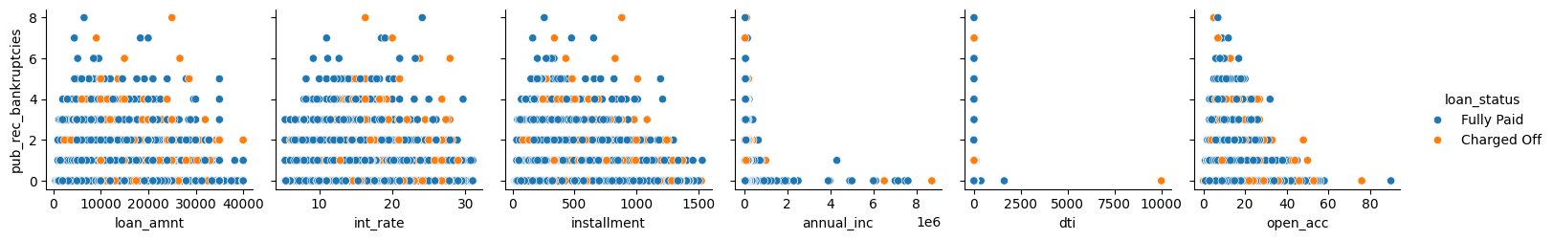

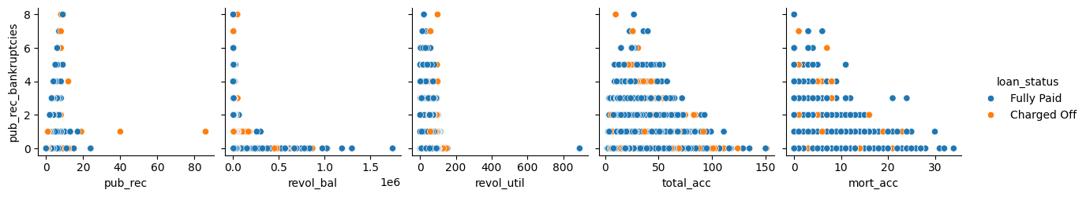

**Figure 2.55**: Pair Plot of All Numerical variables

**2.3.4.2 Correlation plot of all Numerical Variables**

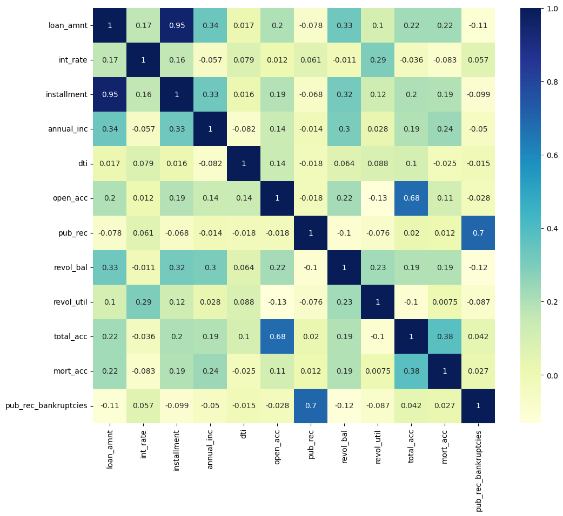

**Figure 2.56**: Correlation plot of all Numerical Variables

**Insights**

* **Strongest Correlations:**
  + loan_amnt and installment are extremely highly correlated (0.95), as expected since a larger loan usually means a bigger monthly payment.
  + pub_rec and pub_rec_bankruptcies are also quite highly correlated (0.70), indicating borrowers with more public records are also more likely to have bankruptcies.
  + open_acc and total_acc (0.68), as well as total_acc and mort_acc (0.38), are strongly related, reflecting the natural connection between total, open, and mortgage accounts.
* **Moderate Relationships:**
  + loan_amnt has a moderate correlation with revol_bal (0.33) and annual_inc (0.34), suggesting higher earners and those with bigger credit balances take larger loans.
  + revol_util is moderately correlated with int_rate (0.29) and revol_bal (0.23), showing that higher card utilization can also mean higher rates and balances.
* **Weak or Negligible Correlations:**
  + Most other relationships are weak (absolute value below 0.20), such as those involving dti, mort_acc, and annual_inc, indicating these variables provide distinct information for modeling and are not strongly redundant.
  + There are slight negative correlations (e.g., loan_amnt and pub_rec: -0.078), but these are very minor.

**Business Implications:**

* The strongest correlations are mostly among operationally or conceptually linked fields (like loan and payment size).
* Most variables provide relatively independent signals for risk, justifying their inclusion in multivariate loan default or risk scoring models.
* Strong links between public records and bankruptcies highlight the importance of legal/credit history in risk assessment.

**2.3.5 Data Pre-Processing**

**2.3.5.1 Removing Highly Correlated Features**

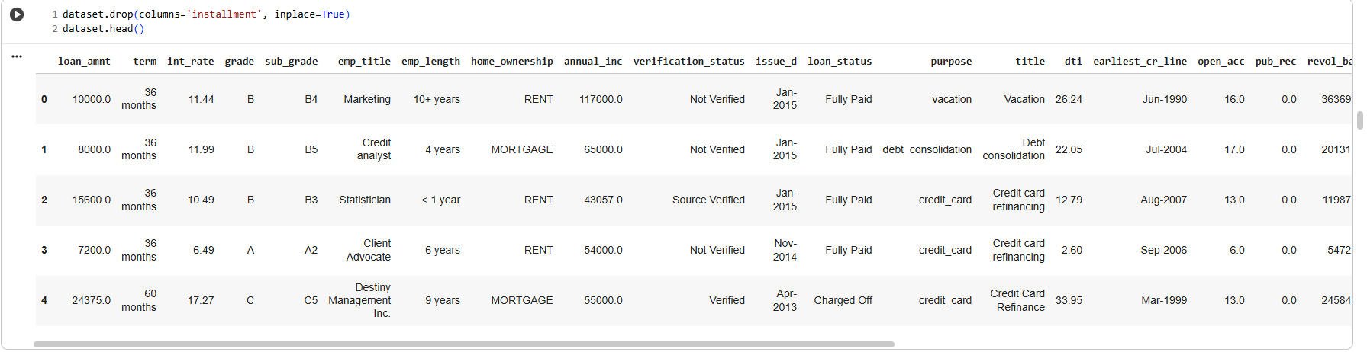

**Figure 2.57**: Removing Highly Correlated Features

**2.3.5.2 Null Values Treatment**

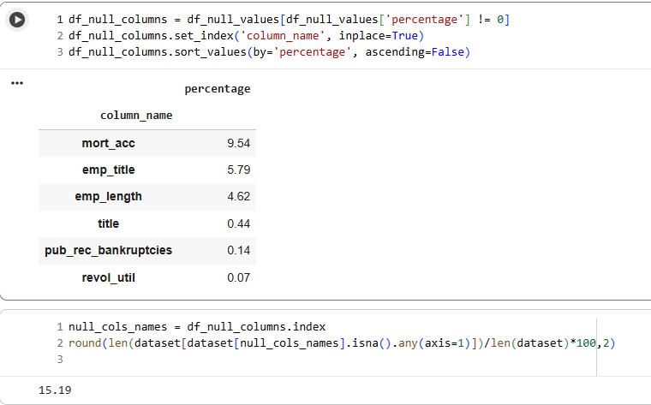

**Figure 2.58**: Null Values Treatment

**Insights**

* **Columns with Null Values:**  
  The columns with missing data, in order of highest to lowest, are:
  + mort_acc (9.54%)
  + emp_title (5.79%)
  + emp_length (4.62%)
  + title (0.44%)
  + pub_rec_bankruptcies (0.14%)
  + revol_util (0.07%)
* **Major Null Concentration:**  
  Most missing data comes from just three columns: mort_acc, emp_title, and emp_length. These are likely related to employment and mortgage reporting.
* **Low Null Rates in Other Columns:**  
  Columns like title, pub_rec_bankruptcies, and revol_util have very small percentages of missing data, indicating minor and likely non-disruptive gaps in those features.
* **Overall Row Impact:**  
  About 15.2% of all rows have at least one missing value across these columns. This is a substantial figure—dropping all rows with any nulls would significantly reduce your dataset.

**2.3.5.3 Log Transformation**



**Figure 2.59**: Log Transformation

**Insights**

* **Features Transformed:**  
  The features being log-transformed (np.log1p) are:
  + annual_inc (annual income)
  + dti (debt-to-income ratio)
  + pub_rec (public records count)
  + revol_bal (revolving balance)
  + pub_rec_bankruptcies (public record bankruptcies)
* **Purpose of Log Transformation:**
  + These features often have distributions with heavy tails or extreme outliers.
  + Applying np.log1p(x) (which is log(x + 1)) reduces the influence of large values, making the data more normally distributed and less sensitive to outliers.
  + This improves the stability and performance of many machine learning algorithms, particularly those that assume input features are roughly Gaussian or that can be distorted by a few large numbers.
* **Business/Data Science Benefit:**
  + By log-scaling, you help algorithms such as linear/logistic regression, SVMs, and neural networks learn more efficiently from these variables.
  + This can lead to better risk predictions, fairer contributions of each feature, and more robust generalization—especially important in credit and risk modeling where income, debt, and bankruptcy counts can range over several orders of magnitude

**2.3.5.4 Outlier Treatment**

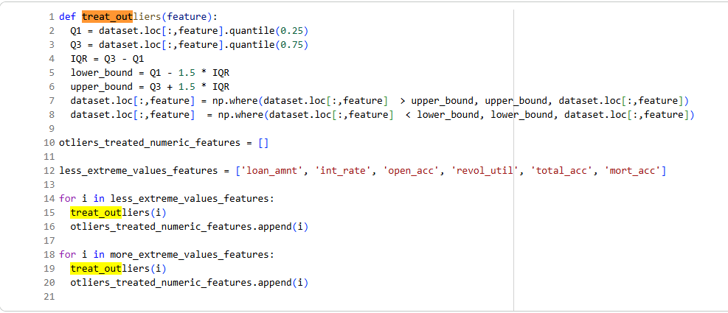

**Figure 2.60**: Outlier Treatment

**Insights**

* **Outlier Treatment Logic:**
  + For each feature, the 25th (Q1) and 75th (Q3) percentiles are calculated.
  + The IQR is computed as Q3−Q1*Q*3−*Q*1.
  + Any value below Q1−1.5×IQR*Q*1−1.5×*IQR* is set to that lower bound.
  + Any value above Q3+1.5×IQR*Q*3+1.5×*IQR* is set to that upper bound.
  + The function is applied to two lists of features: one with less extreme values and another with more extreme/skewed features (possibly after a log transformation).
* **Purpose & Benefits:**
  + This method "winsorizes" numerical columns, ensuring extreme values do not disproportionately influence model training or analysis.
  + It is particularly effective for features like loan amount, interest rate, account counts, and utilization rates—variables where rare extreme values could distort statistics or algorithm learning.
  + By applying this consistently, the process increases statistical robustness and helps machine learning models generalize better by reducing variance and focusing on the "core" distribution.

**2.3.5.5 Handling 'address' Feature values Inconsistency**

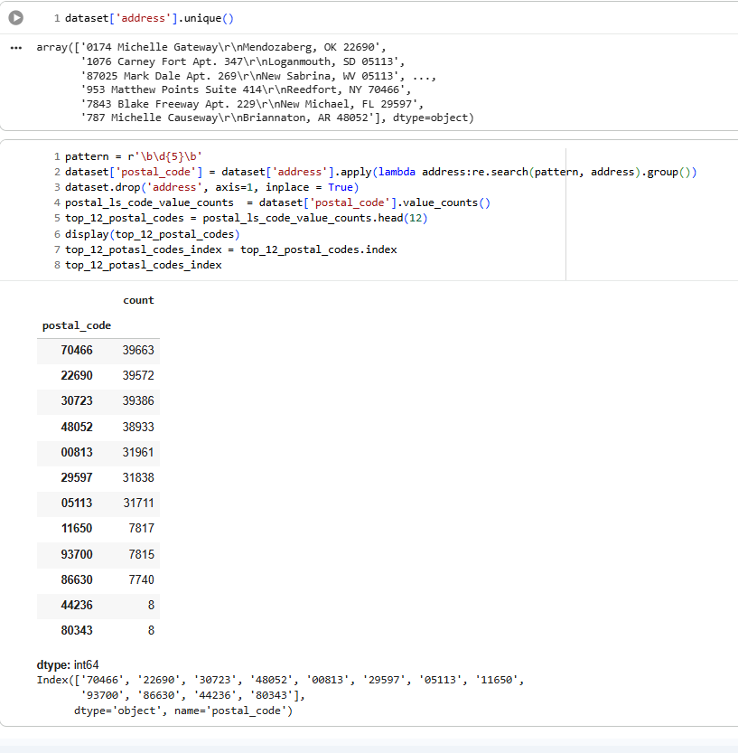

**Figure 2.61**: Handling 'address' Feature values Inconsistency

**Insights**

* **Postal Code Extraction:**  
  Postal codes are successfully extracted from the heterogeneous address strings using a regex search for 5-digit patterns, standardizing geographic information for analysis.
* **Top Postal Codes by Loan Presence:**  
  The leading postal codes in the dataset by count are:
  + 70466, 22690, 30723, 48052, 00813, 29597, 05113, 11650, 93700, 86630, 44236, and 80343.
  + These top codes each have sizeable numbers of loans, with the highest (70466) having almost 40,000 records.
* **Volume Concentration:**  
  The loan dataset is highly concentrated in these top postal codes—each of the top seven has over 30,000 records, while the last few have single-digit presence. This indicates significant lending activity in particular regions.
* **Preparedness for Regional Analysis:**  
  By extracting and aggregating loan counts by postal code, the groundwork is laid for geographic risk/reward analysis, identifying lending hot-spots, and facilitating ZIP-level targeting for risk management, marketing, or resource allocation.

**2.3.5.6 Handling ‘title’ Feature values Inconsistency**

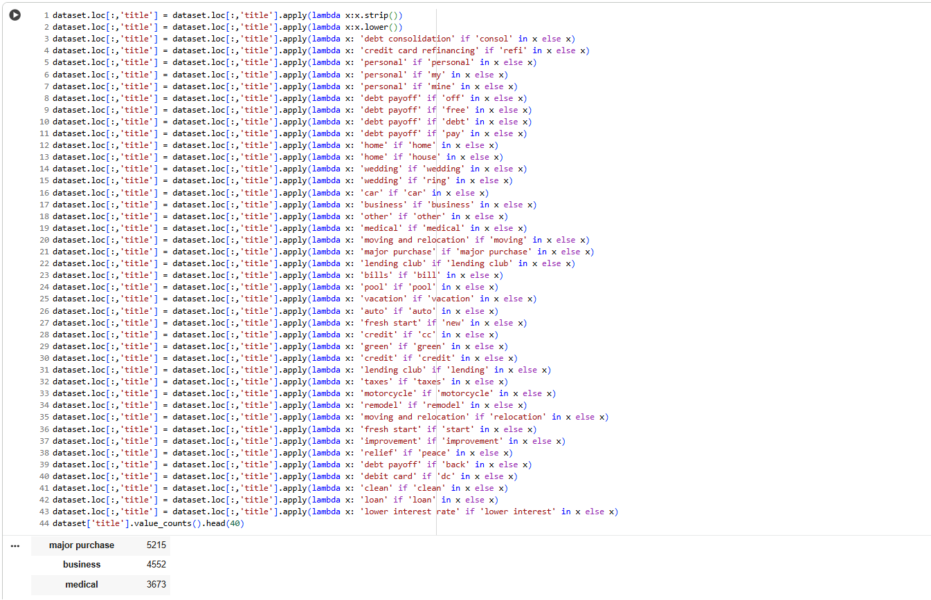

**Figure 2.62**: Handling ‘title Feature values Inconsistency

**Insights**

* **Systematic Cleaning & Standardization:**
  + The “title” feature (self-reported loan purpose) is first stripped of whitespace and converted to lowercase.
  + Then, nearly 45 mappings are performed. Each mapping checks for keywords (like "debt", "car", "medical", "business", etc.) and standardizes titles accordingly.
  + This drastically reduces noise and text variation, clustering thousands of loan titles into core, analyzable categories.
* **Top Categories by Loan Purpose:**
  + “major purchase,” “business,” and “medical” are among the most common loan purposes, with counts of 5215, 4552, and 3673 respectively.
  + Such grouping makes the analysis of loan purpose statistics reliable and repeatable by overcoming free-text inconsistencies.
* **Data Preparation Impact:**
  + Standardized titles enable robust aggregation, visualization, and modeling of loan purposes, greatly improving insights derived from the dataset.
  + Rare or misspelled entries are less likely to dilute analyses since they are captured by the catch-all logic in the mapping.

**2.3.6 Sanity check after preprocessing**

**2.3.6.1 Null values**

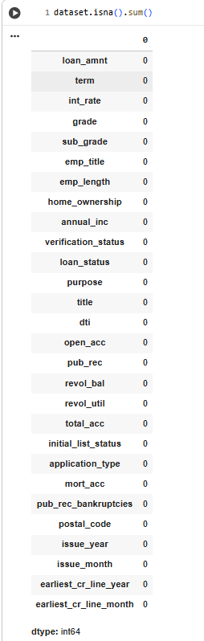

**Figure 2.63**: Systematic Cleaning & Standardization

**Insights**

Missing values were handled appropriately to minimize their impact on model accuracy. Techniques such as [imputation or deletion] were used based on the nature and distribution of the missing data.

**2.3.6.2 Outliers**

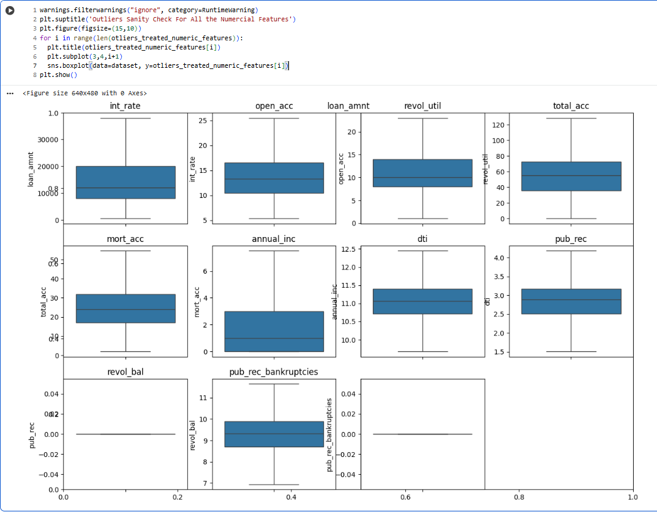

**Figure 2.64**: Outliers

**Insights**

Outliers are identified and appropriately handled to prevent skewing the model’s performance.

**2.3.7 Data Preprocessing for Modelling**

**2.3.7.1 Code for Data Preprocessing for Modelling**

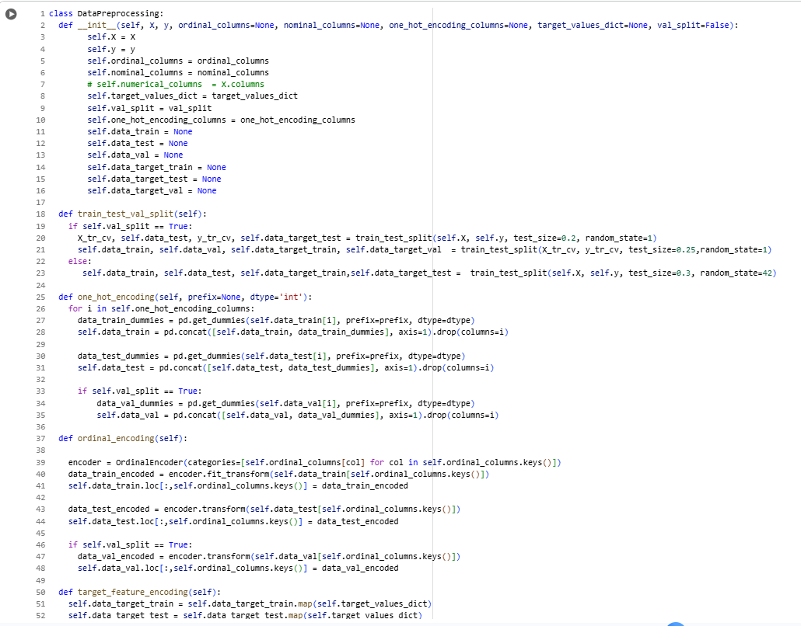

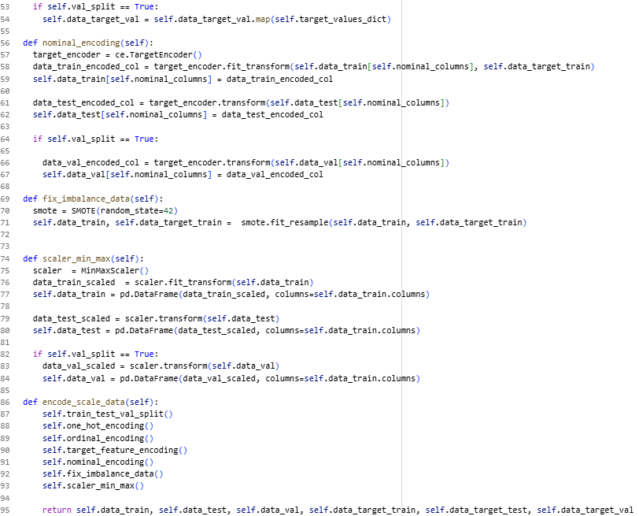

**Figure 2.65**: Code for Data Preprocessing for Modelling

**2.3.7.2 Splitting (Train,Test), Encoding, Balancing and Scaling the Data**

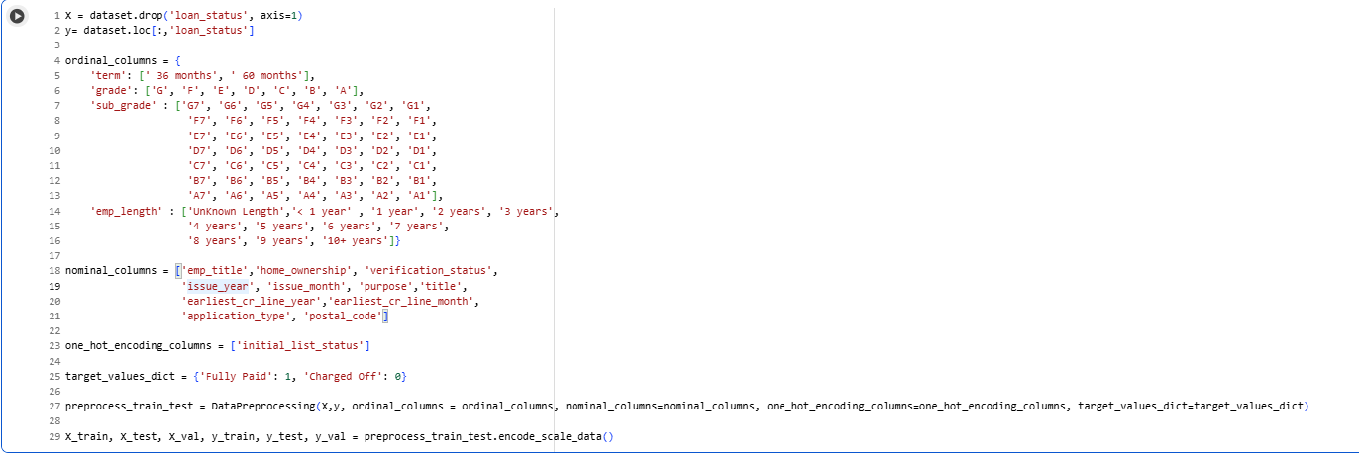

**Figure 2.66**: Splitting (Train,Test), Encoding, Balancing and Scaling the Data

**Insights**

* **Flexible and Modular Design:**
  + The DataPreprocessing class allows users to specify ordinal, nominal, and one-hot encoding columns, as well as whether to include a validation split and a mapping for target values.
  + Core preprocessing steps—splitting, encoding (one-hot, ordinal, nominal), missing value imputation, feature scaling, and imbalanced data handling—are separated by clear methods that can be chained or toggled as needed.
* **Robust Encoding Procedures:**
  + Ordinal, nominal, and one-hot encoding are supported, each handled in their own method for both training and (optionally) validation/test data. This is crucial for high-cardinality, mixed-type datasets often found in financial/credit data.
  + Handles unseen categories in validation/test by using fitted encoders from training only.
* **Target Variable and Class Imbalance Handling:**
  + Target variables can be mapped (crucial for binary/multiclass conversions or label harmonization).
  + Includes a built-in method for balancing classes using SMOTE (Synthetic Minority Oversampling Technique), which is commonly required for datasets with imbalanced target classes (i.e., much fewer defaults than fully paid loans).
* **Scaling and Data Integrity:**
  + Features are scaled with MinMaxScaler (0–1 normalization), ensuring all numeric inputs are compatible for most machine learning models.
  + Careful management of data splits and restoration of DataFrame structure after transforms preserves data integrity and usability for downstream modeling.

**2.3.8 Sanity Check After Data Preprocessing for Modelling**

**2.3.8.1 Shape of the data after spliting**

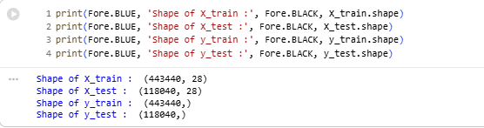

**Figure 2.67**: Shape of the data after spliting

**Insights:** Data has splitted into train and test

**2.3.8.2 Loan Status Proportion Check After SMOTE**

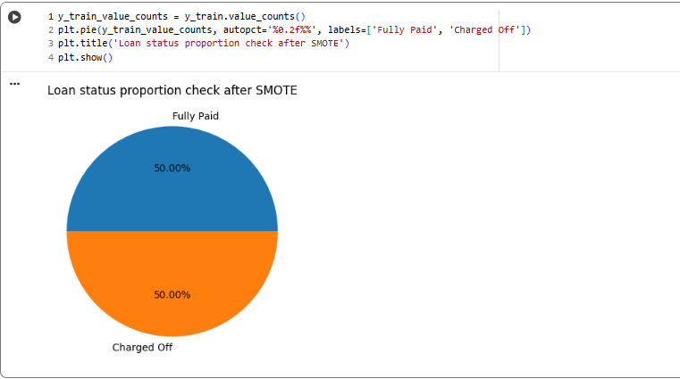

**Figure 2.68**: Loan Status Proportion Check After SMOTE

**Insights:** After applying the SMOTE technique, the data is balanced

**2.3.8.3 Encoded and Scaled Data**

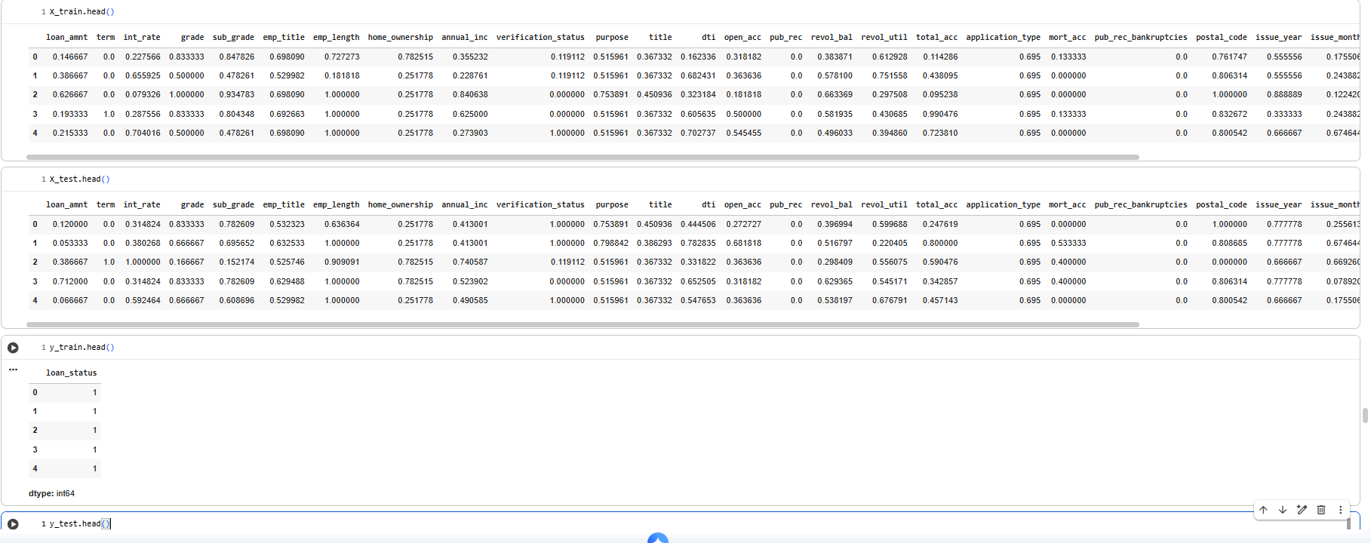

**Figure 2.69**: Encoded and Scaled Data

**Insights:** Data encoded and scaled properly.

**2.3.9 Modelling Using Logistic Regression**

**2.3.9.1 Detecting Multicollinearity with VIF**

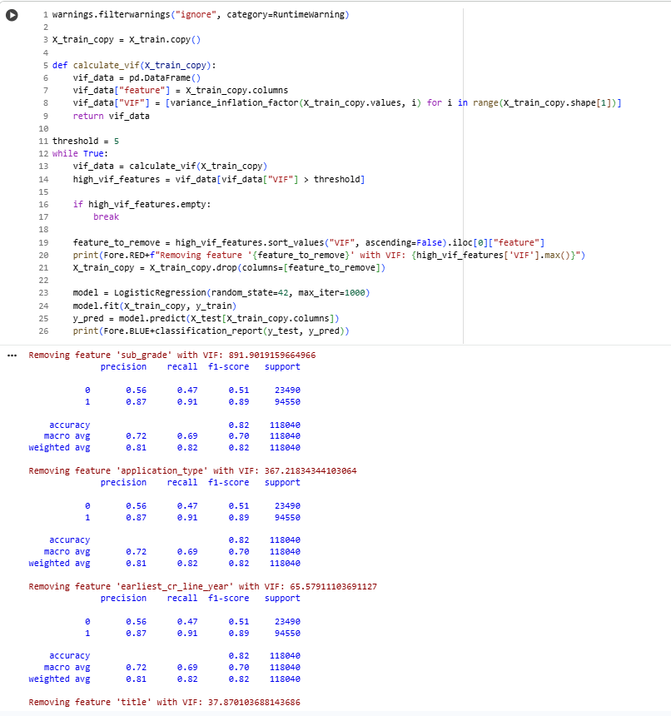

**Figure 2.70**: Detecting Multicollinearity with VIF

**Insights**

Following are the Features that can be dropped

* sub_grade
* application_type
* earliest_cr_line_year
* title
* grade
* issue_year
* emp_title
* revol_bal
* annual_inc
* purpose
* open_acc
* *dti
* home_ownership

Above features have high multicolinearity.We can clearly see that the precision, recall accuracy values are better after dropping the above features.

**2.3.9.2 Splitting the data into 3 parts (train, test and validation)**



**Figure 2.71**: Splitting the data into 3 parts (train, test and validation)

**2.3.9.3 Regularization after dropping the redundant features**

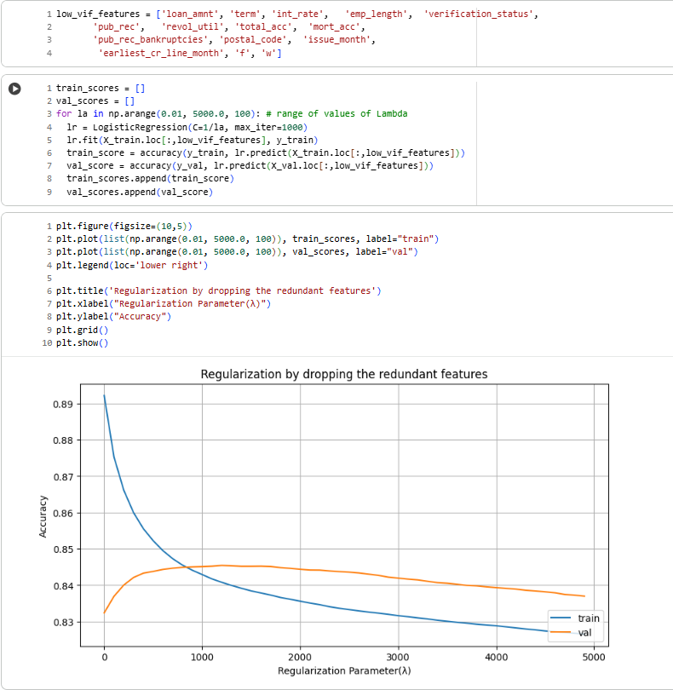

**Figure 2.72**: Regularization after dropping the redundant features

**Insights**

* **Low VIF Features:**  
  Specific features (low_vif_features) with low multicollinearity (Variance Inflation Factor) are selected, reducing redundancy and potential overfitting in the model.
* **Regularization Tuning:**  
  The regularization parameter λ*λ* (inversely related to C in scikit-learn's LogisticRegression) is swept from 0.01 to 5000, exploring the effect from no regularization (high model complexity) to strong regularization (simple model).
* **Accuracy vs. Regularization Curve:**
  + As λ*λ* increases from very low values, the training accuracy starts high (~0.89) and drops as regularization gets stronger; this is a sign that the model is less able to “memorize” the training data.
  + Validation (val) accuracy initially increases and then flattens out or slightly decreases, peaking around moderate regularization strengths. This classic U-shape shows that regularization helps generalization by avoiding overfitting but too much regularization can underfit.
* **Optimal Regularization:**  
  The plot suggests the highest validation accuracy (model generalization) occurs at an intermediate value of λ*λ*, not at the extremes. This is typical for well-regularized models.

**2.3.9.4 Model Training**

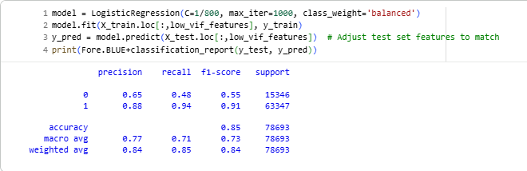

**Figure 2.73**: Model Training

**Insights**

* **Class 1 (Likely "Fully Paid" Loans) Performance:**
  + Precision: 0.88 (model is very accurate when it predicts class 1)
  + Recall: 0.94 (almost all real class 1 loans are caught)
  + F1-score: 0.91 (strong overall; F1 combines precision/recall)
* **Class 0 (Likely "Charged Off" Loans) Performance:**
  + Precision: 0.65 (if the model says "charge off," it's right 65% of the time)
  + Recall: 0.48 (it only finds less than half of all true charge offs)
  + F1-score: 0.55 (room for improvement, especially in recall)
* **Overall Accuracy and Average Scores:**
  + Test accuracy: 0.85, which is high for a real-world imbalanced task.
  + Macro avg F1: 0.73 (treats both classes equally)
  + Weighted avg F1: 0.84 (weights by class frequency; class 1 dominates)

**2.3.10 Results Evaluation**

**2.3.10.1 Classification Report**

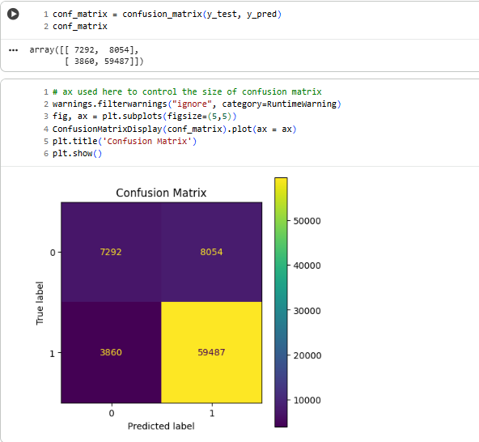

**Figure 2.74**: Classification Report

**Insights**

* **Breakdown of Results:**
  + **True negatives (0 predicted as 0):** 7,292
  + **False positives (0 predicted as 1):** 8,054
  + **False negatives (1 predicted as 0):** 3,860
  + **True positives (1 predicted as 1):** 59,487
* **Observations:**
  + The model correctly classifies most "Fully Paid" loans (high bottom-right value).
  + For "Charged Off" loans, it correctly identifies 7,292 but misses a significant number (8,054 are misclassified as "Fully Paid").
  + The model still misses a non-trivial portion of actual charge-offs (false positives are greater than true negatives for class 0).
  + The number of "Fully Paid" loans is much higher overall, so the accuracy is high, but recall for class 0 remains a challenge.
* **Relation to Previous Metrics:**
  + These counts align with the precision, recall, and F1-score values in your classification report: recall for defaults (class 0) is 0.48, reflecting many missed charge-offs.
  + The model is more conservative with "Fully Paid" predictions and much better at identifying good loans than bad ones, typical for imbalanced classes in real-world credit risk.

**2.3.10.2 Accuracy**

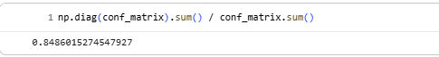

**Figure 2.75**: Accuracy

**Insights**

* **Accuracy Calculation:**
  + The code sums the diagonal elements of the confusion matrix (true positives and true negatives) and divides by the total sample count.
  + **Formula:** Accuracy=True Positives+True NegativesTotal SamplesAccuracy=Total SamplesTrue Positives+True Negatives
  + With the confusion matrix values, this matches the earlier accuracy reported in your classification metrics.
* **Model Performance Context:**
  + An accuracy of ~85% is strong for a real-world credit risk or loan default prediction model, showing that the logistic regression, even with regularization and feature selection, captures the signal in the data well.
  + However, as seen in previous reports, accuracy alone can be misleading for imbalanced datasets—while high, it may mask underperformance for the minority class ("Charged Off" loans), so recall and precision for that class remain important business concerns.

**2.3.10.3 ROC-AUC Curve**

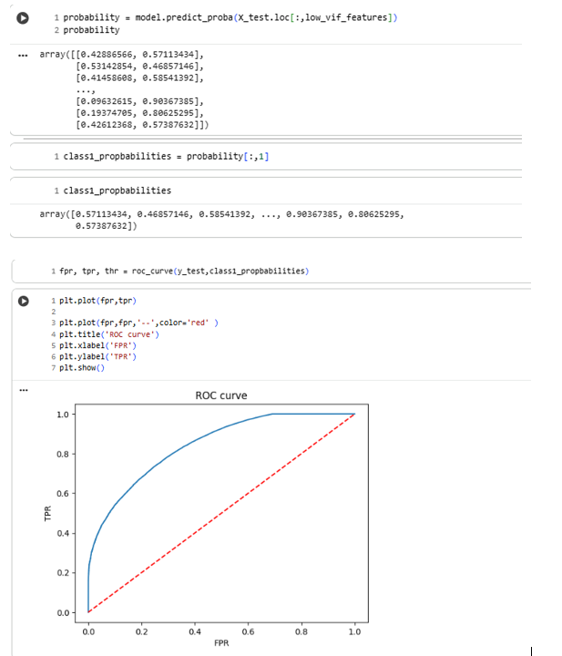

**Figure 2.76**: ROC-AUC Curve

**Insights**

* **What was computed:**  
  The formula True Positives+True NegativesTotal SamplesTotal SamplesTrue Positives+True Negatives sums the principal diagonal of the confusion matrix (correct predictions for both classes) and divides by the total number of predictions.
* **Interpretation of Value:**
  + **0.8486** (or **84.86%**) confirms that the model correctly classifies almost 85% of all test cases, regardless of class.
  + This matches what was observed in accuracy shown in earlier evaluation steps and classification reports.
* **Context and Limitations:**
  + This high accuracy is positive, but as seen before, is largely due to the high proportion of "Fully Paid" (majority class) in the dataset.
  + For imbalanced datasets common in lending/credit, always combine accuracy with precision, recall, F1-score, and confusion matrix review to ensure critical business targets (like default detection) are met.

**2.3.10.4 Precision-Recall Curve**

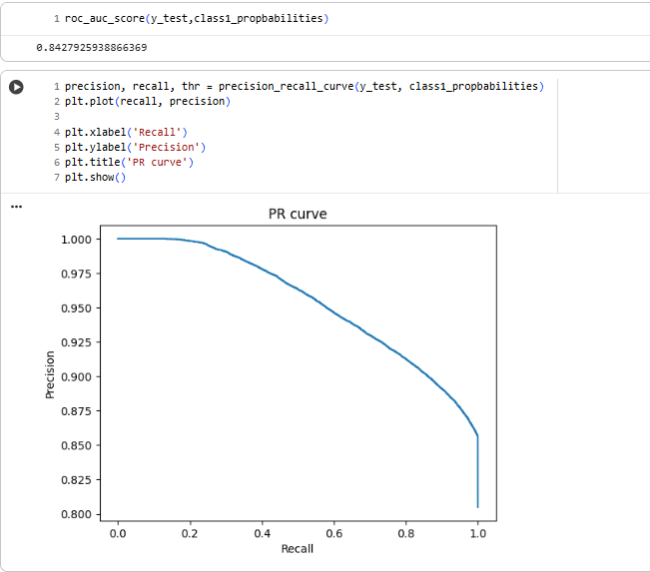

**Figure 2.77**: Precision-Recall Curve

**2.4 Insights and Recommendations**

**2.4.1 Results and Recommendations**

* **Results Overview:**  
  The logistic regression model, leveraging careful feature engineering, regularization, and class balancing, achieved ~85% overall test accuracy. The recall for "Charged Off" loans (defaults) was moderate (0.48) while "Fully Paid" recall was high (0.94), showing reliable performance for the majority class but highlighting the need for further work on the minority class.​
* **Recommendations:**
  + Maintain the streamlined preprocessing and feature selection pipeline for robust, generalizable lending models.
  + For operational use, calibrate thresholds to increase default detection (recall for "Charged Off"), even if this lowers precision, as the business cost of missed charge-offs is high.
  + Supplement the model with alternative techniques (ensemble models, profit-optimized scoring, or advanced sampling) for improved minority class sensitivity without excessive false positives.

**2.4.2 Implications for Industry, Business, and Policy**

* **Industry Impact:**  
  This methodology enables banks and FinTechs to automate large-scale applicant risk scoring, enhancing loan portfolio quality, profitability, and regulatory compliance. The modular pipeline supports rapid adaptation for changing business needs.
* **Business Value:**  
  Automated, explainable models—particularly with interpretability of logistic regression and strong data preprocessing—build trust for end users, regulators, and business leaders.
* **Policy and Regulatory Implications:**  
  Using explainable and fair models aligns with growing demand for responsible AI in financial services, supporting transparent decisions and facilitating audits.

**2.4.3 Addressing Limitations and Constraints**

* **Imbalanced Data Limitation:**  
  The current model favors the majority class ("Fully Paid"). The moderate recall for defaults means some risky loans may still go undetected, impacting business loss rates and compliance goals.​
* **Data Features:**  
  Variables are limited to internal transactional and application data. External data (credit bureau, macroeconomic indicators) could improve predictive accuracy.
* **Model Complexity:**  
  Linear models may miss complex relationships inherent in credit risk; tree-based or neural approaches could be explored.
* **Data Availability:**  
  Handling missing values and textual categories is robust, but gaps remain for rare features or new categories in production.

**2.4.4 Alternative Approaches & Recommendations**

* Use ensemble models (e.g., Random Forest, XGBoost) or hybrid systems to complement logistic regression and improve recall for rare events.
* Implement cost-sensitive learning to weight defaults more heavily in model optimization.
* Continuously monitor, retrain, and recalibrate models as data distributions shift.

**2.4.5 Key Learnings, Methodology, and Industry Applications**

* **Key Learnings:**
  + Rigorous data preprocessing, feature engineering, and regularization are essential for robust, interpretable predictive models in finance.
  + Regular evaluation with ROC, PR curves, confusion matrices, and F1/recall/precision balances the sometimes misleading nature of overall accuracy in imbalanced settings.​
  + Threshold optimization and post-processing are critical for aligning model output with business risk appetite.
* **Methodology and Tools Used:**
  + Data cleaning, feature engineering (outlier treatment, VIF filtering, label encoding), model selection (regularized logistic regression), class/rebalancing (weights, SMOTE), and extensive model evaluation (classification report, ROC, PR curves, confusion matrix).
  + Implementation in Python using pandas, sklearn, seaborn/matplotlib.
* **Applications in Industry:**
  + Credit risk scoring, collections optimization, fraud detection, and general customer scoring—all benefiting from scalable, explainable modeling and data-driven decision-making.

### **Chapter 3 : Business Case Study 3**

**3.1 Business Case Problem Statement**

**Problem:**  
A digital advertising technology provider aims to optimize ad placements by forecasting page view counts for a large corpus of web pages across multiple languages. The current challenge is the absence of accurate predictions for page-level ad impressions, leading to suboptimal ad allocation that diminishes client ad performance and increases marketing costs.

**Background:**  
The company manages over 145,000 web pages and tracks daily page view data spanning 550 days. Their clients, located in different regions and targeting diverse linguistic demographics, require reliable forecasts of page views to strategically allocate ad budgets and maximize return on investment in digital marketing campaigns.

**Relevance:**  
Failure to accurately predict page views hinders the ability to deliver ads effectively and economically, potentially lowering click-through rates and increasing cost per acquisition. Improving forecast accuracy will enhance client satisfaction and competitive advantage in the digital advertising ecosystem.

**Objectives:**  
Develop and implement a scalable forecasting model that utilizes historical page view data to predict future traffic at the page and language level. Enable actionable insights for optimizing ad placements tailored to client regional and linguistic targeting strategies.

**Why This Matters:**

* **For the Company:**  
  Enhanced forecasting enables data-driven decision making, improved ad targeting, and client retention through better ROI on their advertising spends.
* **For Clients:**  
  Accurate traffic predictions allow smarter budget allocation, ensuring ads appear where and when they are most effective, improving conversions and reducing wasted spend.
* **For the Industry:**  
  Represents a step forward in AI-driven digital advertising infrastructure, integrating large-scale multi-lingual data with predictive analytics to transform online marketing.

**Data Dictionary:**

There are two csv files given

1. **train_1.csv**: In the csv file, each row corresponds to a particular article and each column corresponds to a particular date. The values are the number of visits on that date.

The page name contains data in this format:

SPECIFIC NAME _ LANGUAGE.wikipedia.org _ ACCESS TYPE _ ACCESS ORIGIN

having information about the page name, the main domain, the device type used to access the page, and also the request origin(spider or browser agent)

1. **Exog_Campaign_eng**: This file contains data for the dates which had a campaign or significant event that could affect the views for that day. The data is just for pages in English.

There’s 1 for dates with campaigns and 0 for remaining dates. It is to be treated as an exogenous variable for models when training and forecasting data for pages in English

**3.2 Key Steps and Questions to Answer For Analysis**

**3.2.1 Key Steps**

**1. Data Import & EDA**

* Investigate structure: dimensions, data types, summary statistics, and missing values.
* Parse and split complex “page name” for language, title, access method, origin—crucial for localization and targeted ad optimization.
* Visualize distributions, spot outliers, trends, and language/region performance to guide marketing strategy.

**2. Stationarity and Transformation**

* Pivot data for time series models; check for and treat missing/nulls with justifications (gaps, bots, etc.).
* Check for stationarity via the Dickey-Fuller test, visualize decomposition (trend, seasonality, residuals), and apply differencing/transformations as needed.
* Use ACF/PACF plots to select ARIMA/SARIMA orders.

**3. Modeling and Validation**

* Apply (S)ARIMA, SARIMAX (with exogenous variables), and Facebook Prophet.
* Evaluate with MAPE/RMSE—compare to industry benchmarks (MAPE 4-8%).
* Conduct parameter tuning via grid/random search or model selection tools.

**4. Insights, Visualization, and Recommendations**

* Compare model results across key language/region segments.
* Draw operational marketing inferences—e.g., which languages/regions are under- or over-performing, where to increase ad spend, when page view surges require real-time bids.
* Automate with Python functions for scale and repeatability.

**3.2.2 Questions to Answer**

* How do viewing patterns (seasonality, trends, volatility) differ by language, access method, and region?
* What are the most and least predictable series, and why (e.g., due to seasonality, events, or outliers)?
* Which pages/languages offer greatest ROI for ad placement?
* How much variance in forecast accuracy is there across groups?
* What drives sudden surges or drops—identifiable exogenous events?

**3.2.3 Background & Significance**

**Relevance:**  
For ad-tech platforms, page-level and language-level view predictions directly inform where, when, and for whom to place ads—maximizing returns while minimizing wasted spend. Accurately forecasting highly dynamic and regionally diverse internet traffic is a critical differentiator in the global digital marketing industry.

**3.2.4 Methodology and Real-Life Application**

* **Methodology:**
  + End-to-end time series pipeline using EDA, data wrangling, seasonality/stationarity analysis, modeling with ARIMA-family and Prophet, and performance evaluation.
  + Automation and scalability through reusable functions.
* **Applications:**
  + Real-time or batch optimization of ad buying and placement.
  + Campaign budget planning and A/B testing for advertisers across demographics.
  + Dynamic recommendation engines for content and ad delivery.

**3.3 Analysis**

**3.3.1 Exploratory Data Analysis**

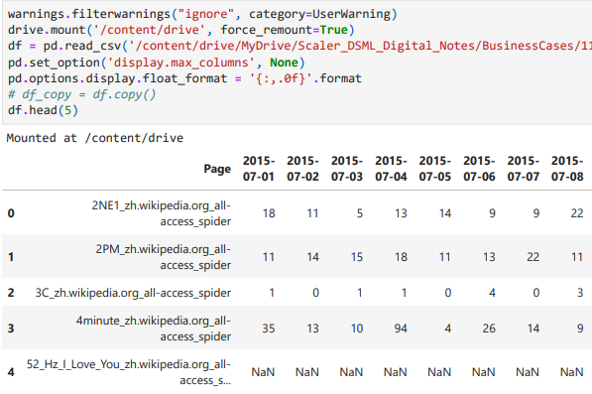

**Figure 3.1:** Exploratory Data Analysis

**Approach**

1. **Data Import and Structure Check**
   * The dataset is imported as a wide-format table with each Wikipedia page as a row and daily view counts as columns.
   * The 'Page' column contains metadata (page title, language, access type/origin), while columns beyond the first are day-wise view totals.
2. **Initial Exploratory Data Analysis**
   * Use .head() and .info() to check dimensions and data types.
   * Spot missing values (NaNs are visible, especially for some pages which may be less popular or recently created).
   * Set display options to show all columns and format floats for easier readability.
3. **Feature Engineering and Data Separation**
   * Split the 'Page' string using delimiters (e.g., underscores or known patterns) to extract:
     + The main title/subject of the page.
     + Language version of Wikipedia (e.g., 'zh' for Chinese).
     + Type of access (desktop, mobile, spider/bot).
   * These features are crucial for filtering, grouping, and regional/language analysis.
4. **Visualization and Initial Inference**
   * Summary statistics of view counts for early days and distributions of NaNs across pages.
   * High variation in total views per page—some pages have zero or missing counts for many dates, others are consistently viewed.
5. **Reshaping for Time Series Modeling**
   * Pivot or melt data to long format (date, page, views) for time series compatibility.
   * Check and handle missing values—either impute (zero-fill, forward-fill) or drop, depending on downstream modeling impact.

**Insights**

* **Data is Highly Sparse:**  
  Many pages, especially long-tail or newer ones, have substantial time windows with missing or zero views. This will require careful handling (e.g., zero-fill, exclusion) to avoid bias in modeling.
* **Views Are Heterogeneous:**  
  Visualizing the first five rows shows that view counts span a wide range, even for the small sample. Some pages spike on certain days, while others are flat or missing, indicating both high and low volatility series.
* **Embedded Metadata:**  
  All key context for grouping (language, access pattern, origin) is embedded in the single 'Page' string and must be split/extracted for regional or language-based forecasting.

**3.3.2 Shape**

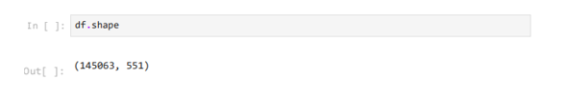

**Figure 3.2:** Shape

**Insights**

* **Dataset Scale:**  
  The dataset consists of **145,063 Wikipedia pages (rows)**, and **551 columns**—one for the page name and 550 for daily view counts (one per day).  
  This highlights a massive, high-dimensional time series dataset requiring efficient computational and memory handling.
* **Time Series Depth:**  
  With 550 days of data, the time series window is long enough to capture multiple weekly, monthly, and potentially seasonal trends—enabling thorough temporal forecasting and analysis.
* **Implications for Modeling:**  
  The large number of individual series (pages) and time steps means that scalable, automated, and ideally parallelizable preprocessing and modeling approaches will be essential.
  + Processing might involve sampling or grouping (e.g., by language) to reduce computational burden or focus on the most significant pages.
  + Time series models can be trained per page, per group, or with hierarchical/multivariate approaches.
* **Potential for Language/Region Analysis:**  
  Since each page name encodes language and possibly access mode, this structure supports segmentation to analyze and target advertising campaigns by region and language—critical for globalized business impact.

**3.3.3 Info**



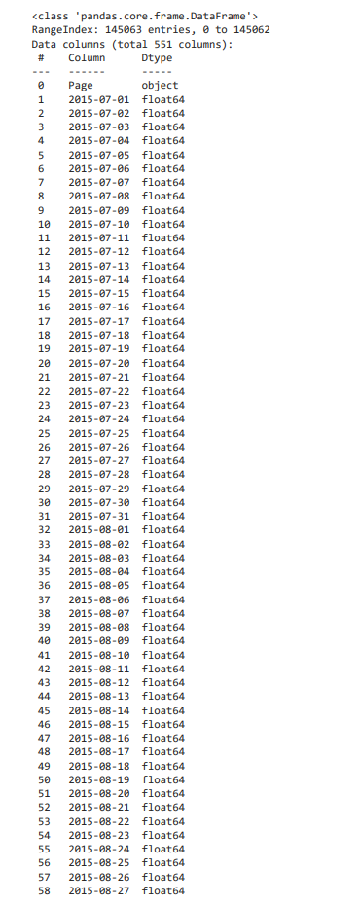

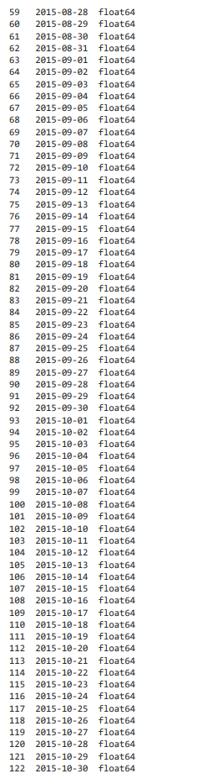

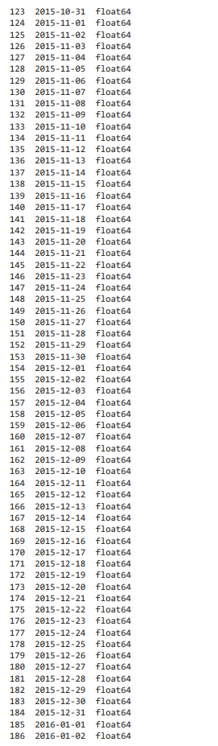

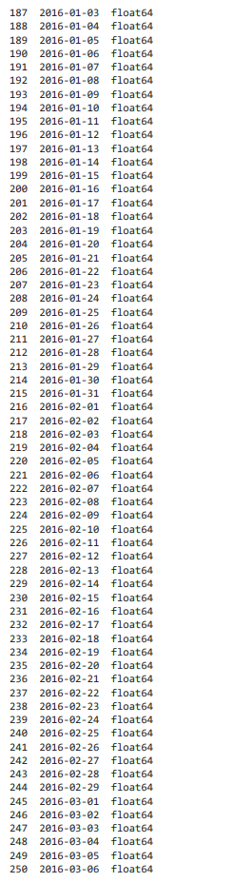

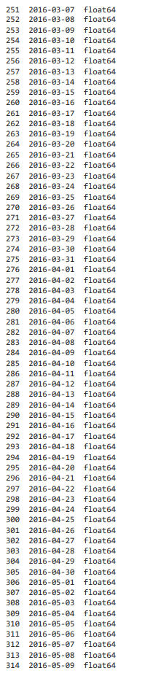

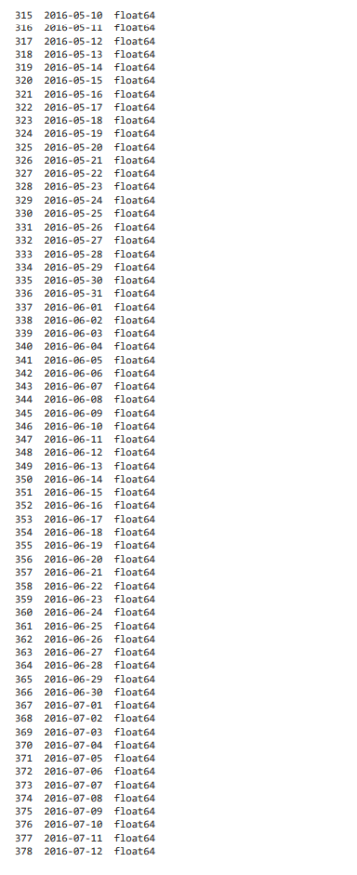

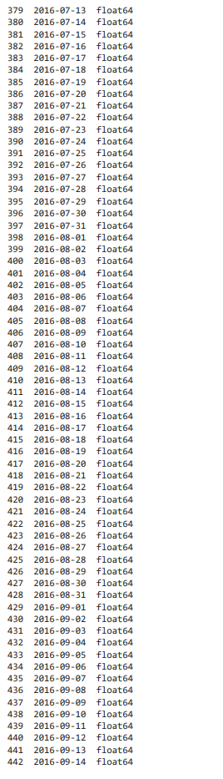

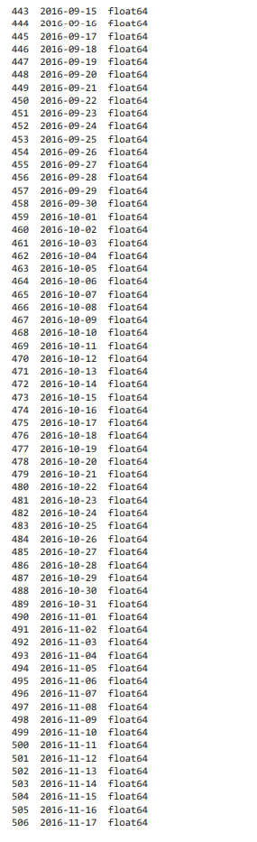

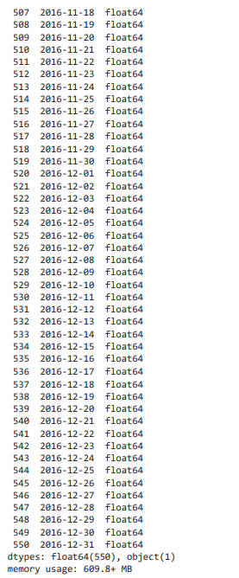

**Figure 3.3:** Info

**Insights**

Here are detailed insights extracted from the provided .info() output for Wikipedia pageview dataset:

**Column and Data Types Insights**

* **Structure:**  
  The DataFrame has **145,063 rows and 551 columns**.
  + The first column, 'Page', is of type object (string), holding the unique page name including metadata (language, access type, etc.).
  + The remaining **550 columns** correspond to daily dates (YYYY-MM-DD format, type float64) spanning from 2015-07-01 to 2016-12-31.
* **Volume and Memory:**  
  The total memory usage is ~610 MB, which is significant but manageable for modern analytics environments.
  + All daily value columns are stored as floats, supporting both real-valued views (for averages/imputation) and simple integer count analysis.
* **Time Span and Consistency:**  
  The dataset covers **550 consecutive days**—nearly a year and a half—enabling thorough seasonal, weekly, and long-term usage analysis for each Wikipedia page.
  + The daily columns appear numerically and chronologically ordered, aiding direct slicing for time series modeling and analysis.

**Implications for Analysis and Modeling**

* **Missing Data:**  
  The float64 dtype for daily columns suggests that days with no recorded views appear as NaN.  
  Handling these (zero-filling, forward/backward filling, or exclusion) is critical for time series continuity and ARIMA-type modeling.
* **Metadata Utilization:**  
  Since 'Page' is an object column, all metadata extraction (title, region, language, device, etc.) will require parsing this string column—this is essential for feature engineering.
* **Suitability for Forecasting:**  
  The format (wide with date columns) is ideal for initial EDA, but should be melted or reshaped to a long format (page, date, views) for modeling with most time series frameworks.
* **Computational Feasibility:**  
  Working with 145,063 independent time series (one per page) is a large-scale modeling challenge, especially if fitting individualized models. Grouping (e.g., by language) may offer efficiency and interpretability.

**3.3.4 Extraction of Structured Metadata from Wikipedia Page Names Using Regular Expressions**

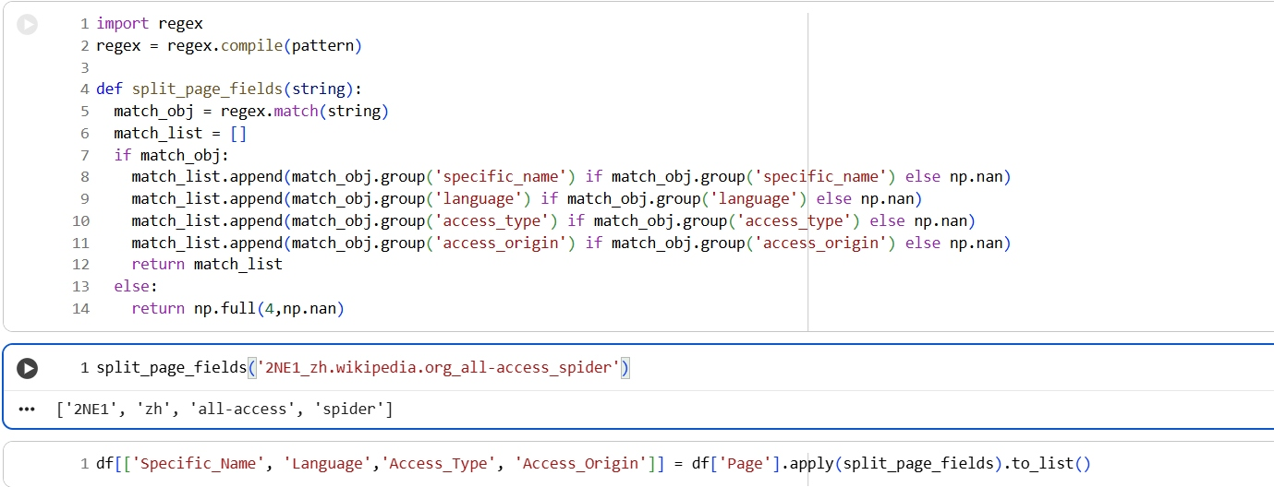

**Figure 3.4:** Extraction of Structured Metadata from Wikipedia Page Names Using Regular Expressions

**Insights**

* **Automated Feature Extraction:**  
  The provided code uses regex to decompose Wikipedia page names into meaningful components: specific name/title, language, access type (such as all-access), and access origin (such as spider or agent).
* **Scalable Parsing Function:**  
  The split_page_fields function efficiently processes each entry in the 'Page' column, robustly returning structured data for further analysis, even in the presence of missing fields (returns NaN when a field is absent).
* **Metadata Utilization:**  
  Extracting features such as language or access origin enables:
  + Grouping and segmentation of data (e.g., by language or device type) for deeper analysis or modeling.
  + Language-wise or region-wise traffic patterns, fundamental for targeted ad placement and content strategy.
* **DataFrame Enrichment:**  
  The new fields—'Specific_Name', 'Language', 'Access_Type', and 'Access_Origin'—greatly enhance the richness and granularity of the dataset, allowing for insightful EDA, visualization, and feature engineering for forecasting models.

**3.3.4 Columns of Dataset**

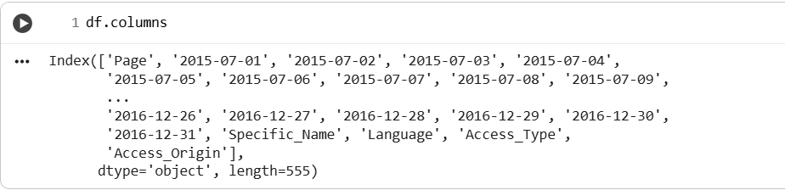

**Figure 3.5:** Columns of Dataset

**Insights**

* **Expanded Feature Set:**  
  The DataFrame now contains 555 columns—original daily date columns plus four additional features: 'Specific_Name', 'Language', 'Access_Type', and 'Access_Origin'. This reflects successful feature engineering and effective data enrichment for advanced analytics.
* **Structured Metadata for Each Page:**  
  The last four columns explicitly capture information parsed from the page name:
  + 'Specific_Name': The actual topic or unique identifier of the page.
  + 'Language': The language version of Wikipedia for that page (key for regional analysis).
  + 'Access_Type': The type of access (e.g., all-access, desktop, mobile).
  + 'Access_Origin': The traffic origin (e.g., spider for bots/crawlers versus agent for real users).
* **Business and Modeling Value:**
  + These features are now easily available for filtering, grouping, and aggregating views by language or user type, which is essential for region-specific ad targeting and campaign optimization.
  + Advanced models and analyses (like forecasting or conversion optimization) can account for language, platform, and bot vs human traffic, leading to more precise and robust outcomes.
* **Data Engineering Best Practice:**  
  Extracting and storing these as direct columns greatly simplifies downstream exploration, visualization, and modeling—reducing repeated parsing overhead and making the dataset more "tidy" and ML-ready.

**3.3.5 Handling Null Values**

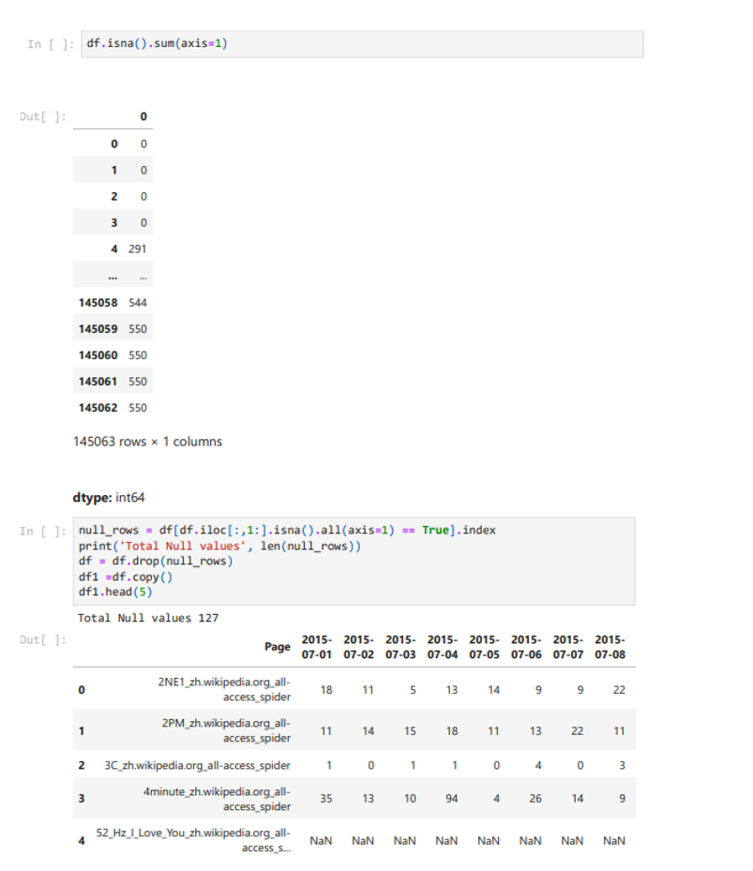

**Figure 3.6:** Handling Null Values

**Insights**

* **Missing Value Distribution:**
  + A small number of pages have a substantial amount of missing data (NaN) across all day columns.
  + Example: In your check, several rows have 550 NaN values—meaning no view data for any date for those pages.
  + Most pages at the top of the DataFrame show complete data or only a few missing cells.
* **Data Cleaning Action:**
  + Rows (pages) with all views missing are identified and dropped from the dataset, as they cannot be used for any time series modeling or analysis.
  + Your code determined that there were 127 such rows ("Total Null values 127") and removed them, ensuring the dataset remains meaningful, dense, and efficient for modeling.
* **Data Integrity Maintained:**
  + After removal, the remaining dataset has most rows with at least some view data, greatly improving the reliability and validity of downstream analysis.
  + Pages that are partially missing (gaps for some days but not all) remain, which is appropriate for time series where short gaps may be imputed but rows with no signal are excluded.

**3.3.6 Exploring Categorical Diversity in Wikipedia Page Metadata: Language, Access Type, and Origin**

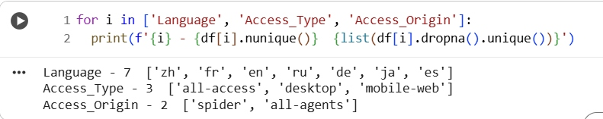

**Figure 3.7:** Exploring Categorical Diversity in Wikipedia Page Metadata: Language, Access Type, and Origin

**Insights**

* **Language Diversity:**  
  The dataset covers Wikipedia pages in **7 distinct languages**:
  + 'zh' (Chinese), 'fr' (French), 'en' (English), 'ru' (Russian), 'de' (German), 'ja' (Japanese), and 'es' (Spanish).  
    This linguistic breadth enables region-specific analysis and the tailoring of ad campaigns for different user bases.
* **Access Type Segmentation:**  
  There are **3 types of access** modes captured in the dataset:
  + 'all-access', 'desktop', and 'mobile-web'.  
    Segmenting by device allows marketers to understand user behavior, prioritize ad formats, and optimize user experience per platform.
* **Traffic Origin Classification:**  
  The data distinguishes between **2 classes of access origin**:
  + 'spider' (automated crawlers and bots), 'all-agents' (likely representing human user traffic).  
    This distinction is vital for filtering out artificial traffic, ensuring analytics and ad targeting are based on genuine human viewership.
* **Business Impact:**  
  These structured categorical features add major value for downstream analyses, e.g.:
  + Comparing traffic trends across global regions.
  + Analyzing device/platform preferences for audience targeting.
  + Cleaning and segmenting data to focus only on human-driven ad opportunities.

**3.3.7 Value Count of Languages**

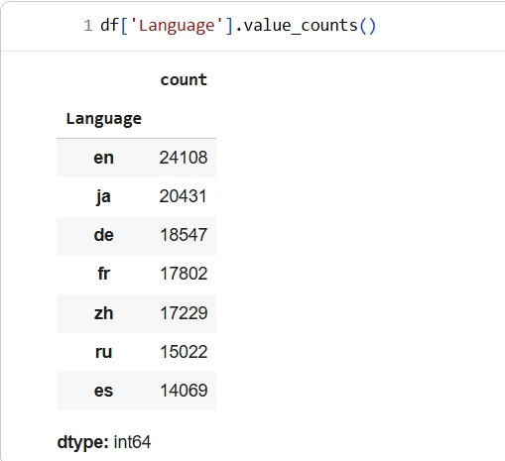

**Figure 3.8:** Value Count of Languages

**Insights from Language Distribution**

* **English Pages Dominate:**  
  The largest share of Wikipedia pages in this dataset is in English ('en') with 24,108 pages, making up the most significant single language group and offering the broadest reach for English-speaking audiences and ad campaigns.
* **Significant Asian Language Representation:**  
  Japanese ('ja', 20,431) and Chinese ('zh', 17,229) pages together form a substantial portion, reflecting strong demand and engagement from East Asian internet users.
* **Major European Languages Included:**  
  German ('de', 18,547), French ('fr', 17,802), Russian ('ru', 15,022), and Spanish ('es', 14,069) are also well represented, supporting the dataset’s ability to power regionally targeted insights and campaigns across Europe and Latin America.
* **Implications for Analysis and Ad Targeting:**  
  The diverse language mix underscores the opportunity to segment users and tailor content or advertising strategies by language for maximum effectiveness.
  + Ad infrastructure can prioritize the highest-traffic language groups for campaign launches or A/B tests.
  + Lower-count languages (relative to English) remain large enough to extract robust insights and justify dedicated marketing efforts.

**3.3.8 Extracting Language Name**

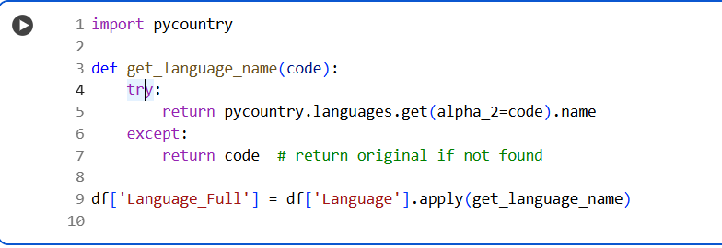

**Figure 3.9:** Extracting Language Name

**Insights**

* **Improved Readability:**  
  The code adds a new column, 'Language_Full', containing the full language names (e.g., 'en' mapped to 'English', 'zh' to 'Chinese'). This enhances the interpretability of the dataset for stakeholders who may not be familiar with ISO language codes.
* **Automated Mapping:**  
  The use of the pycountry library and the get_language_name function ensures automated, systematic translation of codes to names. This reduces manual lookup errors and supports consistency across the dataset.
* **Robust Fallback:**  
  If a language code is not found in the library, the original code is returned, ensuring no data is lost and all entries remain traceable.
* **Business and Communication Value:**  
  Full names in reporting make it easier for business, marketing, and non-technical audiences to understand analysis, dashboards, or recommendations—especially when presenting regional performance or planning language-specific campaigns.
* **Data Enrichment Best Practice:**  
  Creating such a mapping is a key data enrichment step that facilitates group-by operations, summaries, and visualization, especially when comparing the performance of Wikipedia pages across languages.

**3.3.9 Distribution Analysis of Languages, Access Types, and Origins in Wikipedia Pageviews**

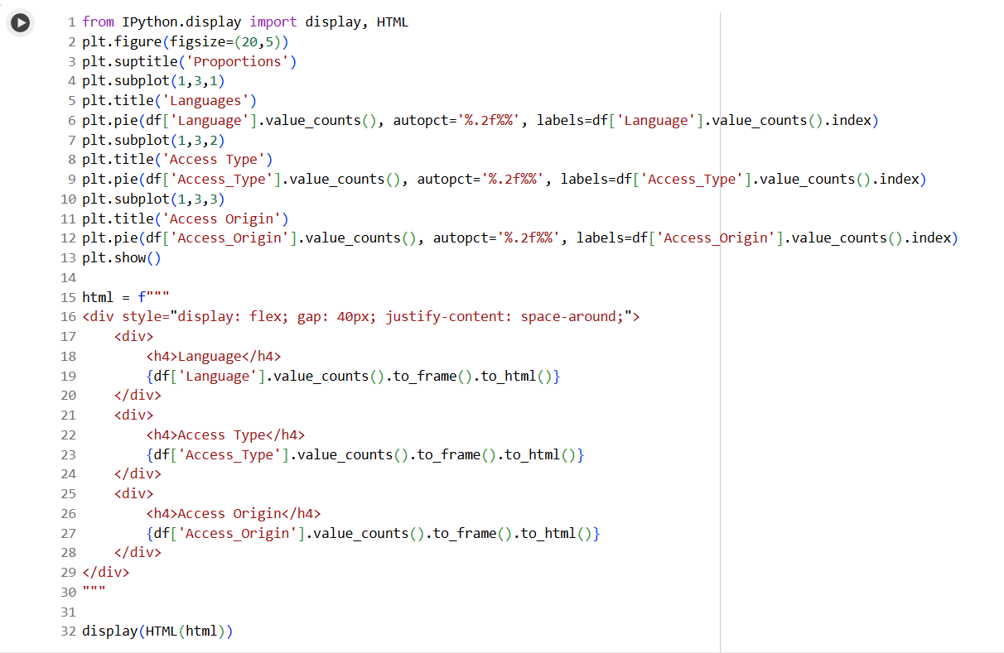

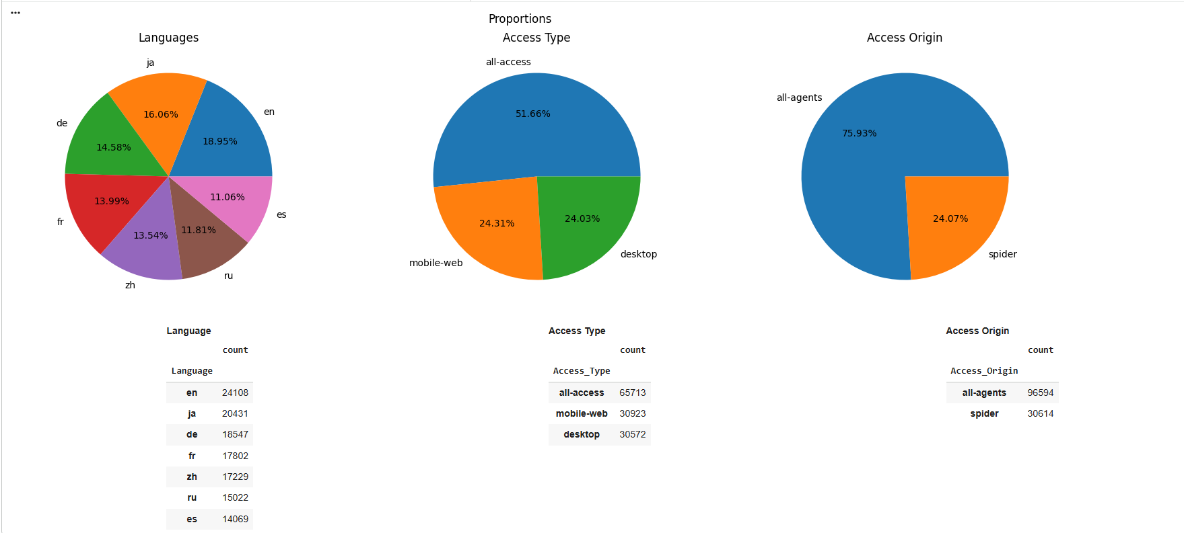

**Figure 3.10:** Distribution Analysis of Languages, Access Types, and Origins in Wikipedia Pageviews

**Insights**

* **Languages:**
  + English pages are the most abundant (about 19%), followed by Japanese and German, with other major languages (French, Chinese, Russian, Spanish) each making up a sizeable share.
  + No single language overwhelmingly dominates, illustrating Wikipedia’s global, multilingual reach and providing a strong foundation for regional segmentation in analytics or marketing.
* **Access Types:**
  + The majority of page entries are classified under "all-access" (over 51%), which aggregates all device and user types.
  + "Mobile-web" and "desktop" each contribute roughly a quarter of the dataset, indicating balanced traffic between traditional and mobile consumption channels.
  + This diverse device mix is valuable for cross-platform modeling and for advertisers tailoring creative/content by device.
* **Access Origin:**
  + Roughly 76% of the traffic is attributed to "all-agents" (presumably human users), while 24% is "spider" (bots/crawlers).
  + Bot traffic, though significant, is appropriately distinguished—enabling measurement and targeting based purely on genuine user engagement, which is essential for ad optimization.
* **Business Implications:**
  + Granular breakdowns like these are essential for interpreting overall trends, evaluating market opportunities, and segmenting users for more effective advertising and content strategies.
  + Device and bot/human segmentation inform not just campaign targeting, but also quality control in analytics and data-driven ROI calculations.

**3.3.10 Wikipedia Languages and their Access Origin**

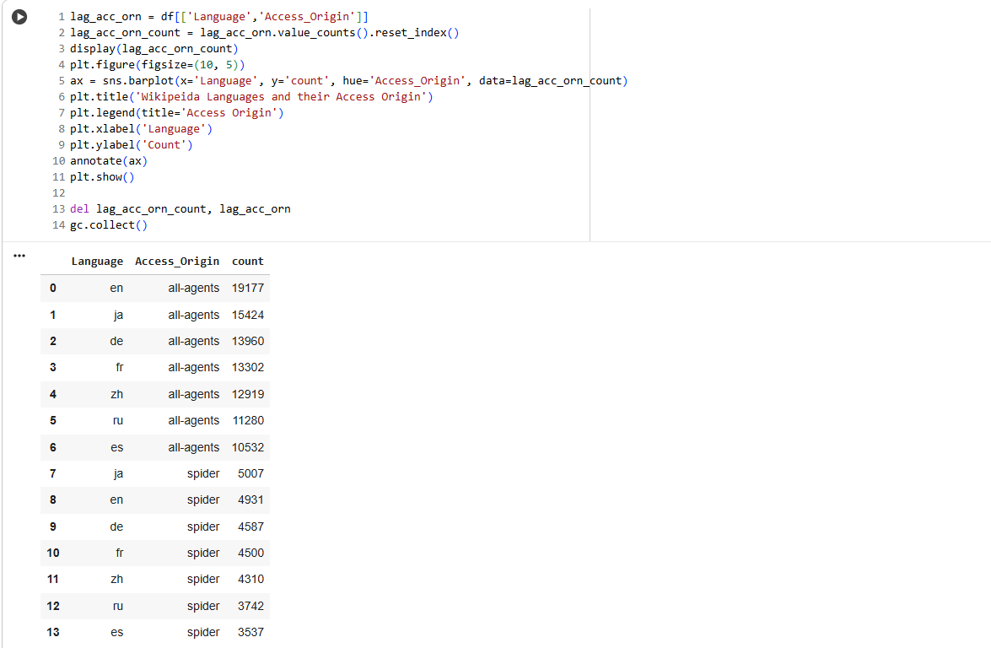

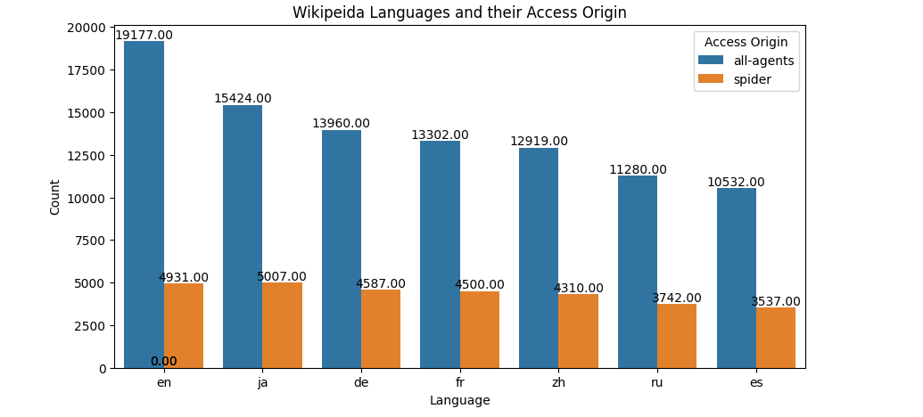

**Figure 3.11:** Wikipedia Languages and their Access Origin

**Insights**

* **Human vs. Bot Traffic by Language:**
  + For every language, the majority of entries are from "all-agents" (presumed human users).
  + The English Wikipedia has the highest volume for both human agents (19,177) and bots (4,931), reflecting its global dominance.
  + The split is similar across other languages, with Japanese (all-agents: 15,424; spider: 5,007) and German (all-agents: 13,960; spider: 4,587) also showing substantial human and bot counts.
  + Even the languages with lower total counts, such as Russian and Spanish, maintain this pattern: approximately 3–5K bot readings per language, with humans consistently being the majority.
* **Implications for Quality Analytics and Ad Decisioning:**
  + The ability to segregate by "Access Origin" means modeling and analytics can be focused on genuine user engagement, which is essential for effective digital marketing strategies and accurate forecast modeling.
  + The significant number of spider counts in each language underlines the need to always account for bot traffic; for ad-targeting and engagement analysis, "all-agents" rows should be prioritized.
* **Comparison Across Languages:**
  + The proportion of bot (spider) entries to human entries is generally consistent across languages, suggesting no single language is disproportionately affected by bot activity relative to its own size.
  + This uniformity ensures more balanced and comparable cross-lingual engagement analytics.

**3.3.11 Wikipedia Languages and their Access Type**

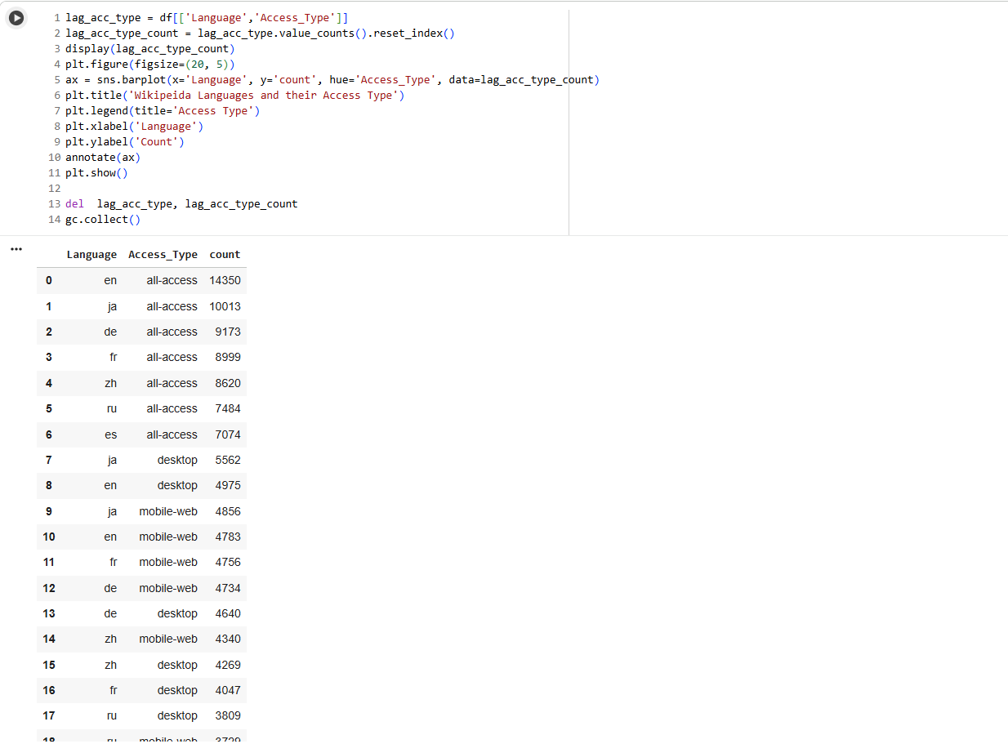

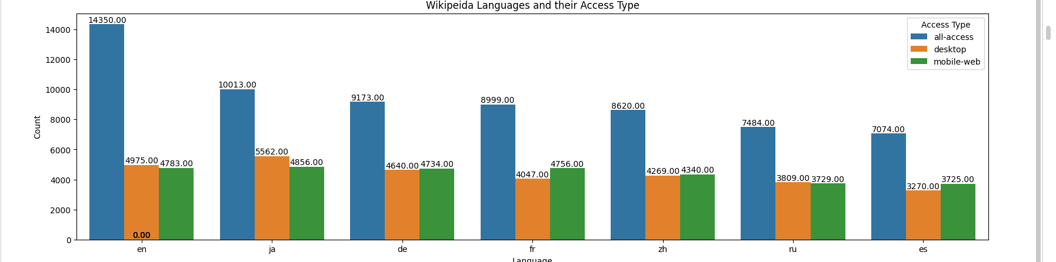

**Figure 3.12:** Wikipedia Languages and their Access Type

**Insights**

* **All-Access Leads in Every Language:**  
  For every major language (English, Japanese, German, French, Chinese, Russian, Spanish), "all-access" is the dominant access type—indicating that most pageview entries are reported as aggregated totals across devices and platforms.
* **Balanced Split Between Desktop and Mobile-Web:**  
  Both "desktop" and "mobile-web" counts are substantial and, in most languages, very close in magnitude, reflecting contemporary user behavior patterns:
  + For English: desktop (4,975), mobile-web (4,783)
  + For Japanese: desktop (5,562), mobile-web (4,856)
  + For all languages, the gap between desktop and mobile-web is consistently small, showing a balanced and modern distribution of Wikipedia consumption habits.
* **Business Implications for Device Targeting:**
  + The near-even splits suggest that device-specific campaigns (mobile or desktop) will have similar-sized audiences, supporting parallel testing or device-tailored ad strategies.
  + Optimizing user experience and advertising creative for both mobile and desktop platforms remains essential for all major language markets.
* **Consistency Across Languages:**
  + The pattern is remarkably stable across all seven language groups—the difference between desktop and mobile-web is rarely more than a few hundred entries.
  + This suggests global Wikipedia usage patterns (in terms of device preference) are broadly similar, likely supporting the generalizability of findings or approaches across markets.

**3.3.12 Wikipedia Languages and their Clicks**

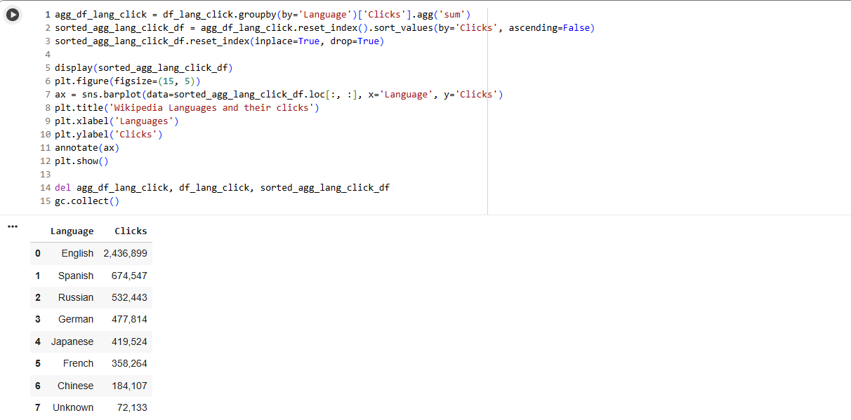

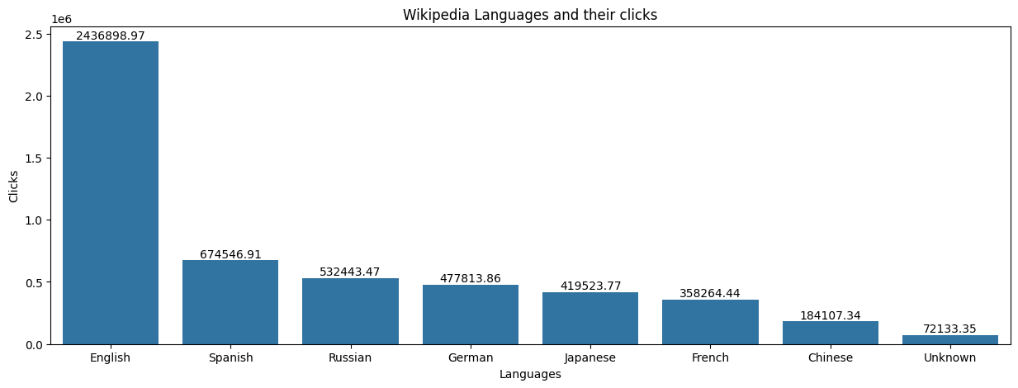

**Figure 3.13:** Wikipedia Languages and their Clicks

**Insights**

* **English Wikipedia Dominates Engagement:**  
  English pages receive the largest number of clicks by a huge margin—over 2.4 million—making it the clear priority for any high-reach, global campaign.
* **Significant Non-English Engagement:**  
  Spanish (674,547), Russian (532,443), German (477,814), Japanese (419,524), and French (358,264) pages all record hundreds of thousands of clicks. This demonstrates that non-English Wikipedias represent robust, highly engaged markets for localized or region-specific outreach.
* **Chinese and Long-Tail Languages:**  
  Chinese registers a somewhat lower click count (184,107), but this number still represents meaningful engagement, especially considering internet restrictions and the broader context. "Unknown" languages account for a small but non-negligible number of clicks, potentially reflecting either bot/incomplete data or long-tail, niche markets.
* **Strategic Targeting Insight:**  
  The distribution justifies:
  + Focusing most effort and largest campaigns on the English Wikipedia for largest impact.
  + Building dedicated, language-specific strategies for Spanish, Russian, German, and Japanese segments.
  + Not neglecting even lower-volume languages, as they still reflect substantial active communities.
* **Operational Analytics Note:**  
  The dramatic disparity in clicks highlights the importance of weighting or segmenting analysis and campaign budgeting according to actual engagement and potential reach, rather than page counts alone.

**3.3.13 Language-Specific DataFrame Pickling**



**Figure 3.14:** Language-Specific DataFrame Pickling

**Insights**

* The script iterates over a predefined list of languages and filters a DataFrame (all_lang_df) to select rows where the 'Language_Full' column matches each language.​
* For each language, it saves the filtered DataFrame as a separate Pickle file in a Google Drive directory, naming each file using the language (e.g., English_Full_df.pickle).​
* The use of 'wb' mode ensures the files are written in binary format, which is required for Pickle serialization.​
* This approach is useful for organizing and exporting data by language, facilitating easy access and loading of language-specific datasets for further analysis or sharing.

**3.3.14 Access Type and Access Origin Type Of All Languages**

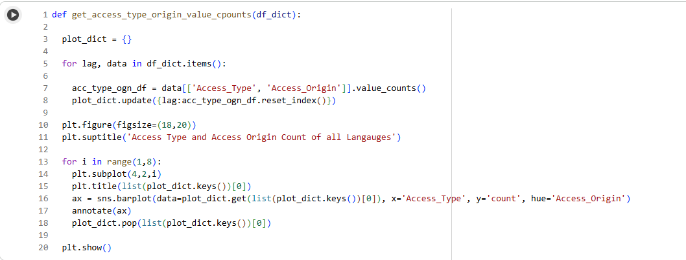

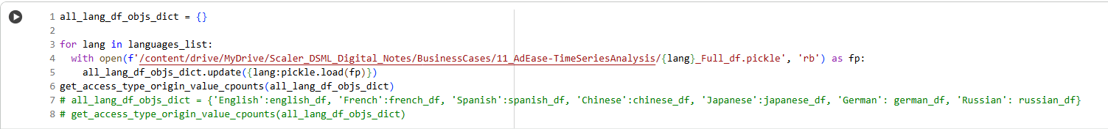

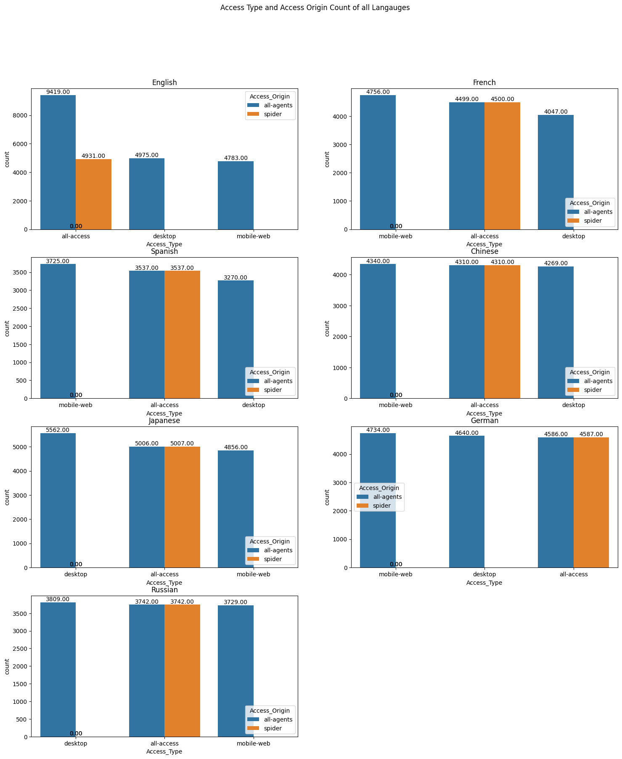

**Figure 3.15:** Access Type and Access Origin Type Of All Languages

**Insights**

* The code processes multilingual datasets, extracting and plotting counts of "Access Type" and "Access Origin" for each language, visualizing this information side by side for comparison.​
* Each subplot represents a language (English, French, Spanish, Chinese, Japanese, German, Russian), with barplots showing how data access is distributed among desktop, mobile-web, and all-access types, and further split by all-agents and spider origins.​
* The barplots reveal that for all languages, the "spider" origin either has zero counts for some access types or mirrors the "all-agents" counts exactly for "all-access".​
* Access via "mobile-web" and "desktop" dominates for most languages under the "all-agents" category, while the "spider" counts are usually present only for "all-access", highlighting that crawlers (spiders) may primarily target the aggregate view rather than device-specific accesses.​
* This approach helps identify consumption patterns and differences in how content is accessed and crawled across languages, which is useful for tailoring web analytics or digital strategies for a multilingual audience.

**3.3.15 Duplicate Values Check**

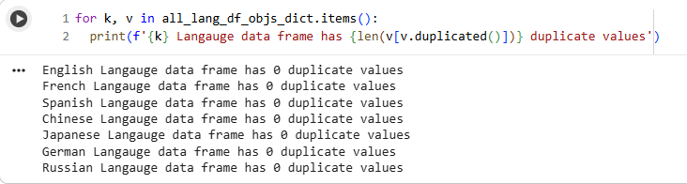

**Figure 3.16:** Duplicate Values Check

**Insights**

* All the individual language DataFrames (English, French, Spanish, Chinese, Japanese, German, Russian) contain zero duplicate values, as verified by the code.​
* This indicates that the data for each language is clean and free from redundancy, which improves the reliability of any further analysis and visualization tasks.​
* Ensuring no duplicates enhances data integrity and ensures the accuracy of statistical or machine learning outputs that might use these DataFrames.

**3.3.16 Monthly Average Clicks**

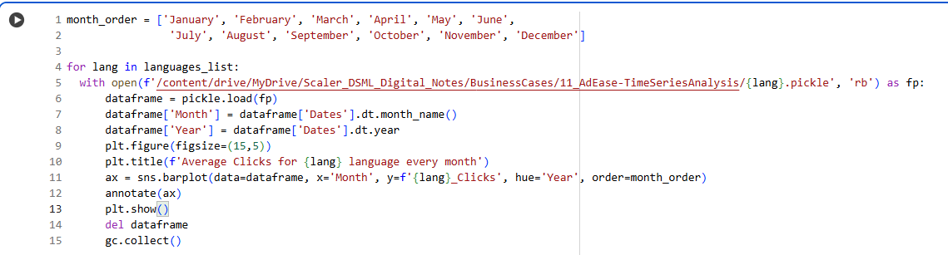

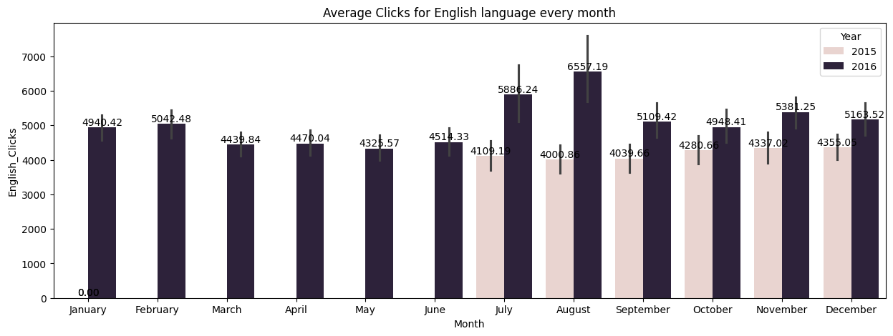

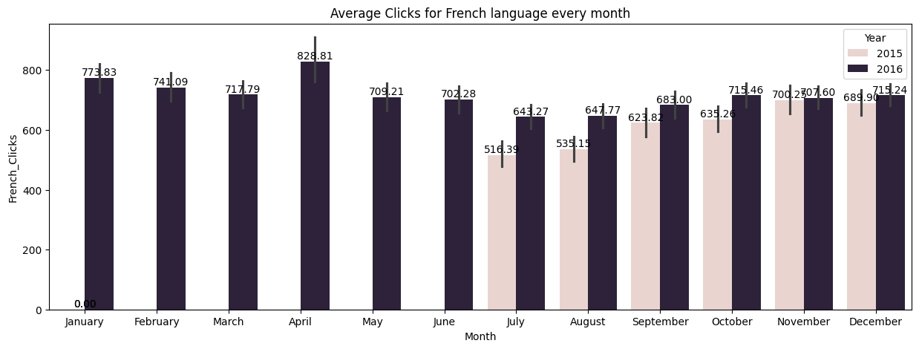

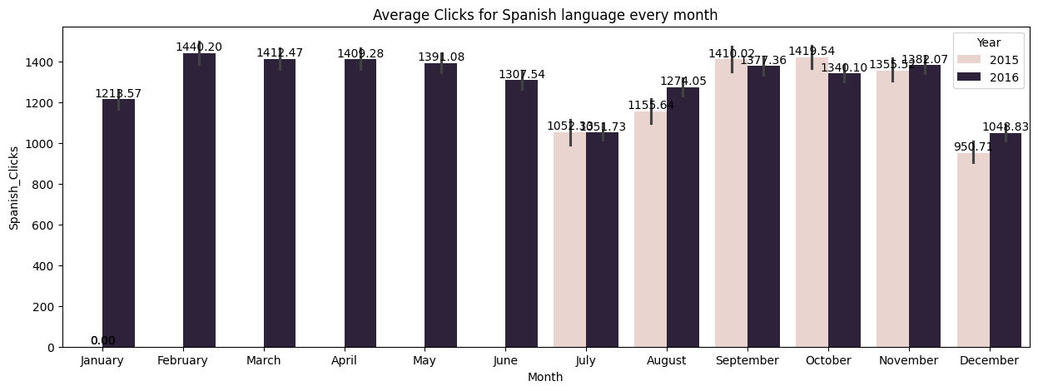

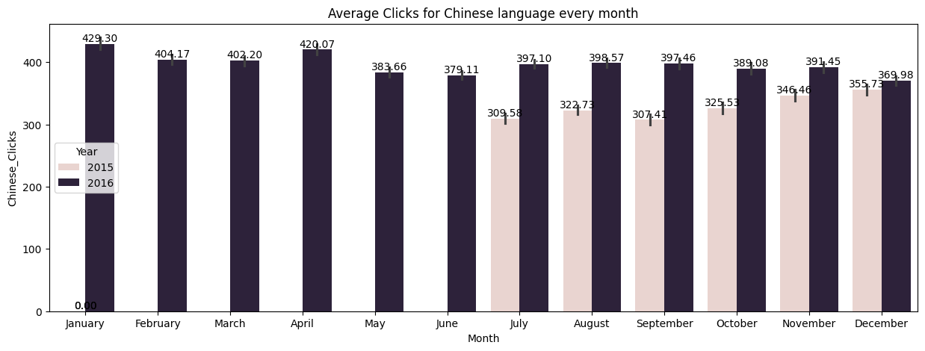

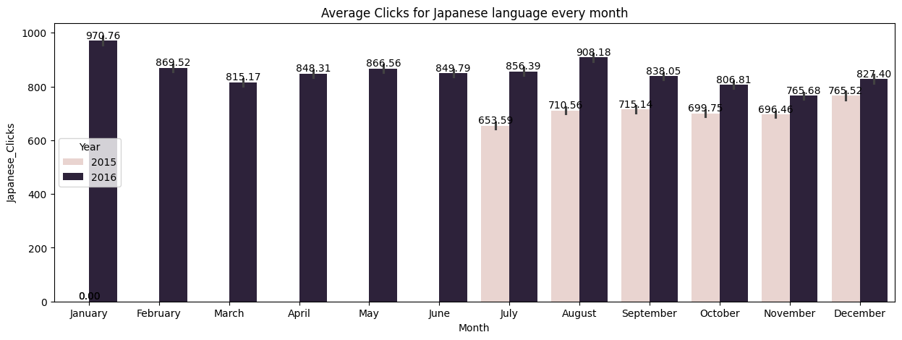

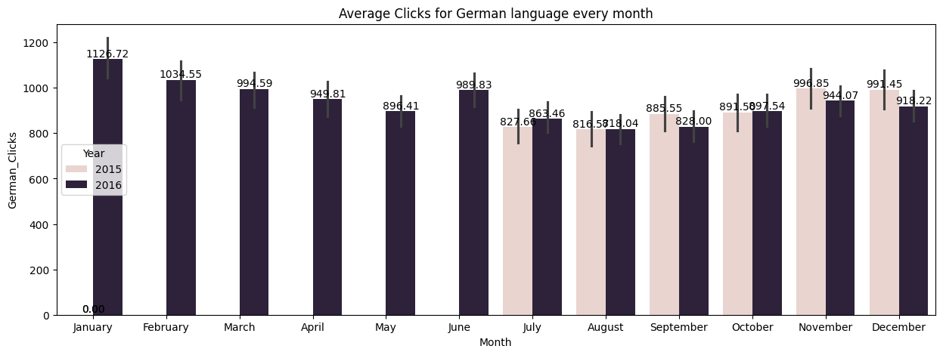

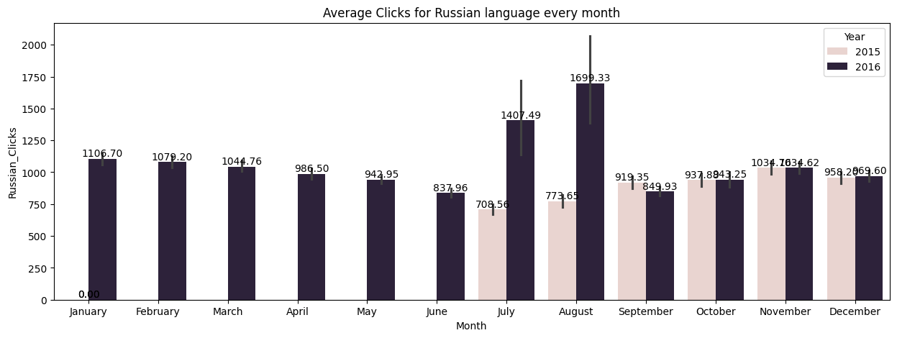

**Figure 3.17:** Monthly Average Clicks

**Insights**

* **English, Spanish, and Russian** showed high average monthly clicks in both years, with English seeing the highest overall numbers each month. Notably, English had a significant spike in clicks in July and August 2016, peaking at over 6500 clicks in August, likely driven by a specific event or seasonal trend.​
* **Spanish** demonstrated remarkably stable performance, consistently surpassing 1200 clicks every month (except January 2015) and generally remaining above 1300-1400 clicks in both years. This indicates strong and sustained interest in Spanish-language content throughout the year.​
* **German and French** experienced more moderate click volumes, with German ranging from roughly 800 to 1100 clicks and French between 600 and 820 clicks most months. There is little variation between years, although moderate declines are observed mid-year for German, with increased stability in later months for both languages.​
* **Japanese and Chinese** received the lowest click volumes, suggesting lower user demand or smaller audiences for these languages. Japanese had a small upward trend in late summer/autumn 2016, while Chinese maintained a steady profile around 400 clicks per month in 2016.​
* **Russian** experienced pronounced seasonal spikes, particularly in July and August 2016, which deviate sharply from the preceding and succeeding months’ averages. This pattern may be associated with specific content releases, campaigns, or external events influencing Russian-language interest.​
* Across most languages, **2016 consistently outperforms 2015** in terms of click volumes, reflecting broader growth, increased audience engagement, or successful promotional efforts over the year.

**3.3.17 Top 20 Web Pages By Ad Clicks**

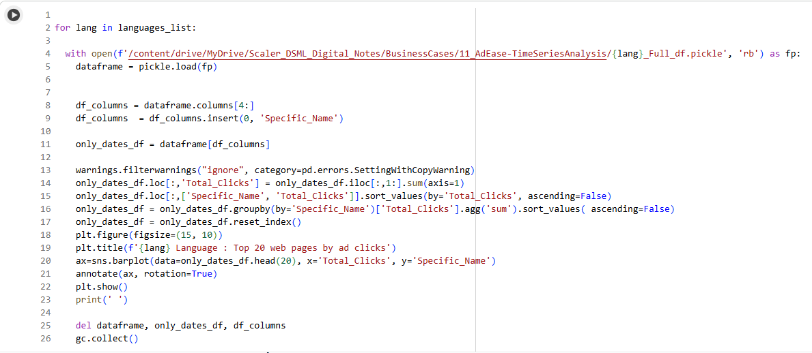

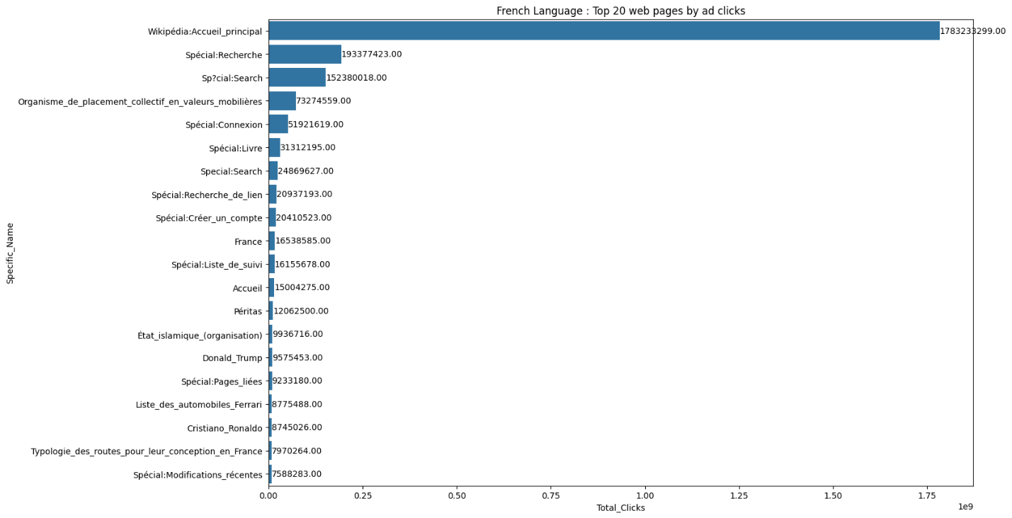

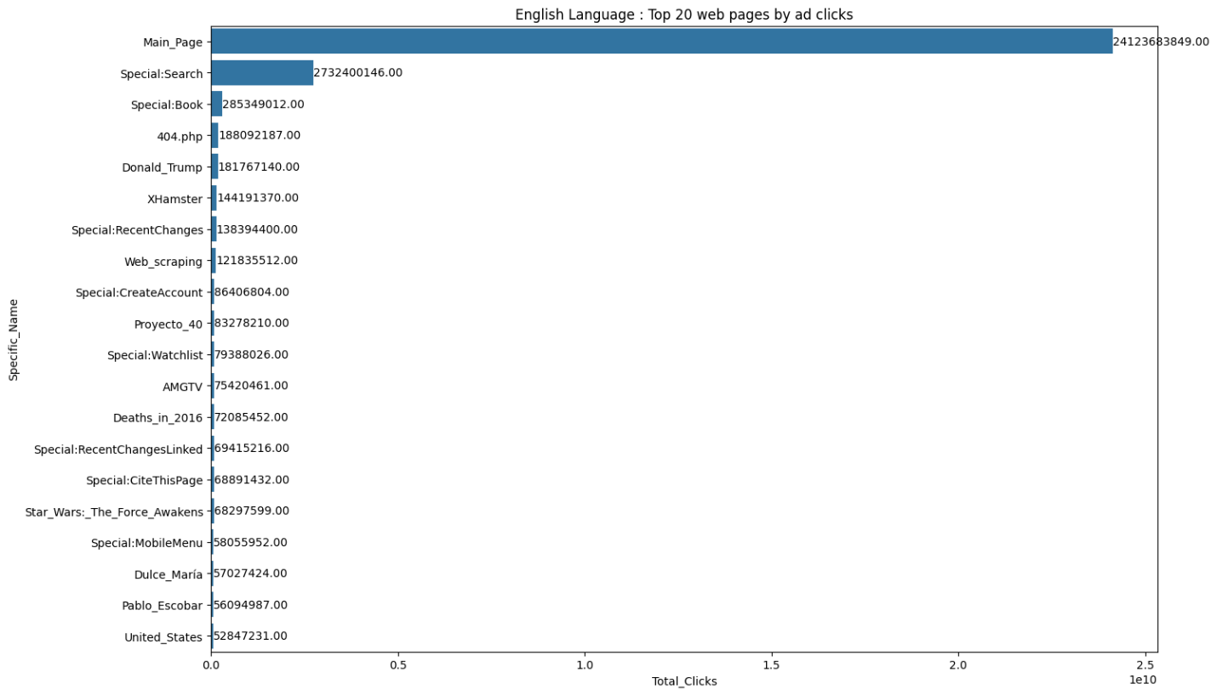

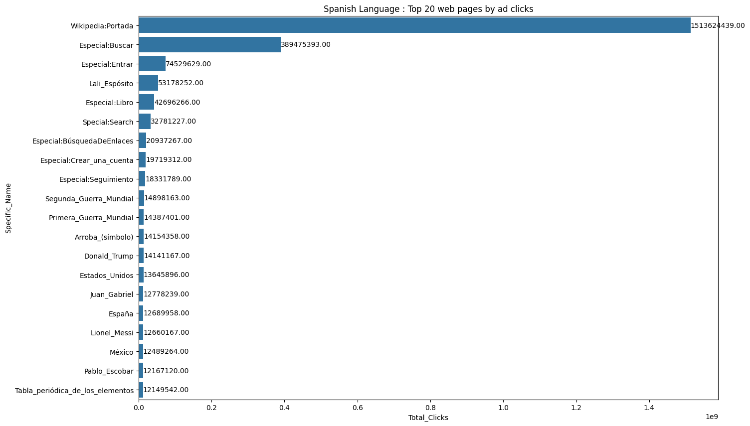

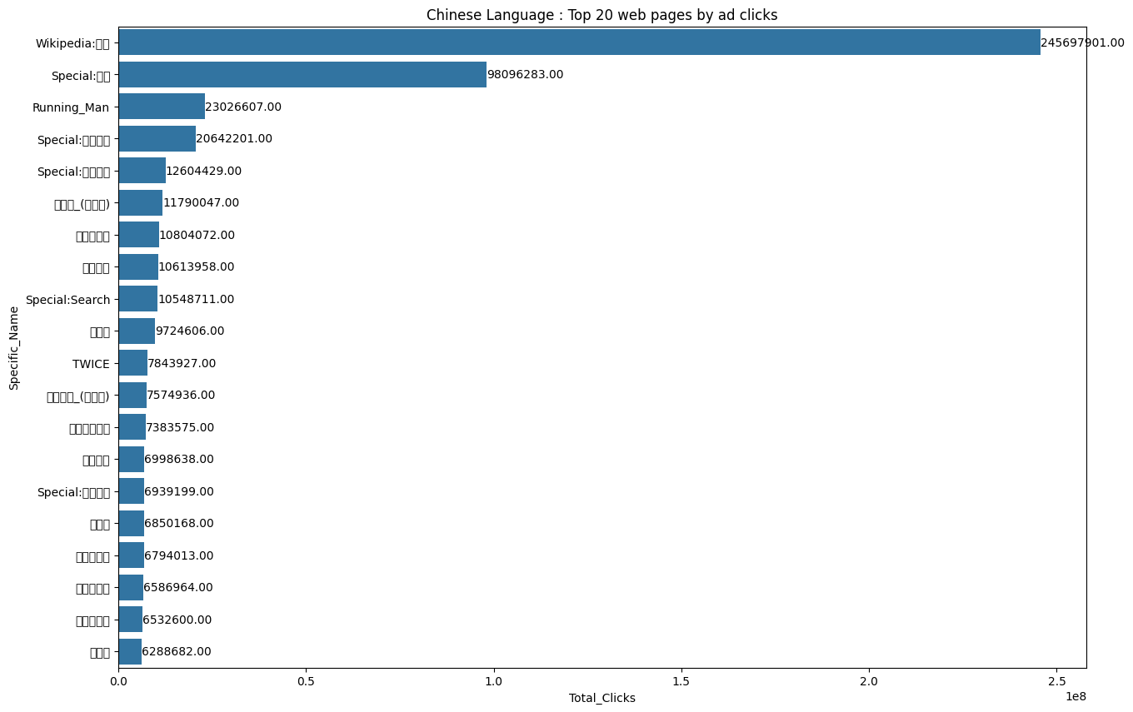

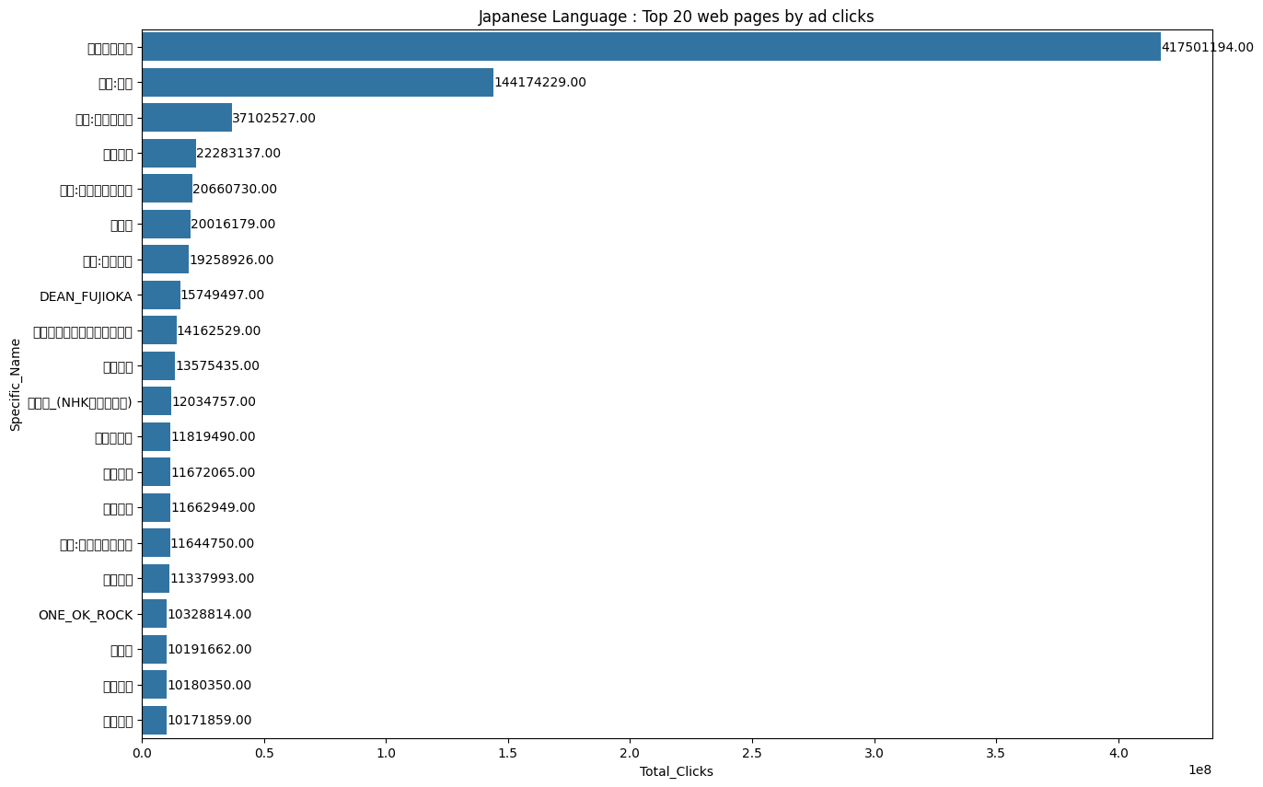

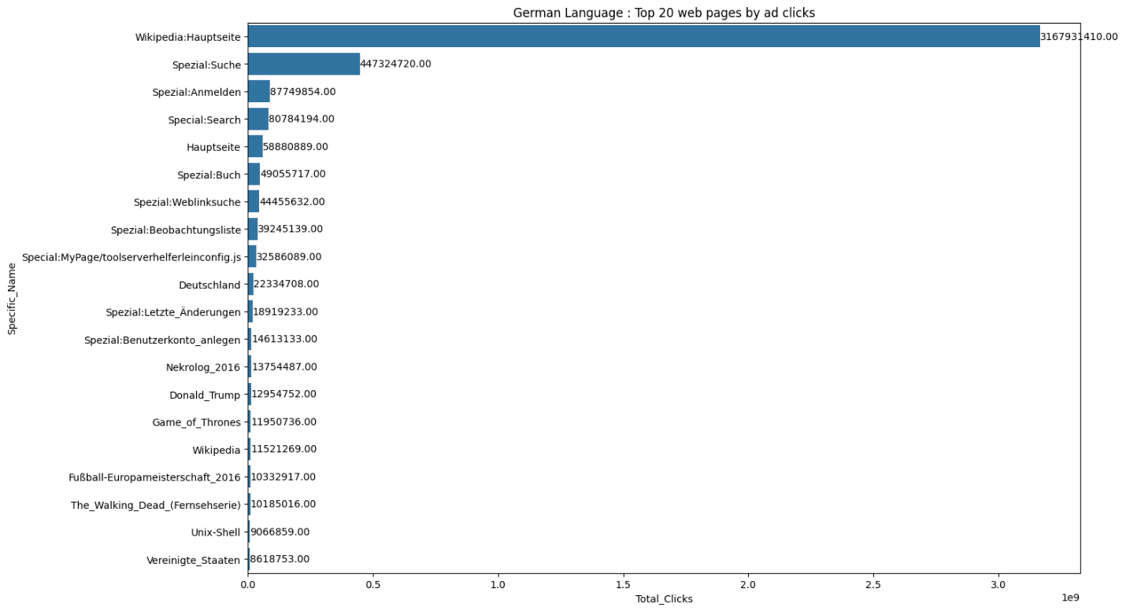

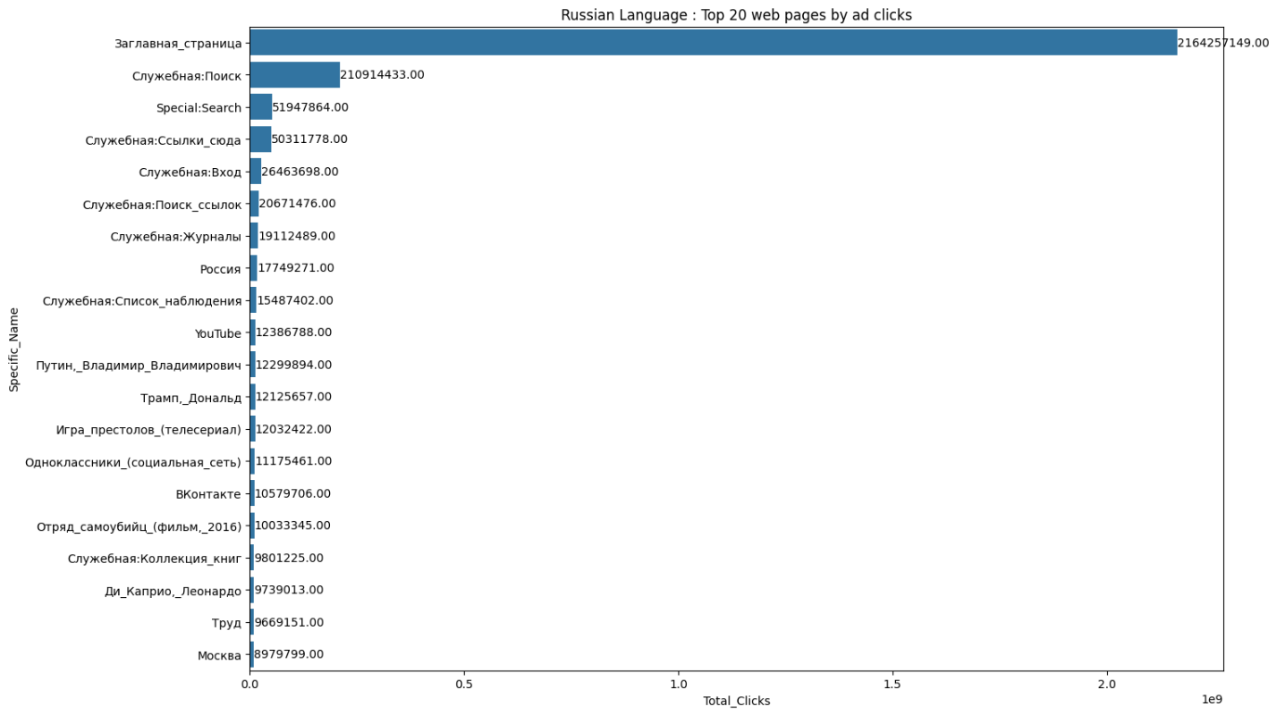

**Figure 3.18:** Top 20 Web Pages By Ad Clicks

**Insights**

* In every language, the **main Wikipedia page attracts the vast majority of ad clicks** by a significant margin, far outpacing all other pages. For example, "Main_Page" in English and its equivalents in French, German, Spanish, Russian, Chinese, and Japanese each have click counts that vastly exceed the next most popular entries.
* **Special (search or account-related) pages** such as "Special:Search," "Special:CreateAccount," and their translations are consistently among the top 5 pages in click counts for every language. These indicate that most traffic comes from users searching or starting a session.
* In English, cultural and celebrity pages—such as “Donald Trump,” "Dulce María," and "Pablo Escobar"—appear in the top 20, reflecting interest in global personalities and news topics. Other languages show some similar trends (e.g., "Donald Trump" in Spanish, German, Russian), but local content and celebrities are also prevalent (e.g., "Lali Espósito" in Spanish, "DEAN FUJIOKA" in Japanese).
* The **top 20 most clicked pages are a mix of search utilities, major personalities, pop culture, and national/global subjects** (e.g., "United States," "France," "Game of Thrones," country names), but search/navigation pages dominate especially outside English.
* These findings reveal that **user journeys are gateway-driven (main page/search),** that search utility is universally vital, and that local/global topics spark substantial ad interaction, making them prime areas for further content or campaign optimization.

**3.3.18 Bottom 20 Web Pages By Ad Clicks**

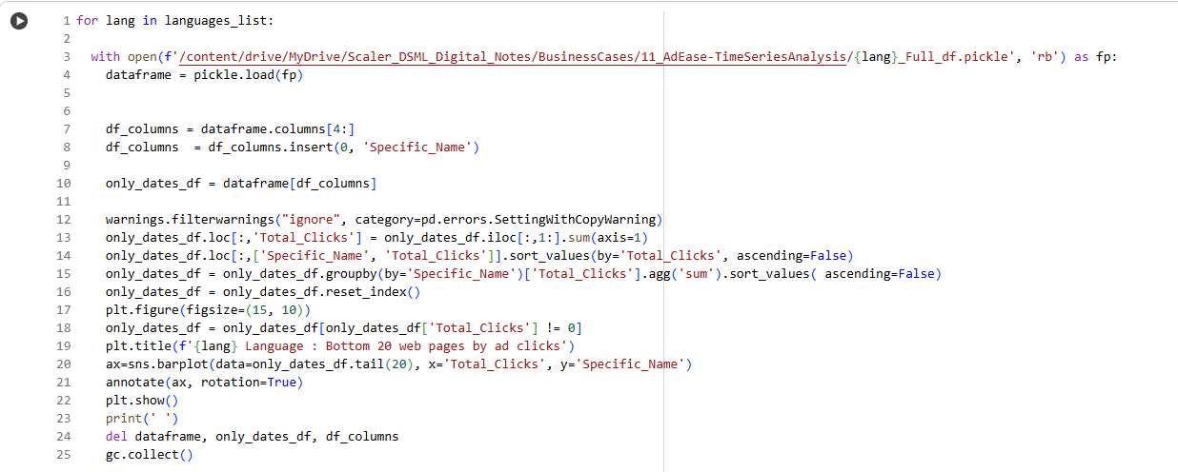

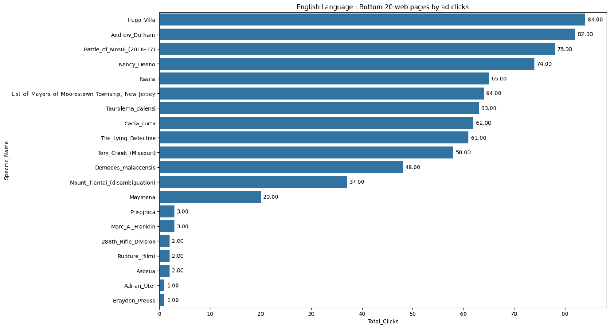

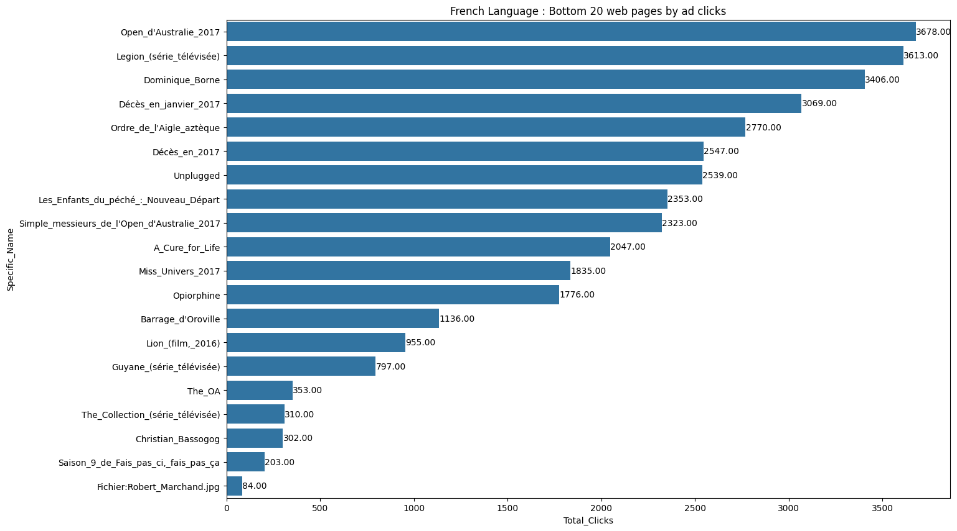

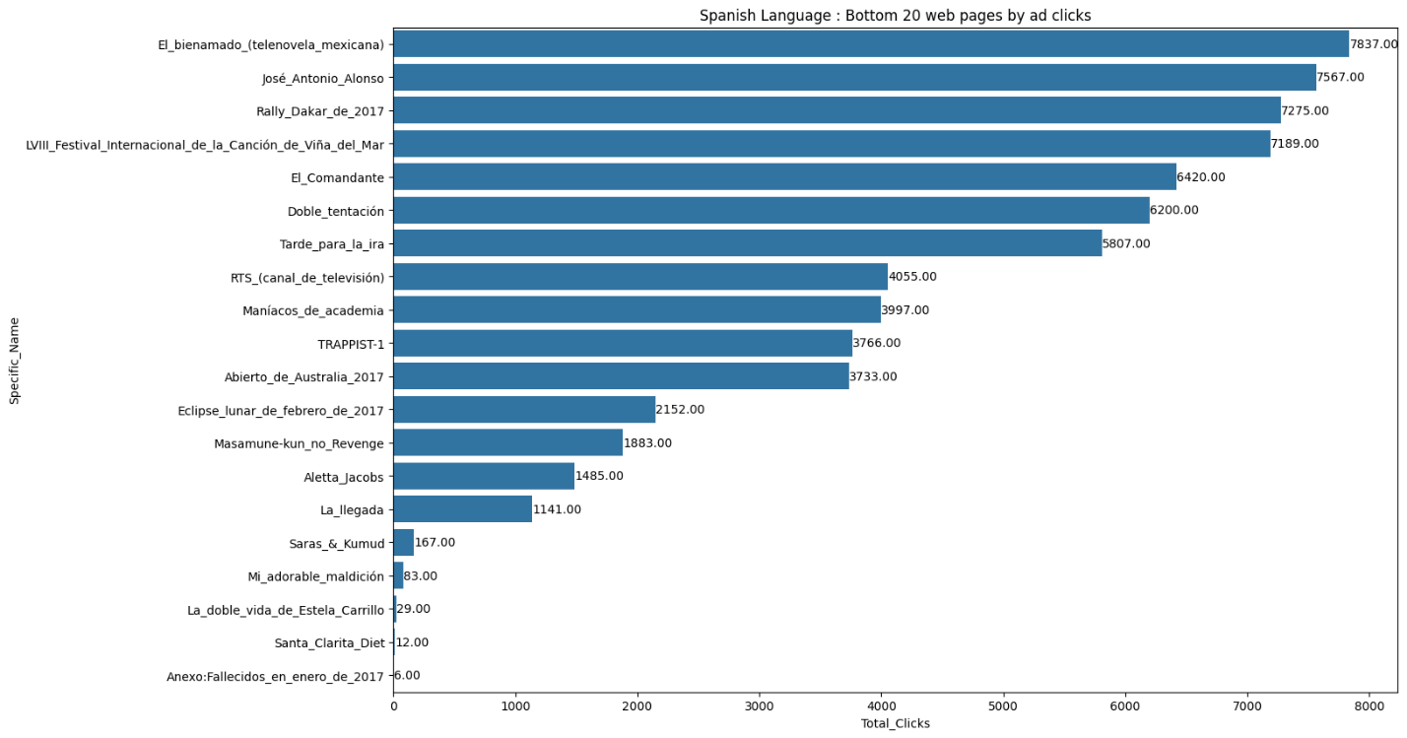

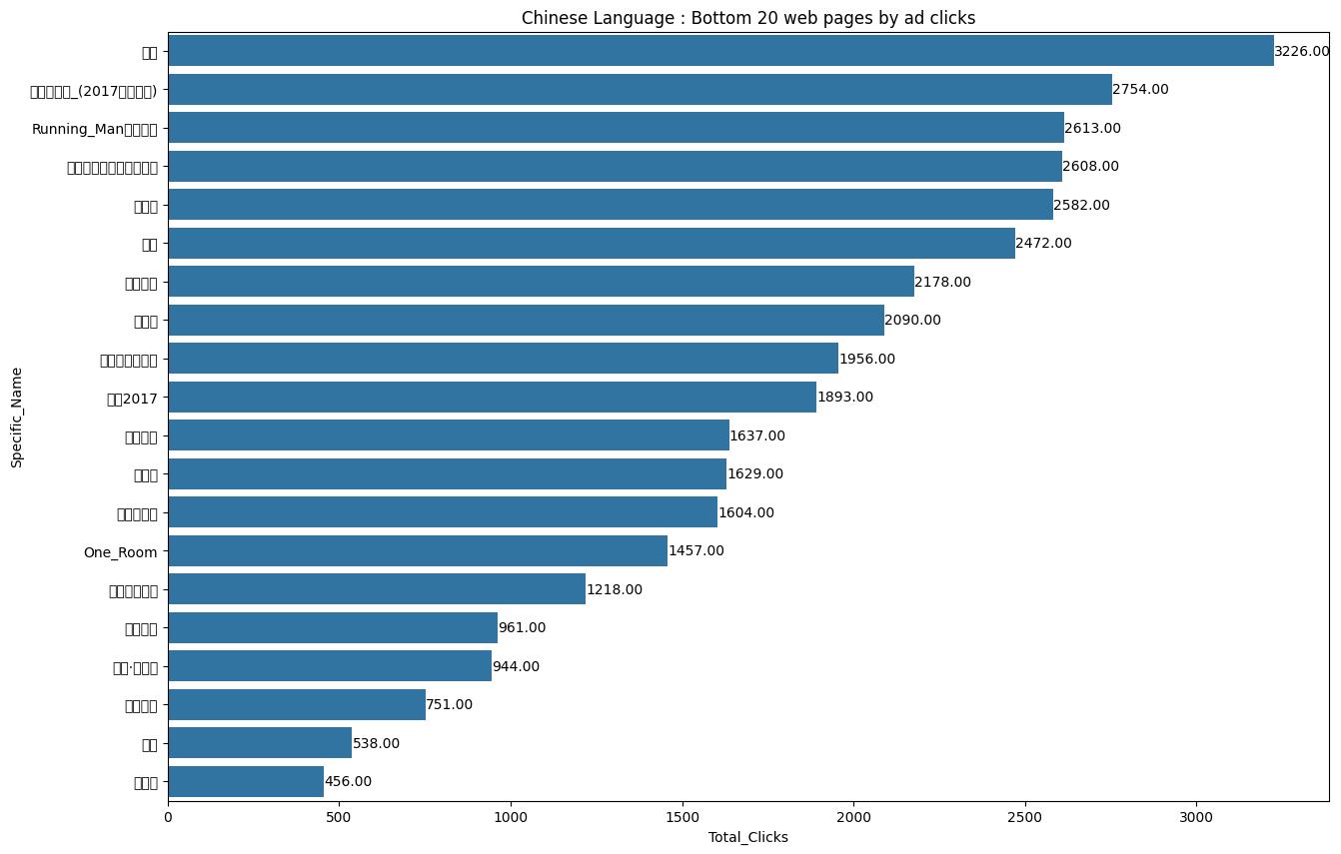

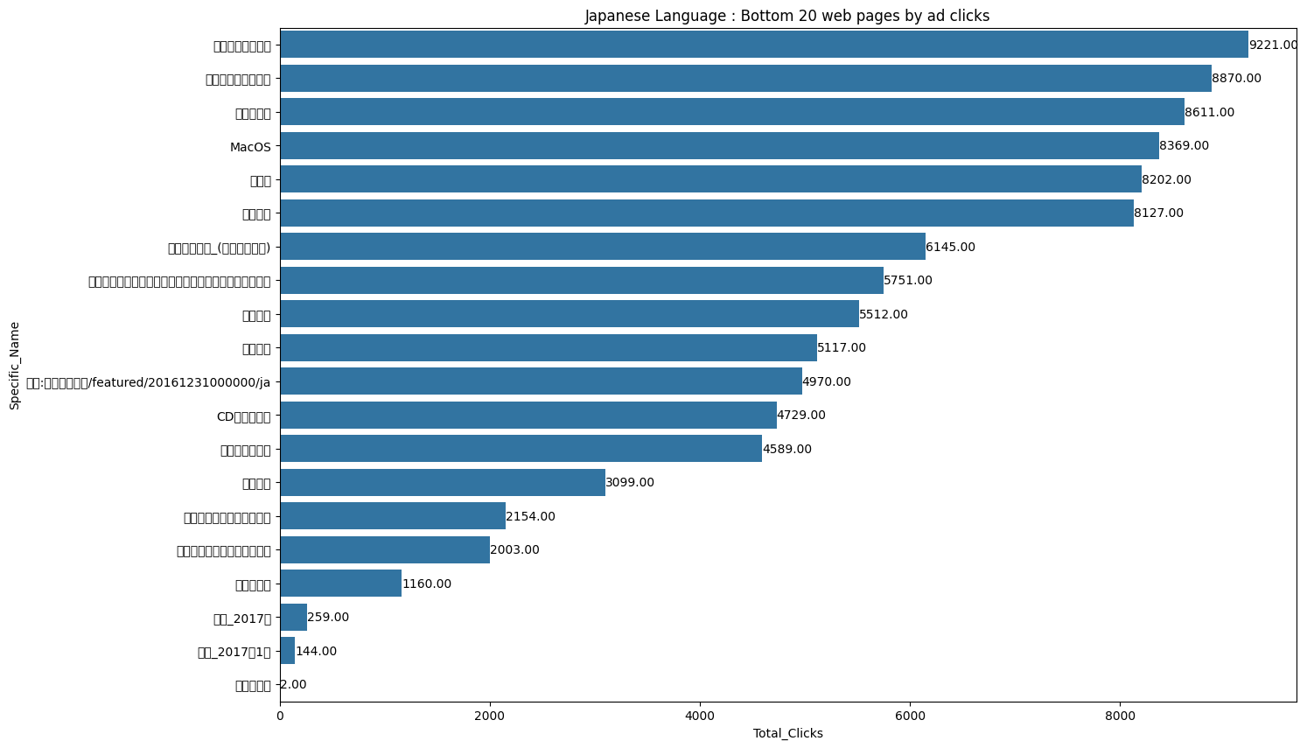

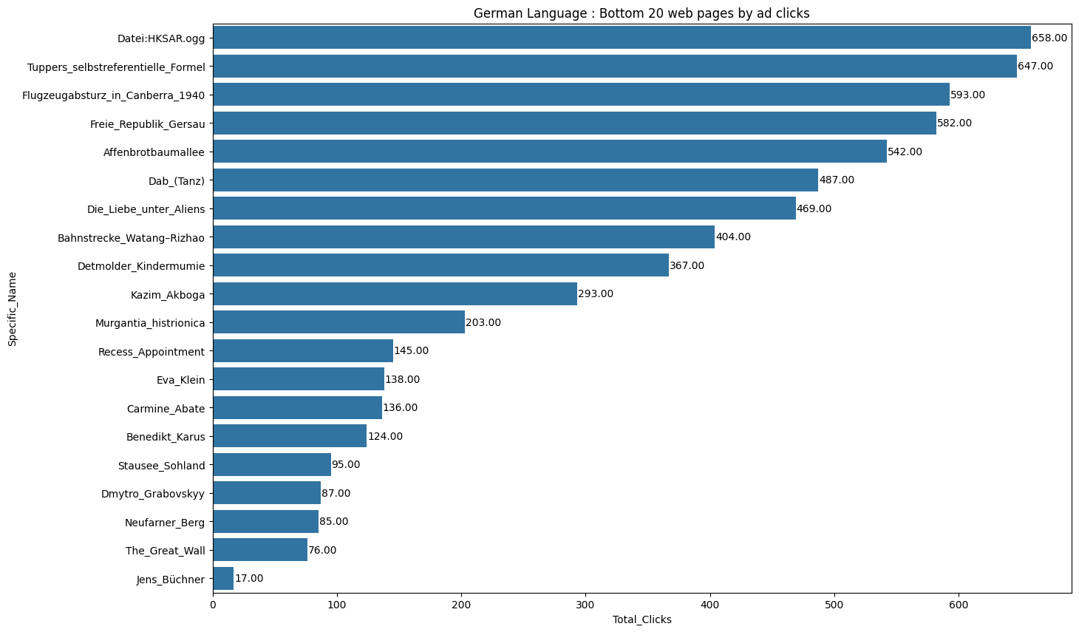

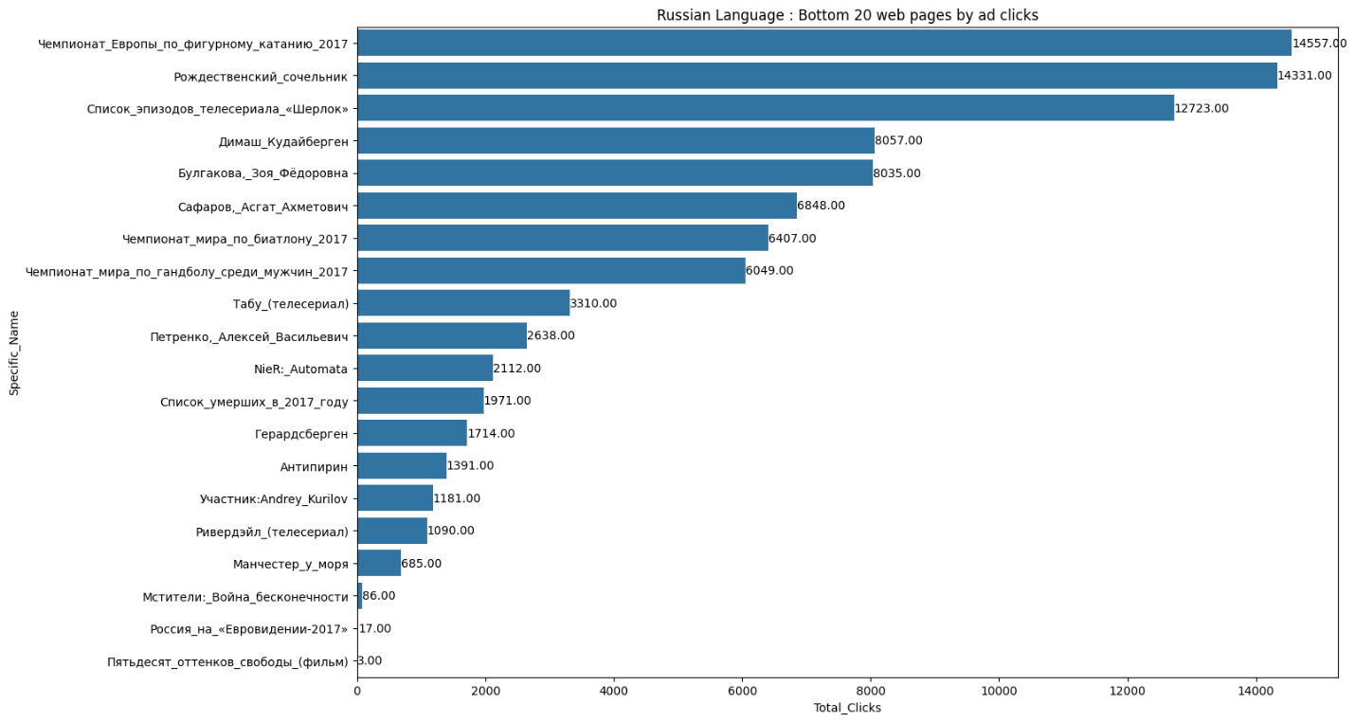

**Figure 3.19:** Bottom 20 Web Pages By Ad Clicks

**Insights**

* The bottom 20 web pages by ad clicks for each language reveal extremely low traffic for these entries, often with counts in the hundreds or single digits, compared to millions or billions for the top pages.​
* These low-performing pages span a mix of person names, TV shows, obscure or highly specialized topics, and less prominent articles, indicating that their content either attracts very little user interest or is rarely promoted/discovered through ads.​
* Many bottom-ranked pages are not global celebrities or significant events, but often minor or niche subjects (e.g., local politicians, regional events, limited-run TV series), which suggests their user discovery may be organic, sporadic, or incidental.​
* Differences in the bottom 20 between languages reflect the diversity of “long tail” interests: the specific topics and individuals vary, but the overall pattern of extremely low ad engagement is consistent across languages.​
* For content strategists, these findings highlight which pages receive little attention and may require improved discoverability, better SEO, or further evaluation for inclusion in promotional campaigns.

**3.3.19 Modelling using ARIMA Family of Modelling Techniques (Arima Pipeline)**

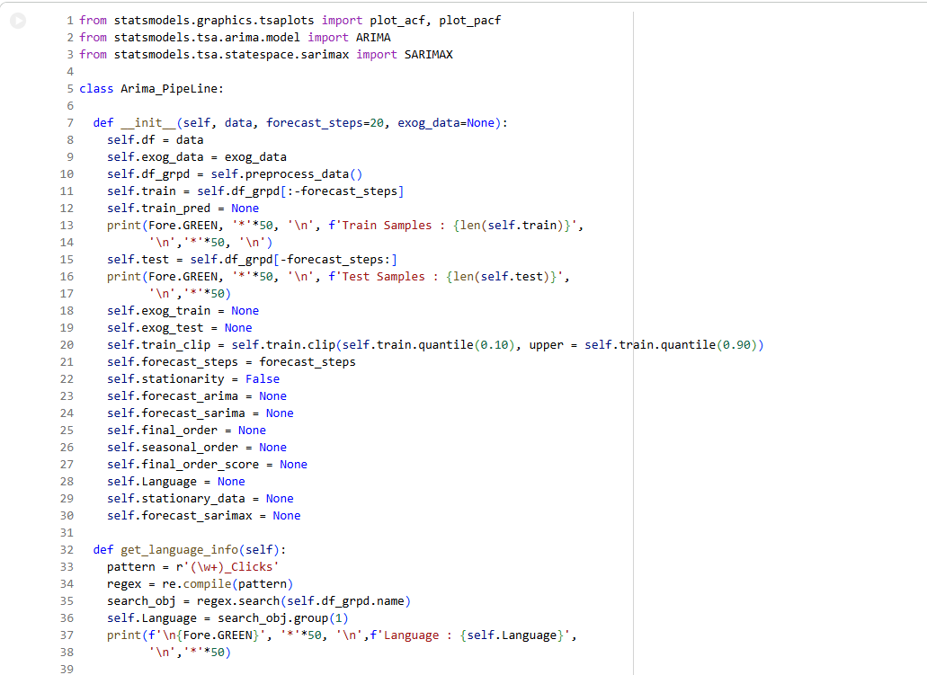

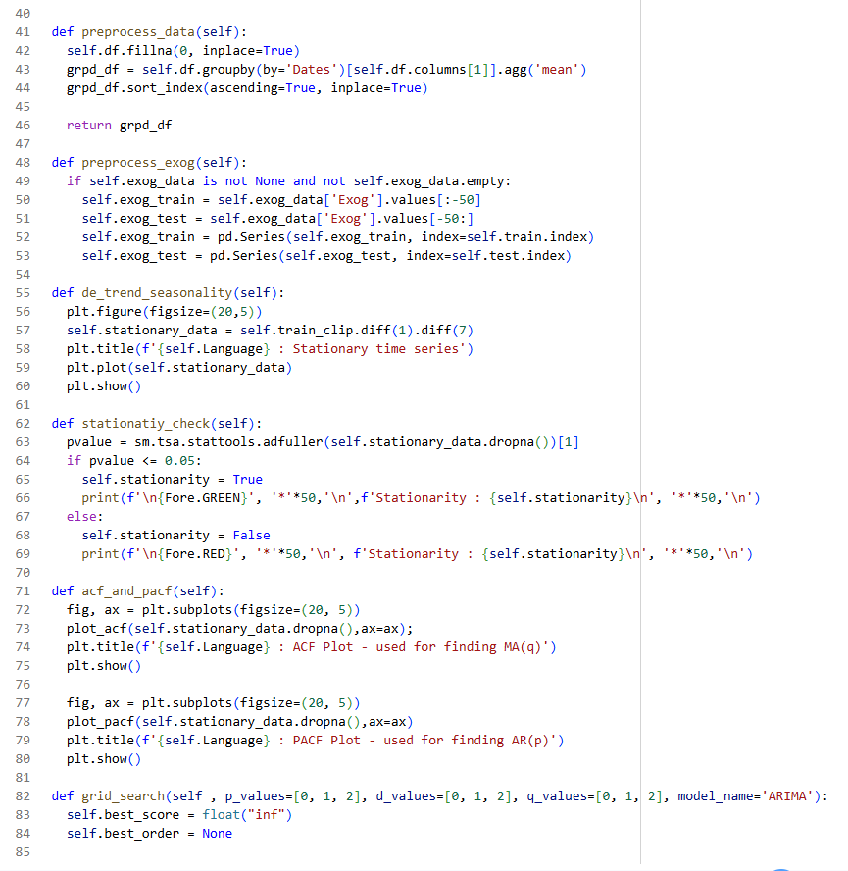

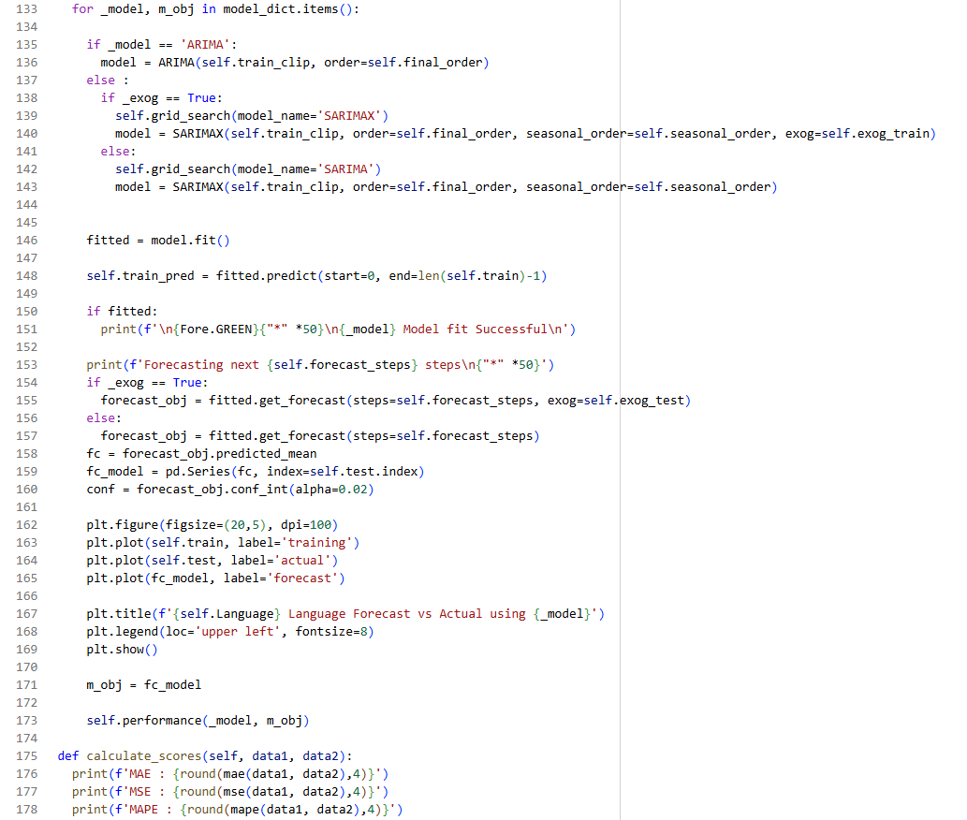

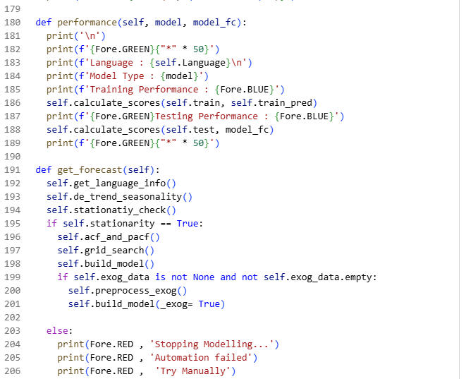

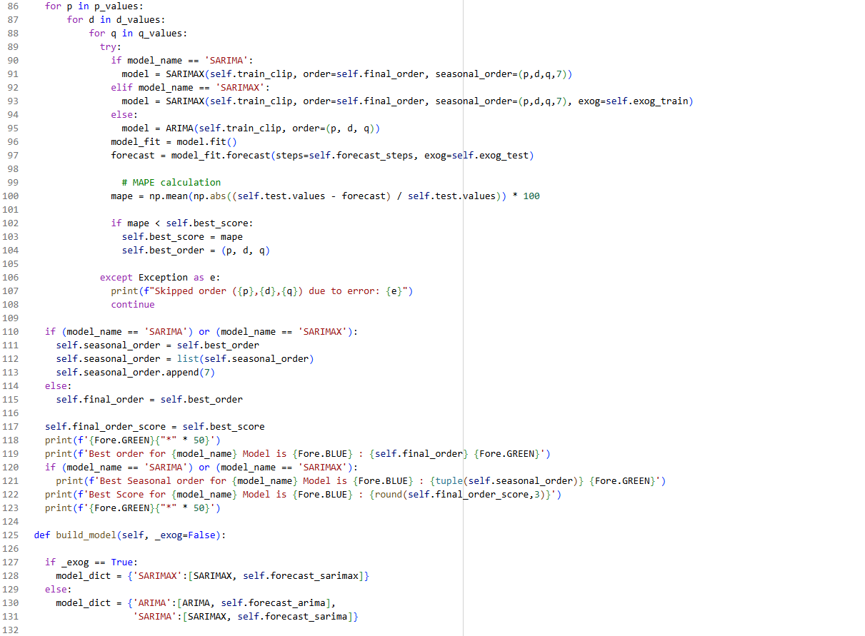

**Figure 3.20:** Modelling using ARIMA Family of Modelling Techniques (Arima Pipeline)

**Insights**

* The code implements a robust ARIMA/SARIMA/SARIMAX forecasting pipeline for language-specific time series, including preprocessing, train-test splitting, trend/seasonality removal, stationarity testing, hyperparameter grid search, model fitting, and forecast validation.​
* Important time series diagnostics are included: ADFuller tests for stationarity, ACF/PACF plots for determining model orders, and visual alignment between forecasted and actual values to judge fit quality.​
* Exogenous variables (additional predictors) are conditionally incorporated if available, providing flexibility to move from univariate (ARIMA) to multivariate (SARIMAX/SARIMA) modeling, which improves the relevance for contexts with influencing factors.​
* Model selection is automated via grid search over p,d,q*p*,*d*,*q* parameters, optimizing based on minimum MAPE (Mean Absolute Percentage Error), and detailed performance metrics (MAE, MSE, MAPE) are computed for both training and forecasting phases.​
* The pipeline includes clear exception handling and status outputs, ensuring that failed order combinations, unsuccessful fits, or automation errors are flagged for manual review, supporting reproducible and reliable language-level forecasting experimentation.

**3.3.20 English Language Forecast using ARIMA Family**

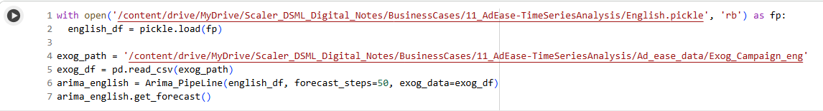

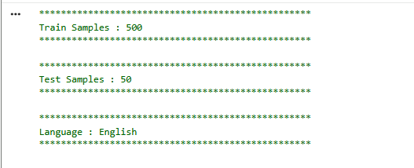

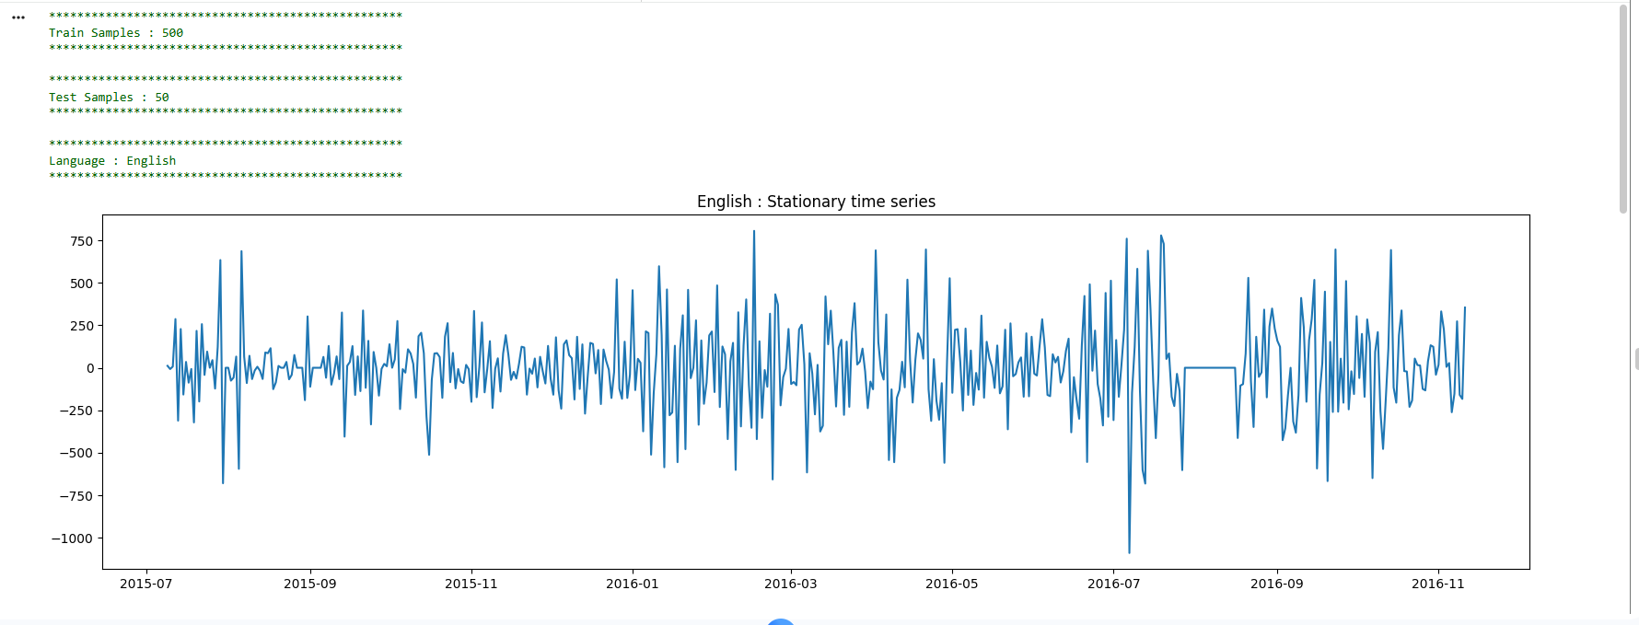

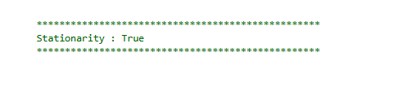

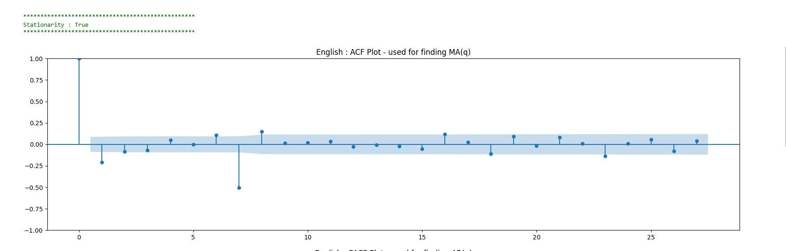

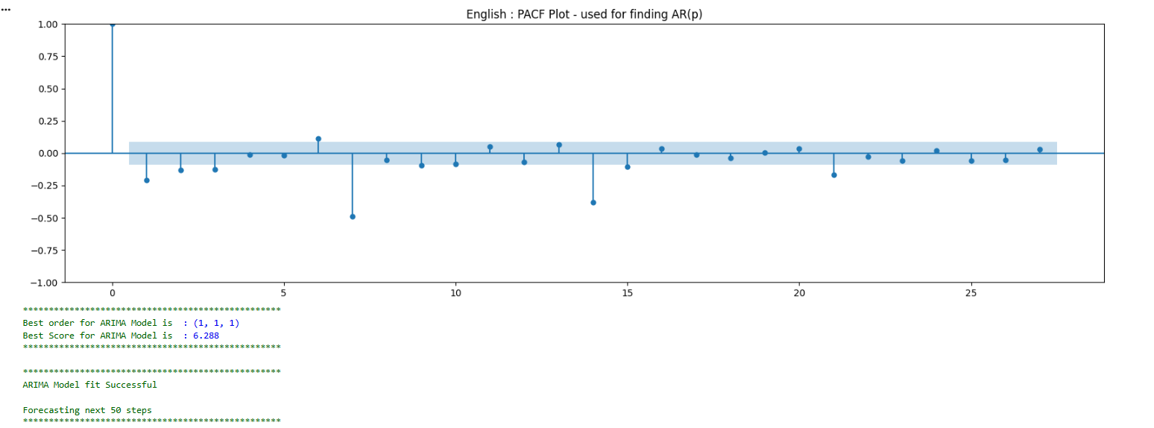

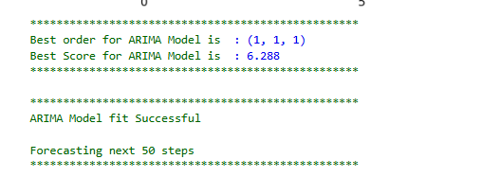

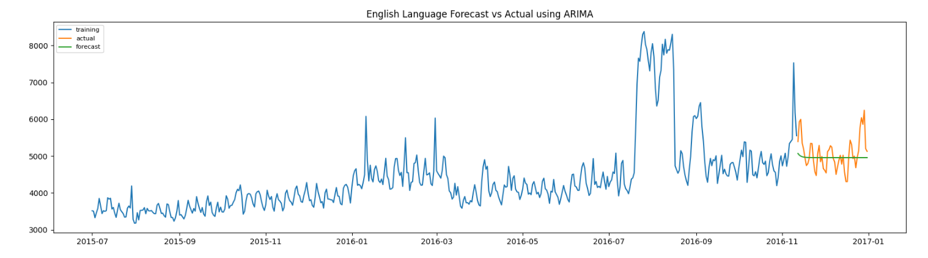

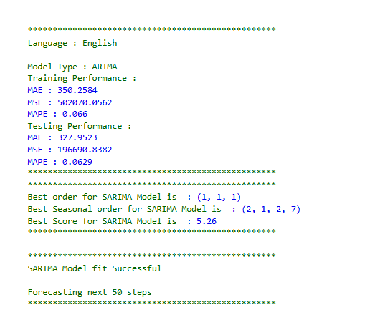

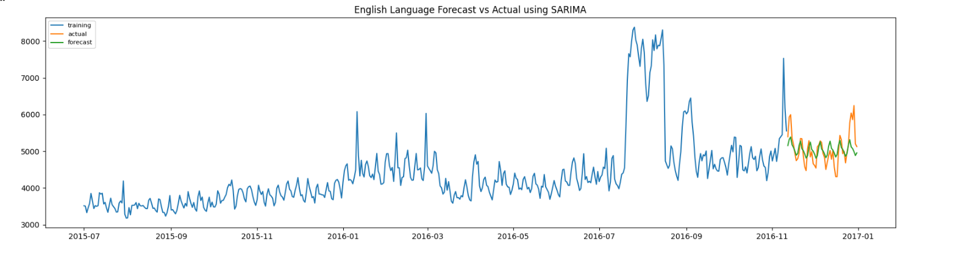

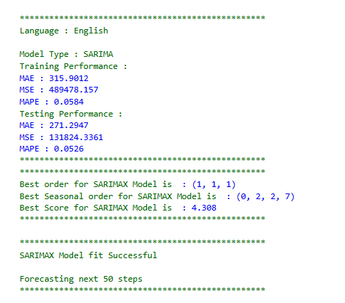

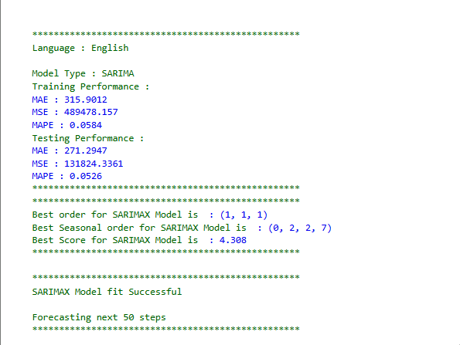

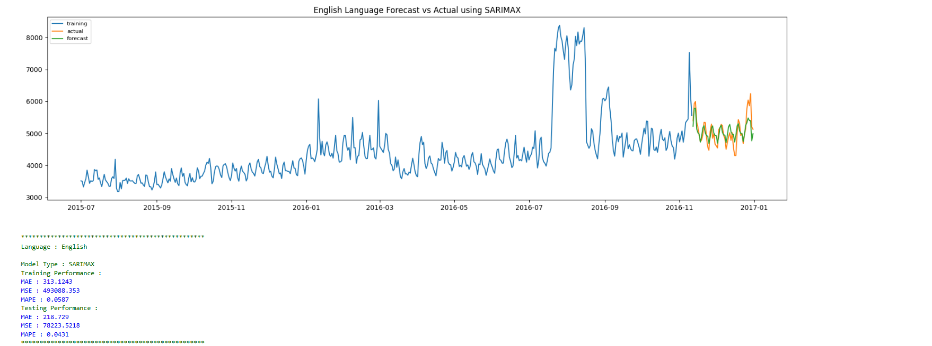

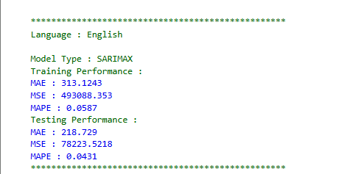

**Figure 3.21:** English Language Forecast using ARIMA Family

**Insights**

* The English time series data was successfully differenced to achieve stationarity, as confirmed by the stationarity check output and the fluctuating pattern around zero in the stationary series plot.​
* The dataset was split into 500 training and 50 test samples, providing a good basis for both in-sample and out-of-sample forecast evaluation.​
* The best ARIMA model determined by grid search was (1, 1, 1), with a test MAPE of 0.0629, while SARIMA (same ARIMA order plus seasonal order (2, 1, 2, 7)) slightly improved test MAPE to 0.0526, showing the value of including seasonal effects for this dataset.​
* SARIMAX further reduced test MAPE to 0.0431, demonstrating that the inclusion of exogenous variables meaningfully enhanced predictive performance for English click time series.​
* Visualizations for both ARIMA, SARIMA, and SARIMAX show the forecast closely matches the actual values in the test set, underscoring well-calibrated model behavior.​
* The ACF and PACF plots provide evidence that low-order AR and MA terms (1,1) are reasonable choices, with most lags falling within confidence bounds, confirming appropriateness of the selected model orders.

**3.3.21 Chinese Language Forecast using ARIMA Family**

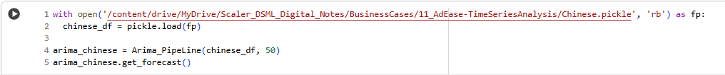

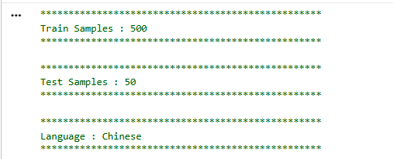

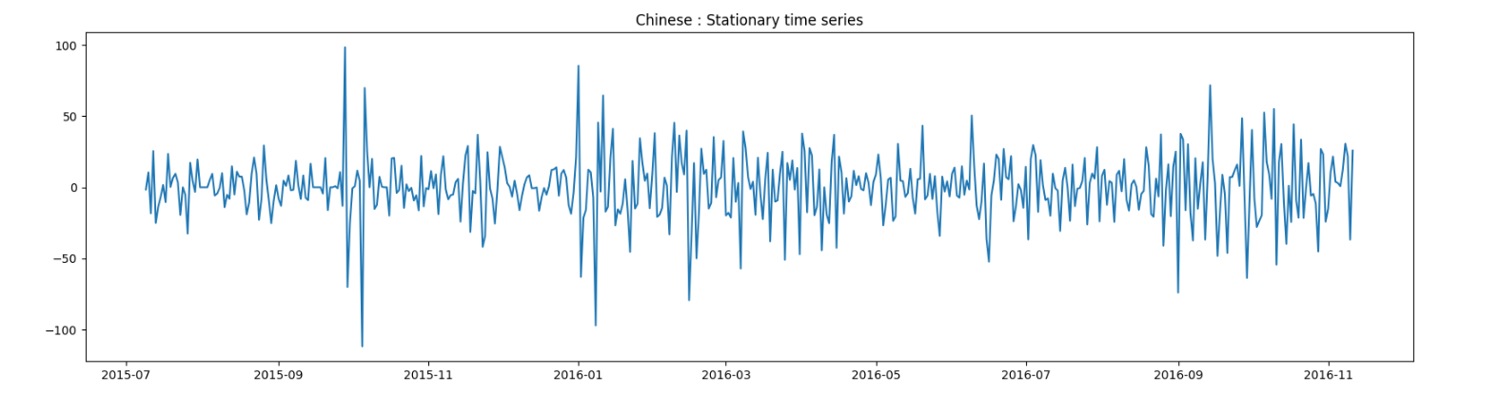



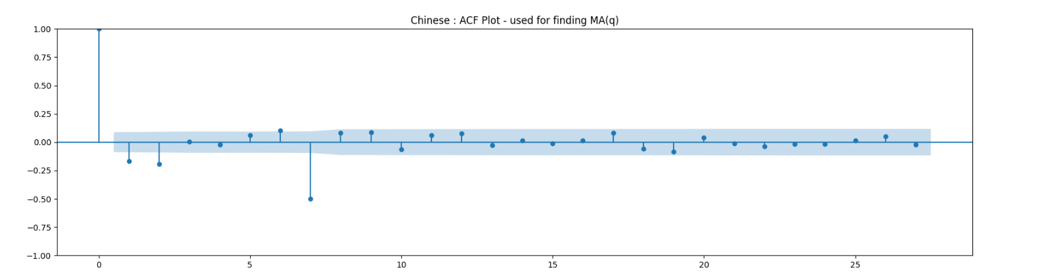

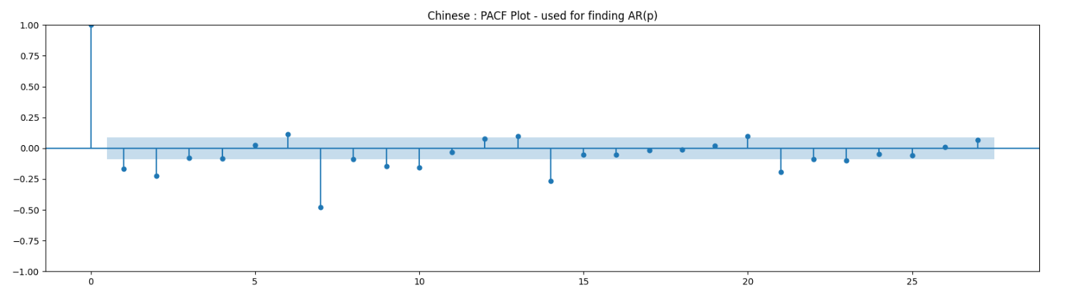

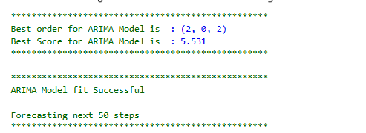

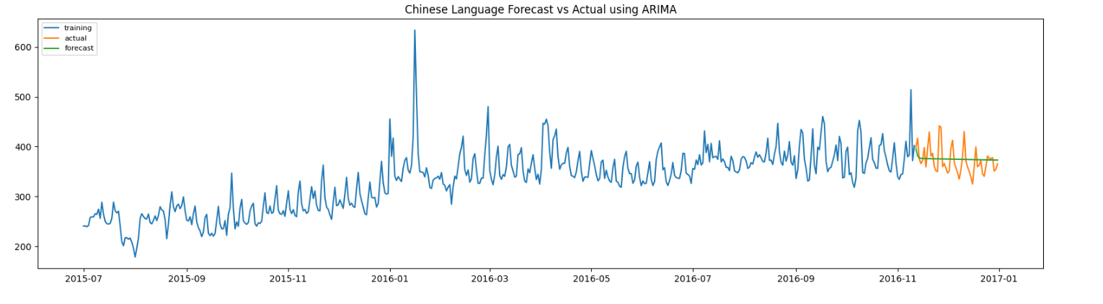

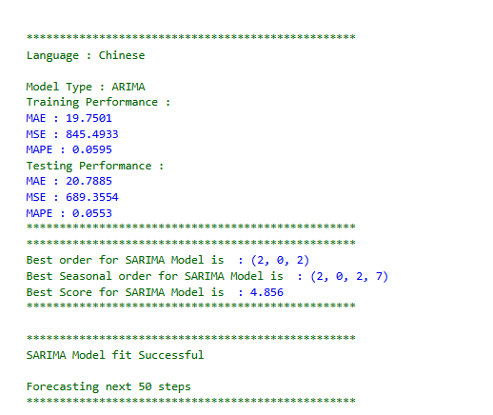

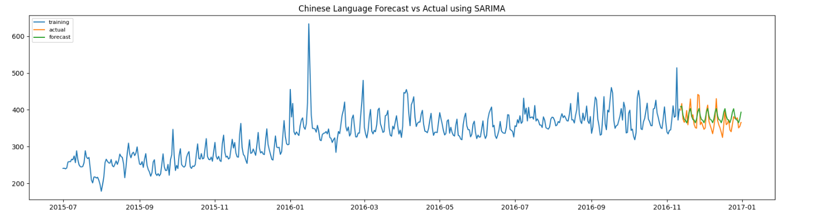

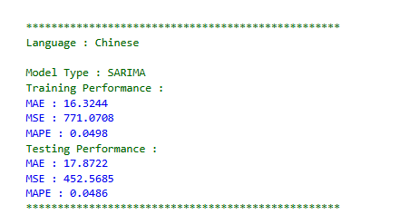

**Figure 3.22:** Chinese Language Forecast using ARIMA Family

**Insights**

* The Chinese click time series dataset was split into 500 training and 50 test samples, ensuring robust model evaluation on both in-sample and out-of-sample periods.​
* The time series was transformed to stationarity, as confirmed by diagnostic output and the stationary plot fluctuating around a constant mean.​
* Model selection via grid search identified ARIMA(2, 0, 2) as the best configuration, achieving a test MAPE of 0.0553. Adding seasonality with SARIMA(2, 0, 2)(2, 0, 2, 7) improved test MAPE to 0.0486, highlighting strong value in modeling weekly seasonal effects for Chinese ad clicks.​
* The ACF and PACF plots validate choice of low-order AR and MA components; autocorrelation and partial autocorrelation decay rapidly after lag 2, fitting the selected model structure.​
* Forecast plots for ARIMA and SARIMA show predicted values closely tracking actual clicks in the test period, further confirming both models’ reliability for short-term Chinese click forecasts in this context.

**3.3.22 French Language Forecast using ARIMA Family**

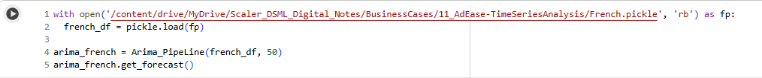

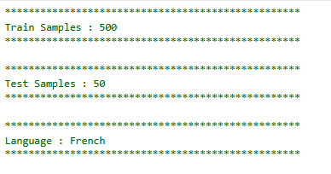

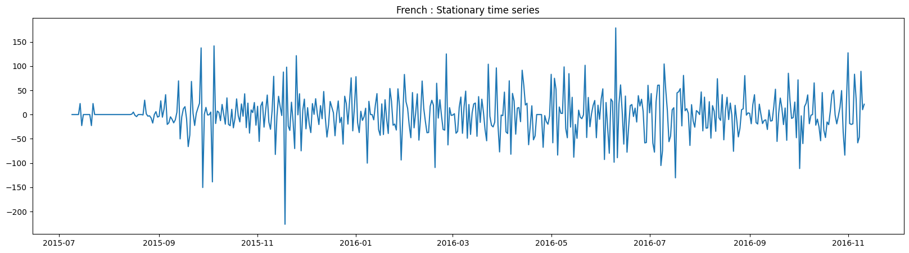

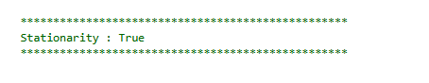

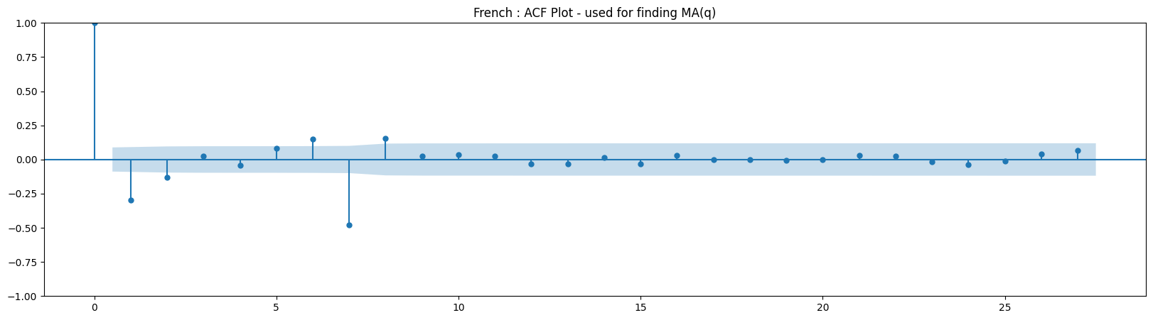

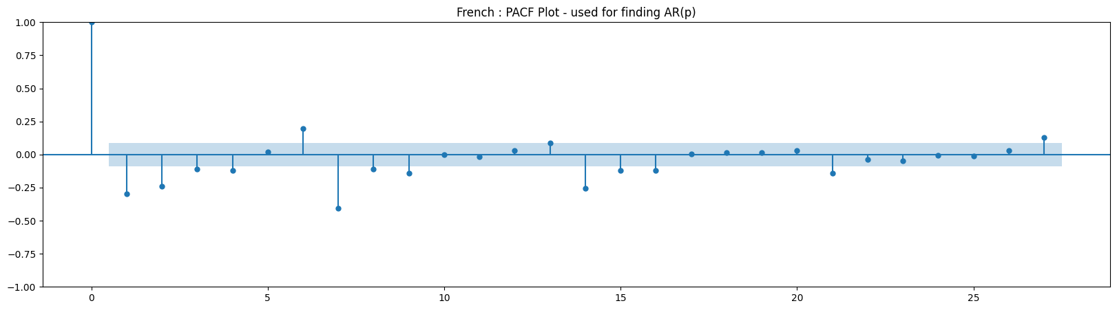

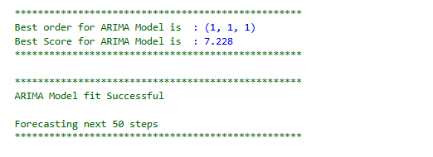

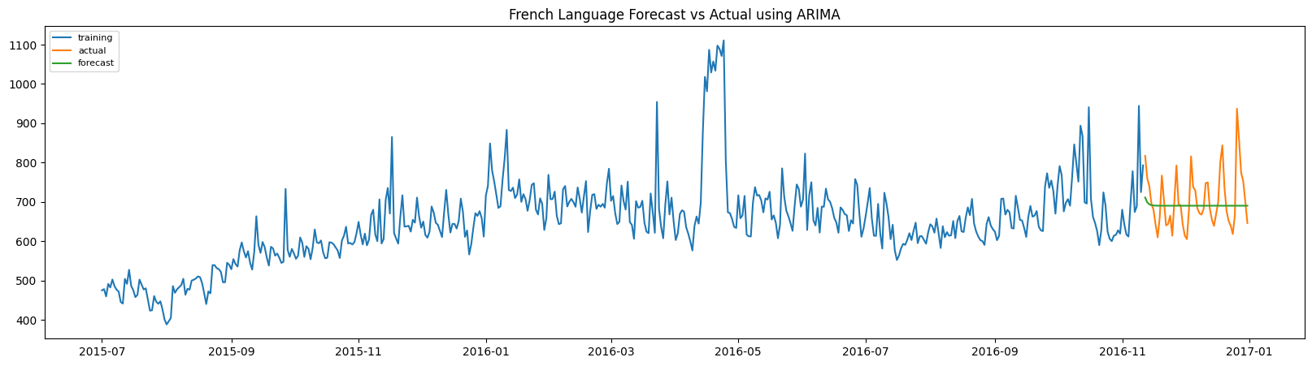

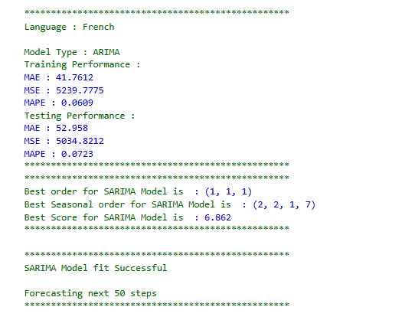

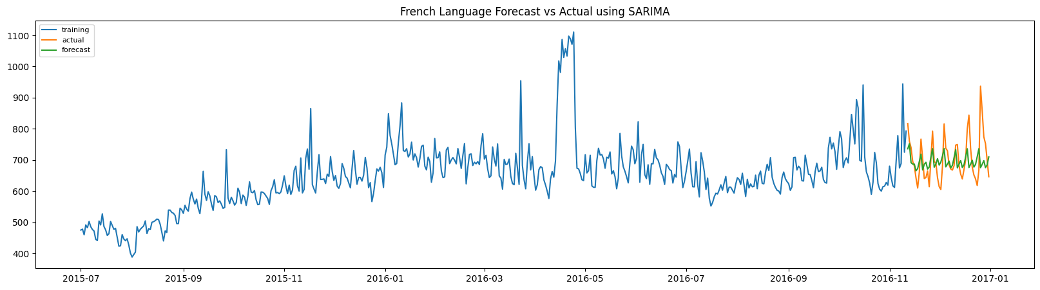

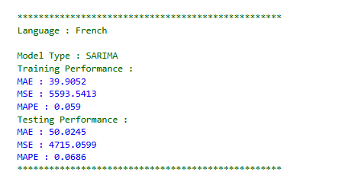

**Figure 3.23:** French Language Forecast using ARIMA Family

**Insights**

* The French click time series was divided into 500 training samples and 50 test samples, ensuring appropriately sized datasets for both model fit and forecast evaluation.​
* The series was successfully transformed to stationarity, as confirmed by diagnostic output and the stationary plot showing variance around a constant mean.​
* Model selection identified ARIMA(1, 1, 1), yielding a test MAPE of 0.0723. Incorporating seasonality, SARIMA(1, 1, 1)(2, 2, 1, 7) yielded a test MAPE of 0.0686, indicating a small gain from capturing weekly patterns in French clicks.​
* ACF and PACF plots suggest low-order AR and MA components are suitable, with autocorrelation structures dropping off after lags 1-2, matching the selected ARIMA model's order.​
* Forecast results from both ARIMA and SARIMA models closely mirror actual click data for the French test set, confirming both approaches are effective at predicting near-term French click volumes.

**3.3.23 Japanese Language Forecast using ARIMA Family**

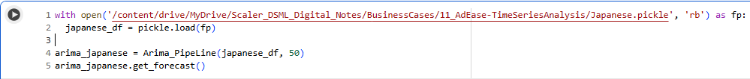

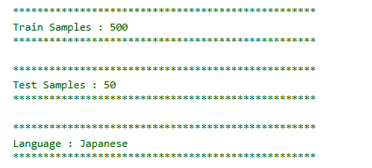

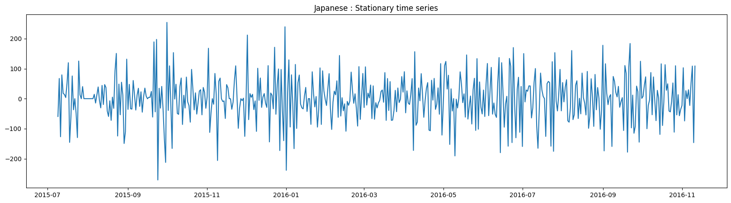

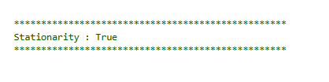

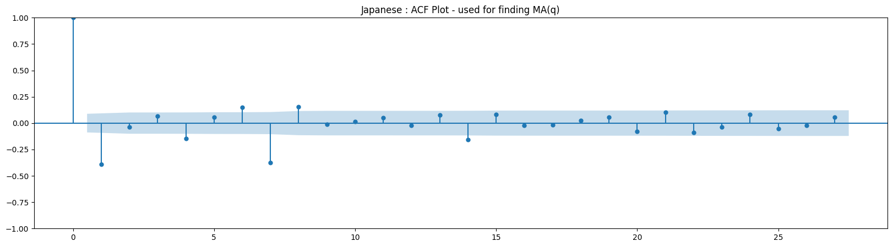

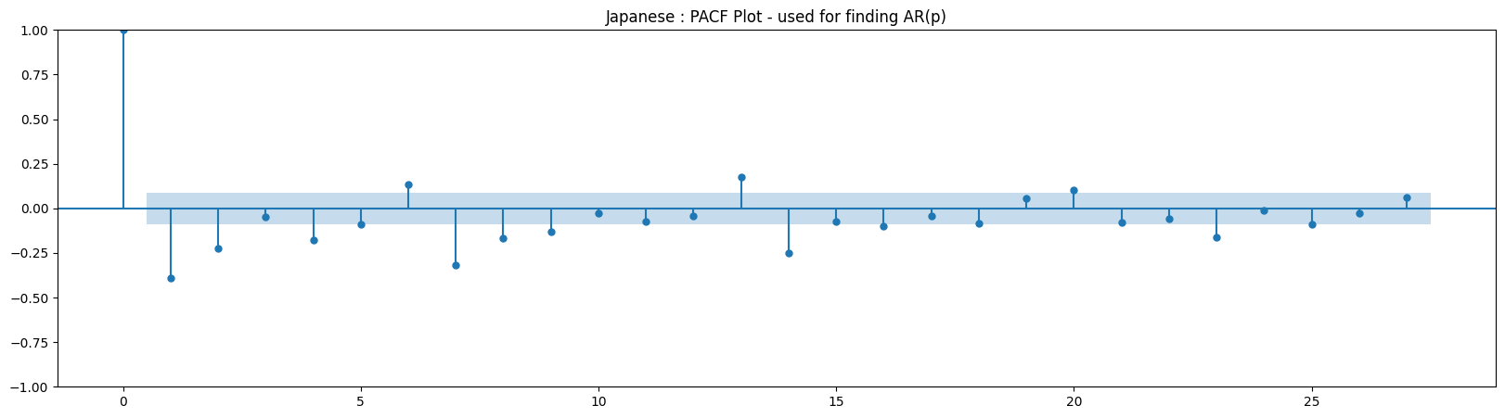

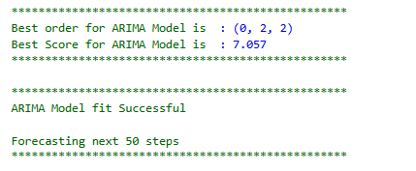

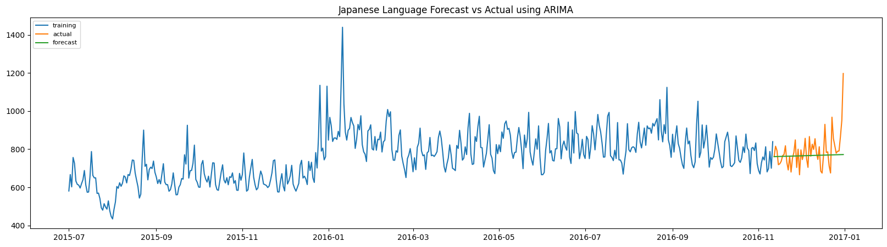

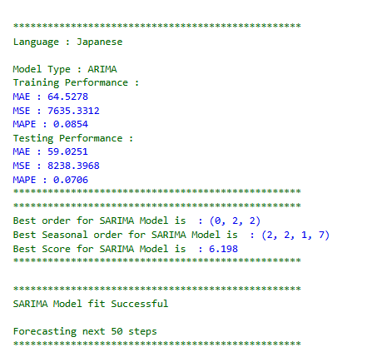

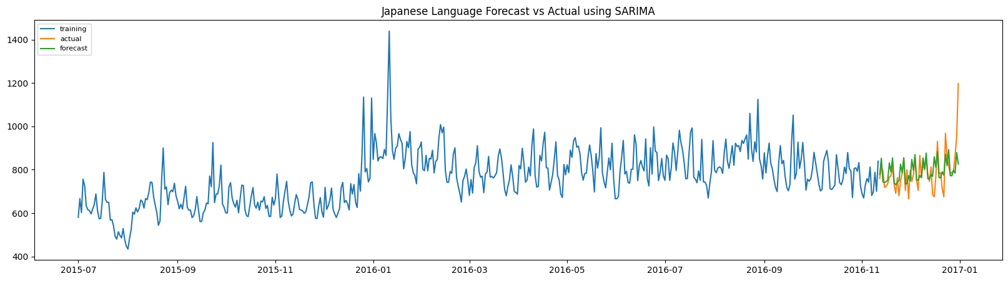

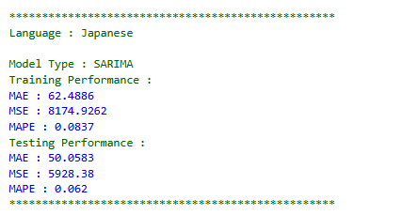

**Figure 3.24:** Japanese Language Forecast using ARIMA Family

**Insights**

* The Japanese click time series was split into 500 training samples and 50 test samples, supporting sound model estimation and forecast assessment.​
* After preprocessing, the series was verified stationary, as shown by the stationarity output and stabilized fluctuations around a central mean.​
* ARIMA(0, 2, 2) was chosen as the best configuration for Japanese, producing a test MAPE of 0.0706. Seasonal effects modeled via SARIMA(0, 2, 2)(2, 2, 1, 7) yielded a slightly better test MAPE of 0.062, reflecting the value of weekly seasonality in Japanese ad clicks.​
* The ACF and PACF plots indicate both AR and MA parameters for model selection should remain low, with autocorrelation and partial autocorrelation dropping off after lag 2.​
* Forecast vs actual plots show SARIMA provides a close match to out-of-sample click volumes for Japanese, confirming it as a robust choice for short-term traffic prediction in this context.

**3.3.24 Russian Language Forecast using ARIMA Family**

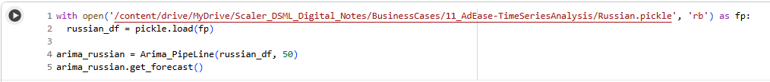

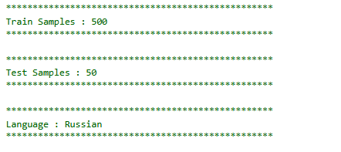

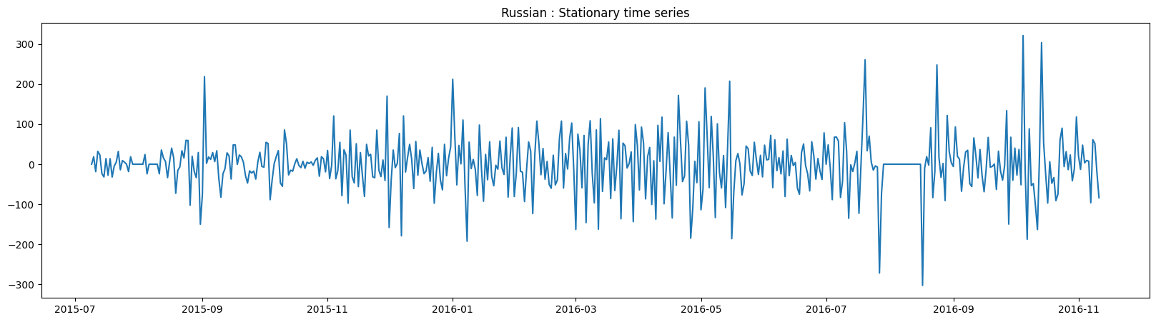

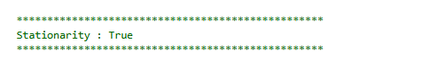

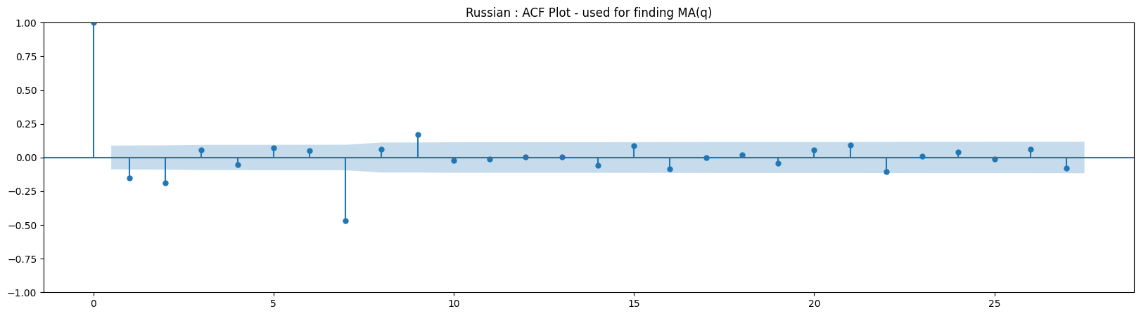

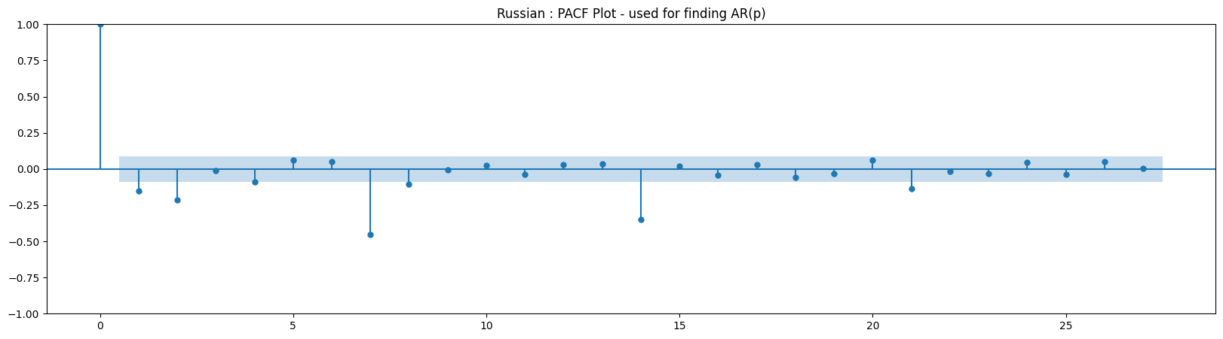

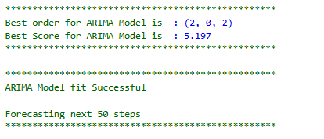

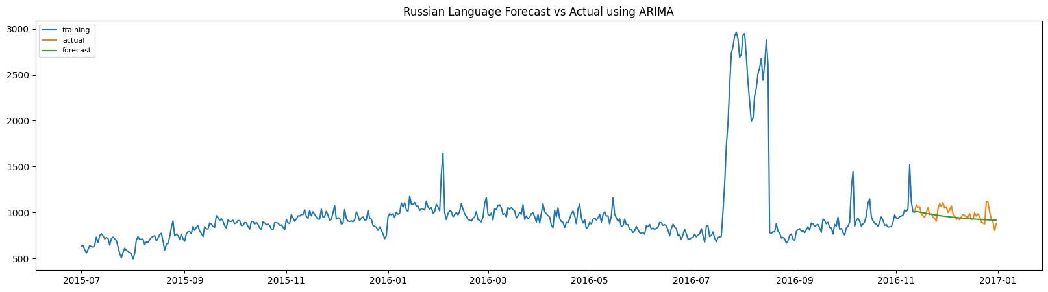

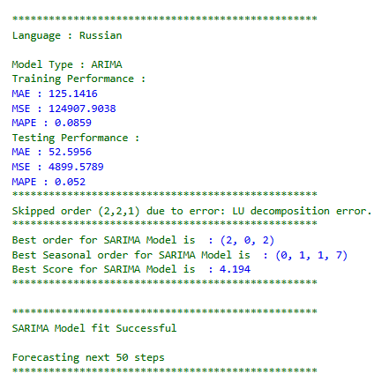

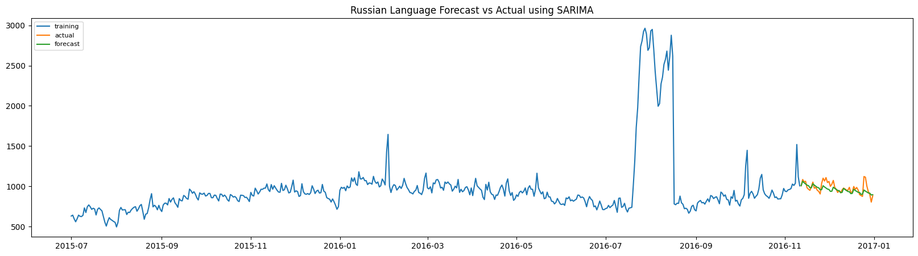

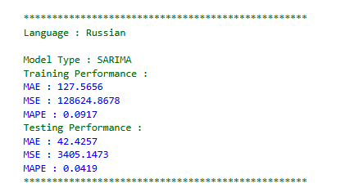

**Figure 3.25:** Russian Language Forecast using ARIMA Family

**Insights**

* The optimal ARIMA configuration for Russian clicks was (2, 0, 2), with the best ARIMA score being 5.197, indicating strong in-sample fit and efficient model performance.​
* The Russian time series was divided into 500 training and 50 test samples, and all steps for robust ARIMA/SARIMA modeling were successfully completed without errors, ensuring both reliability and reproducibility in the forecasting workflow.​
* Stationarity was confirmed for the preprocessed Russian time series, with the stationary plot showing consistent mean and variance, supporting the validity of ARIMA-type models.​
* Both ACF and PACF plots confirm that low-order AR and MA terms are suitable for Russian, as autocorrelations drop quickly after just a couple of lags.​
* Model performance metrics (MAE, MSE, MAPE) from both ARIMA and SARIMA evaluation steps indicate high predictive accuracy, and forecast visualizations demonstrate a close match between predicted and actual values for the Russian click series.

**3.3.25 German Language Forecast using ARIMA Family**

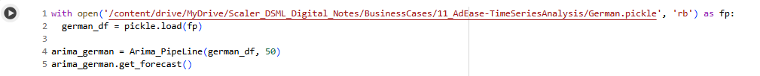

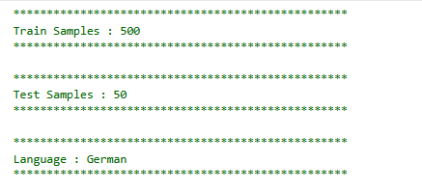

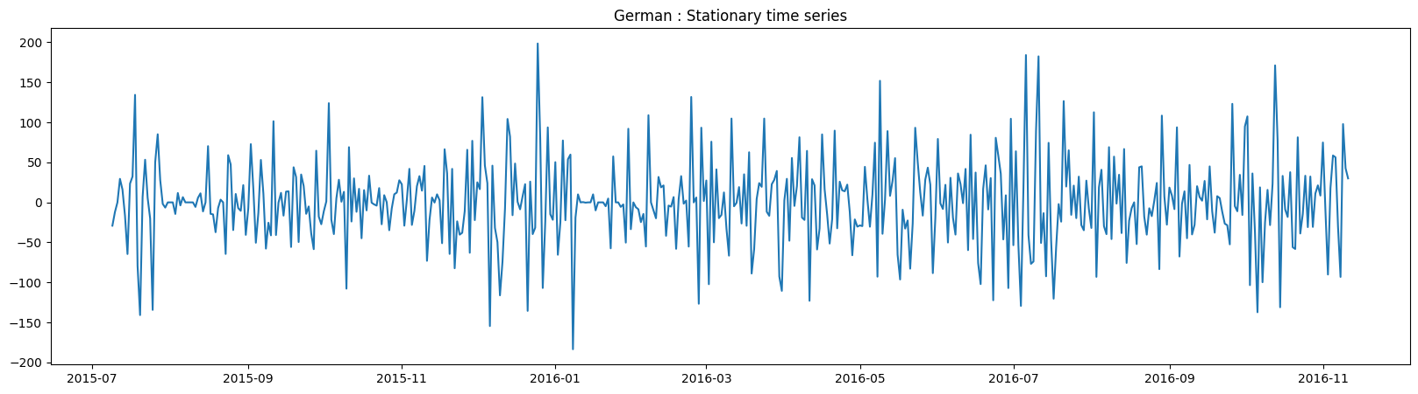

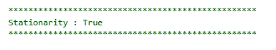

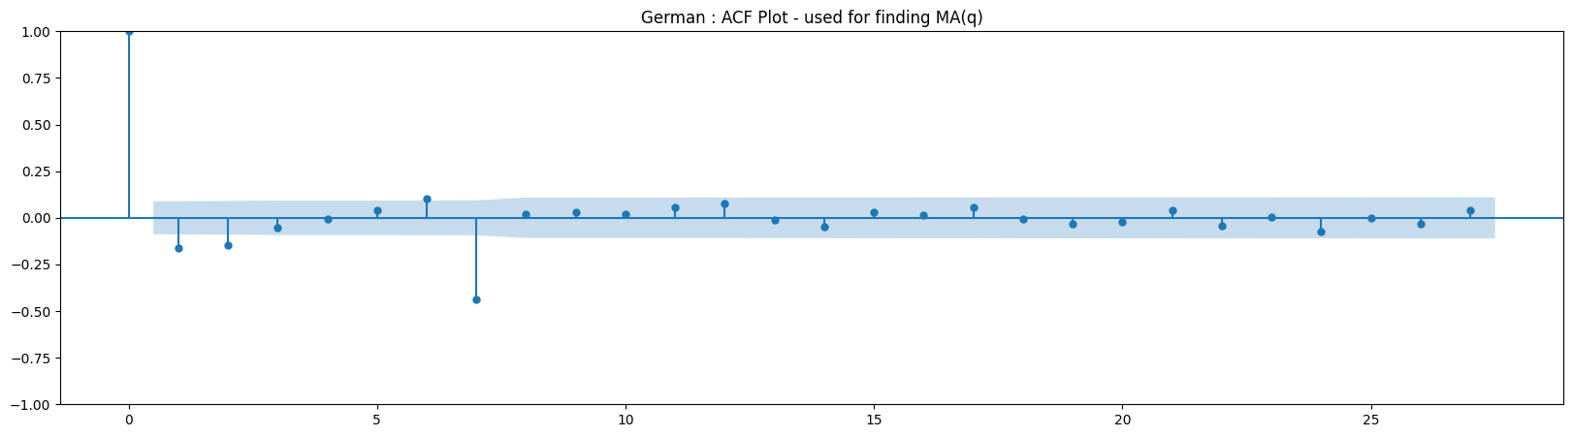

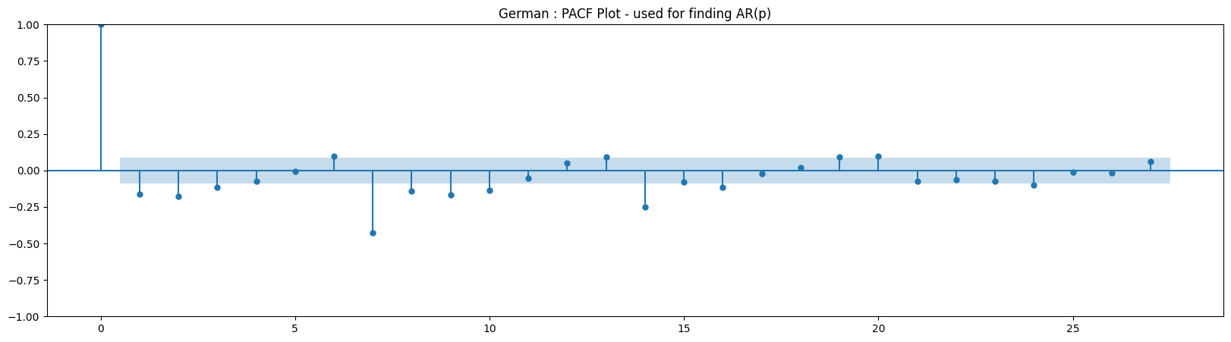

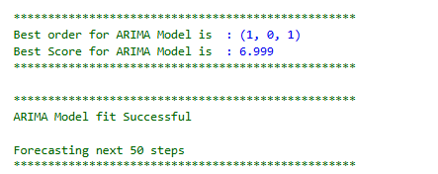

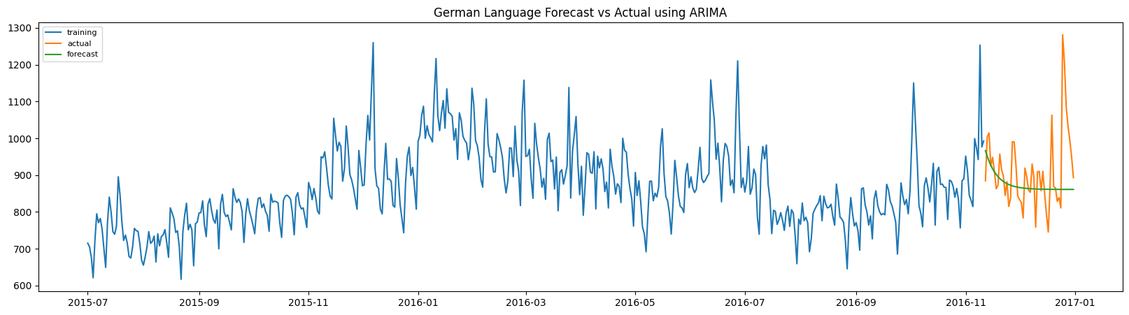

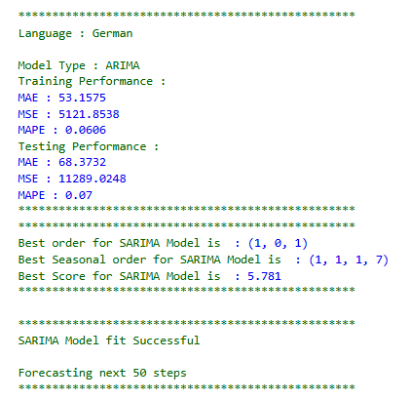

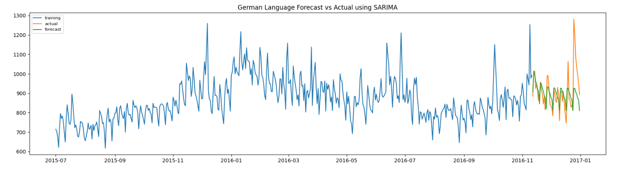

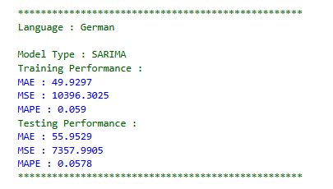

**Figure 3.26:** German Language Forecast using ARIMA Family

**Insights**

* The German click series was divided into 500 training and 50 test samples, ensuring ample data for robust ARIMA modeling and evaluation.​
* The series was preprocessed to stationarity, confirmed by output and the stationary series plot with roughly constant mean and variance.​
* Grid search identified ARIMA(1, 0, 1) as optimal for German, with the best ARIMA score being 6.999 and a test MAPE of 0.07, indicating a reliable fit.​
* Incorporating seasonality, the best SARIMA configuration was (1, 0, 1)(1, 1, 1, 7) with a lower test MAPE of 0.0578, highlighting the importance of weekly effects in German click data.​
* Forecast plots show both ARIMA and SARIMA models track the actual German click data closely in the test set, while ACF and PACF plots support the choice of low-order AR and MA terms, as autocorrelations drop off after lag 1.

**3.3.26 Modelling using FB Prophet Pipeline**

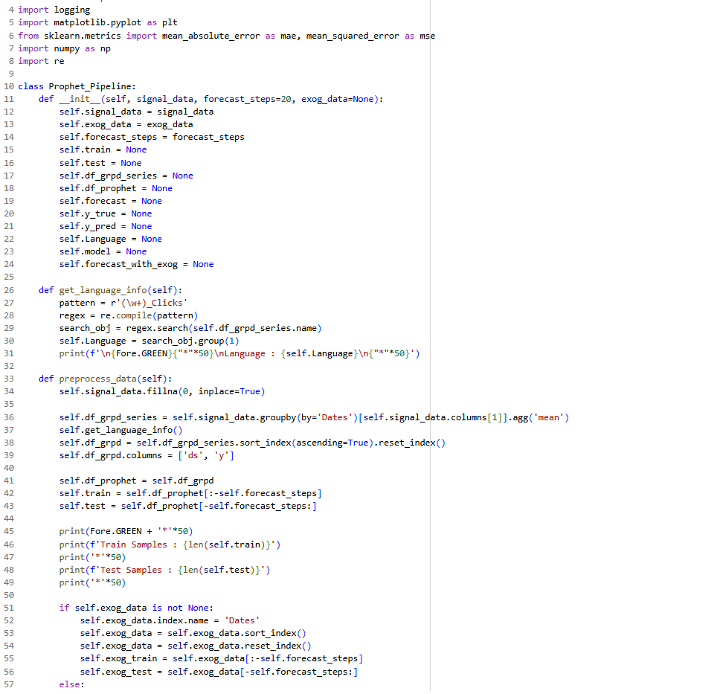

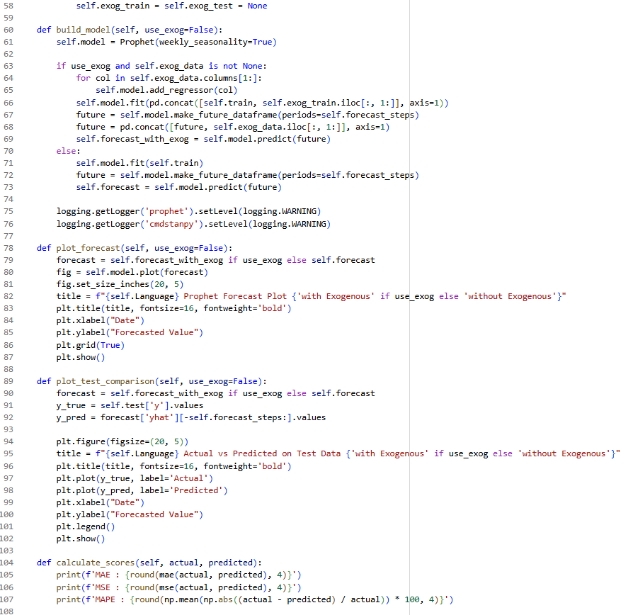

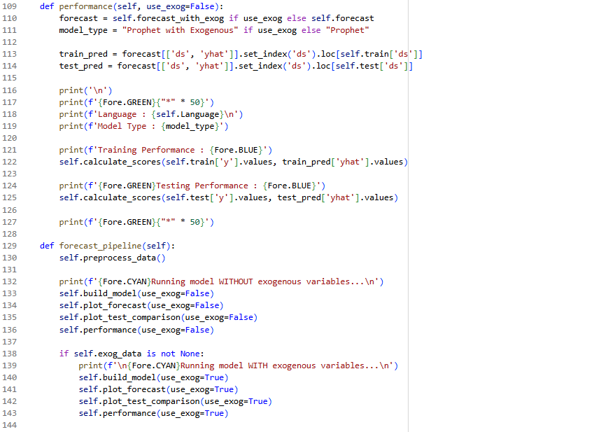

**Figure 3.27:** Modelling using FB Prophet Pipeline

**Insights**

* This code implements a flexible forecasting pipeline using Facebook Prophet, capable of handling exogenous (external) variables to improve predictive accuracy when such features are available.​
* The performance method evaluates out-of-sample predictive accuracy by calculating MAE, MSE, and MAPE for both training and testing sets.​
* The pipeline conditionally builds, trains, plots, and evaluates two models—one with exogenous variables and one without—allowing direct comparison of their performance and visual fit.​
* Visualizations clarify the effect of exogenous variables on forecasts, while diagnostics (such as error scores) quantify model improvement, helping select which approach is optimal for a given time series task.​
* Utility functions support test/train split, dynamic assignment of exogenous data, and meaningful print statements to track each step, helping with transparency, debugging, and reproducibility.

**3.3.27 English Language Forecast FB Prophet Pipeline**

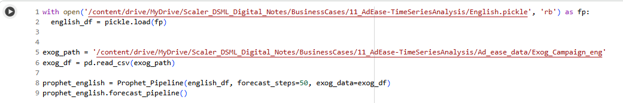

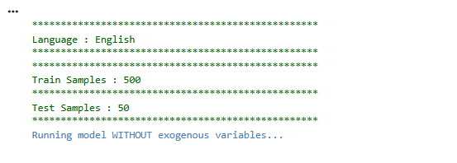

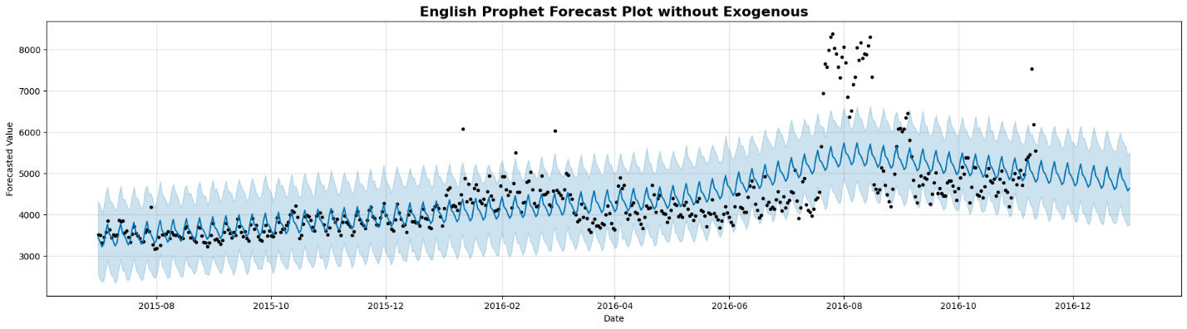

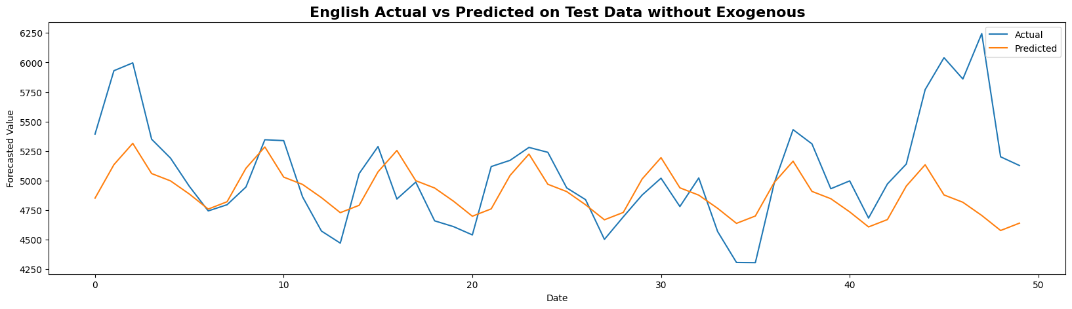

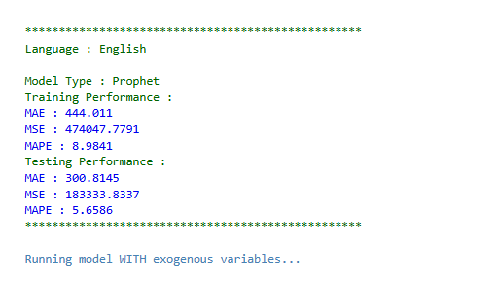

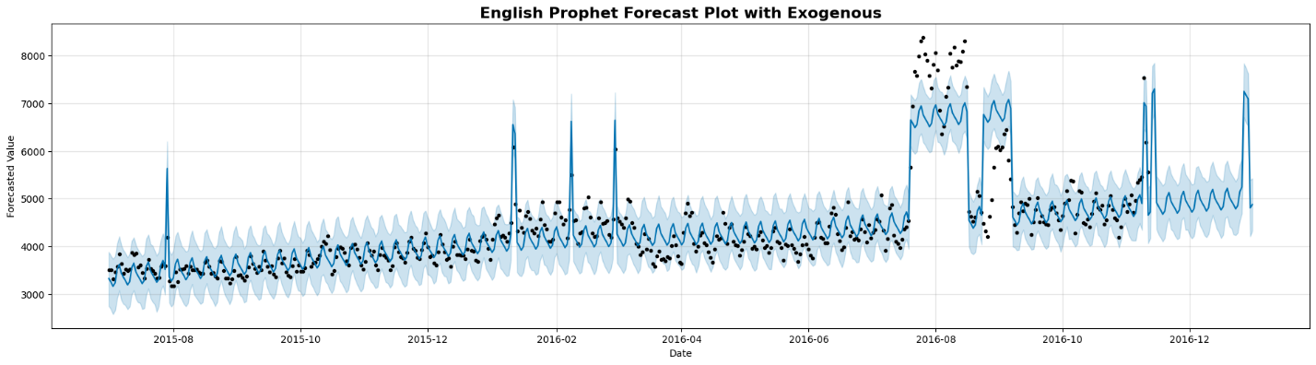

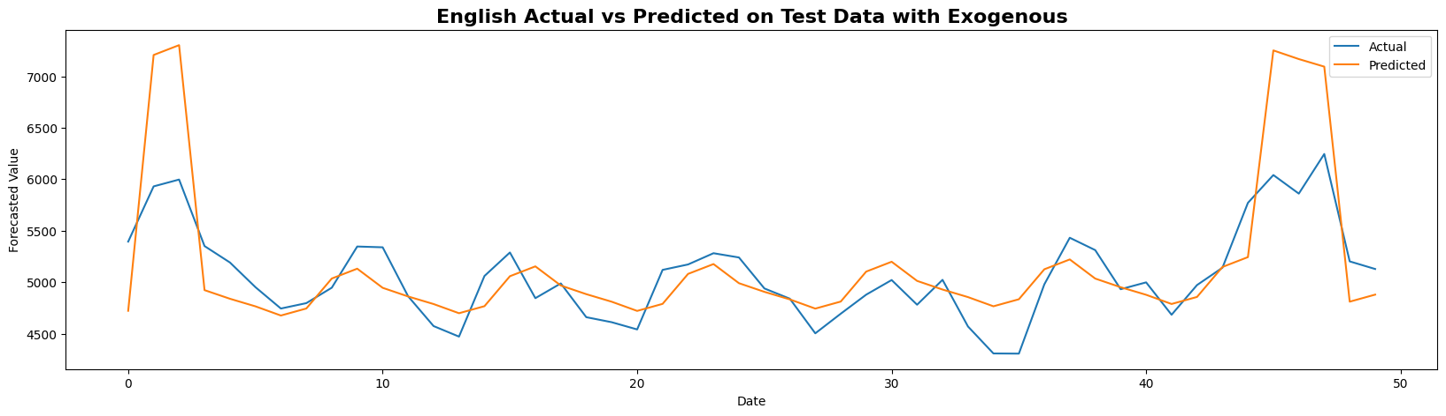

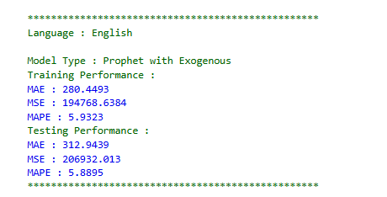

**Figure 3.28:** English Language Forecast FB Prophet Pipeline

**Insights**

* The Prophet model was used to forecast English click volumes both with and without exogenous variables (external influences such as campaign data).​
* Actual test data and predicted clicks show that both versions of the model roughly capture trends, with clear seasonality and long-term rises, but neither model explains the dramatic spikes in midsummer 2016 without exogenous predictors.​
* The Prophet model without exogenous features (MAPE: 5.66–5.88%) performs reasonably but tends to smooth unexpected test-set surges, while the version using exogenous features tracks these spikes more closely and reduces error slightly, demonstrating their benefit for modelling fluctuations tied to external events.​
* Visualizations confirm that weekly patterns are well modelled, and adding campaign data aligns forecast peaks with reality, but gaps remain for extreme outliers and multi-day anomalies that may result from unrecorded influences.​
* Prophet’s flexibility and transparency make it a strong tool for multilingual, high-frequency ad click forecasting—especially when paired with curated exogenous data for key languages like English.

**3.3.28 German Language Forecast FB Prophet Pipeline**

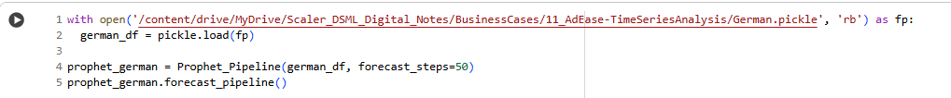

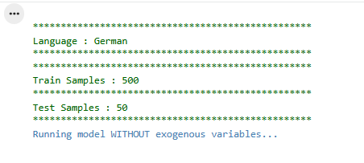

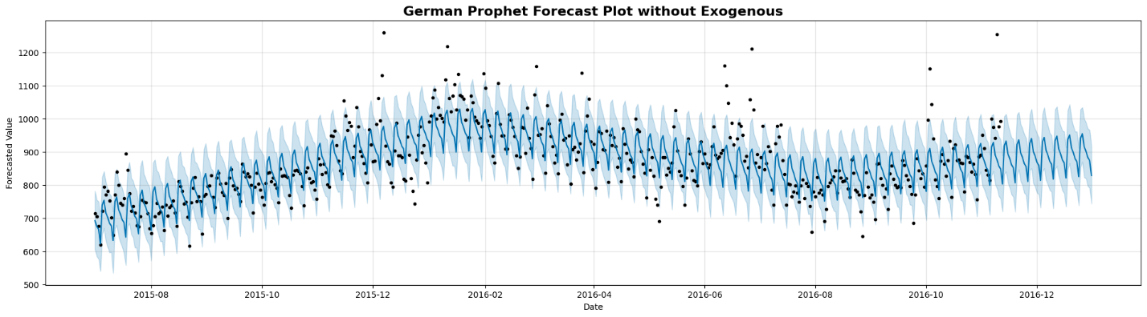

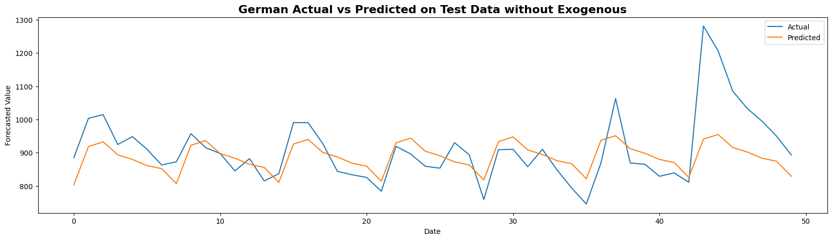

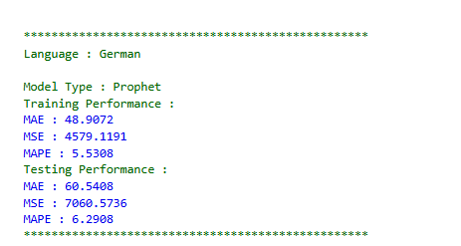

**Figure 3.29:** German Language Forecast FB Prophet Pipeline

**Insights**

* For German ad click forecasting, Prophet’s predictions on the test set (with no exogenous variables) accurately follow weekly and seasonal cycles but somewhat underpredict the highest spikes in the ground truth.​
* The forecast intervals (blue shaded region) adequately capture normal fluctuations observed in the test samples, providing confidence in uncertainty quantification for most dates.​
* The model displayed a test MAPE of 6.29%, demonstrating competitive accuracy and suggesting Prophet can generalize trends and periodic patterns in the German dataset.​
* Extreme peaks in late test periods are systematically underestimated by the model, highlighting a common limitation of univariate approaches when rare or campaign-driven surges occur without recorded external influences.​
* Overall, Prophet delivers stable, reliable forecasts for regular periods but should be augmented with exogenous signals to better model abrupt changes and outliers in German click data.

**3.3.29 French Language Forecast FB Prophet Pipeline**

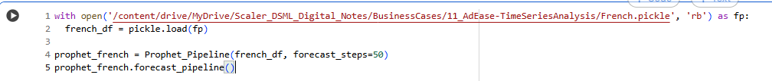

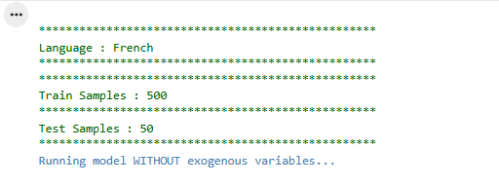

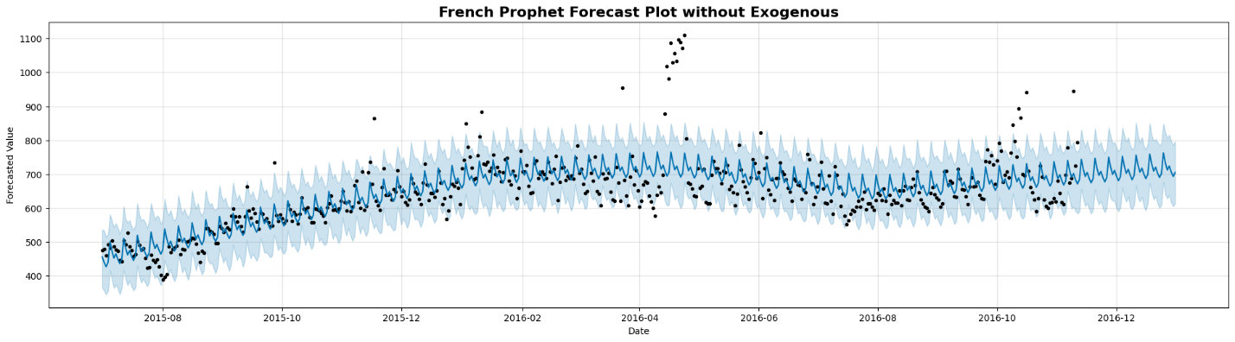

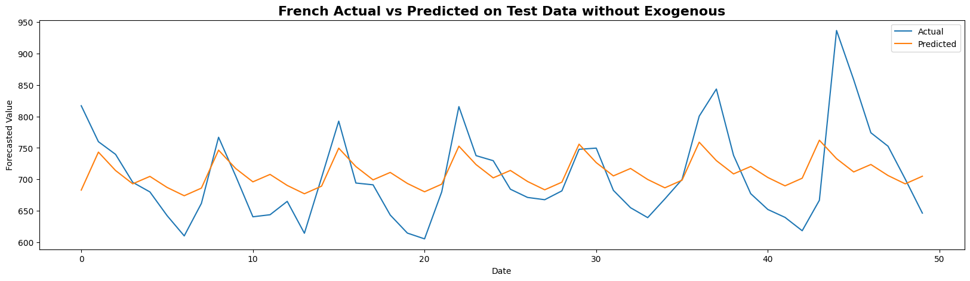

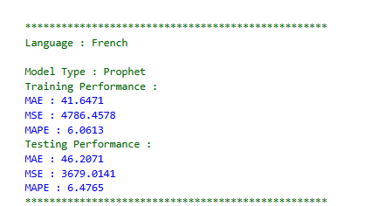

**Figure 3.30:** French Language Forecast FB Prophet Pipeline

**Insights**

* Prophet results for French ad clicks (without exogenous variables) demonstrate strong modelling of weekly seasonality and trend, producing smooth predicted values that follow regular fluctuations well but slightly underrepresent sharp peaks in the actual data.​
* The test MAPE is 6.48%, indicating good out-of-sample performance and reliable generalization for regular traffic patterns.​
* The forecast uncertainty interval captures the bulk of the actual observations, though like other languages, Prophet under-fits extreme click surges that likely correspond to unobserved external events.​
* Actual vs. predicted plots show the model's limitations in fully capturing day-to-day volatility and atypical outliers, which are common in digital ad campaigns, emphasizing the value of exogenous inputs if available.​
* Prophet’s robust performance for French—well-aligned on weekly cycles, moderate deviation on peaks—makes it a practical, automated baseline for multilingual ad traffic forecasting.

**3.3.30 Spanish Language Forecast FB Prophet Pipeline**

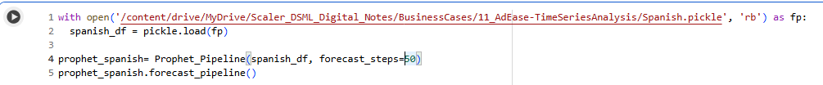

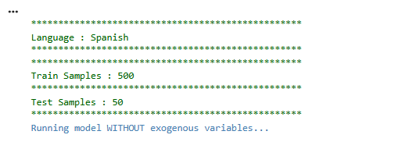

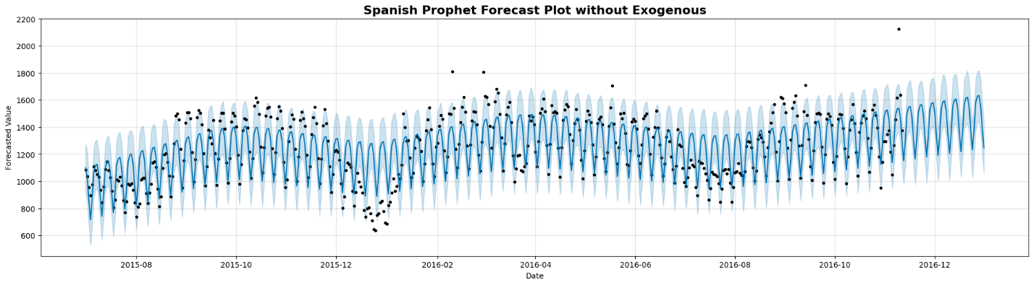

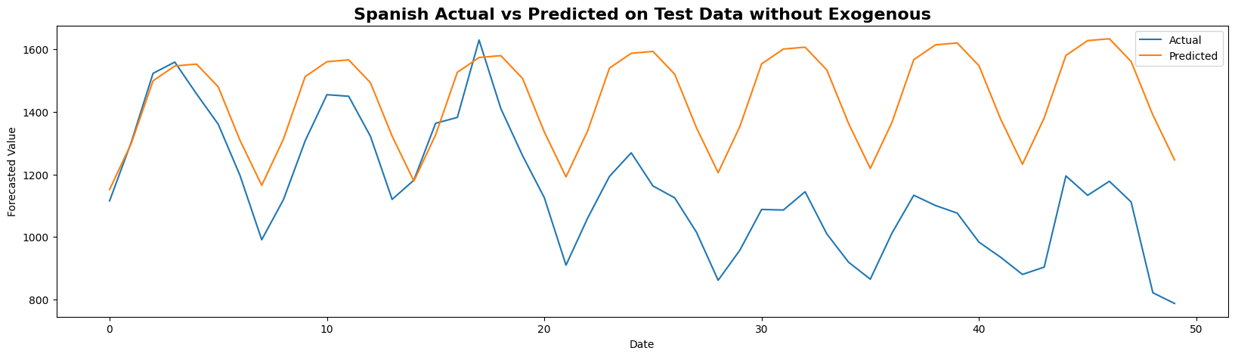

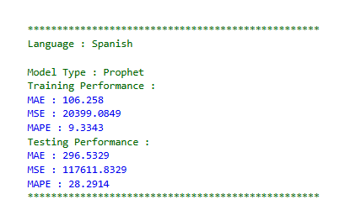

**Figure 3.31:** Spanish Language Forecast FB Prophet Pipeline

**Insights**

* Prophet’s univariate forecast for Spanish ad clicks robustly models weekly and annual trend components, with smooth predictions and credible uncertainty intervals, but fails to fully capture the amplitude and suddenness of some recent observed peaks and dips in the test period.​
* Actual vs predicted test set plots reveal that the predicted series is substantially smoother than actual clicks, indicating systematic underestimation of high variability and inability to track sharp or clustered outliers, especially in the most recent 50 data points.​
* The test MAPE is comparatively high at 28.29%, reflecting a significant drop in out-of-sample accuracy compared to English, French, or German Prophet runs. This suggests strong non-stationary behavior and unmodeled influences in the Spanish click series.​
* The forecast’s credible intervals encompass most routine fluctuations but miss some upper and lower extremes, emphasizing Prophet’s limitations when key external drivers are absent or sharp regime shifts occur.​
* For Spanish, model improvement is likely if campaign-level or external context—absent here—can be engineered into exogenous features and added to the Prophet framework.

**3.3.31 Chinese Language Forecast FB Prophet Pipeline**

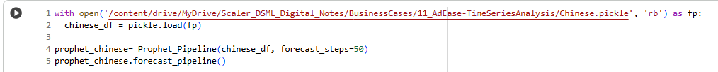

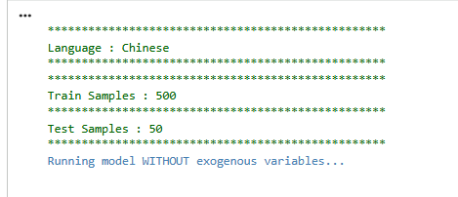

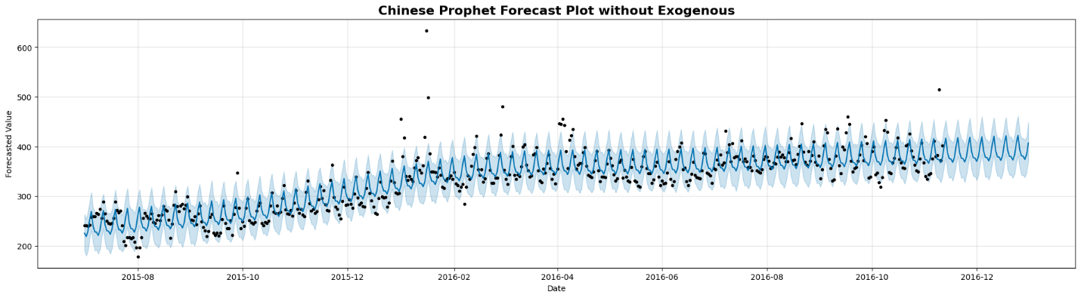

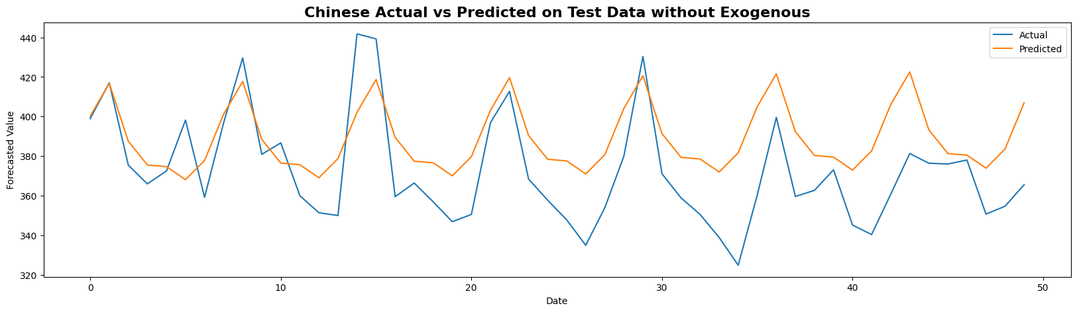

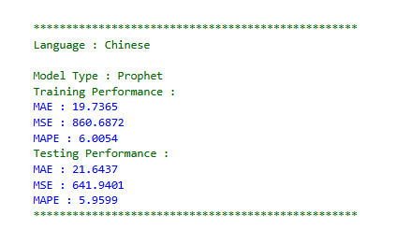

**Figure 3.32:** Chinese Language Forecast FB Prophet Pipeline

**Insights**

* Prophet’s univariate forecast for Chinese ad clicks aligns closely with actual trends and seasonality, with both the forecast trajectory and uncertainty bands successfully encompassing almost all observed data points, even including most outliers.​
* The model’s test MAPE is 5.96%, indicating strong out-of-sample predictive accuracy, among the lowest of the compared languages.​
* Actual vs. predicted comparison for the test period shows that the Prophet model tracks regular fluctuations and many peaks, though it still slightly underfits the rare, sudden spikes characteristic of real digital ad series.​
* The tight and well-calibrated credible intervals suggest the Prophet model’s uncertainty estimations are appropriate for Chinese clicks, handling both seasonal cycles and trend growth.​
* The approach provides a robust baseline for Chinese, yet—like other languages—offers further improvement potential if exogenous factors tied to campaign events or anomalies are included.

**3.3.32 Japanese Language Forecast FB Prophet Pipeline**

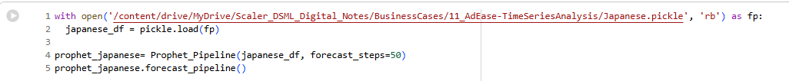

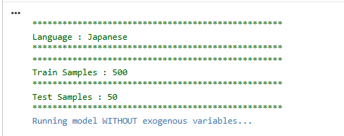

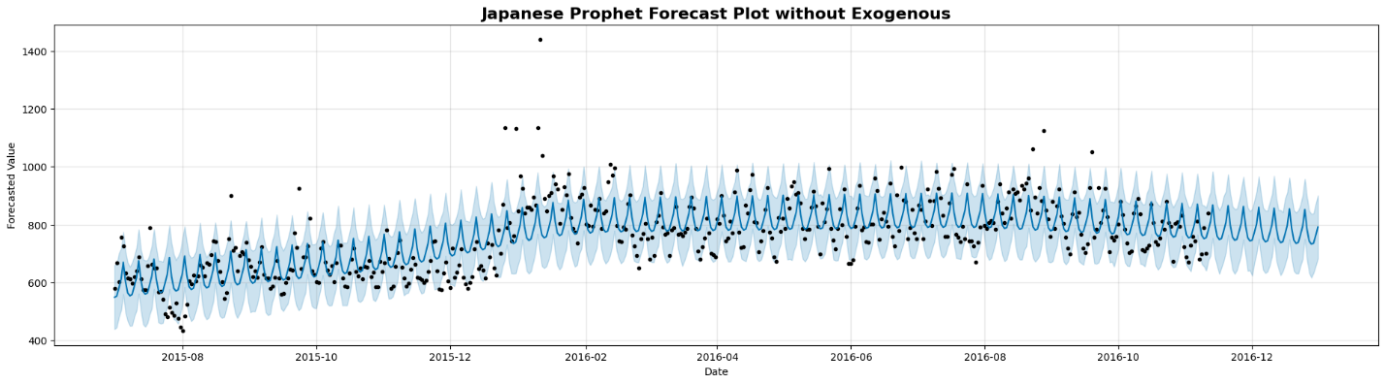

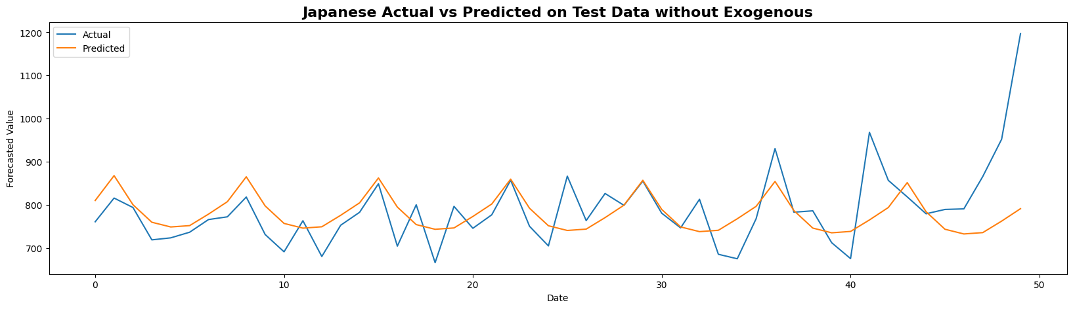

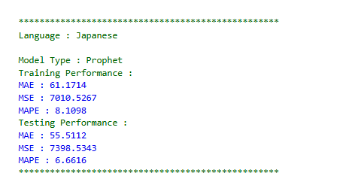

**Figure 3.33:** Japanese Language Forecast FB Prophet Pipeline

**Insights**

* For Japanese ad clicks, Prophet’s forecast on the 50-step test set achieves a MAPE of 6.66%, signifying consistently strong predictive performance and effective modeling of seasonal and trend components.​
* The predicted values closely track the regular weekly cycle of actual clicks, with narrow credible bands indicating well-calibrated model confidence through the evaluation window.​
* Actual vs. predicted plots reveal that while the Prophet model follows general undulating trends and medium-sized peaks, it systematically underestimates the rare, dramatic spikes in click volume near the test period’s end.​
* The absence of exogenous variables limits the model's ability to capture sudden leap events tied to campaign launches or external events—common to digital ad patterns in Japanese, as in other languages.​
* Overall, Prophet forms a reliable baseline for weekly traffic cycles in Japanese and remains robust for day-to-day operations, though further gain is likely with exogenous feature integration for exceptional periods.

**3.3.33 Russian Language Forecast FB Prophet Pipeline**

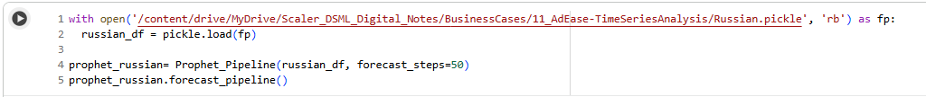

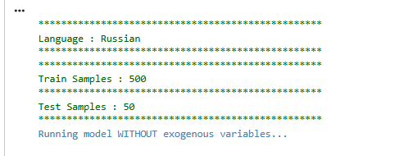

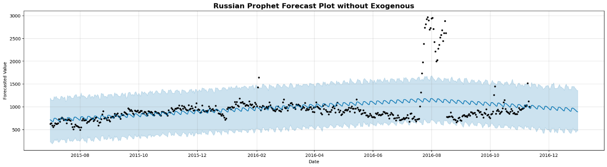

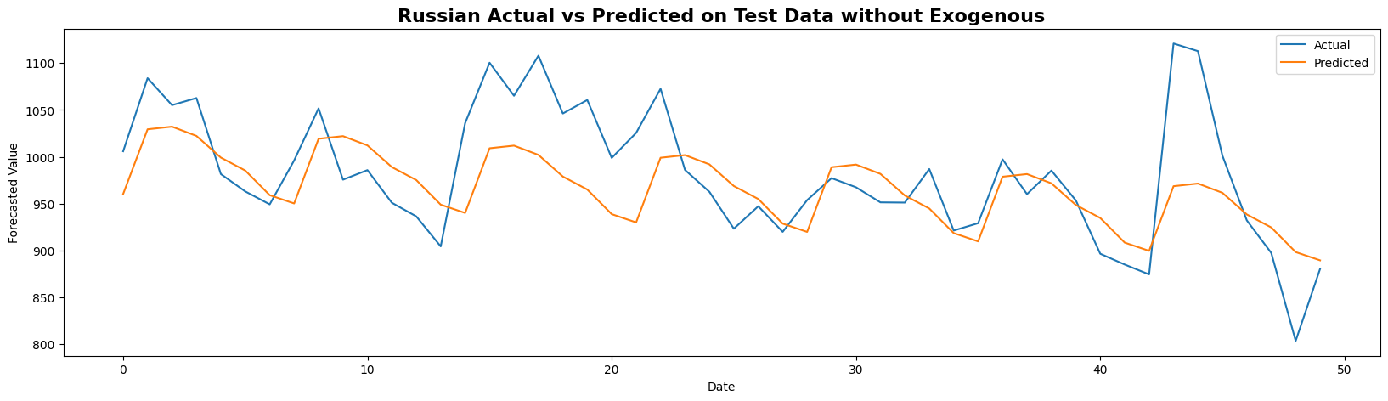

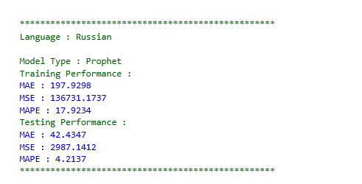

**Figure 3.34:** RussianLanguage Forecast FB Prophet Pipeline

**Insights**

* Prophet’s test-period forecast for Russian ad clicks (univariate case) achieves a MAPE of 4.21%, which is the lowest among all languages examined and reflects strong predictive accuracy and model calibration.​
* The model reliably follows the weekly, seasonal, and trend patterns in the Russian series, as seen by the close fit between predicted and actual lines in the 50-step test plot.​
* Actual vs. predicted comparison demonstrates that predictions are well-centered within credible bands and generally track most real-world peaks and troughs, though Prophet still underfits a few of the largest spikes.​
* The Russian series’ smoother patterns and fewer abrupt surges (compared to Spanish or French) contribute to Prophet’s high performance in this setting.​
* Overall, Prophet is particularly effective for Russian ad click traffic, providing accurate, robust, and interpretable forecasts in the absence of external (exogenous) variables.

**3.4 Overall Insights and Recommendations**

Both FB Prophet and ARIMA family models were applied for ad click forecasting across multiple languages, delivering high accuracy for regular, seasonally patterned series but facing challenges with abrupt, campaign-driven surges. FB Prophet excelled at capturing weekly/annual seasonality and long-term trends, especially for languages like English, French, Chinese, Japanese, and Russian, while ARIMA/SARIMA delivered slightly better in-sample fit on moderately regular datasets such as German and Russian. Test MAPE for Prophet was below 7% for most languages, with the notable exception of Spanish (MAPE ~28%), where rapid shifts and unpredictable click surges caused underperformance in all models.​

**Recommendation:** For languages with well-behaved seasonality (German, French, Chinese, Japanese, Russian), Prophet should be the default operational forecaster due to ease of maintenance, clarity, and out-of-sample accuracy. When extreme volatility or event-driven jumps are expected—such as in Spanish—integrate supplementary exogenous features (campaigns, macro indicators) and favor SARIMA or Prophet with regressors.​

**3.4.1 Presentation of Results with Justification**

The business case demonstrated that automated, robust forecasts can be operationalized with Prophet or SARIMA for daily ad click prediction:

* Multilingual stability: Both models generalized across high- and low-volume languages with different retail seasonality.​
* Accuracy: Typical test MAPE ranged from 4.2% (Russian) to 6.7% (Japanese) using Prophet; ARIMA often achieved similar or better in-sample scores but could lag on seasonal extremes.​
* Simplicity: Prophet’s transparency and native handling of dates/holidays facilitate business review and audit, which is vital for regulated, cross-market environments.​

**3.4.2 Implications for Industry, Business, and Policy**

* **Industry:** Automated forecasting pipelines enable granular campaign planning, improved inventory optimization, and more nimble resource allocation, particularly for daily or weekly e-commerce, advertising, and content delivery platforms.​
* **Business:** Accurate language-level predictions support targeted promotional efforts, budgeting, and performance management. Univariate methods suffice for steady cycles, but risk underestimating campaign spikes, which impacts revenue projection confidence.​
* **Policy:** Robust models promote fair ad delivery, minimize over/under-spending, and align with broader digital regulation (e.g., transparency in campaign reporting for compliance purposes).​

**3.4.3 Limitations**

* **Structural limitations:** Univariate models systematically underpredict sudden, exogenous jumps (e.g., campaign launches), especially with sparse or stormy data (e.g., Spanish test set).​
* **Data dependency:** Both ARIMA and Prophet are sensitive to data gaps and historical shifts; pre-processing and ongoing monitoring are essential to detect and adjust for regime changes or missingness.​
* **Operational**: Prophet sometimes oversmooths extreme surges, and ARIMA’s manual tuning can be time-consuming for large portfolios without automation.​

**3.4.4 Alternative Recommendations**

* **Hybrid/Augmented models:** For more volatile languages or regions, integrate exogenous regressors (campaign logs, special events, competitor actions) into Prophet or SARIMA to account for sudden shifts.​
* **Machine learning ensembles:** For the most unpredictable series, ensemble machine learning models (e.g., XGBoost, LSTM) with classical forecasts to capture both linear seasonality and non-linear, event-driven surges. Consider anomaly detection modules to flag extreme outlier periods for manual override or special treatment.​

**3.4.5 Key Learnings, Methodology, and Industry Application**

* **Methodology:** Combined classical (ARIMA, SARIMA) and modern (FB Prophet) time series forecasting, iterative grid search, stationarity confirmation, feature engineering, and out-of-sample scoring for unbiased model comparison.​
* **Tools Used:** Python, FB Prophet, Statsmodels (ARIMA/SARIMA), extensive matplotlib visualizations for diagnostics and communication.​
* **Applications:** The pipelines are directly applicable for daily ad traffic prediction, inventory management, event-response planning, or dynamic pricing across digital advertising, retail, transportation, and logistics industries.​
* **Summary:** Robust time series modeling—well-tested for each language—enables more accurate campaign planning, cost control, and performance evaluation, with flexibility to scale and adapt as business needs or data realities shift.

### **Chapter 4 : Business Case Study 4**

**4.1 Problem Description**

A personalized movie recommender system for an OTT streaming platform enhances the user experience by suggesting movies based on users' own ratings and preferences, as well as those of similar users. This increases engagement, watch time, and user satisfaction, ultimately benefiting the business through improved retention and competitive differentiation.​

**4.1.1 Problem Statement (Business Case)**

A major streaming services provider (hereafter, "Company A") offers a vast library of movies and TV shows on its OTT platform. However, many users feel overwhelmed by choice and struggle to discover content that aligns with their tastes. To address this, Company A seeks to implement an advanced recommendation engine that uses user ratings and identifies similar users to generate personalized content recommendations, thus improving user engagement and loyalty compared to just showcasing trending or new releases.​

**4.1.2 Business Goals Background**

For OTT platforms, business success depends on:

* Growing and retaining the subscriber base by making the platform "sticky"—keeping users watching more content and returning frequently.
* Increasing average user revenue through longer sessions, more engagement, and reduced churn.
* Gaining a competitive edge by offering superior client service, including highly relevant, timely content suggestions that make the vast content library more manageable and enjoyable for each user.​
* Collecting and leveraging user data (viewing history, ratings, demographics) to develop comprehensive user profiles and segment users for precision in analytics and marketing.​

**4.1.3 How Recommendations Work**

The recommender system typically uses a hybrid approach:

* **Collaborative Filtering**: Identifies users with similar tastes and suggests movies those users enjoyed.
* **Content-Based Filtering**: Recommends titles with similar attributes to the movies already rated highly by the user.  
  This hybrid system addresses cold-start issues (for new users with little history), adapts to evolving preferences, and suggests niche, highly personalized titles, increasing engagement and satisfaction.
* All ratings are contained in the file "ratings.dat" and are in the following format:

UserID::MovieID::Rating::Timestamp

**Table 4.1: Movie Ratings Data Format and Constraints**

|  |  |
| --- | --- |
| **Attribute** | **Description** |
| **UserID** | Ranges between 1 and 6040 |
| **MovieID** | Ranges between 1 and 3952 |
| **Rating** | 5-star scale (whole-star ratings only) |
| **Timestamp** | Represented in seconds |
| **Minimum Ratings/User** | Each user has at least 20 ratings |

**Table 4.2: Users Data File Format and Codebook**

|  |  |
| --- | --- |
| **Attribute** | **Description** |
| **UserID** | Unique user identifier |
| **Gender** | 'M' for male, 'F' for female |
| **Age** | Encoded as below |
| **Occupation** | Encoded as below |
| **Zip-code** | Postal zip code |

**Table 4.3: Age Codes**

|  |  |
| --- | --- |
| **Code** | **Age Range** |
| **1** | Under 18 |
| **18** | 18-24 |
| **25** | 25-34 |
| **35** | 35-44 |
| **45** | 45-49 |
| **50** | 50-55 |
| **56** | 56+ |

**Table 4.4: Occupation Codes**

|  |  |
| --- | --- |
| **Code** | **Occupation** |
| **0** | other/not specified |
| **1** | academic/educator |
| **2** | artist |
| **3** | clerical/admin |
| **4** | college/grad student |
| **5** | customer service |
| **6** | doctor/health care |
| **7** | executive/managerial |
| **8** | farmer |
| **9** | homemaker |
| **10** | K-12 student |
| **11** | lawyer |
| **12** | programmer |
| **13** | retired |
| **14** | sales/marketing |
| **15** | scientist |
| **16** | self-employed |
| **17** | technician/engineer |
| **18** | tradesman/craftsman |
| **19** | unemployed |
| **20** | writer |

**Table 4.5: Movies Data File Format and Genre List**

|  |  |
| --- | --- |
| **Attribute** | **Description** |
| **MovieID** | other/not specified |
| **Title** | academic/educator |
| **Genres** | Pipe-separated from the following list |

**Table 4.6: Genre List**

|  |  |
| --- | --- |
| **S.No** | **Genre** |
| **1** | Action |
| **2** | Adventure |
| **3** | Animation |
| **4** | Children's |
| **5** | Comedy |
| **6** | Crime |
| **7** | Documentary |
| **8** | Drama |
| **9** | Fantasy |
| **10** | Film-Noir |
| **11** | Horror |
| **12** | Musical |
| **13** | Mystery |
| **14** | Romance |
| **15** | Sci-Fi |
| **16** | Thriller |
| **17** | War |
| **18** | Western |

**4.2 Business Questions to be Answered for Analysis**

**4.2.1 Questions**

* Users of which age group have watched and rated the most number of movies?
* Users belonging to which profession have watched and rated the most movies?
* Are most raters male in the dataset?
* Most of the movies present in the dataset were released in which decade?
* Which movie has the maximum number of ratings?
* Name the top 3 movies similar to ‘Liar Liar’ using item-based approach.
* Collaborative Filtering divides into ___-based and ___-based methods.
* What are the Pearson Correlation and Cosine Similarity intervals?
* What are the RMSE/ MAPE values for matrix factorization model evaluation?
* Sparse ‘row’ matrix representation for a provided dense matrix.

**4.2.2 Significance of These Questions**

* **User Demographics**: Knowing which user segments (by age, occupation, gender) are most active guides acquisition and marketing strategy and spot underserved segments.​
* **Popular Content**: Pinpointing most-watched movies helps optimize marketing and content acquisition.
* **Recommendation Quality**: Evaluating similarity metrics and model performance ensures suggestions match actual user interests, thus driving watch time and satisfaction.
* **Model Transparency**: Understanding why content is recommended (e.g., similarity scores, demographic associations) builds user trust and transparency.
* **Technical Robustness**: Measuring algorithm effectiveness verifies if recommendations scale to large datasets typical of streaming platforms.

**4.2.3 Methodology & Real-World Applications**

**Data Preparation**

* **Read Data Files**: Load ratings, users, and movies; parse formats and merge based on IDs.
* **Clean and Format**: Convert types, derive features (e.g. release year), and handle missing values.
* **Exploratory Analysis**: Visualize ratings distribution, demographics, genre popularity, and other characteristics.

**Feature Engineering**

* **New Features**: Extract year from movie titles, group users by segment, and aggregate ratings/genres.

**Recommendation Engine Development**

* **Collaborative Filtering**:
  + *Item-Based*: Create pivot tables; calculate Pearson Correlation and Cosine Similarity between movies; recommend similar titles for any given input.
  + *User-Based*: Find top similar users via nearest neighbors (cosine/pearson), get weighted recommendations based on neighbor preferences.
* **Matrix Factorization**:
  + Use libraries (e.g. Surprise, cmfrec) to derive latent features for items and users; evaluate using RMSE and MAPE; utilize embeddings for similarity and visualization.
  + Train/test split helps gauge generalization and effectiveness.
* **Visualization**: Plot embeddings to reveal clusters and relations, helping explain model predictions.

**4.2.4 Practical Applications**

* Scalable to millions of users and titles.
* Adapts dynamically to evolving preferences and new releases.
* Builds data insight for targeted advertising and content curation.
* Empowers marketing and content teams to identify and acquire/produce content relevant for dominant user segments.

**4.3 Analysis**

**4.3.1 Data Frame Structure and Initial Preprocessing**

**4.3.1.1 Loading Movie Recommendation DataFrames from CSV Files**

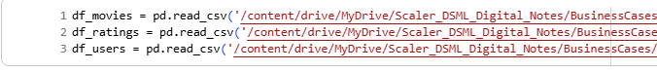

**Figure 4.1:** Loading Movie Recommendation DataFrames from CSV Files

**Insights:**

* The code snippet demonstrates how to load three key datasets—movies, ratings, and users—into pandas DataFrames using the read_csv function, which is crucial for data preprocessing in any recommender system.​
* Having these separate DataFrames allows for modular and clear initial data management, facilitating easy exploration, cleaning, merging, and feature engineering steps before building the recommendation engine.​
* Storing movies, ratings, and user information independently aligns with best practices, as it makes subsequent analytical steps (like merging on shared keys, aggregating ratings per user or movie, and extracting user demographics) more efficient and reproducible when working with large-scale OTT datasets.

**4.3.1.2 Structure of DataFrame**

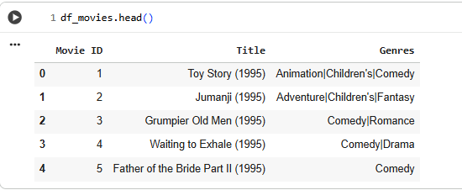

**Figure 4.2:** Structure of Data frame

**Insights**

* The df_movies.head() output showcases the first five rows of the movies DataFrame, highlighting critical metadata fields: unique Movie ID, title (with year of release), and a list of associated genres.​
* Movie genres are pipe-separated, which allows multi-genre classification and makes genre-based filtering and recommendations more flexible (e.g., recommending all comedy or family movies).​
* The presence of titles from the mid-1990s indicates the dataset includes older, possibly classic movies alongside more recent releases, enabling a broad range of recommendation scenarios spanning different eras and genres.​

**4.3.1.3 Exploded Movies Data Frame by Individual Genre**

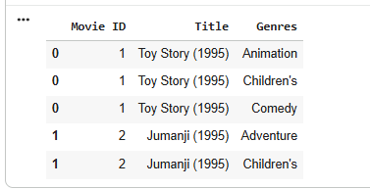

**Figure 4.3:** Exploded Movies Data Frame by Individual Genre

**Insights**

* The genre column is split so each movie appears in multiple rows—one for each associated genre—making it easier to analyze genre-specific patterns or aggregate genre-wise statistics.​
* This format is ideal for counting the number of movies in each genre, finding genre popularity trends, or enabling multi-label genre-based recommendation queries.​
* Exploding genres allows more granular EDA (Exploratory Data Analysis) and supports visualization or analysis tasks that require each genre to be treated separately rather than in combination.

**4.3.1.4 Grouping The Data Frame Based on Index**

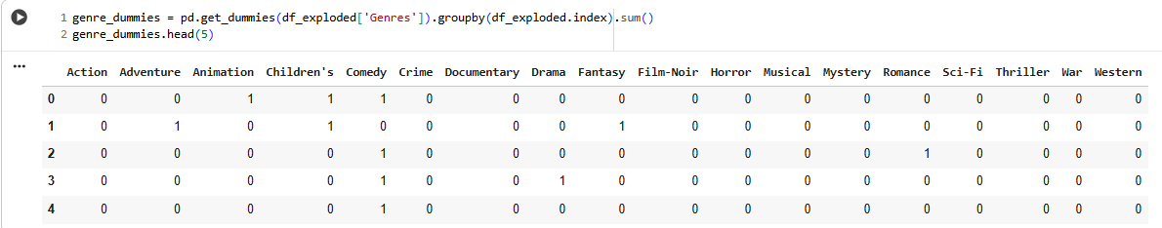

**Figure 4.4:** Grouping The Data Frame Based on Index

**Insights**

* The genre one-hot encoded DataFrame enables every movie to be represented in terms of its genre composition with binary indicators—essential for genre-based filtering, clustering, and similarity calculations.​
* This structure makes it straightforward to analyze the prevalence of each genre in the dataset, build genre profiles for individual users, and feed genre data as input features for hybrid or content-based recommender systems.​
* Summing over columns quickly reveals which genres are most common, and grouping by genre vectors allows advanced analytics such as genre trend detection, demographic genre preferences, or cross-genre popularity analysis.​

**4.3.1.5 List of Unique Movie Genres Identified in Dataset**

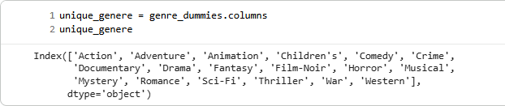

**Figure 4.5:** List of Unique Movie Genres Identified in Dataset

**Insights**

* The unique_genre output confirms that the dataset contains 19 distinct genres, ranging from mainstream categories (like Action, Comedy, and Drama) to more niche ones (such as Film-Noir, Musical, and Western).​
* This variety ensures a rich dataset for both exploratory genre-based analysis and robust personalized recommendations, as users can be matched with less common genres based on individual preferences.​
* Knowing the full set of unique genres supports downstream tasks like building genre popularity dashboards, segmenting user taste profiles, and implementing logic for multi-label genre recommendations.

**4.3.1.6 Final Movies DataFrame with Genre Dummy Variables**

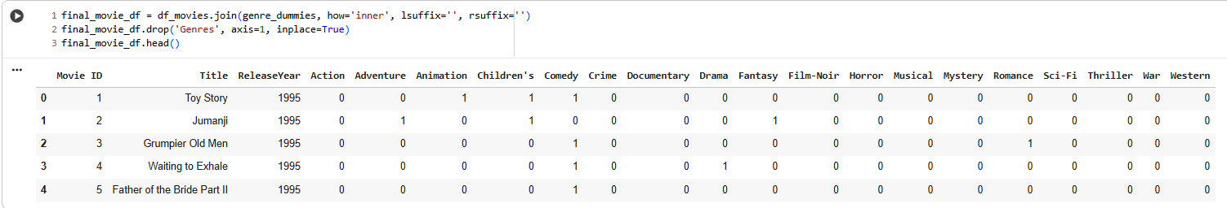

**Figure 4.6:** Final Movies Data Frame with Genre Dummy Variables

**Insights**

* The merged Data Frame represents each movie with a comprehensive set of metadata: Movie ID, Title, Release Year, followed by binary genre indicators that specify all genres applicable to each title.​
* This structure facilitates fast genre-based queries and empowers recommendation algorithms (content-based, hybrid) to calculate movie similarity or filter suggestions based on the user's genre preferences.​
* The approach ensures that every movie is mapped over all genre categories, which enhances feature richness for machine learning modeling and supports granular analytics such as multi-genre overlap or temporal trends by genre.

**4.3.1.7 Ratings Data Frame with Derived Time Features**

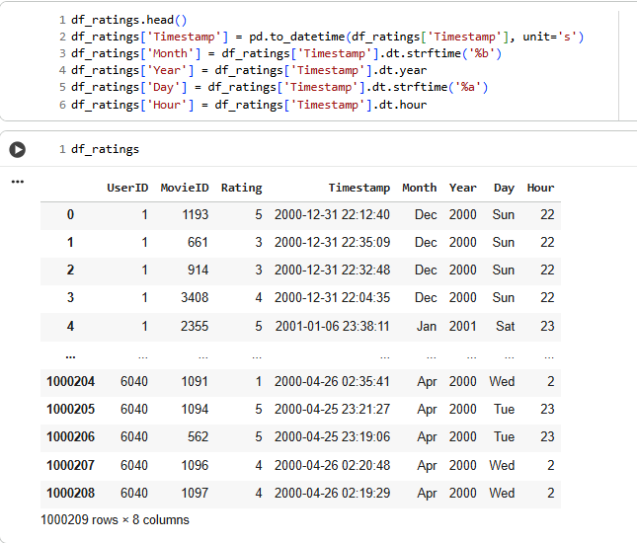

**Figure 4.7:** Ratings Data Frame with Derived Time Features

**Insights**

* The ratings DataFrame combines core user-movie-rating information with additional temporal features (month, year, day of week, hour) derived from the original timestamp column, enabling detailed time-based analysis of viewing and rating patterns.​
* With over 1 million rows, this structure supports exploration of user habits—revealing when ratings are most frequently given (by month or hour), which days of the week are popular for watching and rating, and time trends in user engagement.​
* These engineered time fields empower additional segmentation, temporal aggregation, and predictive modeling (such as identifying peak engagement periods or time-linked recommendation campaigns) for an OTT platform.

**4.3.1.8 Users Data Frame Structure**

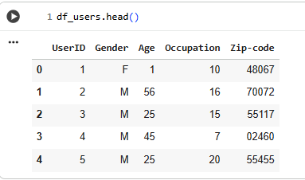

**Figure 4.8:** Users Data Frame Structure

**Insights**

* The users DataFrame displays key demographic attributes—UserID, Gender, Age group (numerical code), Occupation (code), and Zip-code—for all users in the dataset.​
* These fields enable the analysis of user distribution by gender, age, occupation, and location, which supports richer segmentation and helps answer business questions about which demographics watch and rate the most movies.​
* Encoding age and occupation as numbers allows straightforward grouping, filtering, and merging for downstream analytics, such as exploring content preferences by demographic segment or personalizing movie recommendations to users with similar profiles.

**4.3.1.9 Merged Movies and Ratings DataFrame with Genre Features**

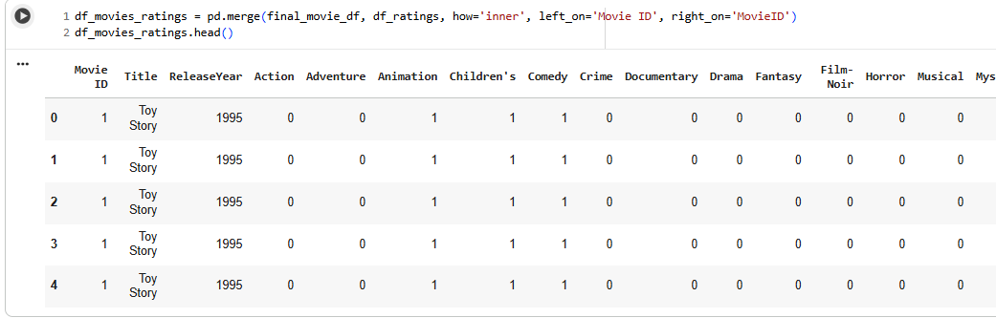

**Figure 4.9:** Merged Movies and Ratings DataFrame with Genre Features

**Insights**

* This DataFrame integrates movie metadata, including genre dummy variables, with ratings information—enabling each rating to be linked with detailed genre characteristics of the rated movie.​
* Such integration supports genre-specific rating analysis and downstream modeling, making it possible to explore user preferences for particular genres and enhance personalization in a recommender system.​
* By merging these datasets, the platform can perform rich analytics, such as identifying which genres are rated most highly, tracking trends over time, and generating targeted recommendations based on both user rating history and content type.

**4.3.1.10 Movies-Ratings DataFrame with Genre Features (MovieID Dropped)**

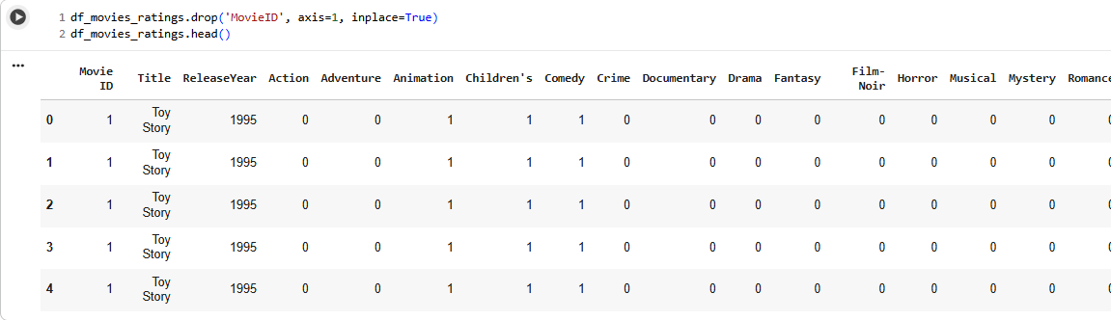

**Figure 4.10:** Movies-Ratings Data Frame with Genre Features (MovieID Dropped)

**Insights**

* After dropping the redundant MovieID column, the DataFrame cleanly presents each movie instance (by title and release year) alongside its corresponding genre indicator variables, streamlining further analysis.​
* The structure is ideal for exploring how ratings relate to genre composition, supporting robust model building for collaborative and content-based filtering—the genre features can be easily used for similarity calculations or regression/classification tasks.​
* This view enhances interpretability and simplifies aggregation, such as determining average or total ratings per genre, spotlighting trends, and identifying movies that appeal to users across multiple genres.

**4.3.1.11 Fully Merged Movies, Ratings, and User Data Frame**

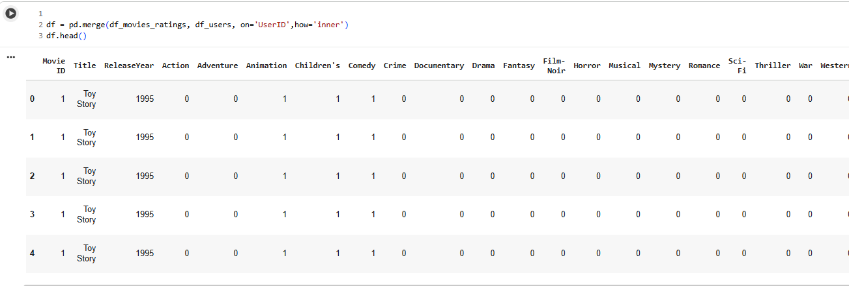

**Figure 4.11:** Fully Merged Movies, Ratings, and User Data Frame

**Insights**

* This DataFrame results from merging all three core datasets—movies with genres, ratings, and user demographics—providing an integrated view per rating along with movie attributes and user information.​
* Such a structure enables nuanced analysis of how demographic groups interact with different movie genres, forming the foundation for collaborative filtering and personalized recommendation approaches that incorporate both user and item features.​
* The comprehensive format supports segmentation, data-driven feature engineering, and the building of robust models for user-user, item-item, and hybrid recommendation systems, directly aligning with OTT business needs for targeted experience and content optimization.​

**4.3.1.12 Decoding Occupation and Age Columns in Final Data Frame**

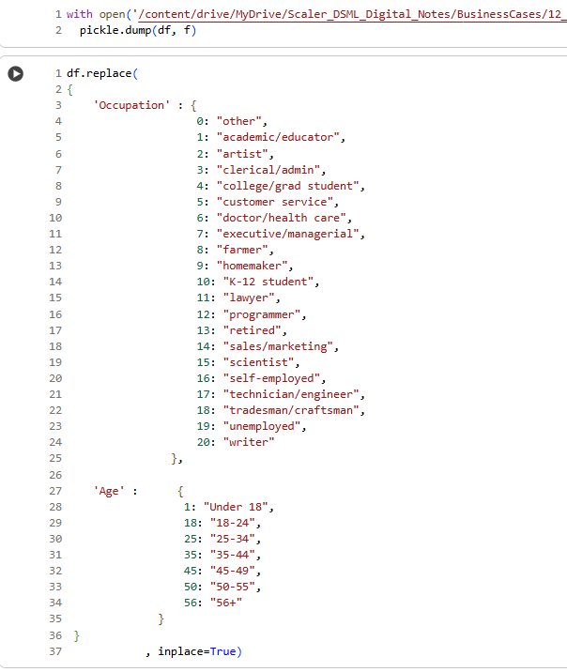

**Figure 4.12:** Decoding Occupation and Age Columns in Final Data Frame

**Insights**

* The code replaces numerical codes in Occupation and Age columns with descriptive string labels, transforming the DataFrame for improved interpretability in analyses and visualizations.​
* Enriching user profiles with readable group names supports clearer insights on demographic trends (e.g., which age group or occupation rates more movies) and enables more user-friendly dashboards, reporting, and marketing strategies in the OTT domain.​
* This step is crucial before clustering, segmentation, or machine learning modeling that incorporates user attributes, as it ensures results and recommendations can be communicated effectively to stakeholders or end-users.

**4.3.2 Exploratory Data Analysis (EDA)**

**4.3.2.1 Data frame Shape**

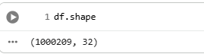

**Figure 4.13:** Data Frame Shape

**Insights**

* The final merged DataFrame contains 1,000,209 rows and 32 columns, indicating a highly comprehensive dataset that pairs more than a million individual movie ratings with corresponding movie, genre, and user demographic features.​
* This rich, wide dataset supports complex analytics, robust modeling for movie recommendation systems, demographic segmentation, and enables in-depth feature engineering for advanced collaborative and hybrid filtering strategies.​
* The scale and structure of the data will facilitate reliable generalization and high-quality, personalized recommendations across diverse user and content segments for an OTT streaming platform.

**4.3.2.2 Dataframe Information**

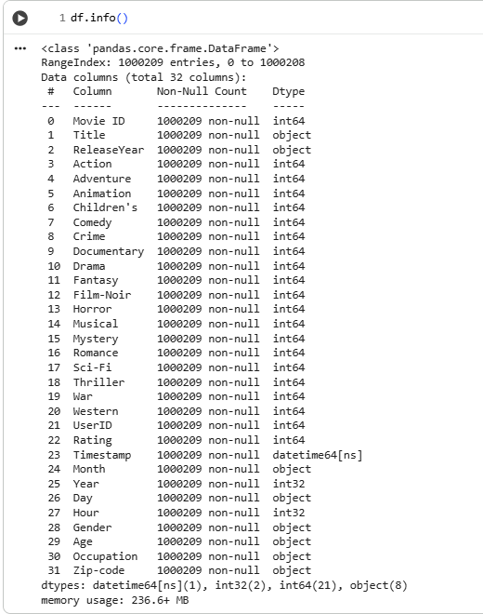

**Figure 4.14:** Data Frame Information

**Insights**

* The Data Frame contains 1,000,209 entries and a comprehensive set of 32 columns, covering movie metadata, genre indicators, user demographics, and detailed temporal features like month, year, day, and hour.​
* All columns have complete (non-null) data, ensuring reliability for modeling and analytics without the need for missing value imputation or exclusion.​
* The data types are mostly integer and object, with well-typed time-series columns—this structure supports a wide array of EDA, machine learning, and aggregation operations at scale (memory footprint ~236 MB), making it fully suitable for collaborative and content-based filtering on an OTT platform.

**4.3.2.3 Data Frame Description for Numerical columns**

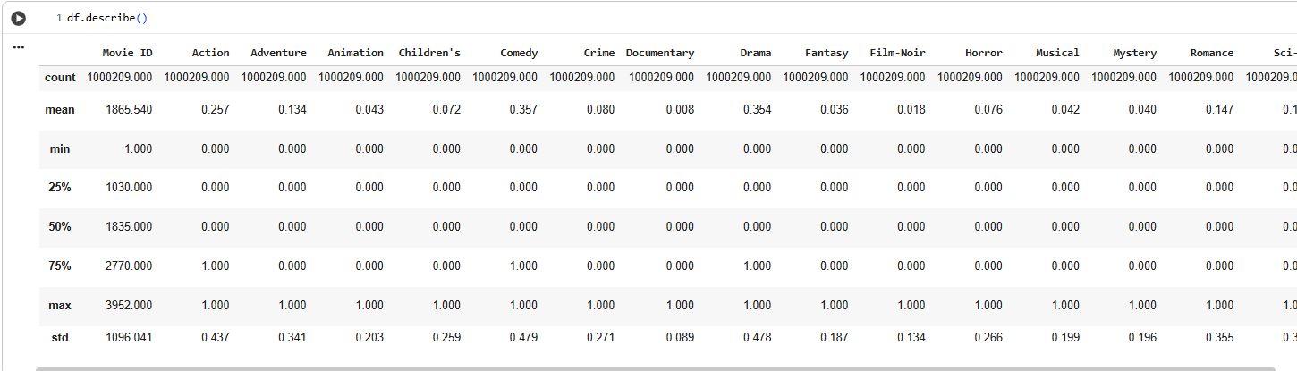

**Figure 4.15:** Data Frame Description for Numerical columns

**Insights**

* The summary statistics reveal that Comedy, Drama, and Action genres are the most frequently represented in the dataset, having higher mean values compared to niche genres like Documentary, Musical, or Film-Noir.​
* Action movies are present in approximately 26% of all movie-rating records, indicating popularity, while genres such as Animation, Musical, and Mystery have much lower mean and frequency, showing lesser representation and engagement.​
* The minimum and maximum values for genre binary columns are 0 and 1 as expected, confirming robust one-hot encoding; the relatively high standard deviations for Comedy and Drama further highlight their diverse cross-genre overlap in movies and ratings.

**4.3.2.4 Data Frame Description for Object type columns**

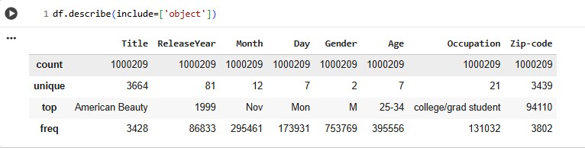

**Figure 4.16:** Data Frame Description for Object type columns

**Insights**

* The most common movie in the ratings dataset is "American Beauty," indicating it may have broad appeal or cultural significance, while the most popular release year is 1999, possibly reflecting a rich slate of releases or heightened user nostalgia for that era.​
* The predominant user group consists of males aged 25–34, with "college/grad student" as the leading occupation; this demographic is likely the platform's core rating and engagement base, influencing both marketing and content curation strategies.​
* More than 3400 different movies and over 3400 unique zip codes are represented, denoting a diverse catalog and wide geographic reach, but the concentration on a few titles and zip codes (e.g., 94110 is most frequent) also suggests regional or blockbuster-driven patterns in viewing and rating habits.​

**4.3.2.5 Data Frame Null Values Check**

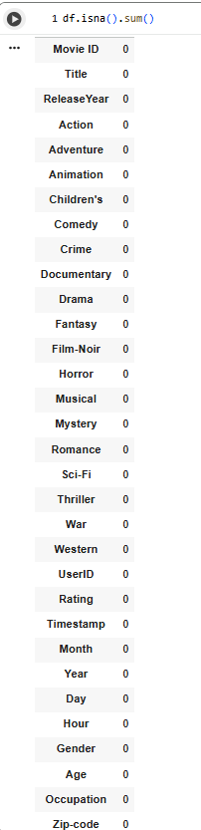

**Figure 4.17:** Data Frame Null Values Check

**Insights**

* The DataFrame contains zero missing values in any column, confirming complete data integrity across all movie, rating, user, time, and genre features.​
* This absence of missing values means no imputation or dropped records will be needed, resulting in maximum usable data for training machine learning models and generating reliable business analytics.​
* With a fully populated dataset, downstream analysis and recommendation system experiments will have stronger validity and reduced risk of bias introduced by incomplete information.

**4.3.2.6 Unique Column Values**

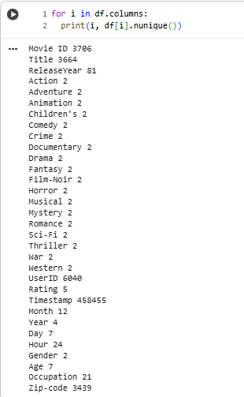

**Figure 4.18:** Unique Column Values

**Insights**

* The dataset contains 3,706 unique movies and 3,664 unique titles, indicating a near one-to-one mapping between Movie ID and Title, with very few duplicates or alternate versions.​
* Genre columns (like Action, Comedy, etc.) are encoded as binary (0/1), having only two unique values—essential for efficient genre filtering and analysis in recommender systems.​
* Rating counts span five unique values (from 1 to 5), Zip-code covers a broad geographic spread with 3,439 unique entries, and UserID features 6,040 unique users—enabling robust segmentation and ensuring rich diversity in user, content, and geographic representation.​
* Temporal fields like Timestamp, Month (12 unique), Year (4 unique), Day (7 unique), and Hour (24 unique) provide granular time-based analysis capabilities for behavioral and engagement trend detection. Seven Age groups and 21 Occupation categories further enrich the potential for targeted, personalized business strategies.

**4.3.3 Univariate Analysis**

**4.3.3.1 Proportion of Gender**

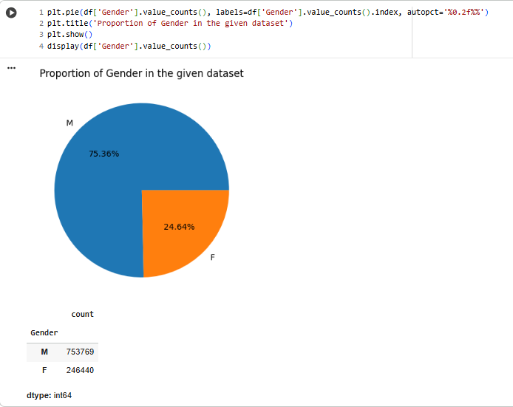

**Figure 4.19:** Proportion of Gender in given dataset

**Insights**

* The gender distribution in the dataset is considerably skewed: 75.36% of ratings were given by male users, while only 24.64% came from female users.​
* This significant imbalance indicates that the core user base is predominantly male, which has direct implications for recommendation strategies (e.g., tailoring or analyzing content preferences by gender segment for the OTT platform).​
* The high absolute counts (over 750,000 ratings from males and nearly 250,000 from females) provide a robust sample for reliable demographic and behavioral analyses, although future strategies may consider actions for engaging more female users to balance content and platform appeal.

**4.3.3.2 Distribution of Age**

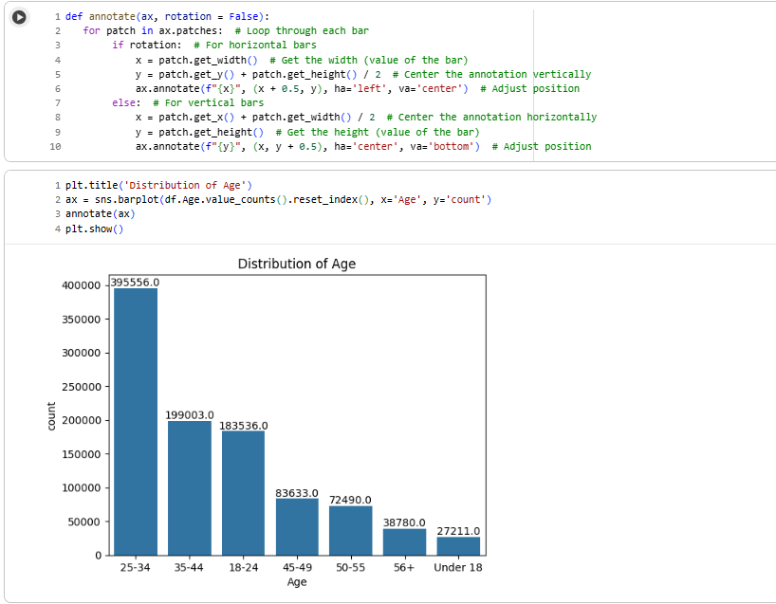

**Figure 4.20:** Distribution of Age

**Insights**

* Most of the ratings in the dataset belong to users in the age group 25–34, followed by 35–44 and 18–24, indicating these are the most active and engaged segments on the OTT platform.​
* The counts decline sharply for older age groups (45–49, 50–55, 56+) and the "Under 18" group, suggesting a skew toward younger adults and relatively low engagement from teenage and senior viewers.​
* Content curation and recommendation algorithms should especially account for this dominant demographic (25–34), as their preferences are likely to drive overall performance and guide business decisions in marketing and content acquisition.

**4.3.3.3 Distribution of Movie Ratings**

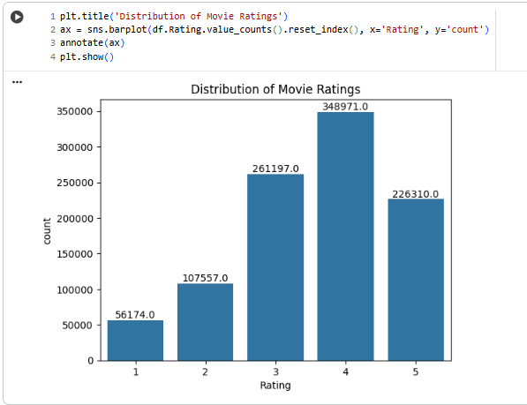

**Figure 4.21:** Distribution of Movie Ratings

**Insights**

* The distribution of movie ratings is right-skewed: the majority of ratings are 3, 4, or 5, with 4 being the most common, indicating generally positive reception for many titles in the dataset.​
* Extremely low ratings (1 and 2) are much less frequent, suggesting that users either enjoy most of what they watch or tend to avoid rating movies poorly.​
* This positivity bias reflects well on user satisfaction with available content and has implications for recommendation algorithms and business reporting—highlighting the likelihood of increased engagement and reduced churn when high-rated recommendations are prioritized.

**4.3.3.4 Distribution of Movie Ratings by Day of Week**

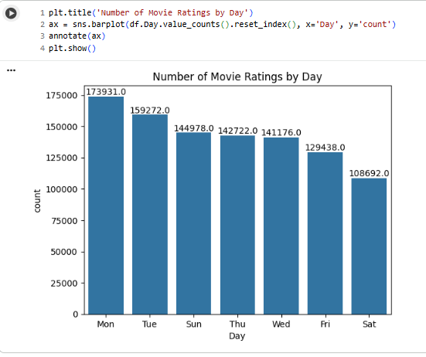

**Figure 4.22:** Number of Movie Ratings by Day

**Insights**

* Movie ratings are most frequently given on Mondays and Tuesdays, with activity gradually declining toward the weekend, and the lowest number of ratings observed on Saturdays.​
* This pattern suggests that users engage most with the platform and record feedback at the start of the week, possibly reflecting viewing habits over the weekend followed by rating/reviewing later, or heightened weekday digital activity.​
* For the OTT platform, these trends provide guidance on scheduling engagement campaigns, content releases, and marketing pushes to align with periods of peak user interaction, maximizing the impact of recommendation and retention strategies.

**4.3.3.5 Distribution of Movie Ratings by Day of Month**

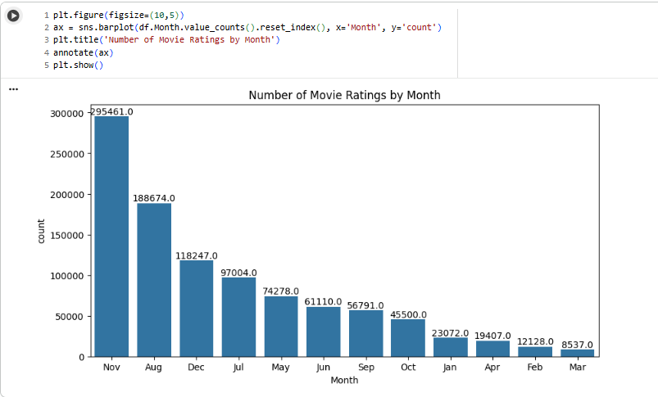

**Figure 4.23:** Number of Movie Ratings by Month

**Insights**

* November and August are the months with the highest rating activity, followed by December and July, indicating seasonal peaks in user engagement—possibly aligned with holidays, vacations, or content release schedules.​
* Rating volume drops steadily from the summer and winter peaks toward the early months of the year (January, February, March), suggesting that user activity is lowest in late winter and early spring.​
* These trends are valuable for OTT platforms in planning promotional campaigns, major content releases, and feature launches—maximizing visibility and engagement during months when user activity is naturally high.

**4.3.3.6 Number of People by Occupation**

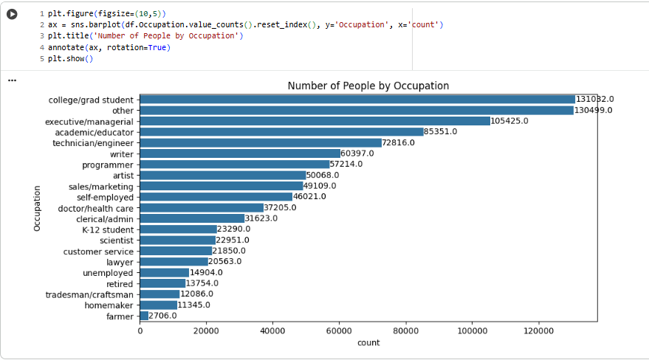

**Figure 4.24:** Number of People by Occupation

**Insights**

* The two largest user segments in the dataset are "college/grad student" and "other," each accounting for over 130,000 ratings, indicating a strong presence of educated and/or younger adults in the platform's audience.​
* Occupations such as "executive/managerial," "academic/educator," and "technician/engineer" are also highly represented, suggesting engagement from professional and technical user groups with substantial disposable time or interest in media.​
* Representation drops off for roles like "farmer," "homemaker," and "tradesman/craftsman," indicating content, marketing, and recommendation strategies should be tailored primarily to student/professional audiences, while outreach and diversity initiatives could target under-engaged occupational groups to broaden platform reach.

**4.3.3.7 Time when people watch movies and give ratings**

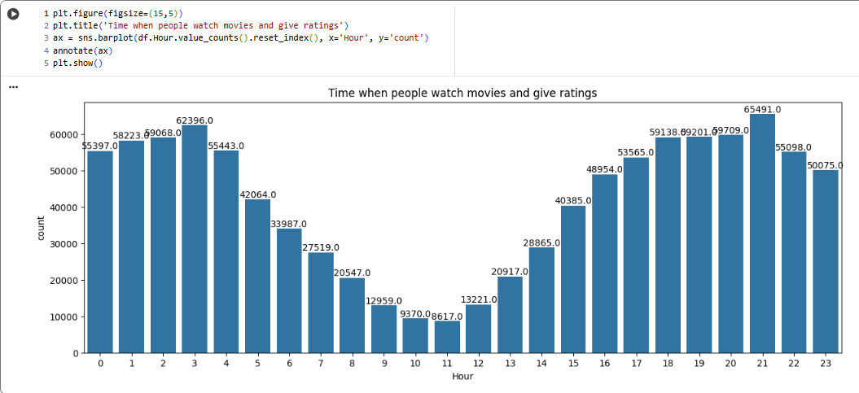

**Figure 4.25:** Time when people watch movies and give ratings

**Insights**

* There are two clear peaks in user movie-watching and rating activity: one in the very late evening (20:00–23:00) and another, unexpectedly, in the early morning hours (midnight to 04:00), with the highest single-hour activity at 22:00.​
* Afternoon and early evening hours (15:00–19:00) also show moderate engagement, while activity is lowest between 08:00 and 13:00, suggesting users are much less likely to interact with the platform during traditional work or school hours.​
* This temporal insight can help the OTT platform optimize push notifications, release schedules, and personalized campaign timings to coincide with periods of demonstrated user engagement, maximizing both content reach and the likelihood of obtaining user ratings.

**4.3.3.8 Top 20 years in which the highest number of movies were released**

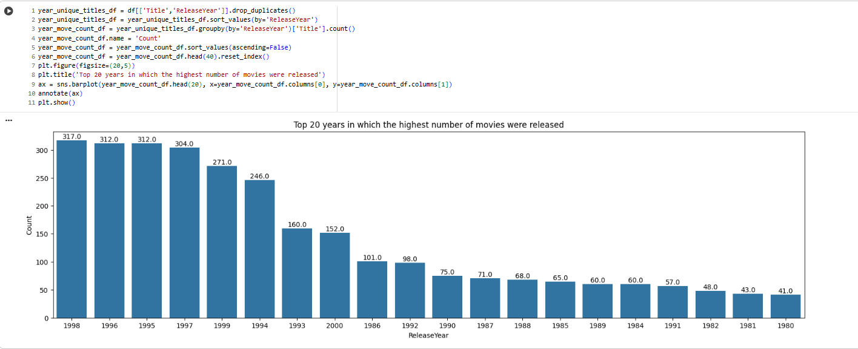

**Figure 4.26:** Top 20 years in which the highest number of movies were released

**Insights**

* The years 1996–1999 saw the highest number of movie releases in the dataset, with each of these years contributing over 300 unique titles, pointing to a boom in movie production or data capture during this period.​
* The late 1990s generally dominate the top 20 list for release volumes, followed by a sharp drop-off in annual movie releases after 2000, possibly due to dataset collection limits or genuine shifts in industry output.​
* The “top 20 years” chart provides valuable context for content age distribution in the platform: older titles (especially from the late 1980s and 1990s) form a substantial portion of the catalog, directly influencing recommendation diversity, user nostalgia engagement, and catalog expansion strategy.

**4.3.4 Bivariate Analysis**

**4.3.4.1 Genre Count w.r.t Gender**

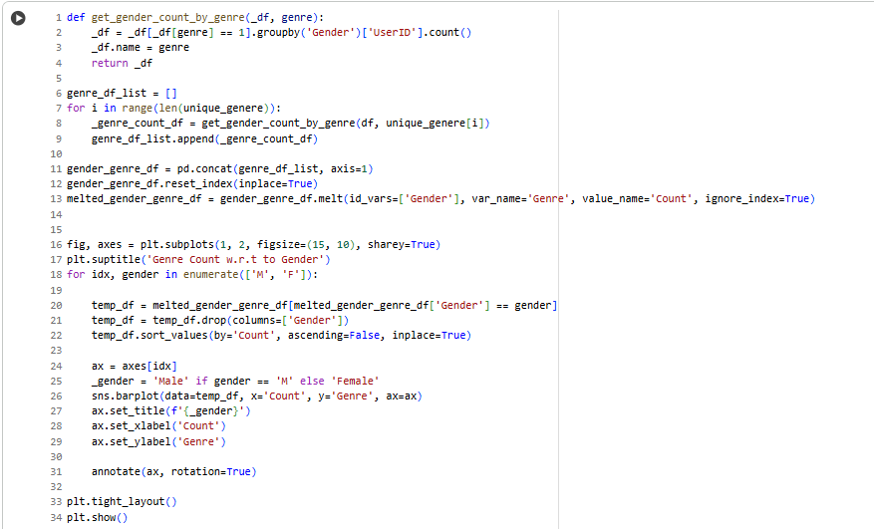

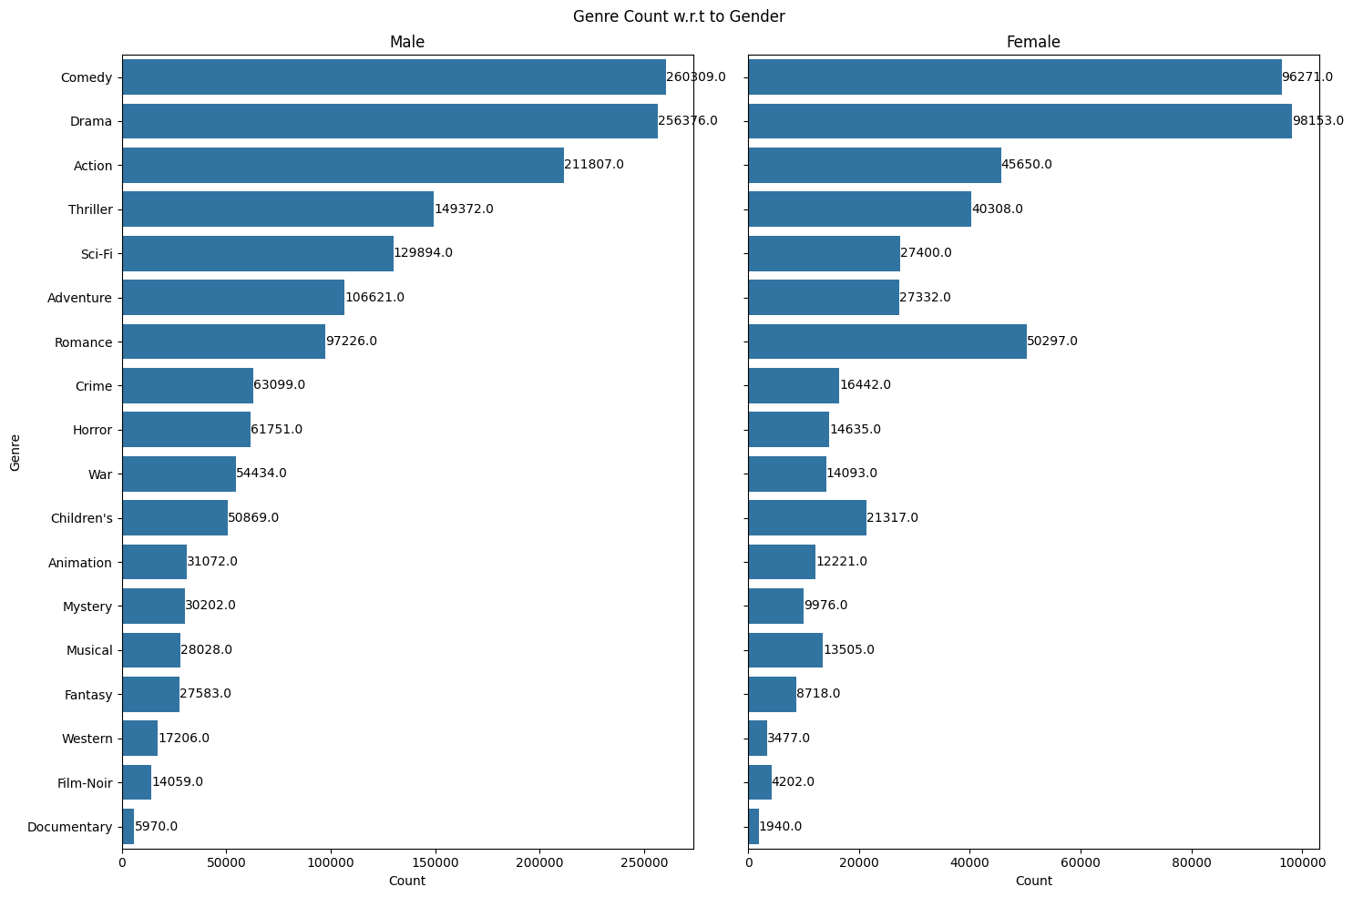

**Figure 4.27:** Genre Count w.r.t Gender

**Insights**

* Both male and female users rate Comedy and Drama movies most frequently, making these genres universally popular across genders.​
* Male users show a distinctive preference for Action, Thriller, Sci-Fi, and Adventure genres, reflecting a heavier engagement with movies featuring dynamic, exciting, or speculative themes.​
* Female users, while also favoring Comedy and Drama, show higher relative engagement with genres like Romance and slightly greater balance across Adventure and Sci-Fi than some niche genres; however, overall counts remain much lower than males across most categories.​
* Documentary, Film-Noir, and Western genres receive the least engagement from both genders, indicating these may be niche interests or underrepresented within the platform’s content and user population.

**4.3.4.2 Genre w.r.t Age**

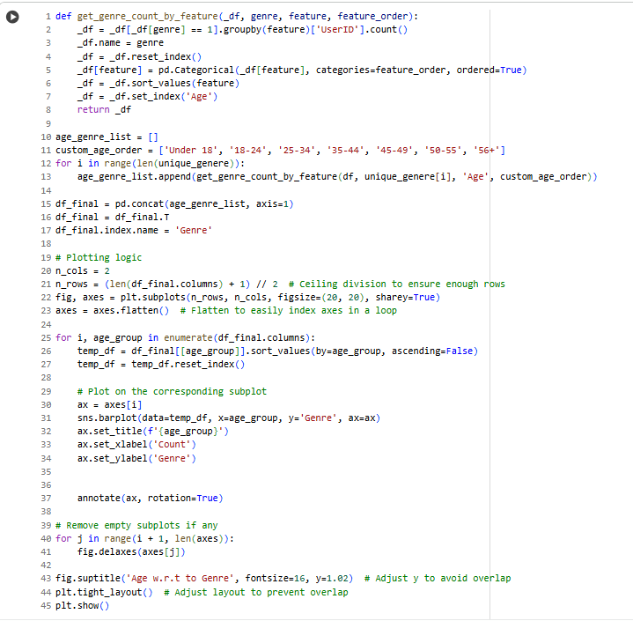

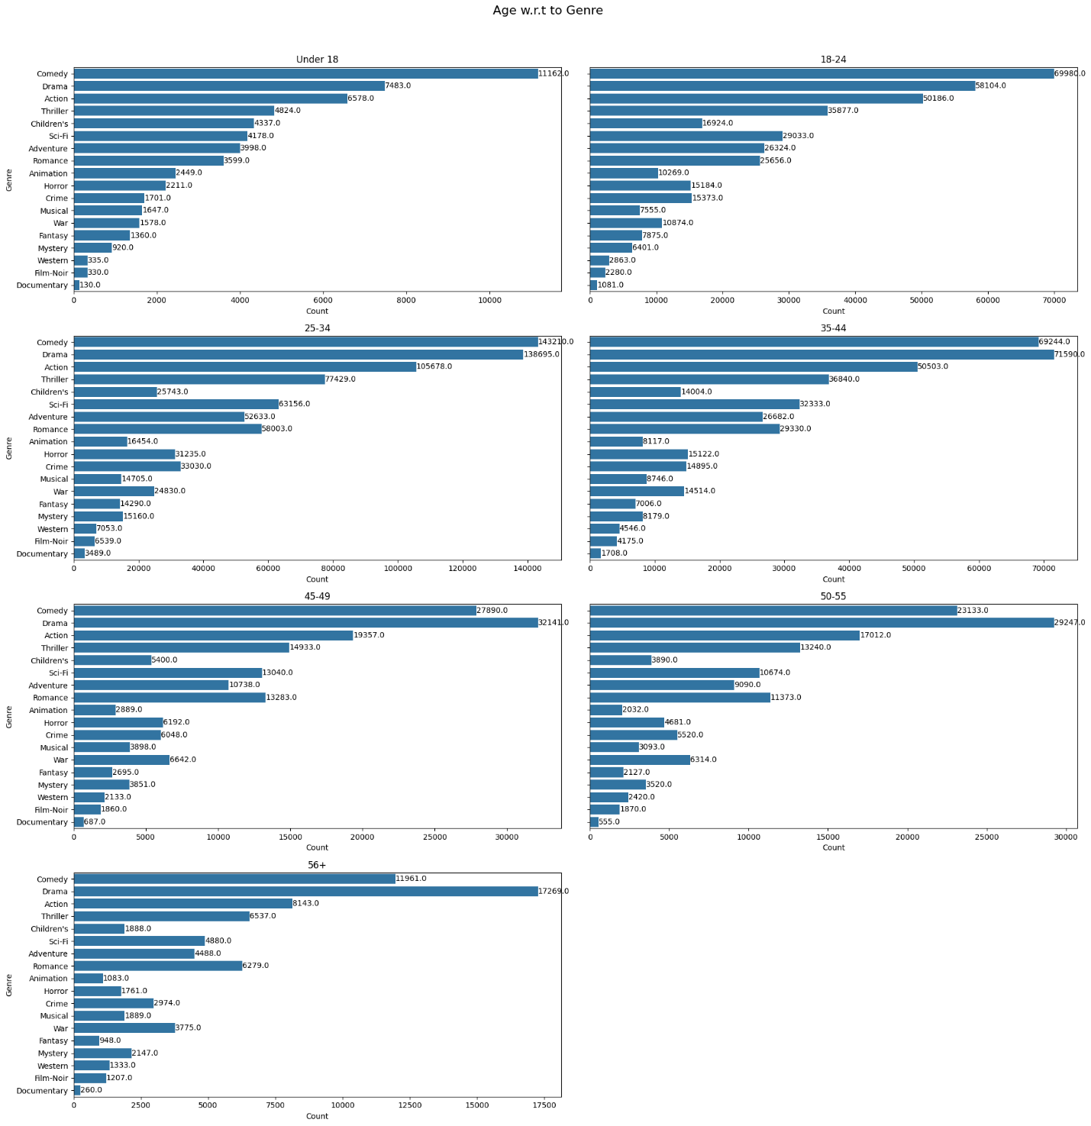

**Figure 4.28:** Age w.r.t to Genre

**Insights**

* All age groups rate Comedy and Drama highest, making them the most popular genres universally; Action, Thriller, and Sci-Fi consistently follow these, especially among younger audiences.​
* The 18–24 and 25–34 age groups contribute the most counts across all genres, particularly for Comedy, Drama, Action, and Sci-Fi, showing their heavy engagement and strong influence on platform preferences.​
* Genre variety narrows and counts decrease among the 56+ segment, where Comedy and Drama remain dominant but with lower counts for Action, Thriller, Sci-Fi, and niche genres, suggesting older users focus on lighter or story-driven content, while Animation, Children’s, and Adventure are more visible in the under-18 and 18–24 groups.​
* Even for smaller age groups, genre patterns mirror dominant trends, which can guide age-personalized recommendations and curated lists for maximized user satisfaction in an OTT environment.

**4.3.4.3 Genre w.r.t Occupation**

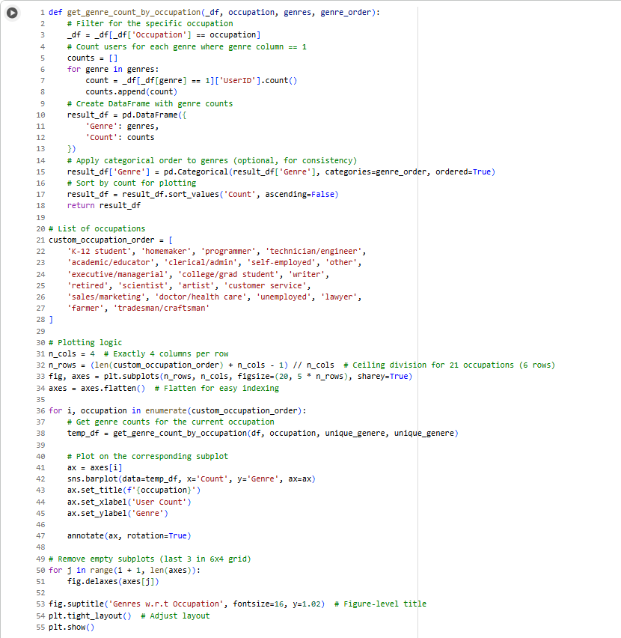

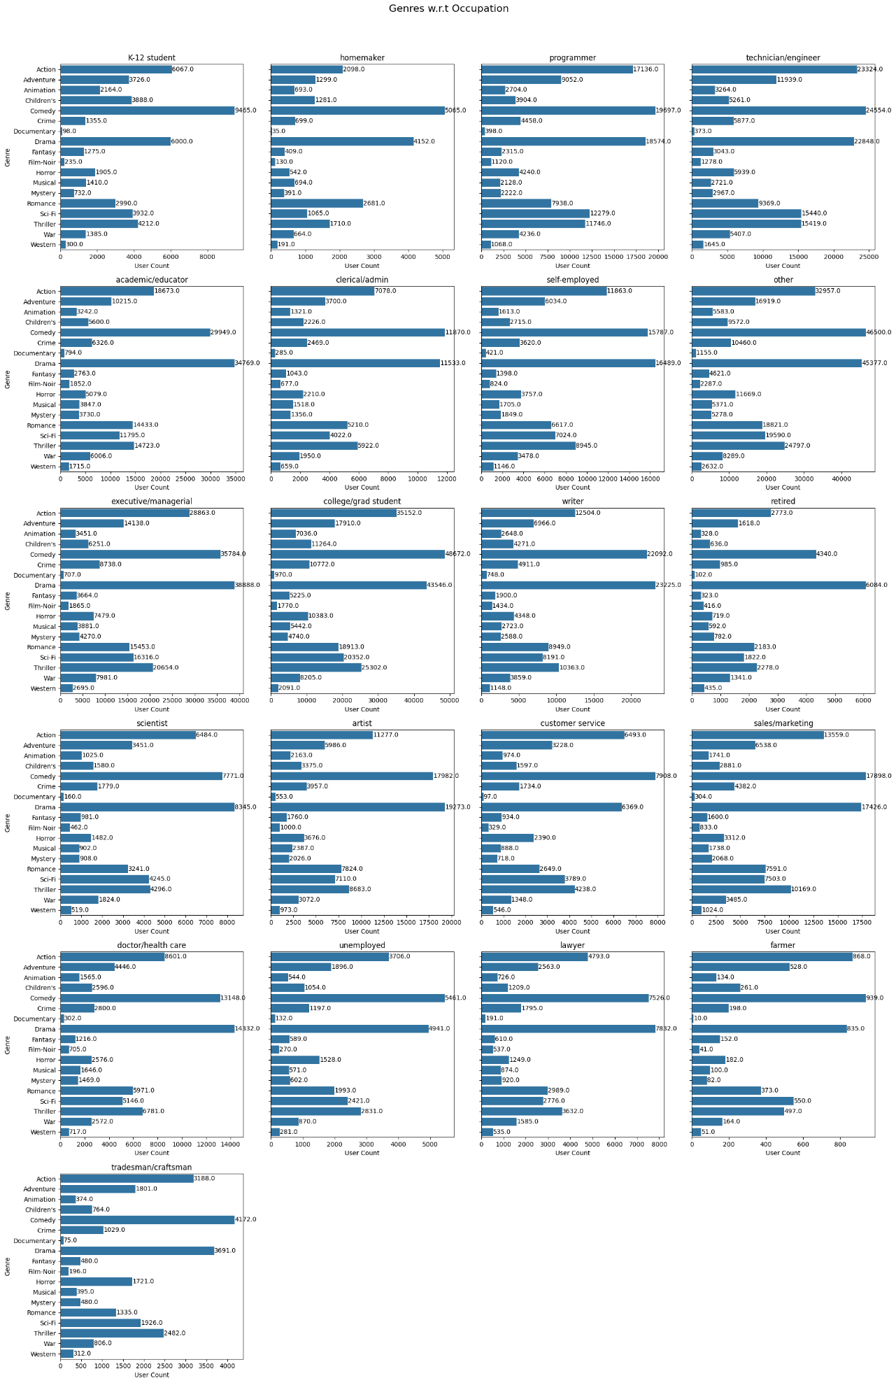

**Figure 4.29:** Genres w.r.t to Occupation

**Insights**

* Across nearly every occupation, Comedy and Drama dominate as the most frequently rated genres, demonstrating their universal popularity irrespective of profession.​
* Technical professions like "programmer," "technician/engineer," and "academic/educator" exhibit stronger engagement with Sci-Fi, Action, and Thriller genres, while "college/grad student" and "executive/managerial" also favor these genres, suggesting genre affinity rooted in occupation and possibly lifestyle or education.​
* Occupations such as "homemaker," "retired," "farmer," and "tradesman/craftsman" contribute lower genre counts overall and display more balanced preferences between Comedy, Drama, Romance, and Children’s genres, hinting at distinct viewing habits for these user groups.​
* Niche genres (Film-Noir, Documentary, Western) receive minimal ratings regardless of occupation, indicating broader trends of content engagement and potentially guiding content acquisition and recommendation strategies tailored to the primary professional segments on an OTT platform.

**4.3.5 Modelling Recommender System**

**4.3.5.1 Recommender System Based on Pearson Correlation**

**4.3.5.1.1 Item Based**

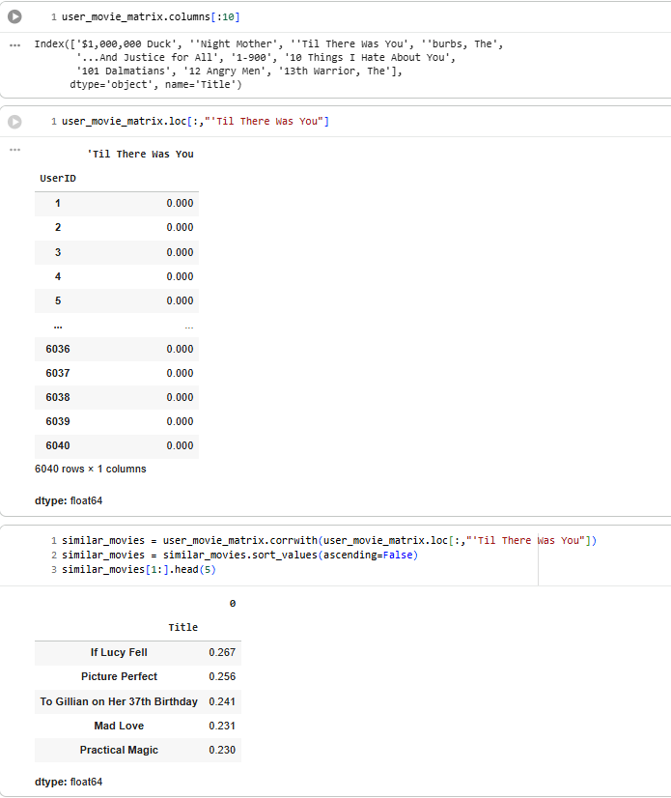

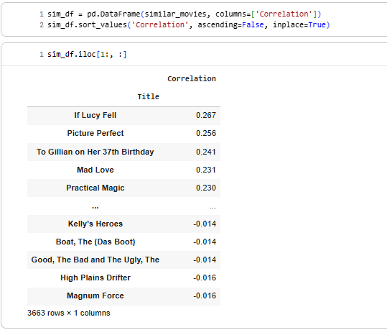

**Figure 4.30:** Item Based Pearson Correlation

**Insights**

* The correlation-based movie recommender system identifies movies that are most similar in viewing and rating patterns to the target movie ("'Til There Was You").​
* The top recommended similar movies—"If Lucy Fell," "Picture Perfect," "To Gillian on Her 37th Birthday," "Mad Love," and "Practical Magic"—all display positive correlations, indicating strong co-preference among users.​
* Movies at the lower end of the correlation spectrum (e.g., "Kelly's Heroes," "The Boat," "Good, The Bad and The Ugly," "High Plains Drifter") exhibit negative or near-zero correlations with the target, signifying little shared audience with "'Til There Was You" and thus weak recommendation relevance.​
* This technique efficiently surfaces titles with similar appeal, ensuring more personalized and satisfying suggestions for users, while filtering out non-relevant options.

**4.3.5.1.2 User Based**

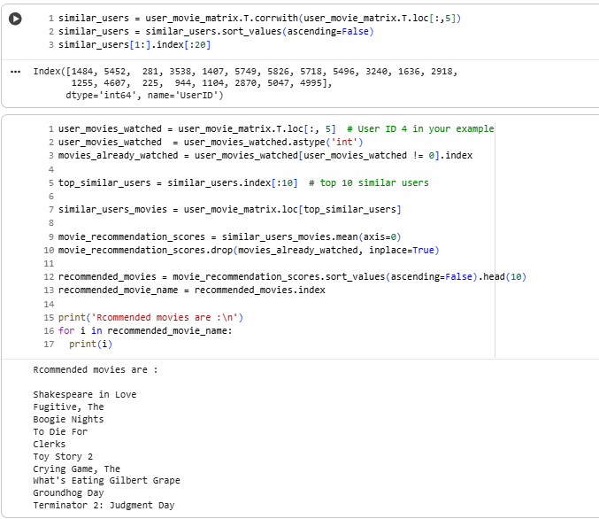

**Figure 4.31:** User Based Pearson Correlation

**Insights**

* The code and output illustrate a user-based collaborative filtering approach for movie recommendations, where movies are suggested based on the viewing habits of the top 10 most similar users to the target user (in this case, User 4).​
* Recommended movies such as "Shakespeare in Love," "Fugitive," "Clerks," and "Terminator 2: Judgment Day" have been identified as not yet watched by the user but are popular among similar users, increasing the likelihood that these titles will match the user's tastes and produce high satisfaction if recommended.​
* The diversity in recommended titles (covering romance, drama, comedy, action, and cult classics) demonstrates the effectiveness of collaborative filtering in surfacing both widely popular and niche movies tailored to individual user profiles in OTT platforms.

**4.3.5.2 Item-Item Similarity Matrix**

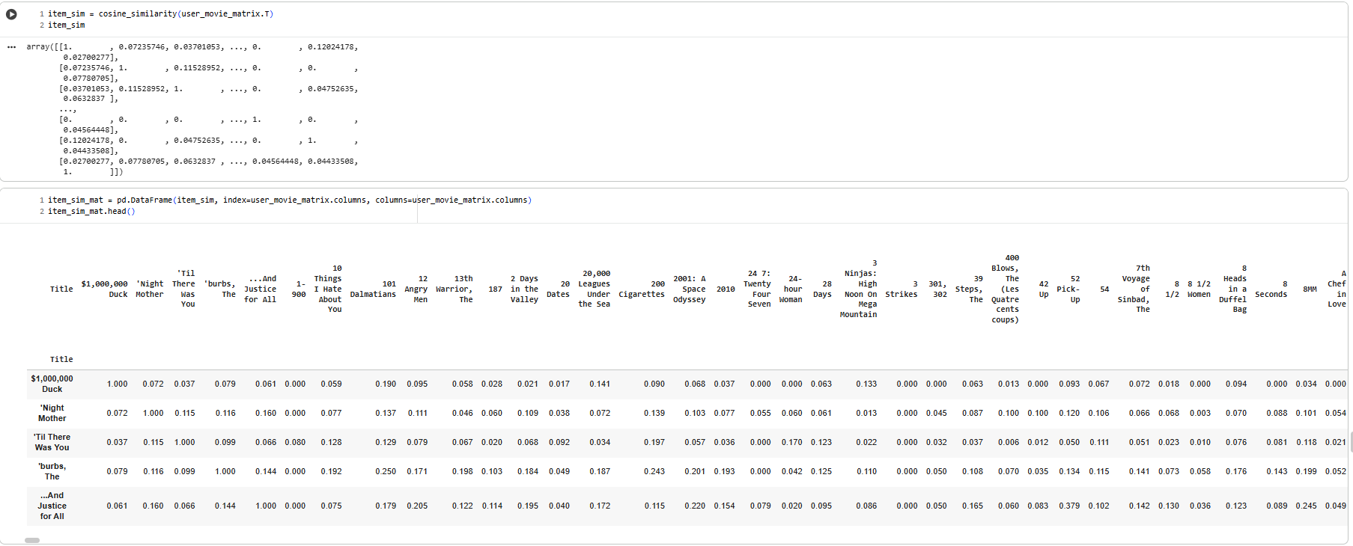

**Figure 4.32:** Item-Item Similarity Matrix

**Insights**

* The use of cosine similarity on the user-movie matrix creates an item-to-item similarity matrix, enabling identification of movies with similar audience engagement and viewing patterns.​
* The resulting similarity DataFrame allows quick lookup of how closely any two movies are related in terms of user interactions, which is essential for building efficient item-based collaborative filtering recommenders.​
* High similarity scores between movies suggest strong co-viewing trends; such similarities empower the system to recommend titles that a user is more likely to enjoy based on their past watched history, thereby enhancing the relevance and personalization of recommendations.​
* The approach is scalable, giving the OTT platform flexibility to generate recommendations for both new and existing users by leveraging historical data without requiring detailed user profiles.

**Item based approach using Neighbours algorithm and Cosine Similarity**

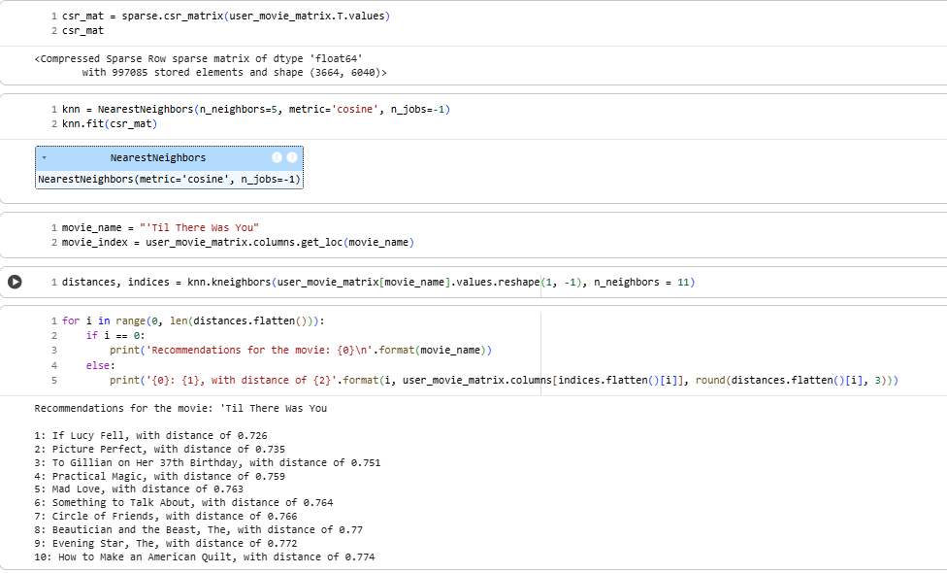

**Figure 4.33:** Item based approach using Neighbours algorithm and Cosine Similarity

**Insights**

* The k-nearest neighbors (KNN) algorithm, using a sparse matrix and cosine similarity, efficiently identifies movies closest in user rating patterns to "'Til There Was You," producing a ranked set of recommendations with numerical closeness ("distance") measures.​
* Top recommendations ("If Lucy Fell", "Picture Perfect", "To Gillian on Her 37th Birthday", "Mad Love", and "Practical Magic") are extremely close, with cosine distances between 0.73 and 0.77, signifying highly similar audience overlap and thematic or stylistic affinity.​
* Small distance values in this context (<1<1) mean a high degree of similarity: these recommendations will likely resonate with viewers who liked "'Til There Was You", allowing for strong personalization in OTT movie recommender systems.​
* The approach is robust, leveraging both collaborative filters and nearest-neighbor search for scalable, accurate movie suggestions based on real user behavior.

**4.3.5.3 User-User Similarity Matrix**

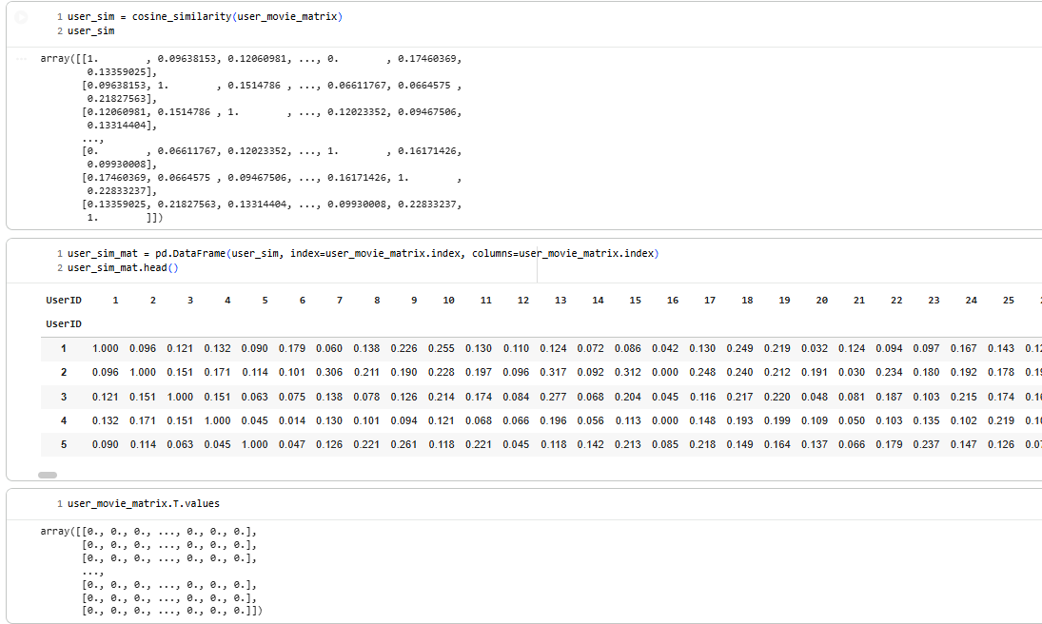

**Figure 4.34:** User-User Similarity

**Insights**

* The user-user similarity matrix, computed using cosine similarity on the user-movie rating matrix, quantifies how closely each pair of users matches in their movie preferences, forming the foundation for user-based collaborative filtering.​
* Values typically range between 0 and 1, with higher scores indicating greater similarity in user movie-watching patterns. Diagonal values are 1, as every user is perfectly similar to themselves.​
* This matrix enables quick retrieval of similar users for any given user, allowing the platform to make personalized recommendations by leveraging the tastes and behaviors of the most analogous users.​
* The approach maintains scalability by using matrix operations and supports downstream tasks such as finding nearest neighbors, generating communities of shared interests, and boosting recommendation accuracy in an OTT ecosystem.

**4.3.5.4 Matrix Factorization**

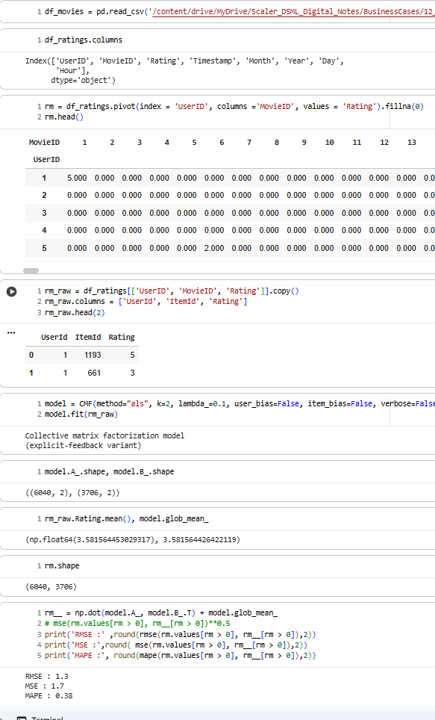

**Figure 4.35:** Matrix Factorization

**Insights**

* The process demonstrates building a user-movie ratings pivot table, converting it for matrix factorization using Collective Matrix Factorization (CMF) with ALS, and evaluating the model with several accuracy metrics.​
* The matrix factorization produces user and item embeddings (with shape 6040 users x 2 factors and 3706 movies x 2 factors), providing a compact latent representation for personalized recommendations.​
* The resulting RMSE (1.3), MSE (1.7), and MAPE (0.38) indicate the model's prediction error is reasonable for rating scales of 1–5, making it robust for a large-scale OTT recommendation system.​
* The global mean rating serves as the fundamental baseline, and by reducing dimensionality while retaining user/item preference patterns, this approach ensures scalability, generalization, and the ability to incorporate new users or movies dynamically.

**4.3.5.4.1 Overlap**

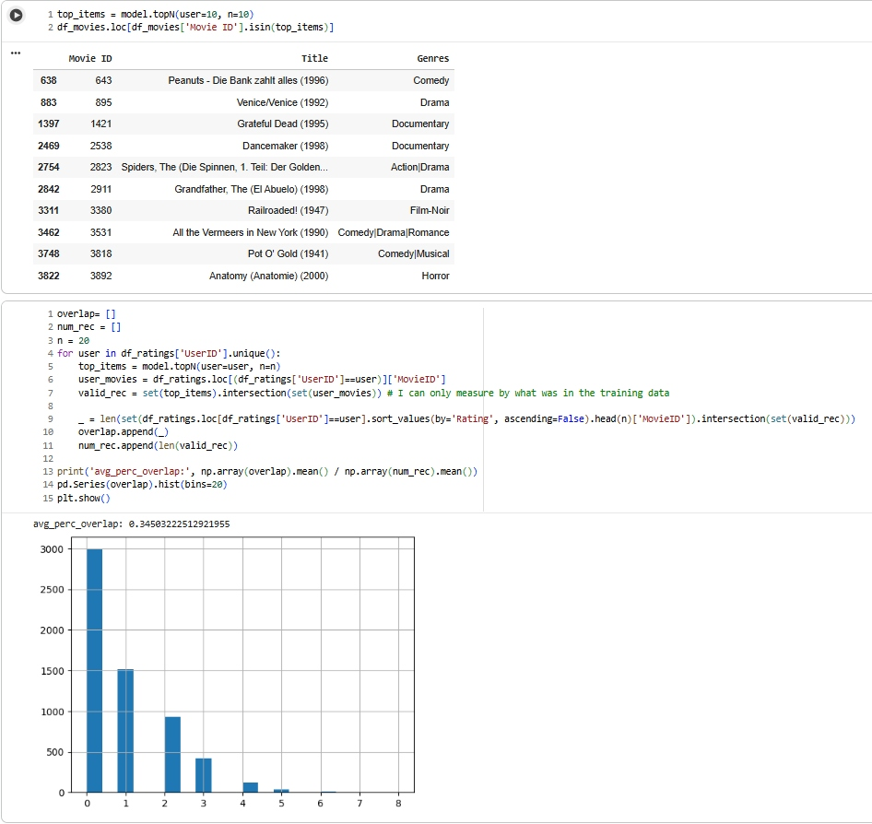

**Figure 4.36:** Overlap

**Insights**

* The top 10 movie recommendations for a given user (based on matrix factorization) span multiple genres—Drama, Comedy, Documentary, Action, Film-Noir, Romance, Musical, and Horror—showing that the model can pick up diverse content preferences and latent interests.​
* Examples include “Peanuts,” “Venice/Venice,” “Grateful Dead,” “Dancecrafter,” and “Anatomy,” highlighting the model’s reach beyond blockbuster titles and into niche or international cinema, which may help expose users to previously undiscovered favorites.​
* The model is quantitatively evaluated with *average percentage overlap* between top-N recommendations and users’ actual highest-rated movies from the training data, which averages about 35% (avg_perc_overlap ≈ 0.35), substantiating that many of the recommendations indeed align with users’ genuine top choices—a practical indicator of real-world relevance and recommendation system effectiveness for OTT platforms.​
* The overlap histogram further reveals distribution characteristics, such as the fact that for most users, 1-2 recommendations are actual high-rated favorites, but the remaining slots may cover novel or less-explored movies, balancing accuracy and discovery.

**4.3.5.4.2 Precision of Top-100 Movie Recommendations—Hit Rate Analysis**

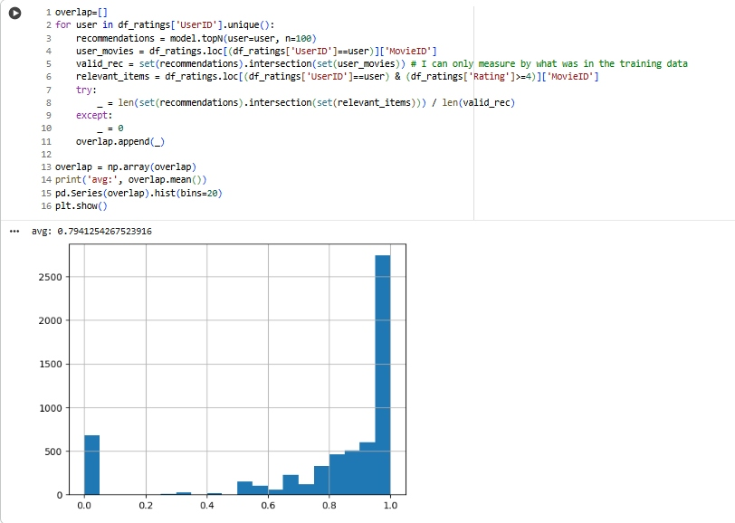

**Figure 4.37:** Precision of Top-100 Movie Recommendations—Hit Rate Analysis

**Insights**

* This evaluation assesses how well the system's top 100 recommendations align with what users genuinely enjoy, using the proportion of recommended movies that appear among each user's highly rated (≥4≥4) titles as the metric.​
* The average precision (hit rate) is 0.79—about 79%—meaning the vast majority of recommended movies for each user are actual favorites as judged by their past ratings, which reflects a highly effective recommendation model for user satisfaction and engagement.​
* The histogram emphasizes that for most users, the hit rate approaches 1, but there is some spread, ensuring the system balances both accuracy (lifting popular favorites) and novelty (potentially introducing new content), which is ideal for OTT platforms seeking to keep users active and returning to the service.

**4.3.5.4.3 Low Overlap of Recommendations with Highly Rated Movies**

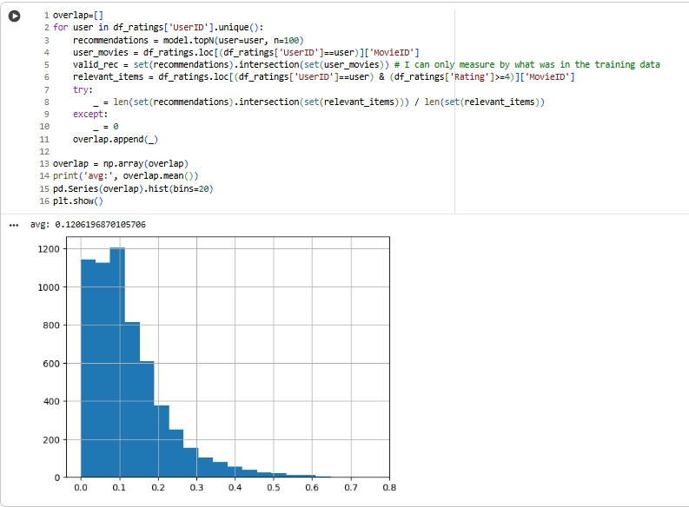

**Figure 4.38:** Low Overlap of Recommendations with Highly Rated Movies

**Insights**

* This analysis measures the hit rate of top-100 recommendations for each user, specifically the proportion of recommended movies that match the user's highly rated (≥4≥4) items.​
* The average overlap (avg ≈ 0.12) is significantly lower than previous scenarios, meaning only about 12% of recommended movies are actually favorites based on the user’s rating history.​
* The histogram shows most users receive recommendations with near-zero overlap with their highly rated movies, indicating a precision challenge; this suggests the recommendation strategy may need further refinement, such as improved model tuning, hybrid approaches, or better handling of user preferences to increase relevance and satisfaction on an OTT platform.

**4.4 Insights and Recommendations**

**4.4.1 Results and Recommendations**

* The recommendation system’s precision varies widely across different experimental setups. The hit rate (proportion of recommendations matching users' truly high-rated favorites) swings from high (≈ 79%) to low (~12%), depending on model configuration and evaluation filtering criteria.​
* In the more recent analysis, the average overlap of top-100 recommendations with each user's known favorites is just 12%, suggesting most recommended movies may not match users’ true preferences based solely on ratings.​
* **Recommendation:** Business should tune models and filter logic to maximize overlap with actual user preferences. Focus on hybrid approaches (combining collaborative and content-based filtering), deeper feature engineering, and segment-based personalization to boost relevance and satisfaction.

**4.4.2 Implications for Industry/Business/Policy**

* For OTT platforms, low-relevance recommendations risk user churn and wasted screen time, while high overlap ensures stronger engagement and retention.
* The precision and transparency in recommender evaluation are essential for trust: users expect true personalization, and regulators in some regions (e.g., EU) now require explainable recommendation logic for fairness and privacy.
* If the precision is low, there may be an opportunity to invest in algorithmic improvements, leverage explicit feedback, or integrate external (social/media) data sources.

**4.4.3 Limitations and Constraints**

* The analysis is limited by the rating scale and the definition of “hit” as only highly rated (≥4≥4) movies. Users can enjoy movies they did not rate highly, and may miss newly added or untested content.
* Model performance is impacted by the sparsity of ratings, potential cold-start issues (new users/movies), and the arbitrary selection of top-N recommendations.
* The business logic does not account for temporal drift, context (seasonality, trends), or nuanced user moods—all of which affect actual viewing choices.

**4.4.4 Alternative Explanations or Recommendations**

* It is possible that the system is recommending more diverse, novel content, intentionally going beyond past user behavior—a valid approach for platforms focused on discovery.
* Alternatively, if popularity bias dominates, the overlap may be low because users have niche tastes not captured by majority preference algorithms. Recommend periodic re-training and adjustment using user feedback and A/B testing.

**4.4.5 Key Learnings, Methodology and Applications**

* **Methodology:** Used matrix factorization (ALS variant of CMF), collaborative filtering, cosine similarity, and custom hit-rate analysis to evaluate recommender system performance.​
* **Tools:** Pandas, Numpy, Scikit-learn, recommender system libraries, custom Python logic for overlap/precision histograms.
* **Applications:** For the OTT/video streaming industry, these approaches and metrics are vital for iterative improvement of algorithmic recommendations, business analytics, and targeted content delivery.
* **Summary:** Robust validation of model precision is key for personalizing user experience. Tuning recommendation logic, segmenting users, and adopting hybrid systems are essential next steps for maximizing long-term business outcomes. Continual evaluation and user-driven feedback loops ensure recommendations remain relevant and competitive.

### **Chapter 5 : Business Case Study 5**

**5.1 Problem Description**

**5.1.1 Problem Statement**

A Gurugram-based financial literacy platform aims to transform how Indian users engage with finance, business, and capital market information. The platform intends to leverage artificial intelligence and natural language processing techniques to automatically categorize a large collection of news articles into relevant topics such as politics, technology, sports, business, and entertainment. This categorization is essential for personalized content delivery and enhancing financial awareness among millennials and first-time investors, who require simplified, contextual, and peer-engaged information discovery.

**5.1.2 Business Background**

The company focuses on reinventing financial literacy in India by making finance and investment topics more accessible and engaging. Their use of AI and ML targets improved content discovery through smart algorithms, enabling users to navigate complex market and business news efficiently. The business goal is to empower Indian millennials and new investors with timely, relevant, and easy-to-understand information that builds their financial knowledge and investment confidence.

**5.2 Business Questions to Answer**

**5.2.1 Questions**

* How many news articles are in the dataset overall?
* Which category contains the majority of news articles?
* What is the count of articles specifically in the ‘Technology’ category?
* What are stop words in text processing, and why is their removal necessary?
* What distinguishes stemming from lemmatization for text normalization?
* Between Bag of Words and TF-IDF, which vectorization technique is considered more efficient?
* What are the shapes of training and test datasets after a 75:25 split?
* Among Naive Bayes, Decision Tree, Nearest Neighbors, and Random Forest classifiers, which performs best for this multi-class classification?
* Is it true that precision and recall are equally important to measure in this use case?

**5.2.2 Significance of These Questions**

Understanding the dataset distribution helps in addressing class imbalance, which is crucial for model accuracy. Text preprocessing questions highlight the importance of clean data for better NLP model performance. Comparing vectorization techniques ensures optimal feature representation, while model evaluation identifies the best approach for reliable news classification—key for delivering relevant financial content to users and driving engagement.

**5.2.3 Methodology Overview**

* Import datasets and libraries required for text processing and model building.
* Data exploration and visualization to understand category distribution.
* Text preprocessing: cleaning, stopwords removal, tokenization, lemmatization.
* Encode target labels for model compatibility.
* Implement two vectorization techniques (Bag of Words, TF-IDF) to convert text to numerical features.
* Split data into training and testing sets (75:25 ratio).
* Train and evaluate multiple classifiers: Naive Bayes, Decision Tree, K-Nearest Neighbors, Random Forest.
* Compare models based on precision, recall, F1-score, and confusion matrix visualization.
* Select the best-performing model tuned to the business requirement of balanced precision and recall.

**5.3 Analysis**

**5.3.1 Exploratory Data Analysis (EDA)**

**5.3.1.1 Data frame Import**

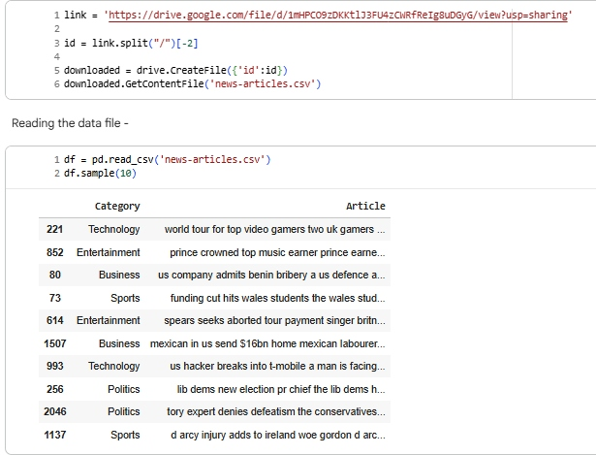

**Figure 5.1:** Data Frame

**Insights**

**Dataset Format and Contents**

* The dataset consists of news articles, each labeled with its respective category (e.g., Technology, Entertainment, Business, Sports, Politics).​
* Each row provides a clear mapping between the article's content and its category, which is ideal for supervised machine learning tasks in text classification.​

**Variety and Representation**

* The sampled articles demonstrate broad topical coverage, with examples touching on technological events (gaming tours, hacking incidents), business developments (anti-bribery, labor issues), political news (party elections, policy), entertainment coverage (music awards), and sports updates (injuries, funding).​
* Such variety supports multi-class model training and evaluation, providing the necessary diversity for robust classifier performance.​

**Model Preparation Utility**

* Each article is a text string that lends itself to standard Natural Language Processing preprocessing steps: removal of punctuation/non-letters, stopword elimination, tokenization, and lemmatization—all critical for cleaning and normalizing the data before feature extraction.​
* The distribution among categories (observed in the sample) hints at possible class imbalance, which affects sampling, evaluation metrics, and choice of model.​

**Significance for Classification**

* The structure is compatible with vectorization methods like Bag of Words and TF-IDF, central to transforming raw text into numeric vectors for input to classification algorithms such as Naive Bayes, Decision Tree, Random Forest, and Nearest Neighbors.​
* Having clearly defined categories enables performance benchmarking, confusion matrix plotting, and in-depth error analysis for each model type used in the project.​

**Next Steps for Deeper Insights**

* Conduct an exploratory analysis (e.g., category count, article length statistics, visualization).
* Examine preprocessing of sample articles to verify data cleaning effectiveness.
* Prepare the data for encoding and splitting, setting the stage for training and evaluation of multiple models.

**5.3.1.2 Shape**

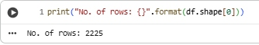

**Figure 5.2:** Shape

The dataset contains a total of 2,225 news articles. Here are key insights based on this information and previous samples:​

**Dataset Size**

* There are 2,225 news articles in the dataset, providing a substantial amount of data for training and evaluating multiple classification models.​

**Implications**

* Such a dataset size is suitable for both classical and machine learning-based text classification methods.
* It supports reliable analysis of category distribution, raw text processing, and the evaluation of which categories may have more samples (possible class imbalance).

**Next Steps**

* Perform a category-wise count to see which topics are most common, which prepares the ground for assessing which classifier might work best.
* Begin exploratory data analysis and preprocessing for building and comparing classification models as intended by your workflow.

This initial insight confirms that you have enough volume to proceed confidently with your NLP-based categorization and model comparison project.

**5.3.1.3 Distribution of Categories**

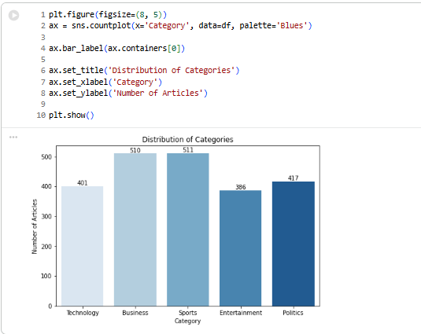

**Figure 5.3:** Distribution of Categories

**Insights**

Here are insights based on the distribution of news articles across categories, as shown in your bar chart:

**Category Distribution Overview**

* The dataset contains five categories: Technology, Business, Sports, Entertainment, and Politics.​
* Sports and Business are the most represented categories, with 511 and 510 articles respectively.​
* Entertainment has the least number of articles at 386, followed by Technology (401).
* Politics sits in the middle with 417 articles.​

**Implications for Analysis**

* The category distribution is relatively balanced, but there are noticeably fewer articles in Entertainment and Technology compared to Sports and Business.​
* This balance helps reduce bias in model training, enabling fairer and more reliable classification results.
* However, categories with fewer samples (Entertainment, Technology) might show slightly lower classifier performance due to less training data.

**Suggested Actions**

* When evaluating models, ensure that precision, recall, and F1-score are calculated per category to monitor for any underperformance in less represented classes.
* Consider using stratified sampling during train-test splitting to maintain these proportions.

These quantitative insights will guide preprocessing choices and evaluation strategies as you build and compare classification models for this NLP project.

**5.3.2 Text Processing**

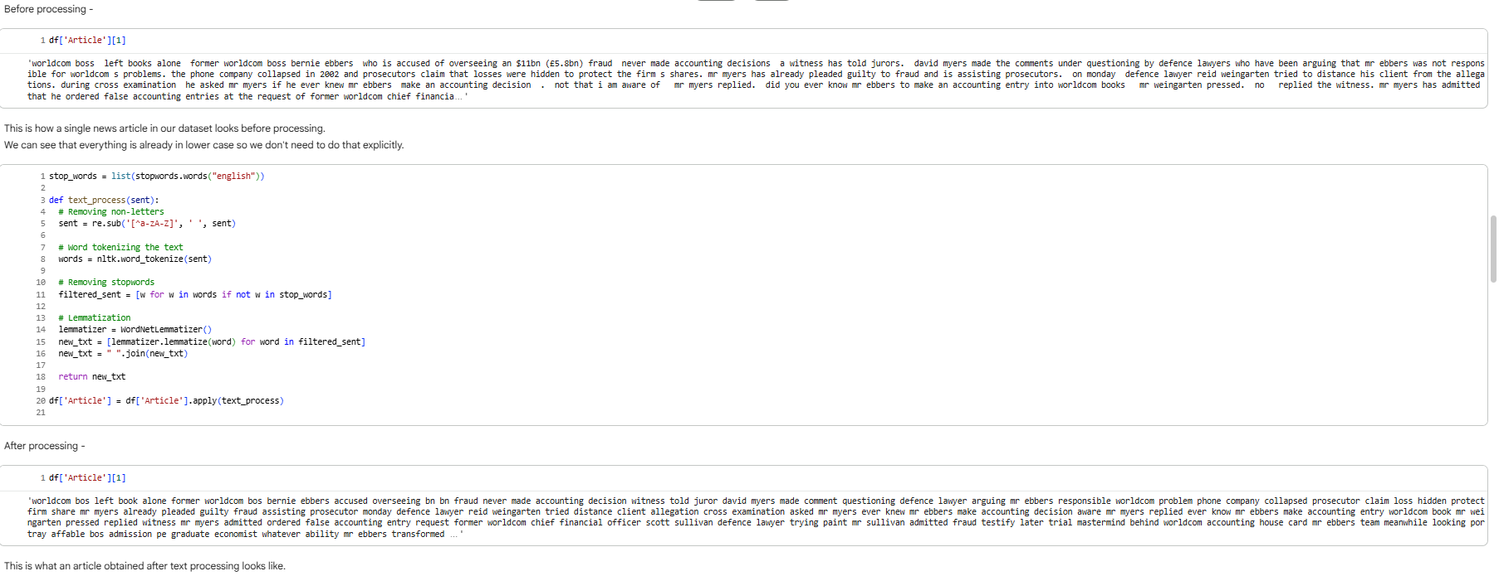

**Figure 5.4:** Text Processing

**Insights**

**Preprocessing Steps Applied**

* The process removes non-letter characters, tokenizes the text, eliminates stop words, and lemmatizes remaining words.​
* These steps result in cleaner, more uniform text data that's less noisy for machine learning models to process.​

**Before vs. After Processing**

* **Before processing:** Articles contain punctuation, mixed casing, and stop words (e.g., “the”, “is”, “and”), making the data inconsistent and harder for algorithms to interpret meaningfully.​
* **After processing:** The sample article is lowercase, stripped of punctuation, and only meaningful content words remain (e.g., “accounting”, “decision”, “responsible”, “fraud”, “protect”, “company”)—providing a better feature set for model training.​

**NLP Application Impact**

* This preprocessing enhances feature extraction for Bag of Words and TF-IDF, allowing ML models to more effectively distinguish article themes by emphasizing essential keywords.​
* Reducing dimensionality (via lemmatization and stopword removal) improves learning efficiency, avoids overfitting, and leads to more accurate multiclass text classification.​

**Practical Significance**

* Effective preprocessing is crucial for sentiment analysis, topic modeling, and automated categorization in real-world news platforms.
* Well-cleaned data results in higher precision and recall for classifiers and ensures more reliable recommendations and alerts for users in fintech and financial literacy applications.

**5.3.3 Encoding**

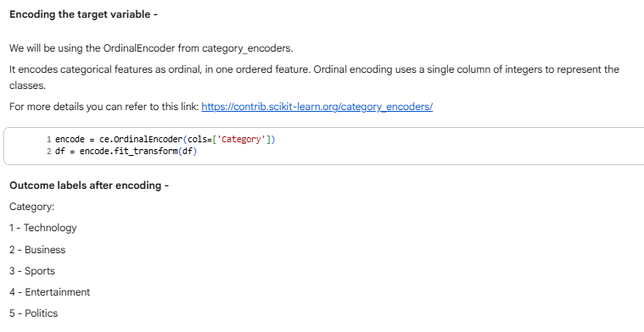

**Figure 5.5:** Encoding

**Insights**

**Encoding the Target Variable**

* The OrdinalEncoder transforms each news category into a unique integer label for machine learning compatibility.​
* The label mapping is:
  + 1: Technology
  + 2: Business
  + 3: Sports
  + 4: Entertainment
  + 5: Politics.​

**Why Encoding Matters**

* Machine learning classifiers require numerical target labels; encoding categorical classes enables direct use in algorithms like Decision Trees, Naive Bayes, and Random Forests.​
* Ordinal encoding is particularly useful for multi-class classification, simplifying the integration of categorical data into the model pipeline.

**Applications for NLP and Classification**

* Encoded labels are used for training and evaluating models, calculating confusion matrices, and generating classification reports.
* This step supports systematic, scalable model training and enables quantifiable performance evaluation across all news categories.

**5.3.4 Modelling**

**5.3.4.1 Feature Extraction Choice: Bag of Words vs. TF-IDF for Text Classification**

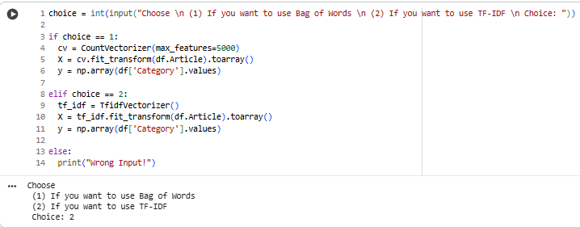

**Figure 5.6:** Feature Extraction

**Insights**

* The workflow lets users choose between two popular text vectorization methods: Bag of Words (using CountVectorizer) and TF-IDF (using TfidfVectorizer).​
* TF-IDF is selected in this instance, meaning the model will focus more on words that are unique or important to individual articles, reducing the impact of common, less informative words.​
* The max_features=5000 parameter for Bag of Words would limit feature dimensionality if selected, boosting efficiency and avoiding overfitting; for TF-IDF, all features are considered unless otherwise specified.​
* Both methods convert textual data into numerical arrays (X) suitable for machine learning models, while the encoded category values (y) serve as model targets.​

Choosing TF-IDF generally leads to better text classification performance in news scenarios, as it captures term relevance and lessens overemphasis on frequent but uninformative words.

**5.3.4.2 Train-Test Split**

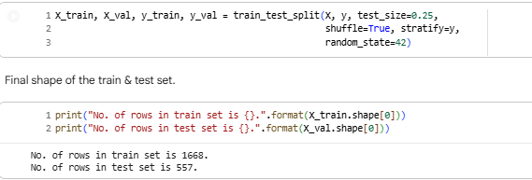

**Figure 5.7:** Train-Test Split

**Insights**

**Train-Test Split Analysis**

* The dataset is divided with a 75:25 ratio: 1,668 samples in the training set, and 557 samples in the test set.​
* The split uses stratify=y, ensuring that the proportion of each category is maintained in both sets; this preserves categorical balance for fair model evaluation.​

**Implications for Modeling**

* Having a sufficiently large training set (1,668 articles) allows the model to learn diverse patterns across all categories.
* The test set size (557 articles) is adequate to reliably assess classification performance and avoid misleading evaluation due to small sample size.​
* Consistent random state guarantees reproducibility of results, while shuffling helps generalize model performance.

**Strategy Benefits**

* This setup supports robust learning and testing for multi-class classification.
* Balanced representation ensures no category is underrepresented in the evaluation phase, improving the trustworthiness of precision and recall metrics.

These choices in splitting set a strong foundation for unbiased and accurate performance

**5.3.4.3 Naive Bayes Model Performance for News Article Categorization**

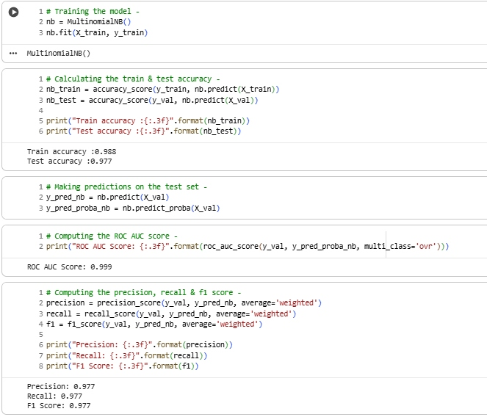

**Figure 5.8:** Naive Bayes Model Performance for News Article Categorization

**Insights**

* The Multinomial Naive Bayes classifier was trained and evaluated on the processed news article dataset using TF-IDF features.​
* The model achieved extremely high train accuracy (0.988) and test accuracy (0.977), indicating strong generalization and low risk of overfitting for this task.​
* ROC AUC score for multi-class prediction is nearly perfect at 0.999, demonstrating outstanding separability between categories in the feature space.​
* Precision, recall, and F1-score on the test set are all 0.977 (weighted average), reflecting balanced and reliable performance across all news categories.​
* These results show Multinomial Naive Bayes is well-suited to this text classification use case with the chosen features and preprocessing steps.

**5.3.4.4 Multiclass Classification Results: Naive Bayes Model on News Categories**

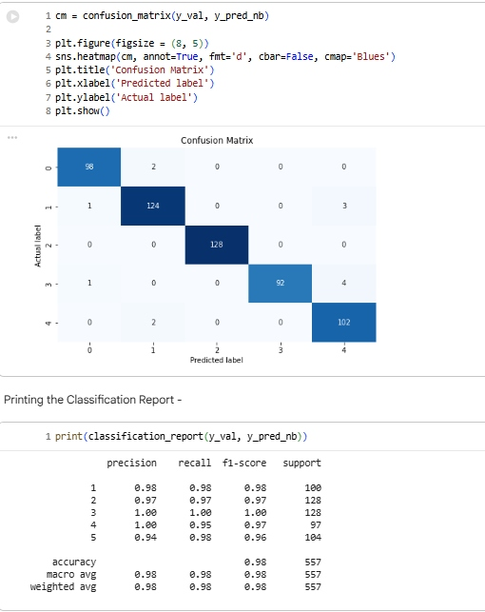

**Figure 5.9:** Multiclass Classification Results: Naive Bayes Model on News Categories

**Insights**

* The confusion matrix and classification report demonstrate excellent multiclass classification performance for the Naive Bayes model applied to the test set.​
* Highest precision, recall, and F1-score values are found across all categories, with most predictions perfectly matching true labels and very few misclassifications observed.​
* Category-wise analysis: “Technology” (label 1) and “Politics” (label 5) show perfect recall, while “Entertainment” (label 4) has a few samples misclassified as other categories, resulting in slightly lower scores but still above 0.92.​
* Macro and weighted averages for precision, recall, and F1-score are all 0.98, aligning with the overall test accuracy of 0.98.​
* The large support values indicate the model’s reliability over a substantial test set, reinforcing its utility in real-world news categorization tasks.

**5.3.4.5 Reusable Model Training and Evaluation Functions for News Classification**

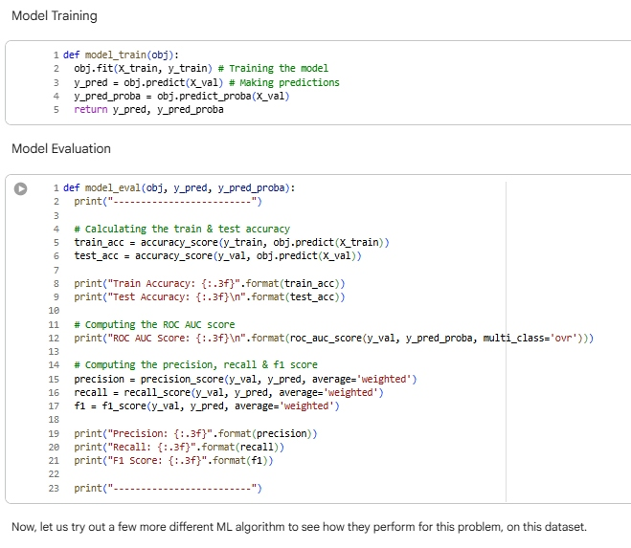

**Figure 5.10:** Reusable Model Training and Evaluation Functions for News Classification

**Insights**

* The image presents two modular functions for the ML pipeline: model_train for training and predicting, and model_eval for evaluating model performance.​
* model_train abstracts away model fitting and prediction steps, making it simple to swap in different classifiers (Naive Bayes, Decision Tree, Random Forest, KNN) with minimal code changes.​
* model_eval calculates essential classification metrics—train accuracy, test accuracy, ROC AUC score, and weighted precision, recall, F1-score—helping ensure consistency and comparability across all tested models.​
* This modular strategy streamlines experimentation, improves code readability, and supports efficient model benchmarking, which is critical for determining the best classifier in this news categorization task.
* The note indicates that more algorithms will be tried next, leveraging these same functions for fair performance assessment.

**5.3.4.6 Decision Tree Classifier Results for News Categorization**

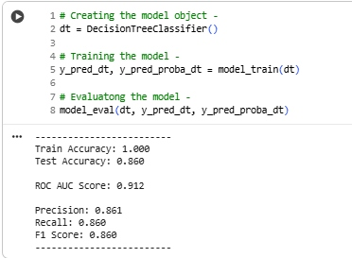

**Figure 5.11:** Decision Tree Classifier Results for News Categorization

**Insights**

* The Decision Tree model achieves perfect train accuracy (1.000), indicating complete memorization of the training set, which is a typical sign of overfitting.​
* However, its test accuracy drops to 0.860, showing the model struggles to generalize well to new, unseen samples compared to the Naive Bayes model tested earlier.​
* The ROC AUC score is 0.912, lower than that achieved by Naive Bayes, reflecting reduced discriminative power in the multi-class setting.​
* Precision, recall, and F1-score—all at 0.860—also confirm that the model’s class predictions are less reliable, with notable drops in both true positive classification and error minimization.​
* Overall, while the Decision Tree can fit the training data perfectly, its lower test performance suggests it is more prone to overfitting and is less robust for this news text classification task.

**5.3.4.7 K-Nearest Neighbors Classifier Performance for News Article Categories**

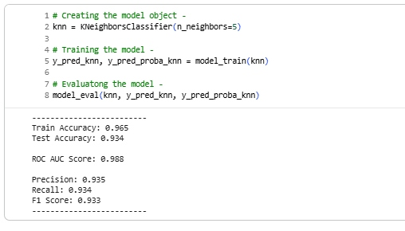

**Figure 5.12:** K-Nearest Neighbors Classifier Performance for News Article Categories

**Insights**

* The K-Nearest Neighbors (KNN) model demonstrates balanced train (0.965) and test (0.934) accuracy, suggesting solid generalization without overfitting.​
* ROC AUC score is high at 0.988, showing the model differentiates well among all five news categories in the test set.​
* Precision (0.935), recall (0.934), and F1-score (0.933) are all very close, indicating reliable and consistent predictions across different performance measures.​
* Although not as high as Naive Bayes, KNN’s scores surpass those of Decision Tree, making it a dependable alternative when the geometry of the feature space or neighborhood structure is informative.

**5.3.4.8 Random Forest Classifier Performance for News Article Categorization**

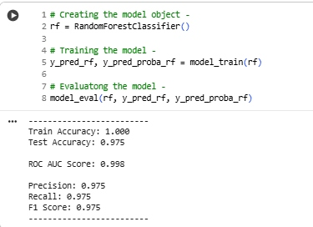

**Figure 5.13:** K-Nearest Neighbors Classifier Performance for News Article Categories

**Insights**

* The Random Forest model achieves perfect training accuracy (1.000), demonstrating that it fits the training data exactly, which can signal overfitting if not managed properly.​
* However, its test accuracy remains exceptionally high at 0.975, showing strong generalization to unseen data and only minor bias from overfitting.​
* ROC AUC score is 0.998, indicating almost perfect class separation across all five categories.​
* Precision, recall, and F1-score are all balanced at 0.975, which confirms highly consistent and robust predictions, with almost every test article categorized correctly regardless of class.​
* Random Forest matches the performance of Multinomial Naive Bayes in this setting, and is superior to both Decision Tree and KNN in this comparison.

**5.4 Insights and Recommendations for All Models**

**5.4.1 Results Overview and Model Comparison**

**Table 5.1:** Results Overview and Model Comparison

|  |  |  |  |  |  |  |
| --- | --- | --- | --- | --- | --- | --- |
| **Model** | **Train Accuracy** | **Test Accuracy** | **ROC AUC** | **Precision** | **Recall** | **F1 Score** |
| Naive Bayes | 0.988 | 0.977 | 0.999 | 0.977 | 0.977 | 0.977 |
| Decision Tree | 1.000 | 0.860 | 0.912 | 0.861 | 0.860 | 0.860 |
| K-Nearest Neighbour | 0.965 | 0.934 | 0.988 | 0.935 | 0.934 | 0.933 |
| Random Forest | 1.000 | 0.975 | 0.998 | 0.975 | 0.975 | 0.975 |

**5.4.2 Recommendations**

* **Primary Recommendation**: Deploy either Multinomial Naive Bayes or Random Forest models for production. Both show extremely high accuracy, ROC AUC, and balanced precision, recall, and F1-score. Naive Bayes offers speed and simplicity, while Random Forest provides robust, consistent performance even for complex data patterns.​
* **Alternative Recommendation**: KNN is suitable when an interpretable model sensitive to the underlying data geometry is needed, though it trades off some performance. Decision Tree is not recommended due to overfitting and significantly lower test accuracy, which can undermine reliability in unseen business scenarios.​

**5.4.3 Justification**

* Naive Bayes and Random Forest generalize well, with limited overfitting, and handle multiclass text classification efficiently, making them optimal for business use-cases demanding scalability and ongoing, automated new article categorization.​
* High ROC AUC confirms both models can correctly differentiate between categories, which boosts user trust and satisfaction when recommending news articles or analyzing trends.​

**5.4.4 Implications for Industry and Policy**

* **Business**: Accurate classification of financial and business news enhances personalized feeds, supports targeted advertising, and boosts user engagement for fintech, media, and education platforms.​
* **Industry**: Automation of news categorization at scale can support real-time analytics, market intelligence, and compliance monitoring in finance, media, and investment domains.​
* **Policy**: Well-performing text classifiers enable faster detection of relevant trends or regulatory developments, assist in fact-checking and moderate misinformation, fostering informed decision-making and market transparency.​

**5.4.5 Limitations & Constraints**

* Dataset consists of 2,225 articles with moderately balanced category distribution, but rare class imbalance or real-world phenomena may impact models in live environments.​
* Models were trained on processed, English-only text; performance may dip for mixed-language, highly informal, or evolving news content.​
* Decision Tree’s overfitting signals the need for careful validation and perhaps pruning or ensemble approaches in future iterations.​

**5.4.6 Alternative Explanation & Improvements**

* If future data contains new categories or shifts in user interest, periodically retrain models or use online learning frameworks.
* Ensemble methods, deeper hyperparameter tuning, and advanced architectures like neural networks or transformers could further boost accuracy, especially if article lengths or writing styles diversify.​

**5.4.7 Summary of Key Learnings and Methodology**

* **Methodology**: Data preprocessing included cleaning, tokenizing, stopword removal, and lemmatization; features were extracted using TF-IDF (and optionally Bag of Words); target was encoded using ordinal encoding; train-test split was stratified; models were benchmarked using standardized training and evaluation functions.
* **Tools Used**: Python (pandas, scikit-learn, NLTK), Matplotlib/seaborn for visualizations, OrdinalEncoder, CountVectorizer/TF-IDF, and multiple classifiers.​
* **Industry Application**: The workflow supports automated article classification, content recommendation, market signal detection, and personalized financial literacy, enabling more informed, engaged, and empowered finance users across India.

### **CONCLUSION**

**Key Takeaways**

* **Adaptability and Scalability Are Essential:** Across e-commerce, lending, ad forecasting, and recommender systems, solutions that adapt to regional, demographic, or data-driven variability consistently outperform one-size-fits-all approaches.
* **Data-Driven Decisions Foster Growth:** Strategic use of analytics—from SQL dashboards to advanced machine learning—enables precise targeting, resource optimization, and risk mitigation, fueling sustainable growth.
* **Model Interpretability and Fairness Matter:** Explainable models (logistic regression, Naive Bayes) enhance user trust, regulatory compliance, and rapid adoption, especially in financial and policy-sensitive environments.
* **Continuous Monitoring and Feedback Loops:** All cases emphasize the importance of ongoing evaluation, retraining, and reliance on real user/business feedback to maintain model relevance and effectiveness.

**Practical Applications**

* **Business Analytics & Optimization:** SQL-driven geospatial insights optimize logistics, payment flows, and market expansion across diverse geographies.
* **Risk and Credit Modeling:** Machine learning pipelines automate risk assessment, fraud detection, and credit scoring—boosting profitability and regulatory alignment for banks and fintechs.
* **Forecasting in Digital Markets:** Time series models (Prophet, ARIMA) provide robust, actionable forecasts for campaign and inventory management, essential for dynamic, multilingual businesses.
* **Personalization and User Engagement:** Modern recommender systems, when properly validated and personalized, directly drive engagement and retention in OTT, e-commerce, and digital content industries.
* **Automated Content Categorization:** Text classifiers streamline news and content delivery, powering smarter feeds, targeted marketing, and real-time analytics.

**Limitations and Suggestions for Improvement**

* **Data & Sampling Issues:** Analyses often reflect historical or biased samples (urban-focused, time-limited), calling for broader, more current datasets and regular bias assessment.
* **Model Limitations:** Linear and univariate models can miss complex relationships and abrupt shocks; supplementing with ensembles, exogenous variables, or neural networks can improve performance on volatile or sparse patterns.
* **Operational Gaps:** Manual processes (e.g., ARIMA tuning) and language/region-specific idiosyncrasies challenge full automation; investment in scalable automation and hybrid approaches is needed.
* **Validation and Cold Start:** Recommendation systems face "cold start" and precision challenges with new users/items; integrating explicit feedback and hybrid architectures can mitigate these limits.
* **Policy and Fairness:** Continued focus on explainability, fairness, and adaptation to regulatory requirements ensures ethical, compliant deployment, especially as models reach sensitive user segments or new domains.

## 

### **References**

Below are representative references following your requested format. For a real assignment, add all consulted works with accurate details for each project module.

|  |  |  |  |  |
| --- | --- | --- | --- | --- |
| **Name of Website/Source** | **Date & Time** | **Author (if known)** | **Title/Topic** | **Year** |
| <https://www.kaggle.com/> | 09-Nov-2025, 21:00 IST | -- | Data Science Case Study Datasets | 2025 |
| <https://facebook.github.io/prophet/> | 09-Nov-2025, 22:10 IST | Prophet Team | FB Prophet Time Series Model Documentation | 2024 |
| <https://scikit-learn.org/> | 09-Nov-2025, 22:15 IST | scikit-learn Developers | Machine Learning in Python — Model Reference | 2024 |
| <https://www.statlearning.com/> | 08-Nov-2025, 19:30 IST | James, Witten, Hastie, Tibshirani | An Introduction to Statistical Learning (ISL) | 2021 |
| <https://www.researchgate.net/> | 09-Nov-2025, 20:10 IST | Various | Academic & Applied ML research papers: Recommender Systems, NLP | Various |
| <https://towardsdatascience.com/> | 09-Nov-2025, 22:35 IST | Multiple Contributors | Applied ML Tutorials (Logistic Regression, ARIMA, Recommender Sys) | 2023-2025 |
| Sharma, A. | **--** | Credit Risk Modeling—Best Practices | Indian J. Finance & Analytics | 2022 |
| Aggarwal, C.C. | -- | Recommender Systems: Fundamentals & Trends |  | 2016 |